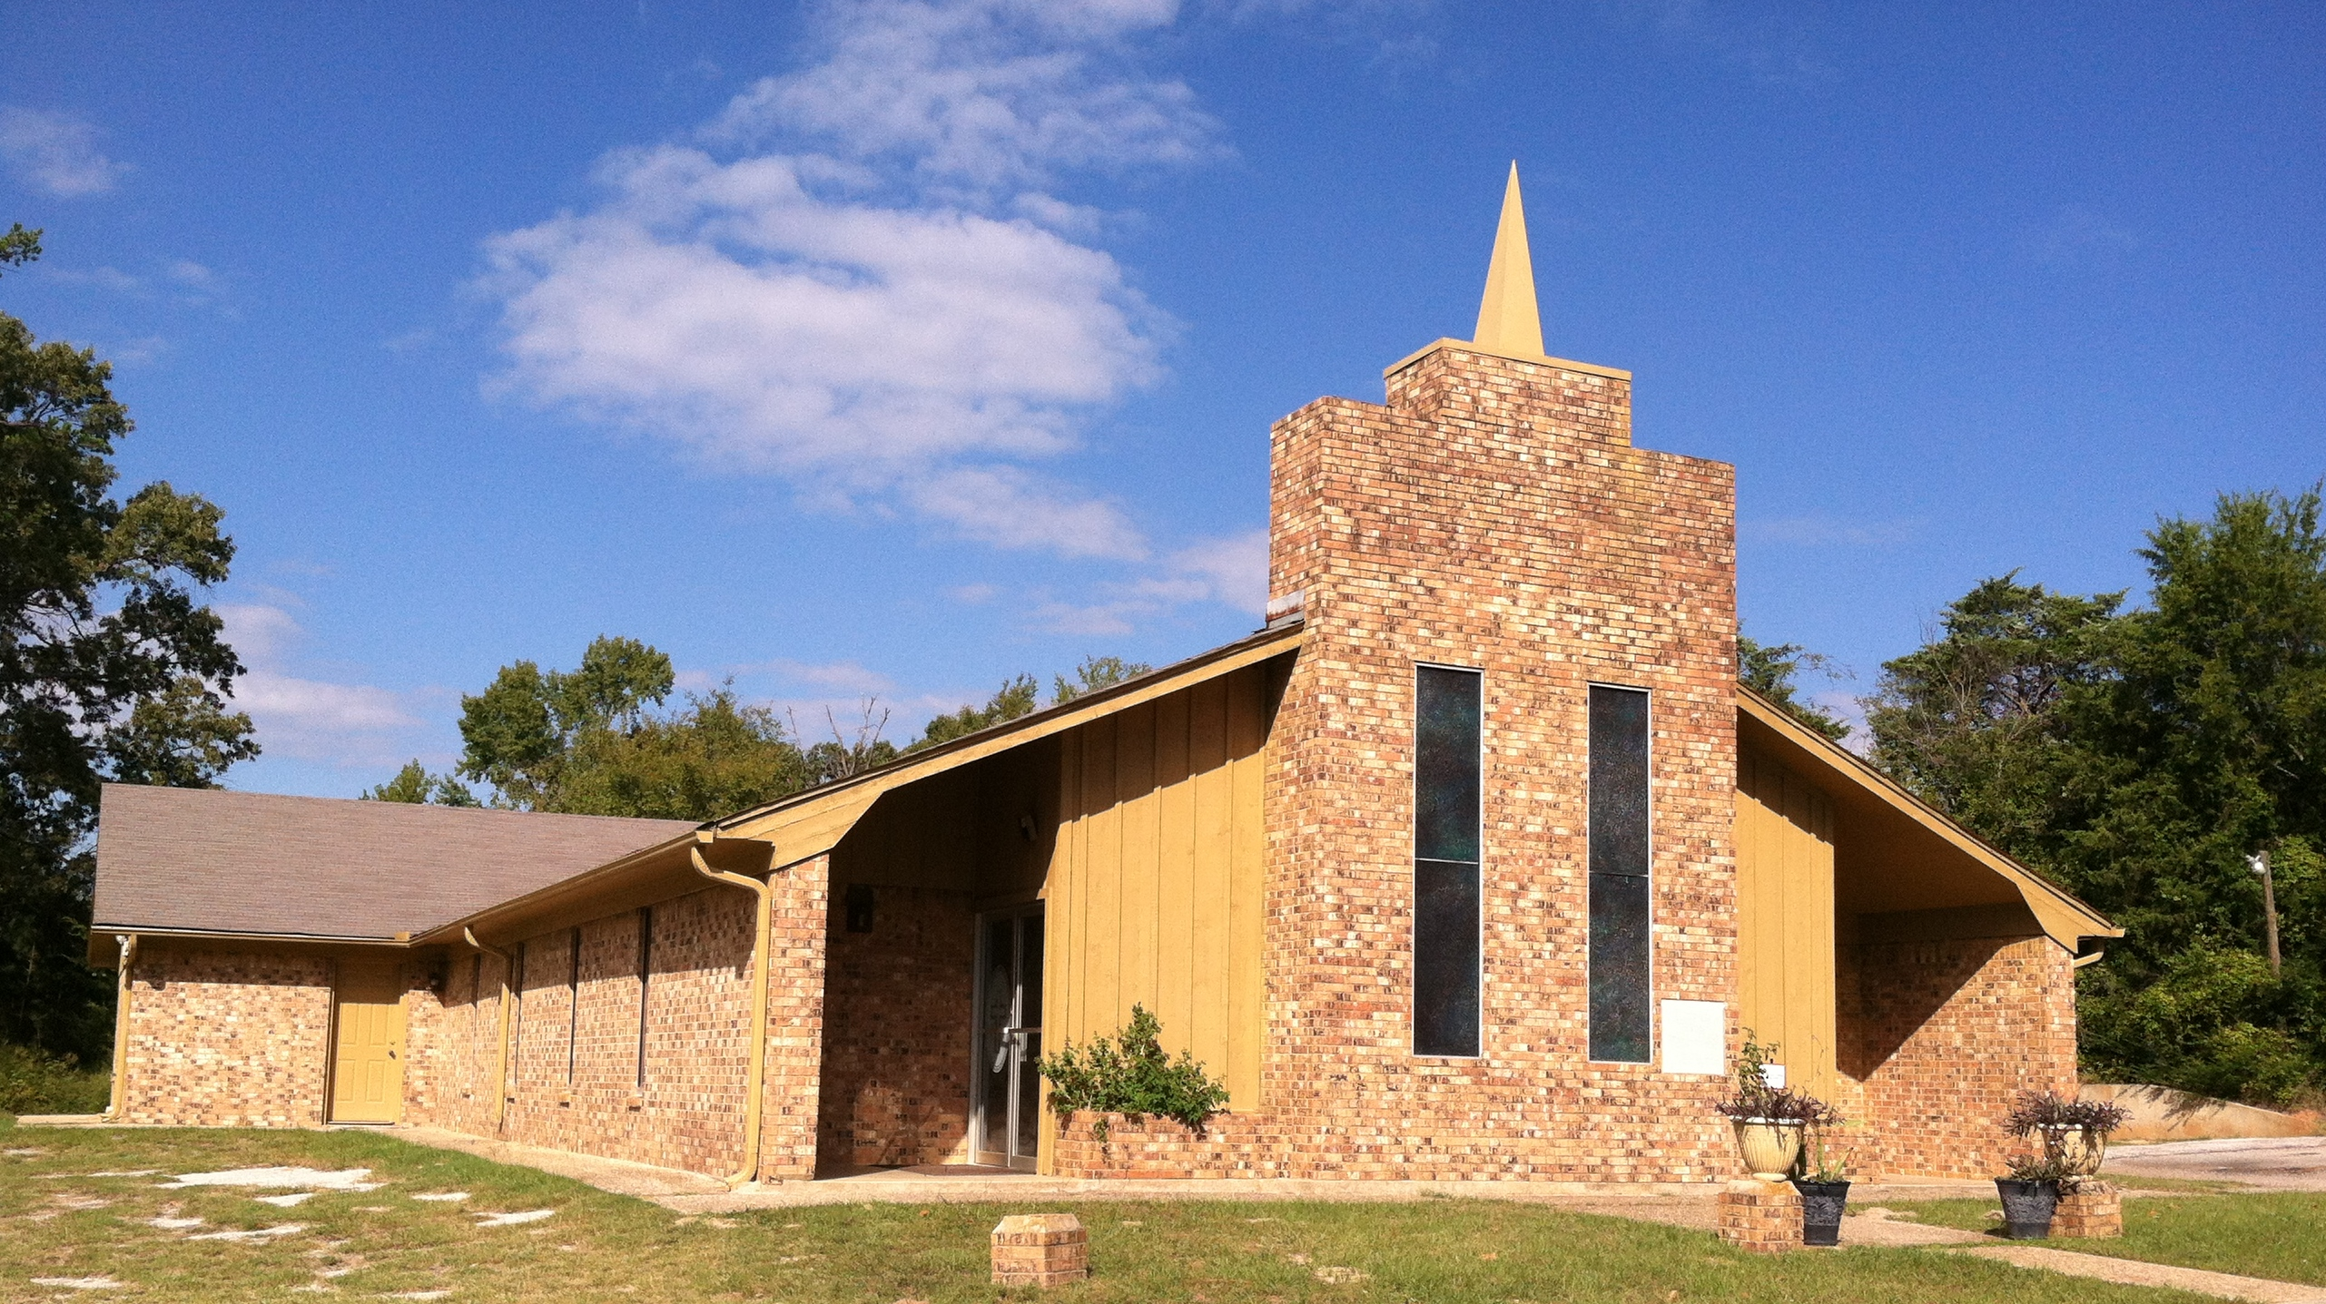

The History of
Starrville Christian Methodist Episcopal Church

In 1870, scarcely seven years after the freeing of slaves, Starrville (colored) Christian Methodist Episcopal Church was organized. The early pioneers were working (just south to where our church site is today) when their owner came and told them they were free. The men were so happy; they fell on their knees and begin giving thanks to God for their freedom. They later cut pine trees and built a brush arbor in that same spot and begin worshipping the Lord. No attempts were made to recount the various steps and the ardent workers whose enthusiasm and devotion helped to make this house of God come into being during the first years. Even so, we realize that every step and every devoted worker deserves recognition.

The pioneers and first builders of the Starrville CME Church were:
Johnson Wheeler George Wheeler Bud Wright
William (Bob) Ates Lee Brooks Brook Fevers and others

The connectional budget, per member, at one time was ten cents per member. Around 1885 and 1887, two churches were formed out of members from this church - Starrville Church of the Living God and Cole Hill CME Church.

The earliest records available tell us that one of the oldest pastors in charge at this church was Rev. George Smith of Arp, Texas. Many ministers have given spiritual guidance to the supportive members of this flock. Recorded among those Sheppard’s were the Reverends: Wesley R. Moreland; I.W. Whitmore; Rev. Wick; C.C. Wallington; B.F. Williams; J.E. Mathis; George Jones; Oscar Freeman; F. W. Bendy; C. J. Williams; Charles Hill; Tommy Starks; David Isom; Dr. Micheal DeVaughn; Curtis King; Dr. Andre Dukes; T. J Davis, Jr., Roy Ingram and currently, Ronald E. Daniels, Sr..

Presiding Elders have been: Reverends: C. W. Moorehead; T.H. Moore; N.B. Stewart; E. J. Turner; Dr. A.C. Mitchell Patton; Floyd Ferguson and presently, Donald R. Madlock, Sr.

Presiding Bishops have been: Bishops: H.P. Porter; Bertram W. Doyle; Norris S. Curry, Sr.; Caesar David Coleman; Marshall Gilmore; Ronald M. Cunningham and currently, Henry M. Williamson, Sr..

On March 22, 1970, the trustees and members met and discussed the building of a new church. A building fund was established and members made pledges. Mr. Augusta Cross, Jr. and Mr. Eddie L. Wynn were instrumental in getting large donations from interested individuals and foundations.

In May of 1970, the Church Conference gave approval of the proposed plan and Mr. Eddie Wynn was elected General Chairman. The late Rev. T.H. Moore was Presiding Elder and gave moral support and encouragement to the project. Mr. Wynn contacted various sub-contractors to get an estimated figure and recommended this to the Quarterly Conference.

Constructions of the new building begin in February of 1972. Mr. Wynn contacted East Texas Savings and Loan. A $35,000 loan was approved. The Tyler Bank and Trust Company entered and financed the mortgage. When the church was completed, East Texas Savings and Loans carried the mortgage on a 15 year contract. Repayment began in June of 1972; the church was paid in full on January 5, 1982.

The Service of Consecration was held Sunday, June 4, 1972, with the late Bishop Norris S. Curry, delivering the message. The Pastor at this time was Rev. George Jones. The Service of Mortgage Burning was held in1972. In the beginning years, this church celebrated Homecoming and Revival Week starting the second Sunday of August each year. After moving into this building, the officials agreed to hold the revival services on the fourth Sunday in July. This was done to not interfere with the attendance of the Central Texas Annual Conference, which was being held during the second week of August.

In November 1984, the church agreed for trustees Eddie L. Wynn, August Cross, Jr. and Billy Cross to sign for a $22,000 loan with Nations Bank, Tyler. Rev. C. J. Williams was Pastor. We enlarged the fellowship hall, put down new tile, improved restrooms, put in new carpet throughout the sanctuary and built a concession stand. Payment of this project was completed in June of 1994.

In 1998, during the pastoral-ship of Dr. Andre Dukes, we begin discussing the addition of classrooms. Later, the membership agreed to start a building fund by asking members to commit to pledges. Members could pay their pledges off in a year’s time. On Sunday, April 18, 1999, we celebrated the One Hundred-thirtieth Church Anniversary. The Theme: “A Church Preparing For Tomorrow, Today.” Starrville presented a Souvenir Journal on this day. Rev. Darryl Hampton, Pastor of Jenkins Memorial was the guest speaker,

In the August 7, 2000, official board meeting, the officers and Pastor, Rev. T. J. Davis, Jr. agreed for trustees to sign for a note with Southside Bank, Tyler. The purpose was for adding five classrooms, improving the Pastor’s study, enlarging the kitchen and adding an office. On September 16, 2000, during a quarterly conference, the membership agreed for the following trustees to secure the loan ($25,000). Trustees were: Eddie L. Wynn, Derrick C. Choice, Kevin L. Wynn, Billy G. Cross and Augusta Cross. Mr. Eddie Wynn drew up the plans for the addition. Billy Cross was appointed Chairperson of the building committee. Luis Hernandez was chosen as contractor. Works begin on October, 2000.

Educational Wing Consecrating was held on Sunday, February 18, 2001, 3:00 P.M. – “Theme: Vision Becoming a Reality.” Bishop Marshal Gilmore was the speaker and presided during the Acts of Concentration.

The Music Department is an integral part of our worship service each Sunday. Currently, music is provided by one of the following choirs: Male Chorus, Inspirational Choir, Youth and Young Adult Choir and Children and Youth Choir.

In July of 2008, Rev. Ronald E, Daniels was named as Pastor of Starrville. During his tenure Rev. Daniels has been instrumental in developing an “Essential” Church for the 21st Century. Under his leadership our morning worship membership increased and there has been rejuvenation in members participating and becoming actively involved in the various auxiliaries and ministries.

In 2010, a loan was secured with Southside Bank for facility renovations and improvements. In the fall of 2010, the church began amassing funds for a Van Ministry. In January of 2011, Starrville became actively involved in the One Church, One School Ministry. Starrville sponsors backpacks for thirteen students from Winona ISD; this is in conjunction with the East Texas Food Bank Backpack Program. Through this program, students are given backpacks filled with food for the weekends and school holidays. Starting in June of 2011, Starrville began participation in the Adopt a Highway Program. A stretch of road on Hwy 271 will be cleaned and maintained by Starrville members. Throughout recent years, our Youth and Young Adults have participated in many community volunteer projects such as: Tyler Salvation Army: Ringing Christmas Bell, East Texas Food Bank and Souper Bowl of Caring with contributions to Make A Wish Foundation, East Texas Crisis Center and the North Tyler Youth Center. Each year, the youth dedicate part of their Thanksgiving Day to serving meals to the homeless at the Salvation Army.

Our Children, Youth and Young Adults minster in the community through Puppets, Praise Dancing “Sacred Praise” and MIME presentations.

