TIDEWATER BOWHUNTERS AND ARCHERS INC.
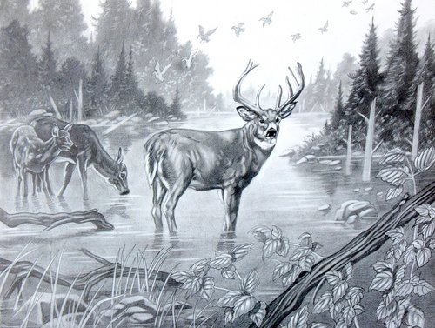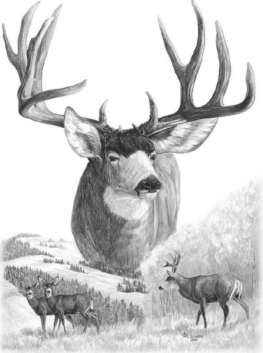
APPLICATION FOR MEMBERSHIP
DATE: ___________________
NAME: ___________________ _________________________ ________________
Last First Middle
ADDRESS: ___________________________________________________________________
___________________________________________________________________
PHONE: (_____) ___________________________
TYPE OF MEMBERSHIP REQUESTED: SINGLE ______________ FAMILY______________
IF FAMILY MEMBERSHIP, LIST NAMES AND AGES OF FAMILY MEMBERS UNDER AGE 18:
_______________________________________________________________________________
_______________________________________________________________________________
LIST MEMBERSHIPS IN OTHER HUNTING OR ARCHERY RELATED CLUBS:
_______________________________________________________________________________
_______________________________________________________________________________
HAVE YOU COMPLETED THE NATIONAL HUNTER COURSE?
IF YES, WHERE: _____________________________ WHEN: ___________________________
ARE YOU A CURRENT MEMBER OF THE IBO? ___________________________________________
IF YES, EXPIRATION DATE: ____________________________________
IF I AM ACCEPTED AS A MEMBER OF TIDEWATER BOWHUNTERS AND ARCHERS INC. I AGREE TO:
- ABIDE BY ALL TBA BYLAWS.
- UNLESS PREVIOUSLY COMPLETED, COMPLETE THE NATIONAL HUNTER EDUCATION COURSE WITHIN MY FIRST YEAR OF MEMBERSHIP IN TBA.
- ABIDE BY ALL STATE GAME LAWS AND REGULATIONS, AND I UNDERSTAND THAT IF I AM CONVICTED OF A GAME LAW VIOLATION, MY MEMBERSHIP IN TBA WILL BE TERMINATED, WITHOUT REFUND OF PREPAID DUES.
- I UNDERSTAND THAT MEMBERSHIPS EXPIRE DECEMBER 31ST, REGARDLESS OF MEMBERSHIP ACCEPTANCE DATE, AND THAT RENEWAL FEES ARE DUE ON OR BEFORE THE SECOND REGULAR CLUB MEETING OF THE NEW YEAR.
SIGNATURE _______________________________________________
♦♦♦♦♦♦♦♦♦♦♦♦♦♦♦♦♦♦♦♦♦♦♦♦♦♦♦♦♦♦♦♦♦♦♦♦♦♦♦♦♦♦♦♦♦♦♦♦♦♦♦♦♦♦♦♦♦♦♦♦♦♦♦♦♦♦♦♦♦♦
THIS SECTION TO BE COMPLETED BY TBA OFFICERS
♦♦♦♦♦♦♦♦♦♦♦♦♦♦♦♦♦♦♦♦♦♦♦♦♦♦♦♦♦♦♦♦♦♦♦♦♦♦♦♦♦♦♦♦♦♦♦♦♦♦♦♦♦♦♦♦♦♦♦♦♦♦♦♦♦♦♦♦♦♦

INDICATE DATE ACTION COMPLETED:
NEW MEMBER VOTED IN: ________________________________________
MEMBERSHIP DUES COLLECTED: __________________________________
MEMBER PRESENTED WITH PATCH/HAT: ___________________________
MEMBER PRESENTED WITH TBA DECAL: ____________________________
SIGNATURE BY VERIFYING CLUB OFFICER AND TITLE: ____________________________________
____________________________________

MEMBERSHIP RENEWAL DATE:
___________________________________ ___________________________________
___________________________________ ___________________________________
___________________________________ ___________________________________

