Sowing a Seed
Setting the Scene
For many years years I have worked to develop and promote philosophical enquiry with children. Initially this was in the primary school context and later included nursery and secondary levels. The work led to several books for teachers being written, as well as papers and presentations at many conferences – both nationally and internationally. Despite education systems that don’t seem to rate ‘thinking’ as a very important activity (and this seems to be the case in many countries), the work was given a boost by an academic study which showed that by using a ‘thinking through philosophy’ method children’s confidence grew significantly, IQ was raised, and critical thinking skills developed. Importantly, youngsters were also measurably more emotionally intelligent. That is, not only were they thinking more effectively, they were applying that thought to their own lives – showing wisdom.

A Call for Help
Several years ago I received a letter from the Grenadan Minister for Education asking that I might train some of their teachers in philosophical enquiry. Unfortunately they couldn’t afford to pay since a recent hurricanes had demolished some of their schools! My wife and I agreed to work for nothing and the Education Renaissance Trust kindly paid our fares for three visits, and also bought them resources. Resources were badly needed – we had scoured the second island of Grenada for Caribbean stories so as to write some materials that drew on their own culture and traditions, but sadly the only children’s book of any description for sale was a Ladybird version of Heidi. It took a time and hard work to gain the trust of the people with whom we were working, but by the third visit we had worked with every school on the two smaller islands of Grenada, and had also trained a group as ‘Philosophy Leaders’ to be resource persons in their own schools.
On about the last day of the third visit I sat in a classroom on Petite Martinique observing a lesson. The school was 150m from the clear water, the sun was shining with not a cloud in the sky. It seemed idyllic, but I knew that many of the children lived in small shacks. One or two lived in a shipping container with holes cut out for windows. From these situations, the children emerged each day with smiling faces and pristine school uniforms! The teacher had opted to prepare his own materials and not use one of those that Doris and I had prepared for them. The young man started to read – ‘Snow White and the Seven Dwarves’. My heart sank. Where would this go? But as the story finished and a few questions were asked about the story, the children identified an emerging theme of ‘trust’ and then began to explore this through their observations and questions. WOW – fantastic! My heart soared! The teacher ‘got it’. The children ‘got it’! They had moved from the concrete (the story of Snow White) to the abstract – the philosophical question ‘What is Trust?’ It was about them – their lives, who they trusted and why or why not. Should they trust? And so on. From now on they would be just that little bit more conscious of the concept of trust, and indeed in situations requiring trust they would be awakened into the present by that knowledge.
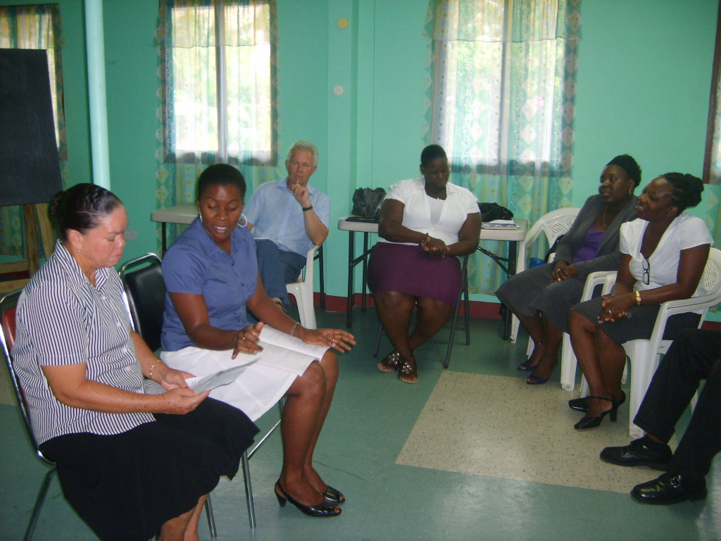
Teacher ‘Philosophy Leaders’ taking an ‘Enquiry’ in pairs during training

A Challenge in India
In response to another request, my wife and I found ourselves in India on another project – to work with two NGO’s and train teachers in ‘philosophy with children’. One NGO works with twenty villages and the other with over a hundred. At the first visit the situation seemed quite overwhelming. After all, there are 1.2 billion people in India. What good could come of training a few village teachers? There seemed a futility in the idea. We were 350 miles inland from Pune, in amongst a collection of small villages. Conditions were not easy - Doris found it difficult when a rat made nightly visits to our room, and I was not too happy about it myself. (However, it was obviously intelligent rat since it took away the English newspaper I stuffed in the hole, no doubt to show off to its friends!) We were warned to keep a look out for scorpions but if we saw one not to kill it but catch it and put it outside. Yeah right! The conditions may have been a bit difficult for us but the love, gratitude and hospitality we received, shone through. One evening we were being shown a small irrigation project and we passed through a tiny farm. The farmer immediately lit a brush fire and roasted some corn for us. This a man whose annual income was about £75. A young woman from the neighbouring small-holding was threshing grain on a flat stone (she didn’t have such an area at her house) and she immediately spoke to our guide, insisting that the next night we visited her home for some food. This we subsequently did, and we sat on the pressed dung floor on a small rug kept for special occasions, and had some roasted peanuts. These she cooked in a pan on a small open fire set between two bricks. Her son of about six was called to bring a torn and ragged schoolbook and proudly read some words. It emerged that the lady had been to primary school but her husband had never been to school and couldn’t read or write.
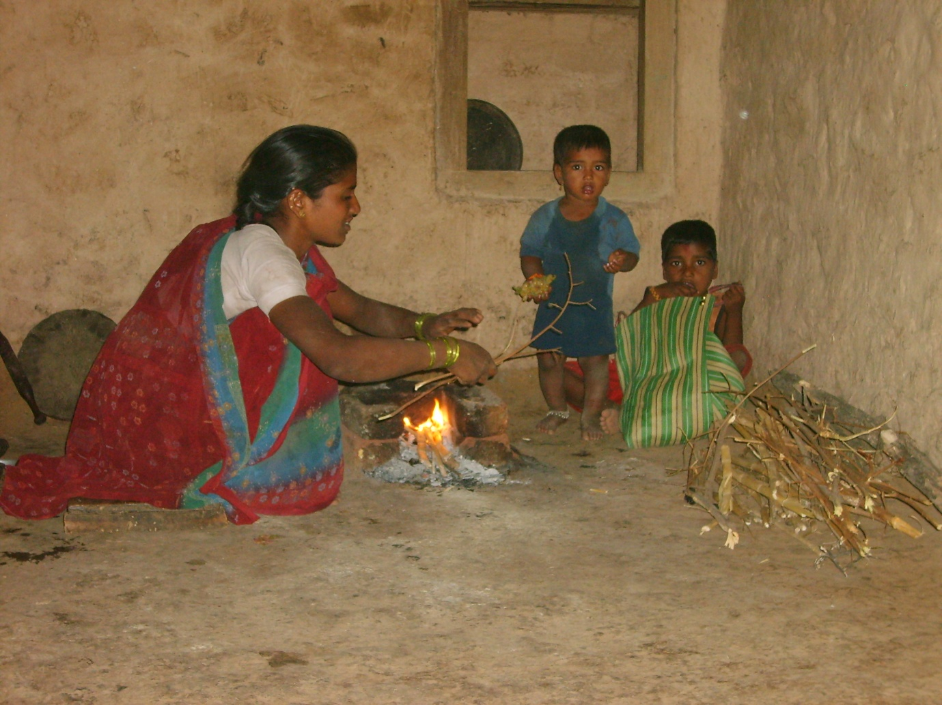
Over the next of days we visited a variety of schools over a wide area. The most desolate was a small nursery which was a room about 4mx4m where the only resource was a small blackboard about 50cmx50cm. Some of the children aged only four walked three kilometres to school. The teacher brought a couple who lived a longer distance on the back of her scooter. To begin to work in such circumstances was a challenge, but with those big eyes looking at us, the owners of which had walked all that way for education – how could we refuse? With time to plan the best approach and programme before our next visit, we gave an introduction and some training to some staff of one of the NGO’s before heading back to Scotland.
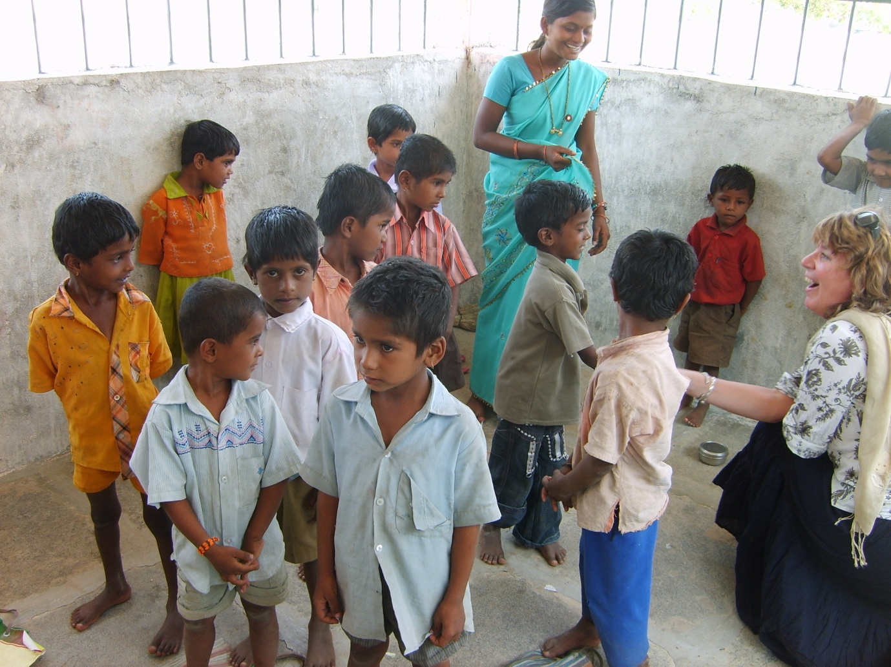

Just One or Two Intelligent People
On the second visit we trained groups of teachers in the enquiry method in two areas, about 300 miles apart. Even this is a difficulty. Those who have travelled in remote areas of India by car know that it is with genuine relief that one arrives at one’s destination alive and without injury. Therein lie many tales for another occasion! We had taken sets of materials in Marathi so teachers had resources to take away with them. Running workshops with translation was difficult – especially when the translator left after half an hour never to be seen again. There were also some cultural difficulties with which to work and yet respect. For example all the ladies sat together but for some things we wanted mixed working groups. Doris modelled games used with youngsters to mix up a class but initially the aim was subverted by the participants! With much humour and love we persevered and things progressed. By the end of the two days the teachers were full of enthusiasm. Training which was interactive and where the experiences of the participants were valued, was a new experience for the teachers. Word of our presence had got out and I was asked to speak for an hour to a group of a hundred teachers on some government training a few miles away. However, the people on our course wouldn’t let me go, for fear they missed out on something!
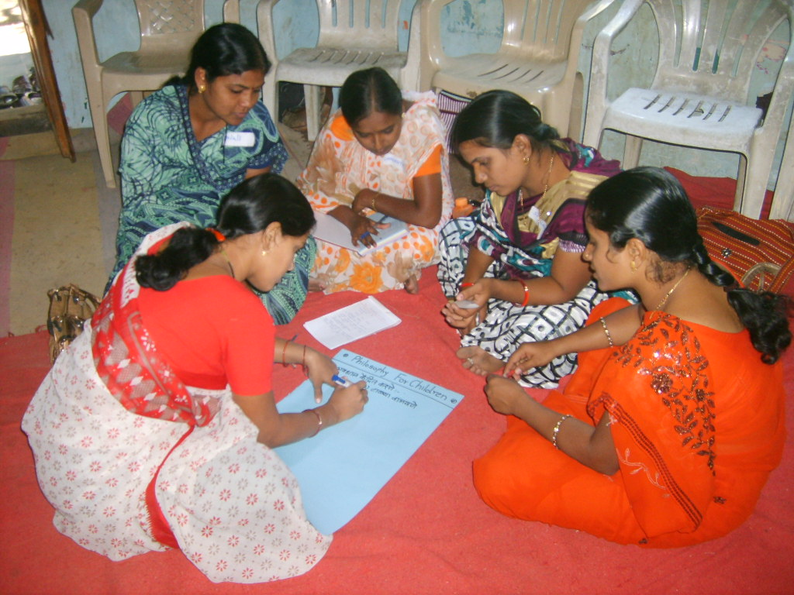
The best part of the trip was what began to emerge when we went back to the area where we had begun in such a small way the year previous. ‘And this is where the story really begins...’ – to quote Neddy Seagoon! What had been given had been used with intelligence and creativity by two people from the Yerala Project Society and to date, with more support, has resulted in another philosophical garden.
- Firstly, one man had taken weekly sessions with a group of 14/15 year olds using the books given and his own translations. We watched such a session and noted the confidence with which the children spoke, and importantly this included the girls. They started from stillness after ‘the exercise’ and then in lively fashion pursued the truth of an idea and how it related to their own lives. Most of the children were involved. It was fascinating to us that later, through a translator, the children spoke of how the year’s philosophy work had been useful to them. The words were exactly the same as those from students in our earlier academic studies in the UK. They felt more confident, they were less frightened to put forward an idea, they felt their thinking in other subjects was improved, and they were more tolerant and empathetic with others and could show wisdom in their actions.
- In another example, a lady had taken the method and used it when she worked with mothers and adolescent girls in the city of Sangli. Previously she had had difficulty in getting people to speak – especially on the issue of infanticide. However, she said that she was able to use the method to bring to the surface the thoughts and feelings of the women and properly explore the issues.
- The same lady then began to explore how to use the approach in the workplace. The NGO has a small electronics unit that makes items for commercial sale. (For example a kit of a small solar panel, a battery and an LCD light that can be given to people in rural areas without electricity.) The unit is staffed by widows who are HIV positive and gives them a means of being self-sufficient. Using the philosophical enquiry approach the staff have begun to explore issues around their own situations, the workplace, their lives. This is on-going but the lady reports positive feed-back and growing self-confidence.

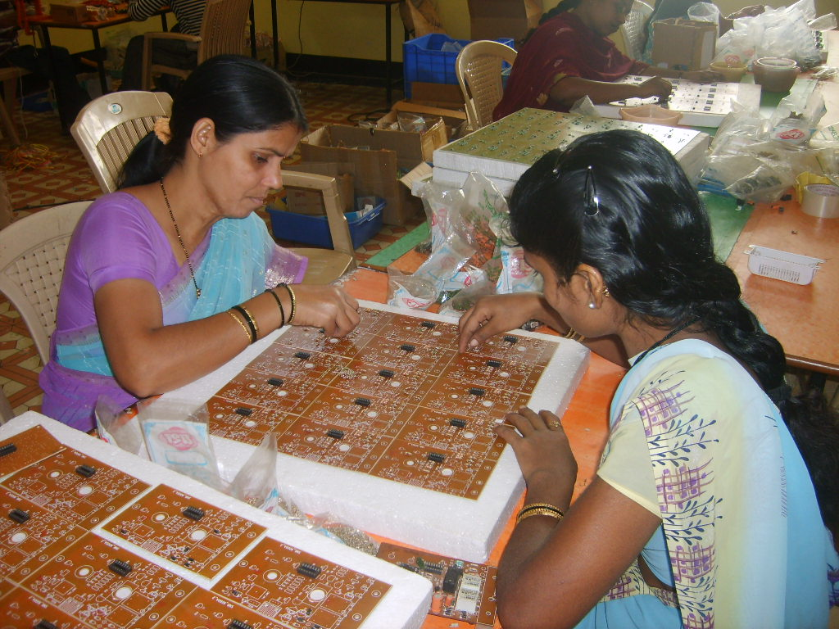

- The most recent report I have had speaks of using philosophy sessions with a small rural radio station. Surprisingly, even in the small rural villages, there are quite a few people with mobile phones – the pricing structure being cunningly adapted to their situation. These are also used to listen to the radio. One teacher with whom we worked, with guidance from the two NGO workers mentioned previously, has begun a weekly philosophy session on the radio – using the same materials we supplied for children. A story is given (often a traditional Indian tale), and a theme drawn from it, then some questions posed. Listeners phone in with responses and the theme can be developed the next week. On a theme of honesty one farmer phoned to say he was honest in the selling of milk from his buffalo but when the milk collector had accused him of mixing water with it he was affronted and then became dishonest and began to mix water with it! The presenter used the conversation to start the next session the following week and reports that people share their thoughts, feelings and experiences from their personal lives as they explore the themes. It has come as a freedom to the listeners that instead of receiving the usual moralising ‘finger pointing’ to which they are used, they (whether they realise it or not) are taken to a deeper level of considering the reasons for their actions – to that point of informed decision. Running such a programme is a very difficult concept but I have encouraged them along the lines that it is only through trying something that it can be refined and the ‘recipe’ improved.
So little was given and yet this ‘flowering’ has shown that it only takes one or two intelligent people to take up an idea and work with it creatively for many others to benefit.
P.S. What next?
Collectors (a bit like Chief Executives of County’s) of two areas have asked that the approach be introduced in their schools and we build their capacity for doing their own future training of teachers. Watch this space!

Paul Cleghorn

