|  |  |
| --- | --- |
|  | ADVANTAGE HCS |

# Employment Application

## Applicant Information

|  |  |  |  |  |  |
| --- | --- | --- | --- | --- | --- |
| Full Name: |  |  |  | Date: |  |
|  | Last | First | M.I. |  |  |

|  |  |  |
| --- | --- | --- |
| Address: |  |  |
|  | Street Address | Apartment/Unit # |

|  |  |  |  |
| --- | --- | --- | --- |
|  |  |  |  |
|  | City | State | ZIP Code |

|  |  |  |  |
| --- | --- | --- | --- |
| Phone: |  | Email |  |

|  |  |  |  |  |  |
| --- | --- | --- | --- | --- | --- |
| Date Available: |  | Social Security No.: |  | Desired Salary: | $ |

|  |  |
| --- | --- |
| Position Applied for: |  |

|  |  |  |  |  |  |
| --- | --- | --- | --- | --- | --- |
| Are you a citizen of the United States? | YES | NO | If no, are you authorized to work in the U.S.? | YES | NO |

|  |  |  |  |  |
| --- | --- | --- | --- | --- |
| Have you ever worked for this company? | YES | NO | If yes, when? |  |

|  |  |  |  |
| --- | --- | --- | --- |
| Have you ever been convicted of a felony? | YES | NO |  |

|  |  |
| --- | --- |
| If yes, explain: |  |

## Education

|  |  |  |  |
| --- | --- | --- | --- |
| High School: |  | Address: |  |

|  |  |  |  |  |  |  |  |  |
| --- | --- | --- | --- | --- | --- | --- | --- | --- |
| From: |  | To: |  | Did you graduate? | YES | NO | Diploma:: |  |

|  |  |  |  |
| --- | --- | --- | --- |
| College: |  | Address: |  |

|  |  |  |  |  |  |  |  |  |
| --- | --- | --- | --- | --- | --- | --- | --- | --- |
| From: |  | To: |  | Did you graduate? | YES | NO | Degree: |  |

|  |  |  |  |
| --- | --- | --- | --- |
| Other: |  | Address: |  |

|  |  |  |  |  |  |  |  |  |
| --- | --- | --- | --- | --- | --- | --- | --- | --- |
| From: |  | To: |  | Did you graduate? | YES | NO | Degree: |  |

## References

Please list three professional references.

|  |  |  |  |  |
| --- | --- | --- | --- | --- |
| Full Name: |  | | Relationship: |  |
| Company: |  | | Phone: |  |
| Address: |  | | | |
|  |  | |  |  |
| Full Name: |  | | Relationship: |  |
| Company: |  | | Phone: |  |
| Address: | |  | | |
|  |  | |  |  |
| Full Name: |  | | Relationship: |  |
| Company: |  | | Phone: |  |
| Address: |  | | | |

## Previous Employment

|  |  |  |  |
| --- | --- | --- | --- |
| Company: |  | Phone: |  |
| Address: |  | Supervisor: |  |

|  |  |  |  |  |  |
| --- | --- | --- | --- | --- | --- |
| Job Title: |  | Starting Salary: | $ | Ending Salary: | $ |

|  |  |
| --- | --- |
| Responsibilities: |  |

|  |  |  |  |  |  |
| --- | --- | --- | --- | --- | --- |
| From: |  | To: |  | Reason for Leaving: |  |

|  |  |  |  |
| --- | --- | --- | --- |
| May we contact your previous supervisor for a reference? | YES | NO |  |
|  |  |  |  |
|  |  |  |  |

|  |  |  |  |
| --- | --- | --- | --- |
| Company: |  | Phone: |  |
| Address: |  | Supervisor: |  |

|  |  |  |  |  |  |
| --- | --- | --- | --- | --- | --- |
| Job Title: |  | Starting Salary: | $ | Ending Salary: | $ |

|  |  |
| --- | --- |
| Responsibilities: |  |

|  |  |  |  |  |  |
| --- | --- | --- | --- | --- | --- |
| From: |  | To: |  | Reason for Leaving: |  |

|  |  |  |  |
| --- | --- | --- | --- |
| May we contact your previous supervisor for a reference? | YES | NO |  |
|  |  |  |  |
|  |  |  |  |

|  |  |  |  |
| --- | --- | --- | --- |
| Company: |  | Phone: |  |
| Address: |  | Supervisor: |  |

|  |  |  |  |  |  |
| --- | --- | --- | --- | --- | --- |
| Job Title: |  | Starting Salary: | $ | Ending Salary: | $ |

|  |  |
| --- | --- |
| Responsibilities: |  |

|  |  |  |  |  |  |
| --- | --- | --- | --- | --- | --- |
| From: |  | To: |  | Reason for Leaving: |  |

|  |  |  |  |
| --- | --- | --- | --- |
| May we contact your previous supervisor for a reference? | YES | NO |  |

## Military Service

|  |  |  |  |  |  |
| --- | --- | --- | --- | --- | --- |
| Branch: |  | From: |  | To: |  |

|  |  |  |  |
| --- | --- | --- | --- |
| Rank at Discharge: |  | Type of Discharge: |  |

|  |  |
| --- | --- |
| If other than honorable, explain: |  |

## Disclaimer and Signature

I certify that my answers are true and complete to the best of my knowledge.

If this application leads to employment, I understand that false or misleading information in my application or interview may result in my release.

|  |  |  |  |
| --- | --- | --- | --- |
| Signature: |  | Date: |  |

ADVANTAGE HEALTH CARE STAFFING

Name: _______________________________________ Date:_______________

The following information is needed to complete your file. If you have any questions, please call our office (432)466-1994

__ Copy of Driver’s License ­­­­__ ORMC PKG

__ Copy of MMR or Titer __ CC MIDLAD PKG

__ Copy of Nursing License __ CC ODESSA PKG

__ Copy of Credentials __ ANDREWS PKG

__ Hepatitis B Documentation __ LAMESA PKG

__ Drug Screen Agreement/Test __ OCEANS PKG

__ Application __ ALPINE PKG

__ Copy of Social Security Card

__ Copy of CPR Card

__ TB Test within 1 year

__ Hepatitis B Consent/Declination

__ Release for Background Check

__ References

__ Confidential Statement

__ Management Safety Policy

__ Independent Contractor

__ Authorization to Release

__ W4

__ Skills Check List

__ License Verification

__ Signature Sheet

__Other: _______________________________

__________________________________________ __________________

Signature Date

ADVANTAGE HEALTH CARE STAFFING

P.O. BOX 80126

MIDLAND TX 79708

**HEALTHCARE PROFESSIONAL RESPONSIBILITIES AGREEMENT**

Practitioner Name: _____________________________________________________________________

I understand that as a healthcare professional, I am responsible for maintaining an active professional license while accepting work/shifts through Advantage Health Care Staffing. I attest that there are no legal proceedings or inquires in process that could result in suspension or revocation of my license. I also agree to IMMEDIATELY inform Advantage Health Care Staffing in the event of any inquiry or legal proceeding that could result in suspension or revocation of my license/certification.

I understand that if I fail to notify Advantage Health Care Staffing and the company discovers that I worked with an expired suspended or revoked license I will no longer be eligible to work through Advantage Health Care Staffing.

I attest that I am not currently excluded, suspended, debarred or otherwise ineligible to participate in Federal health care programs (i.e., Medicare, Medicaid, etc.), I further attest that I have not been convicted of a criminal offence related to the provision of health care items or services, nor are there any judgements pending against me that will result in my being excluded, debarred or otherwise declared and “ineligible Person”.

I agree to immediately notify Advantage Health Care Staffing of any event that results in my being classifieds as an “ineligible Person”.

I understand that if Advantage Health Care Staffing learns that I am on a state (if applicable) or federal exclusion list (GSA) list or OIG Sanction report), I will immediately be removed from the Companies active practitioner list and will not be eligible for work at any of Advantage Health Care Staffing facilities.

The information I have given is true and accurate to the best of my knowledge. I hereby authorize Advantage Health Care Staffing to release this Critical Care/E.R./Telementry/Med-Surg Checklist to Client facilities of Advantage Health Care Staffing in relation to consideration of my working as a licensed medical professional with those facilities.

Signature__________________________________________ Date _____________

Print Name ________________________________________

**CREDENTIAL ACKNOWLEDGEMENT**

AHCS strives to ensure each healthcare professional maintains proper credentials and certifications. Each healthcare professional however, bears the ultimate responsibility to ensure he/she has current credentials and certifications prior o working any shift. Accordingly, AHCS will not schedule a healthcare professional for any shifts during a time when they do not have current certifications and credentials**. In the event a healthcare professional works a shift without current certifications and credentials, AHCS will not pay the healthcare professional for that shift.** By applying for shifts with ACHS and by accepting shifts from AHCS, you have acknowledged your understanding of this rule and waive any right to demand compensation for shifts worked without proper certifications and credentials. If you work a shift for AHCS without proper certifications and credentials and AHCS pays you for that shift, you also grant AHCS the right to deduct the amount paid for such shifts from any future compensation due you.

Signature______________________________________________ Date _____________

Print Name ________________________________________________

AGREEMENT TO SUBMIT TO DRUG SCREEN

I have been informed that if Advantage Health Care Staffing or ay client facility or the employees or agents of such client or facility, based on my behavior, appearance or documentation discrepancies is concerned that I may be under the influence of drugs or alcohol or may otherwise have violated the client facility rules against drug and alcohol used or diversion of drugs and that my ability to perform my duties is therefore in question, I will be requested to submit to a drug and/or alcohol screen by blood, breath alcohol and/or alcohol screen by blood, breath alcohol and/or urine drug tests, which is to be administered by the client facility or designee.

I have been informed and I understand that my agreement is submit to the requested alcohol and/or drug screens by blood, breath alcohol and/or urine drug tests is completely voluntary on my part, and that I have the right to refuse to submit to the test(s). I am aware and have been told that my refusal to submit to the drug and/or alcohol screen by blood, breath alcohol and/or urine drug test and/or medical assessment may be grounds for my removal from Advantage Health Care Staffing list of eligible independent contractors.

I have also been informed that the results of this drug and/or alcohol screen by blood, breath alcohol and/or urine drug test will be released to the Human Resources Manager of the client facility or his/her designee and to such other officials and employees as the Human Resources Manager or his/her designee may determine necessary. I hereby consent to such release. I understand that the information so released will be used to determine whether I violated the work rules concerning drug and alcohol use or diversion of drugs and that the results of such tests, along with other relevant information obtained investigating this matter, may form the basis for my removal from Advantage Health Care Staffing list of eligible independent contractors.

I have read and understand the above information and have decided to voluntary=ily submit to the requested drug and/or alcohol screen by blood, breath alcohol and/or urine drug test, and/or medical assessment by the client facility or designee and laboratory and in recognition of this agreement, do sign this consent form.

I acknowledge and agree that the sample given by me shall become the property of the administering client facility, and I hereby relinquish all rights to ownership and possession thereof.

I agree to hold Advantage Health Care Staffing and any administering client facility and their respective officers, directors, employees, agents and servants harmless for their use of the results of these tests as well as release thereof as provided for herein.

BACKGROUND CHECK AUTHORIZATION

I hereby authorize any law enforcement agency and/or background check service to furnish Advantage Health Care Staffing or its agent information related to my criminal history. I hereby release AHCS and all its agents and employees, the law enforcement agency and all employees of the law enforcement agencies, all background check services and all employees and/or agents of background check services furnishing information, from all liability resulting from the furnishing of this information to AHCS. I certify that the statements made by me on the “Background Check” form are true, complete, and correct to the best of my knowledge and belief and are made in good faith. I understand that any false statements made herein will void my eligibility to accept work as a Self Employed Independent Contractor through AHCS.

PLEASE PRINT

___________________________________________________________________________

LAST FIRST MIDDLE

List any former names used:

__________________________________________________________________________

Driver’s License, State and #

___________________________________________________________________________

Date of Birth (MM/DD/YY):

___________________________________________________________________________

Out of State Address and Dates of residency (from/to)

Address _________________________________________ Dates __________________

Address _________________________________________ Dates __________________

Address _________________________________________ Dates __________________

Address _________________________________________ Dates __________________

**REFERENCE AUTHORIZATION**

I, authorize my employers, schools, law enforcement agencies and/or persons who may aide Advantage Health Care Staffing in determining my suitability for providing profession services to thir customer, to provide reference information to Advantage Health Care Staffing, I hereby release all such employees, individuals and/or organizations contacted, from all liabilities for issuing this information to AHCS from all liabilities for issuing this information to customers or potential customers for the purpose of determining my suitability for providing professional services in AHCS customers’ facilities.

**YOUR RESPONSIBILITIES**

It is the responsibility of each employee to observe, learn and follow all safety rules and regulations for the office and independent contract labor personnel to observe, learn and follow all safety rules and regulations learned in orientation at each facility in which he or she accepts shifts. If you feel that you have not been given proper and complete instruction on safety rules and regulations for a facility at which you have accepted an assignment, immediately ask you supervisor for the further instruction/information. Each facility will have its own set of rules and regulations. Do no assume that through orientation at one facility will apply at other facilities. If you have any concerns that after asking for safety rules and regulations you are still not properly educated on how to perform your assignment safety, contact Advantage Health Care Staffing immediately.

**ALCOHOL AND CONTROLLED SUBSTANCES POLICY**

Advantage Health Care Staffing has adopted an alcohol and controlled substances policy to ensure the safety and well-being of all employees and Independent Contract Labor Personnel (ICLP). Company policy forbids employee/(ICLP) from being under the influence of, in possession of and consumption of alcoholic beverages and the possession or use of any controlled substance on the premises, while on company business or en route to any business or services associated with AHCS in any way.

The definition of a “controlled substance” is any drug, narcotic, inhalant, hallucinogen, barbiturate, amphetamine, mixture or compound not prescribed by a licensed physician for the legitimate treatment of a specific employee’s/ICLP’S medical condition.

Employees/ICLP taking prescription drugs for an illness or other legitimate medical need must notify their direct supervisor in writing of the possible effects of the medication which my impair the individual’s physical or mental capabilities and/or impair ability to perform their job functions. The notification should also include the length of time expected to take the medication.

Users of controlled substances or alcoholic beverages present a danger, not only to themselves, but to all others with whom they come in contact. Lack of mental alertness, slow reactions and other effects of alcohol and drugs lead to poor judgment and errors that place other persons in grave danger. Management cannot and will not allow the safety of others in the office, facilities or on the roads to be compromised.

Violation of any of the following rules may subject an employee to disciplinary action, including immediate termination, and my result in the removal of an ICLP from Advantage Health Care Solutions, list of eligible employees.

1. No alcoholic beverages may be brought onto or consumed on Advantage Health Care Staffing’s property or the property of a facility contracted with AHCS. Alcoholic beverages may not be consumed while conducting business, providing services or while in route to ay business or facility associated in any way with AHCS. Employee and ICLP may not be under the influence of alcohol while conducting business or in route to any activities or facilities associated with AHCS in any way.
2. No controlled substances may be brought onto or used on AHCS property or the property of a facility contracted with associated with AHCS. Controlled substances may not be used while conducting business, providing services or in route to any business or facility associated in any way with AHCS. Employees and ICLP may not be under the influence of controlled substances while conducting business, providing services or in route to any business activities or facilities associated with AHCS in any way.
3. Employees/ICLP taking prescription drugs for an illness or other legitimated medical need must notify their direct supervisor in writing of the possible effects of the medication which may impair the individual’s physical or mental capabilities and/or impair their ability to perform their job functions. The notification should also include the length of time expected to take the medication. All medical information will be kept confidential and any breach of privacy and confidentiality will be dealt with accordingly.
4. No employee may give, sell or otherwise transfer any controlled substance or prescription drug to any other person while conducting business, providing services or in route to any activity associated with AHCS in any way. To do so is in violation of federal law and the persons involved will be reported to law enforcement authorities immediately.

**I understand that it is my responsibility to become familiar with and abide by these safety policies, insofar as they apply to the duties which I shall perform as an employee or an Independent Contract Labor Personnel. I also understand that compliance with these safety policies is part of the terms of my professional relationship as an employee or Independent Contract Labor Personnel with AHCS and I agree to abide by them.**

Employee Signature: ___________________________________________

**ADVANTAGE HEALTH CARE STAFFING**

**PO BOX 80126**

**MIDLAND TX 79708**

**PPD SKIN TEST**

Employee Name ______________________________________________

Have you ever had a positive reaction? ____________________________

Have you ever had a BCG vaccine? ________________________________

Are you pregnant? _____________________________________________

Date of PPD placement: ______________ Arm: R ___ L ___

0.1cc ID Manufacture: __________________________________________

Lot # _____________________ Exp ___________________

Given by: ____________________________________________________

Date read: ___________________ By: ___________________________

RESULT: Positive ___________ Negative ____________

Employee Signature: ___________________________________________

**HEPATITIS B VACCINE CONSENT/DECLINATION**

1. **Declination of Hepatitis B Vaccine**

I am refusing the Hepatitis B Vaccine and hold harmless Advantage Health Care Staffing. I understand that due to my occupational exposure to blood or other potentially infectious materials, I may be at risk of acquiring Hepatitis B Virus (HBV) infection. I have been given the opportunity to be vaccinated with Hepatitis B Vaccination.

________________________________ ___________________

Signature Date

1. **Documentation of Hepatitis B Vaccine Series**

I have received the completed Hepatitis B Vaccine Series, and have attached to this form the documentation which proves my receipt of the HBC Series.

Provide written proof of immunity (attach supportive documentation)

Provide written proof of previous vaccination (attach supportive documentation)

Provide written proof of medical contraindication (attach supportive documentation)

________________________________ ___________________

Signature Date

**Direct Deposit Authorization**

**Only applies to those who wish to be eligible for Direct Deposit**

I (we) hereby authorize ADVANTAGE HEALTH CARE STAFFING hereinafter called “COMPANY”, to initiate credit entries to my (our) account previously indicated and the financial institution previously named, hereinafter called “DEPOSITORY”, to credit the same to such account. This authority is to remain in full force and effect until COMPANY has received written notification from my (or either of us) of its termination in such time and in such manner as to afford COMPANY and DEPOSITORY a reasonable opportunity to act on it.

**DIRECT DEPOSIT**

Fill in only if you wish to participate in Direct deposit

|  |  |  |
| --- | --- | --- |
| Date | Name (Print) | Social Security Number |
|  |  |  |

|  |  |
| --- | --- |
| Financial Institutions Name | Financial Institutions Address |
|  |  |

|  |  |
| --- | --- |
| Routing Number | Account Number |
|  |  |

Signature Date

**ADVANTAGE HEALTH CARE STAFFING**

**P.O. BOX 80126**

**MIDLAND TX 79708**

**CHICKEN POX A.K.A. VARICELLA ZOSTER VIRUS (VZV)**

**VERIFICATION/ADVISORY**

**PLEASE FILL OUT SECTION 1 OR 2:**

I, _________________________________, have experienced a chicken pox (varicella zoster) virus infection at a previous time in my life.

_________________________________________ __________________

Signature Date

**SECTION 2:**

I, _________________________________, have never had a chicken pox (varicella zoster) virus infection or **I do not know** whether I have ever had the chicken pox. I have been advised by ADVANTAGE HEALTH CARE STAFFING to have an antibody titer to screen for immunity to the chicken pox virus. I have been advised to seek immunization if titer is low or negative. I acknowledge that chicken pox can be a serious disease in adults, and I may become exposed through clinical practice.

___________________________________________ __________________

Signature Date

Time Sheet

# ADVANTAGE HCS LLC

## Work is hectic getting help doesn’t have to be

## P.O. BOX 80126, Midland, TX 79708

## Fax Number (432)242-3805

## Phone (432)466-1994

|  |  |
| --- | --- |
| Employee name: | Title: |
| facility Name: | Area worked: |
| charge nurse: ____yes ____nolunch: ___yes ____no | special unit: __ICU __OB,L&D, Nursery __ER __NICU __other __ |

|  |  |  |  |  |  |
| --- | --- | --- | --- | --- | --- |
| Date | Start Time | End Time | Regular Hours | Overtime Hours | Total Hours |
| Sunday |  |  |  |  |  |
| Monday |  |  |  |  |  |
| Tuesday |  |  |  |  |  |
| Wednesday |  |  |  |  |  |
| Thursday |  |  |  |  |  |
| Friday |  |  |  |  |  |
| Saturday |  |  |  |  |  |
| Weekly Totals |  |  |  |  |  |

|  |  |
| --- | --- |
|  |  |
| Employee signature: | Date: |
| Supervisor signature: | Date: |

Each employee is responsible for time sheet signatures at the end of each shift.

At the end of every shift fill out one time sheet, do not put multiple days on one time sheet, make one copy and give to DON, keep one for yourself and FAX a copy to (432)242-3805





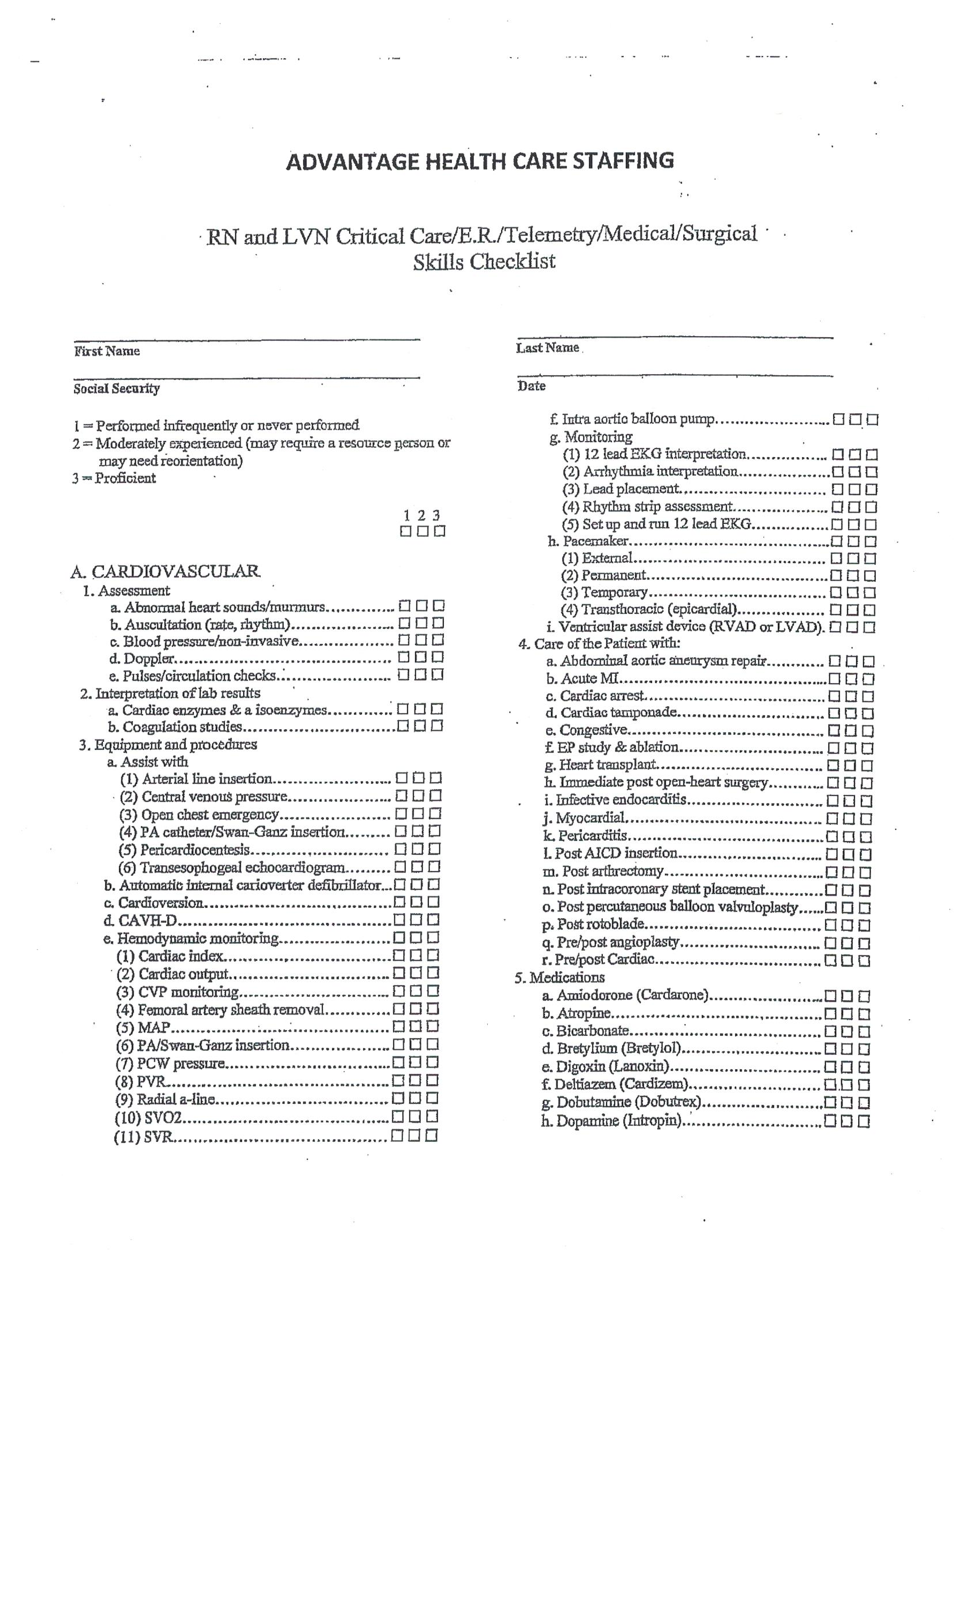

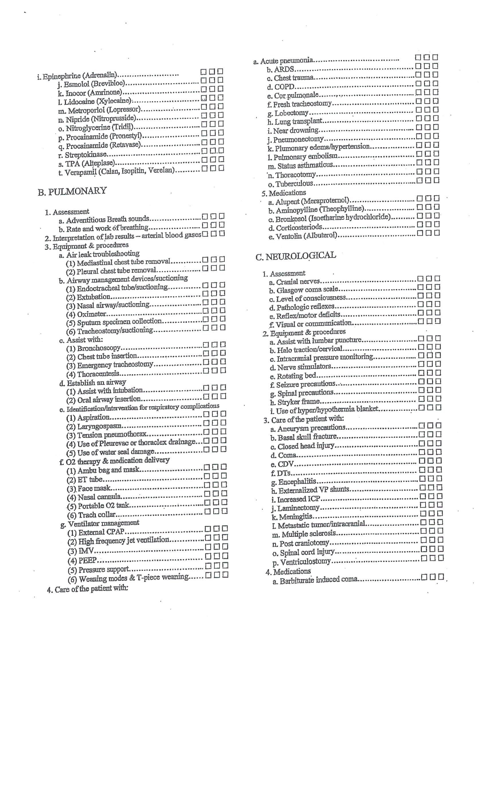

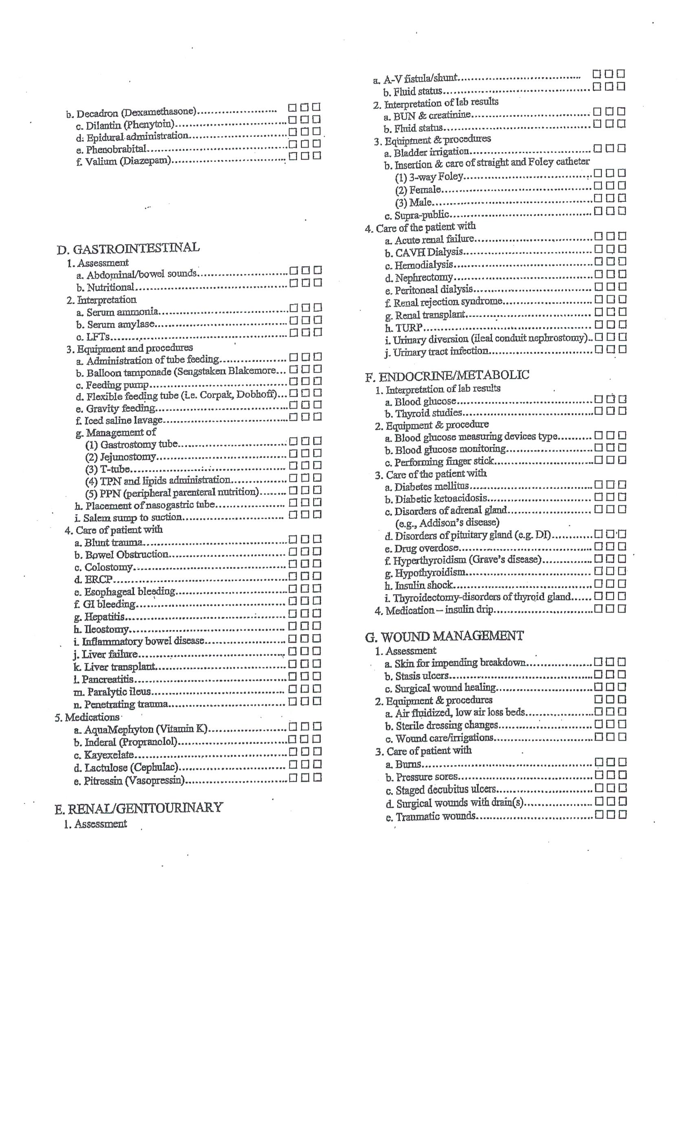

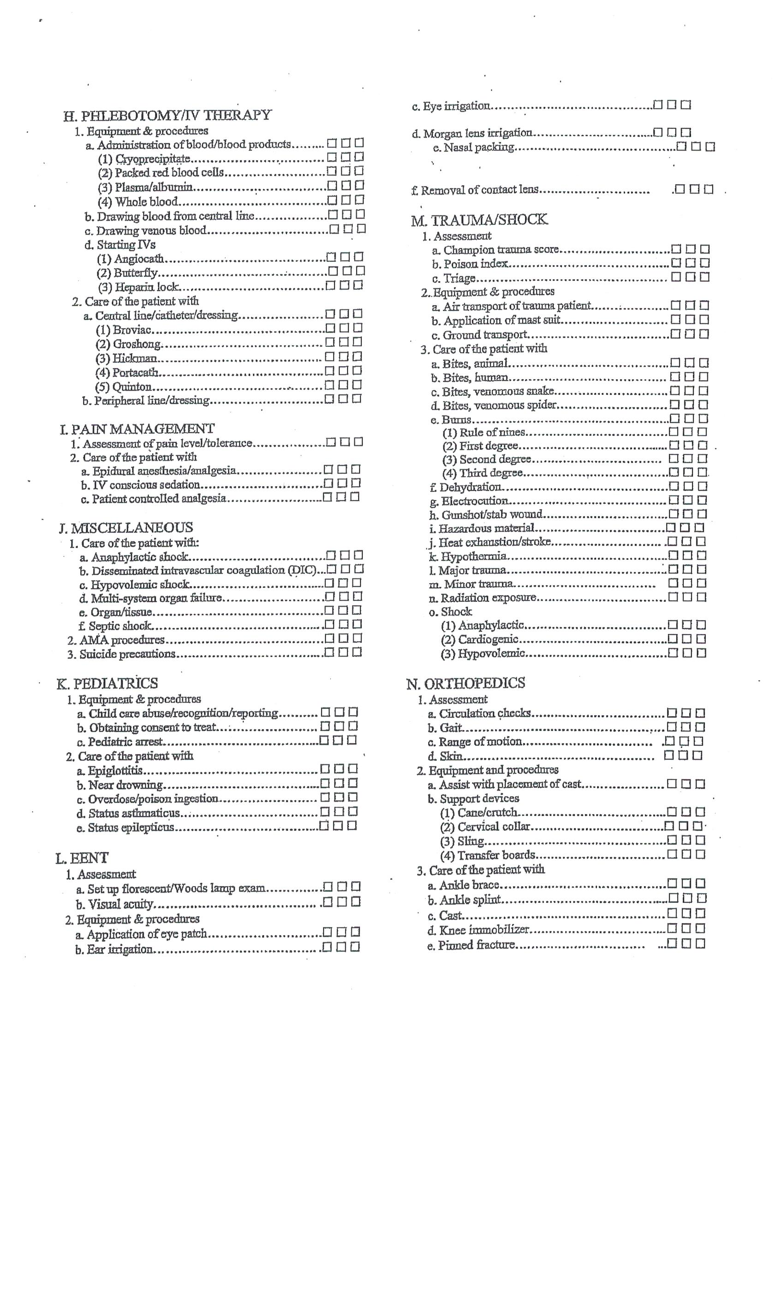



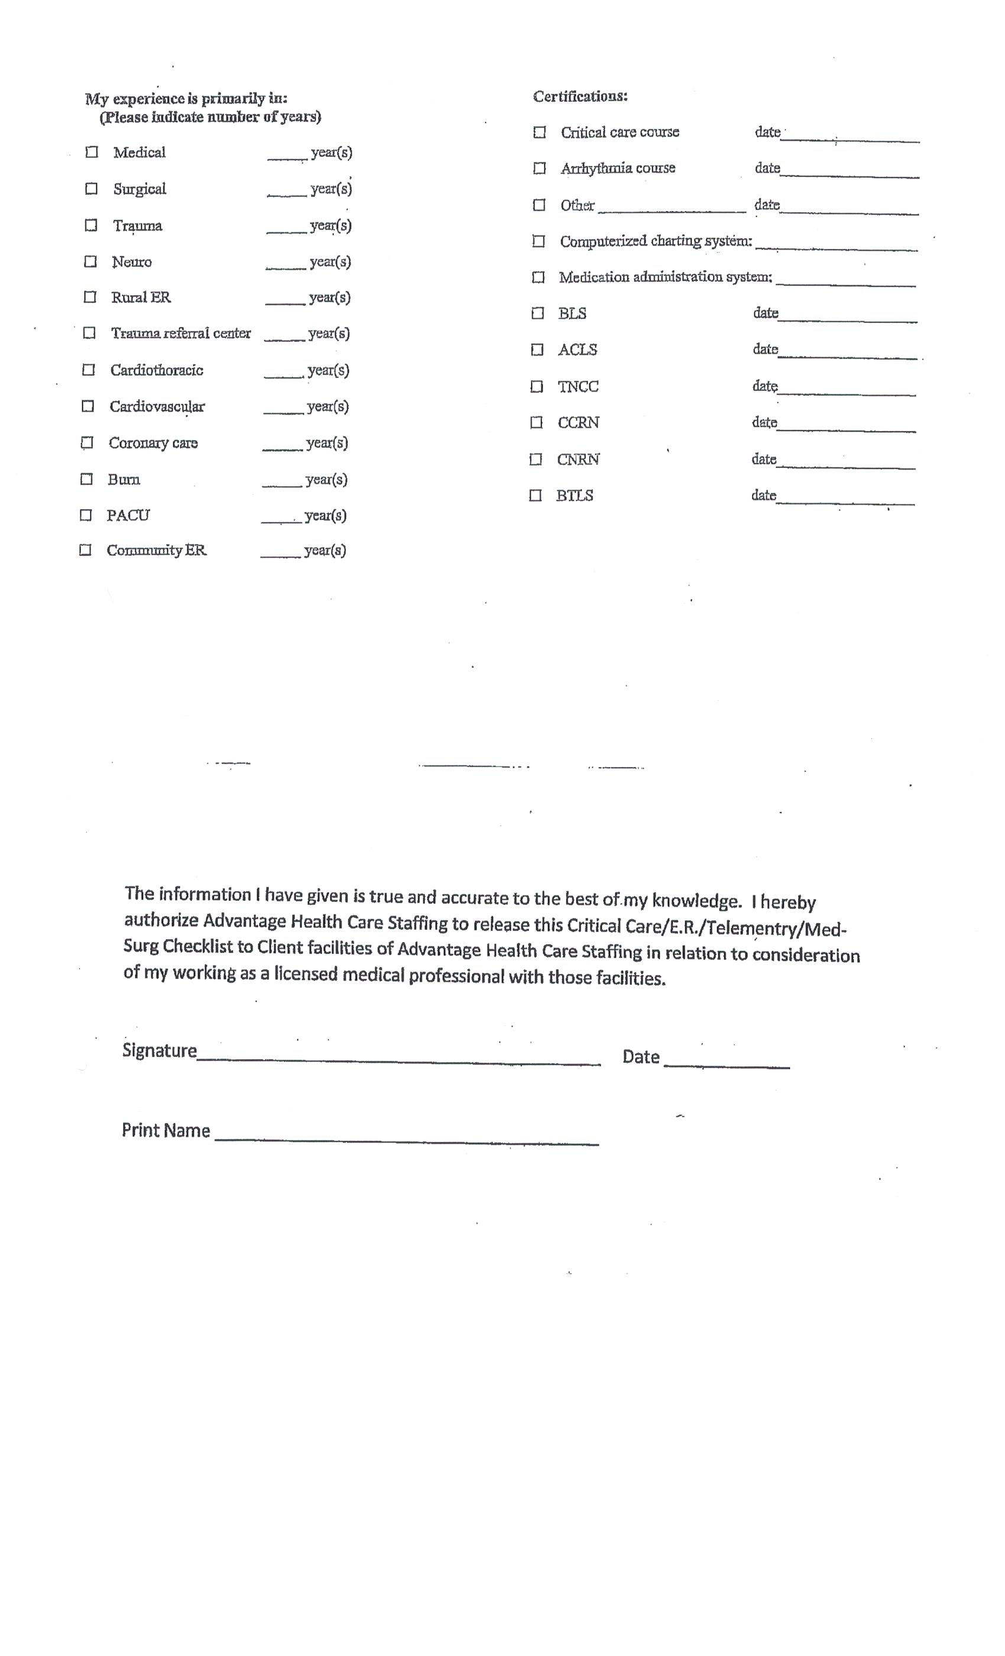

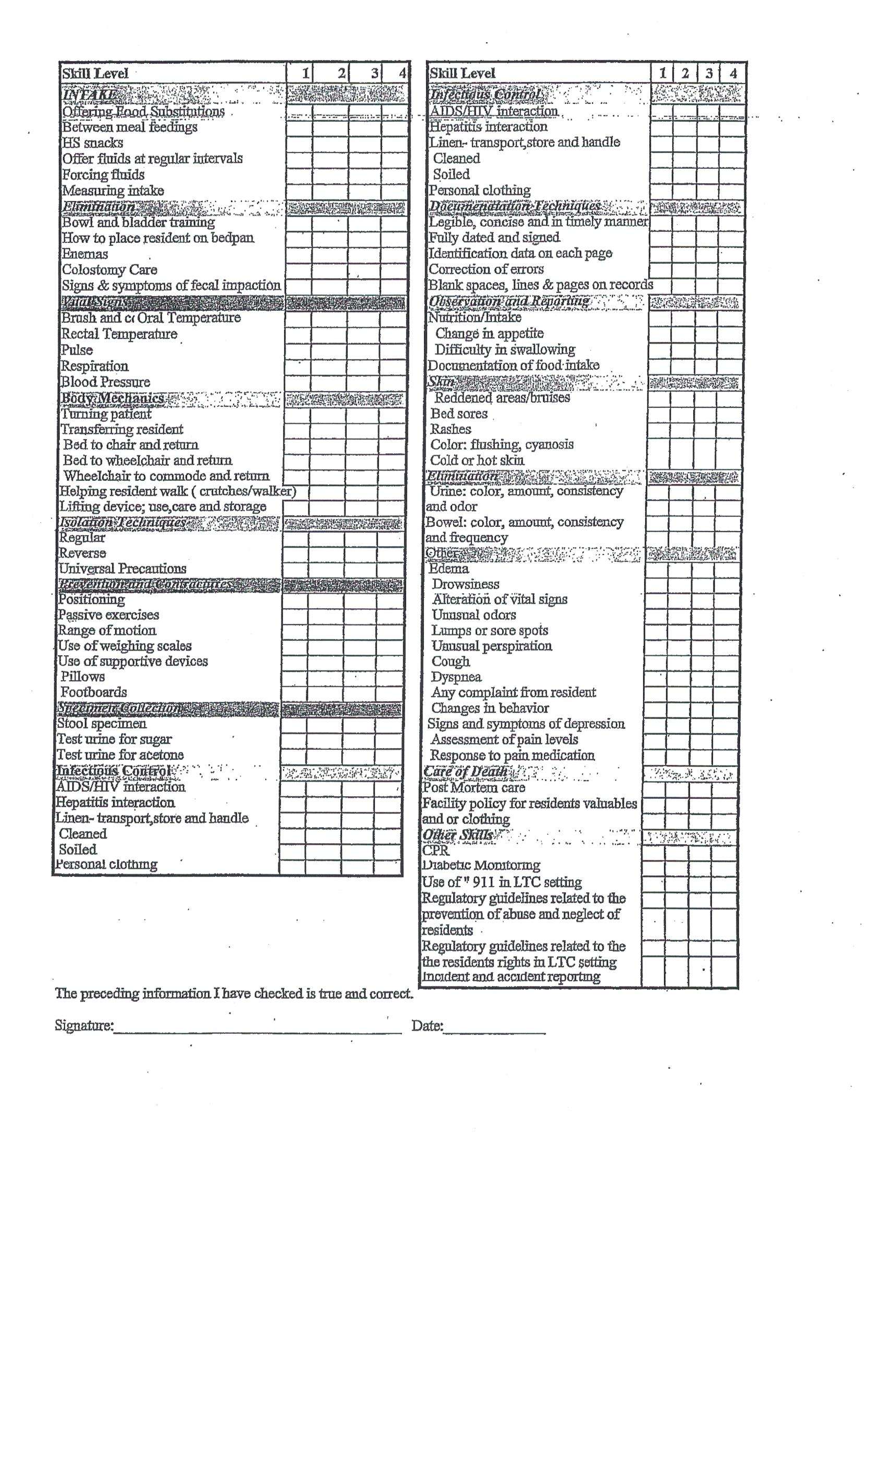

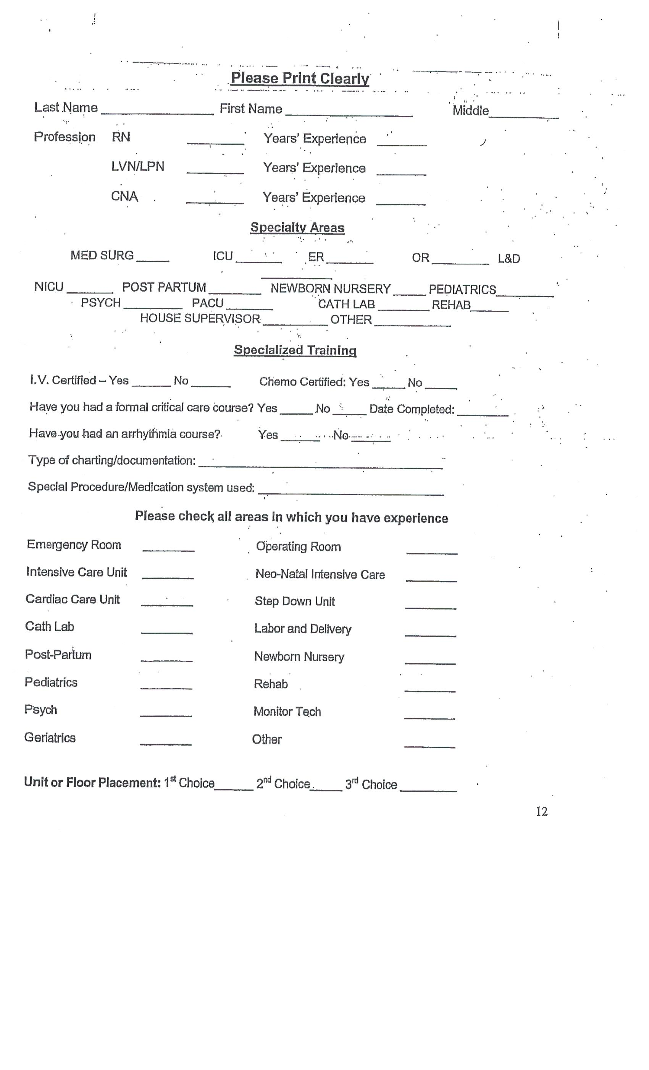

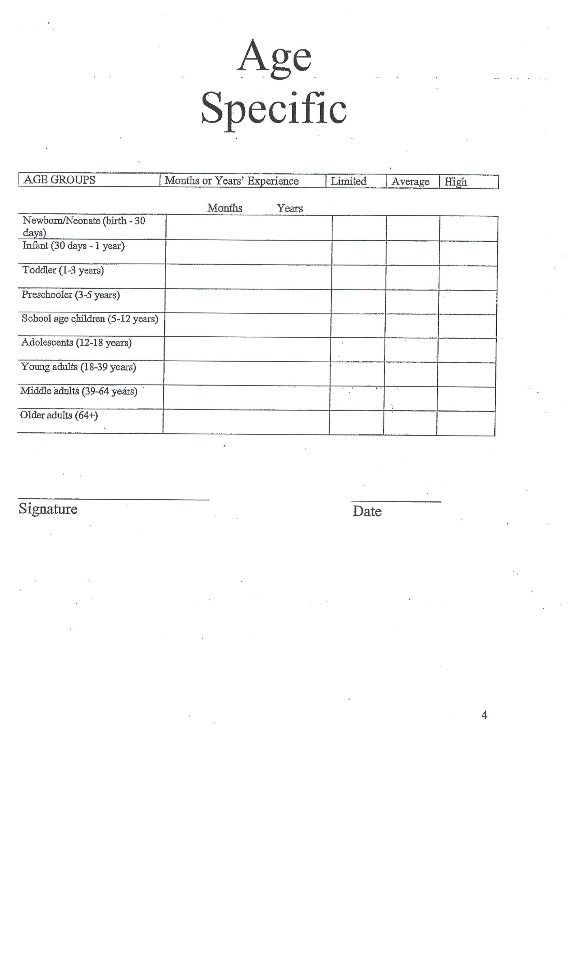

**Exhibit B**

**Benefits Waiver for Assigned Employees**

*.*

**Agreement and Waiver**

In consideration of my assignment to CLIENT by AHCS, I agree that I am solely an contractor of AHCS for benefits plan purposes and that I am eligible only for such benefits as AHCS may offer to me as its contractor. I further understand and agree that I am not eligible for or entitled to participate in or make any claim upon any benefit plan, policy, or practice offered by CLIENT, its parents, affiliates, subsidiaries, or successors to any of their direct employees, regardless of the length of my assignment to CLIENT by AHCS and regardless of whether I am held to be a common-law employee of CLIENT for any purpose; and therefore, with full knowledge and understanding, I hereby expressly waive any claim or right that I may have, now or in the future, to such benefits and agree not to make any claim for such benefits.

Contractor WITNESS

Signature Signature

Printed Name Printed Name

Date Date

**Exhibit C**

**Confidentiality Agreement for Assigned Employees**

*.*

**Assigned Employee Confidentiality Agreement**

As a condition of my assignment by AHCS to CLIENT, I hereby agree as follows:

I will not use, disclose, or in any way reveal or disseminate to unauthorized parties any information I gain through contact with materials or documents that are made available through my assignment at CLIENT or which I learn about during such assignment.

I will not disclose or in any way reveal or disseminate any information pertaining to CLIENT or its operating methods and procedures that come to my attention as a result of this assignment.

Under no circumstances will I remove physical or electronic documents or copies of documents from the premises of CLIENT.

I understand that I will be responsible for any direct or consequential damages resulting from any violation of this Agreement.

I agree to a non-compete for 12 months from my last day of employment with AHCS.

Contractor WITNESS

Signature Signature

Printed Name Printed Name

Date Date