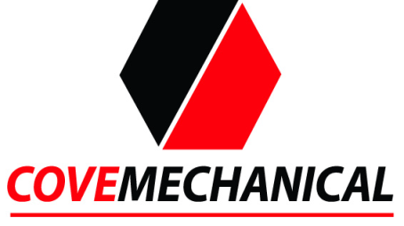

Our Commitment To Privacy

We take customer privacy seriously and do not sell or give out any customer information. Cove Mechanical, Inc. is committed to respecting the privacy of individuals and recognizes a need for the appropriate management and protection of any personal information that you agree to provide to us. We will not share your information with any third party outside of our organization, other than as necessary to fulfill your request.

