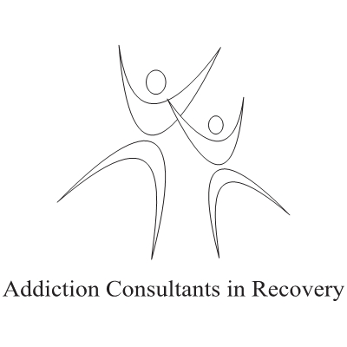

Substance Abuse Awareness Training for Employees: Employee Addiction Awareness Training © Learning Outcomes.

At the end of this training your employees will:

#1. Understand that chronic Substance Abuse is a disease.
#2. Identify feelings common to people who abuse substances.
#3. Learn signs of Substance Abuse in others.
#4. Learn some steps to take if a loved one abuses substances.
#5. Understand what the company will do to help employees who abuse substances.
#6. Learn the steps to take if they are, or suspect they are, a substance abuser.
#7. Identify and recognize how to connect with free community resources that assist people who have a problem with substances.
#8. Have a chance to speak to someone in long term Recovery from a severe Substance Use Disorder.
#9. Have a resource to call for further help or information.
Time for delivery: Approximately 1 Hour including Q & A.
Time may vary slightly depending on group size and questions.

*This module is carefully designed to create self-reflection and possible self-referral in employees taking it that have a moderate to severe Substance Use Disorder.
* Julian Toy and Addiction Consultants in Recovery offer no guarantees of any kind either express or implied that employee self-referral and/or Recovery will occur. The training gives the employee the information they require if they need, want or choose to pursue 12 Step Recovery from a moderate to severe Substance Use Disorder. The employee may continue to use substances even after self-reflection and/or self-referral to any program, treatment or group, 12 Step or otherwise.
To book your Substance Abuse Training or for a quote contact:

Julian Toy H.S.C. R.S.S.W. Substance Abuse Professional
Direct Line: 905-866-7301
Web: www.myaddictionexperts.com
E-Mail: juliantoy@myaddictionexperts.com

© 2014 Julian Toy

