Eaton Mobile Veterinary Service
919-810-6492

Goat Recommendations

Normal Health Parameters:

Rectal temperature: 102 – 104 F
Pulse: 70 – 90 beats per minute
Respiration: 15 – 30 breaths per minute
Puberty: 4-12 months
Gestation: 150 days (5 months)

Deworming Recommendations:

Panacur (Fenbendazole): 1 ml per 10 lbs orally, dose can be doubled

Strongid (Pyrantel Pamoate): 2 ml per 10 lbs orally

Ivermectin: Paste is per pound on Tube, Injectable by Veterinarian

Rotate between the above 3 de-wormers every 2-3 months. Perform fecal egg counts to check for resistance yearly. Keep environment as clean as possible. Keep feed off ground and away from feces.

If you have an infection of Protozoan/Coccidia use Albon or Corid
Deworm does 30 days before kidding.

Vaccination Recommendations:

All goats should be vaccinated yearly for Clostridium perfringens Type C and Type D, as well as, Clostridium tetani (Tetanus). Goats in this area should be vaccinated for rabies yearly.

Vaccinate pregnant does one month before they give birth to pass on passive immunity to the kid.

Kids from vaccinated does should be vaccinated between one to two months of age and then boostered one month later.

Kids from unvaccinated does should be vaccinated at one to three weeks of age and boostered twice in three to four week intervals.

In endemic areas, vaccinate for leptosporosis yearly.

Vaccinate breeding does for Chlamydia and Campylobacter before breeding and repeat mid-gestation.
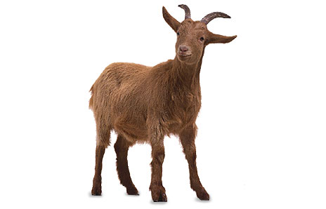
General Health Recommendations:

All new arrivals of any age should be isolated for 30 days and dewormed before joining the herd.

Keep feet trimmed every 2-3 months as needed.

Expose kids to hay and grain early to promote rumen development.

We recommend dehorning at the age of 4 to10 days.

For pet goats, castration could be delayed until 1-3 months.

For dairy goats, castration should be when dehorned at the age of 4 – 10 days.

For meat goats, castration is determined by the age of marketing.

