Nutrition Plus, Inc.
Emily Roark Patti Brenn Susan Morrell
(620) 221-2777 (620) 218-4994 (785) 224-4104
roark2@cox.net pattibrenn@cox.net smorrell12@gmail.com
www.nutritionplusinc.com
July is:
National Baked Bean Month
National Culinary Arts Month
National Grilling Month
National Hotdog Month
National Ice Cream Month
National July Belongs to Blueberries Month
National Picnic Month
National Peach Month

Important dates:

July 31st – Checks/direct deposits go out

“Infant Feeding in the CACFP”

ASAP - Topeka Workshop at library 6:30 pm
ASAP - Winfield Workshop at Presbyterian church
6:30 pm

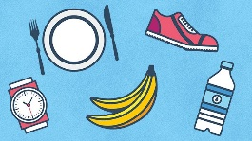
Let’s boost those immune systems!!

In light of the current health crisis inflicting our communities, here are some tips to boost your immune system.
- Get sufficient sleep. Sleep is critical to most of the body’s functions, including the immune system. It is recommended that 30 minutes prior to sleep, including nap-time, screens are turned off to get the best chance at proper sleep. Let daycare parents know what you’ve learned.
JULY 2020

- Soap-it-up at the sink. This has been covered repeatedly by social media, television and print media. Do not get lax in this important step. Please continue to wash often with soap and water.
- Replace toothbrushes after an illness. Although it doesn’t technically boost your immune system, replacing a toothbrush after a virus can prevent the spread of the virus from the sick toothbrush to the other members of the family, therefore preventing the spread of the disease. Talk with your daycare parents about this.
- Supercharge your diet! In many cases, you are feeding daycare children 3 out of their 5ish meals/snacks of their day. Packing these with as many nutrient-dense foods as possible, will give their bodies a great chance to fight off the nasty stuff trying to invade their bodies. Try adding Berries: raspberries, blueberries, strawberries, cherries, acai, goji. Citrus fruits: grapefruit, oranges, tangerines, clementines, lemons, limes. Other foods with boosting properties are: kiwi, papaya, red bell peppers, broccoli, garlic, ginger, turmeric, spinach, almonds, sunflower seeds, poultry, (mom’s chicken soup isn’t just a myth), shellfish, and yogurt with live and active cultures, like Greek yogurt. If you have picky eaters, like most of you do, there are hundreds of recipes online for smoothies, salads, soups or casseroles to cleverly disguise these helpful foods.
Stay strong. You can do this!
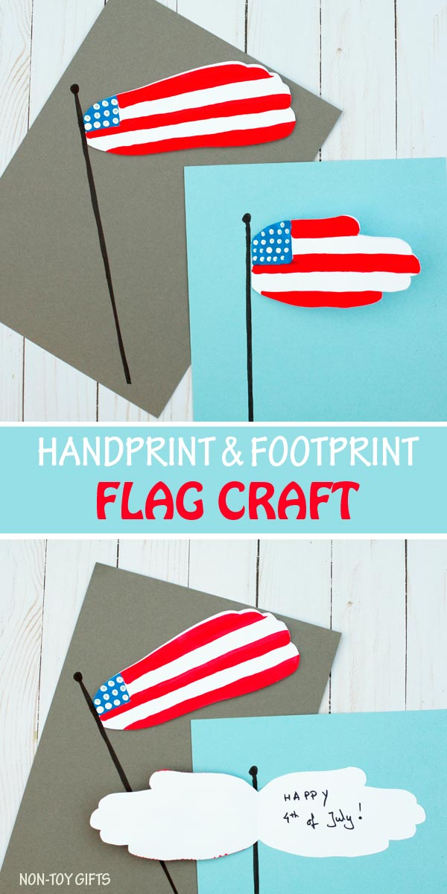

Supplies:

Cardstock paper: white and another colored paper
Pencil
Scissors
Craft paint: red, white and blue
Paintbrush
Q-tip
Black marker
Glue

Step 1: Fold the white cardstock paper in half and trace your kid’s hand or foot onto the paper. Make sure that the hand or foot is close to the fold. For tracing footprints, you will want to use a 12″ x 12″ cardstock paper and fold it diagonally to make sure you have enough room.
Step 2: Cut out the handprint or footprint.
Step 3: Paint the American flag on one side of the handprint or footprint. Start with a blue square in the left upper corner. You may want to wait for the blue paint to dry before you move on to the red stripes. This way the blue paint won’t get mixed with the red one.
Step 4: Dip a Q-tip in white paint and make the stars by pressing the Q-tip several times on the blue square.
Step 5: Use a black marker to draw a flag pole on the colored cardstock paper.
Step 6: Glue the back of the handprint or footprint to the paper, next to the flag pole.

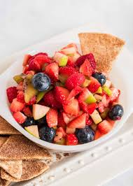
Fruit Salsa with Pita Chips

1 cup strawberries, finely chopped
¾ cup raspberries, blackberries, or blueberries, finely chopped
1 apple, finely chopped
1 cup melon of choice, finely chopped
3 tablespoons lemon juice
Cinnamon and nutmeg

Combine fruit in a mixing bowl and add lemon juice. Sprinkle cinnamon and nutmeg to taste. Refrigerate before serving. Serve each child ½ cup fruit salsa with 4 plain pita chips. (Snack crediting: 7 servings for ages 1-5)

As always, we are proud of what you are doing for our children. Thank you. Emily, Patti & Susan

