Light
- You will need a laptop or iPad for this
- Conduct PowerPoint presentation on IWB from www.twinkl.com details objects that produce light. For example, torches, light bulbs and the sun.

- Complete IWB activity from www.topmarks.co.uk.

www.topmarks.co.uk
select whiteboard resources in tabs
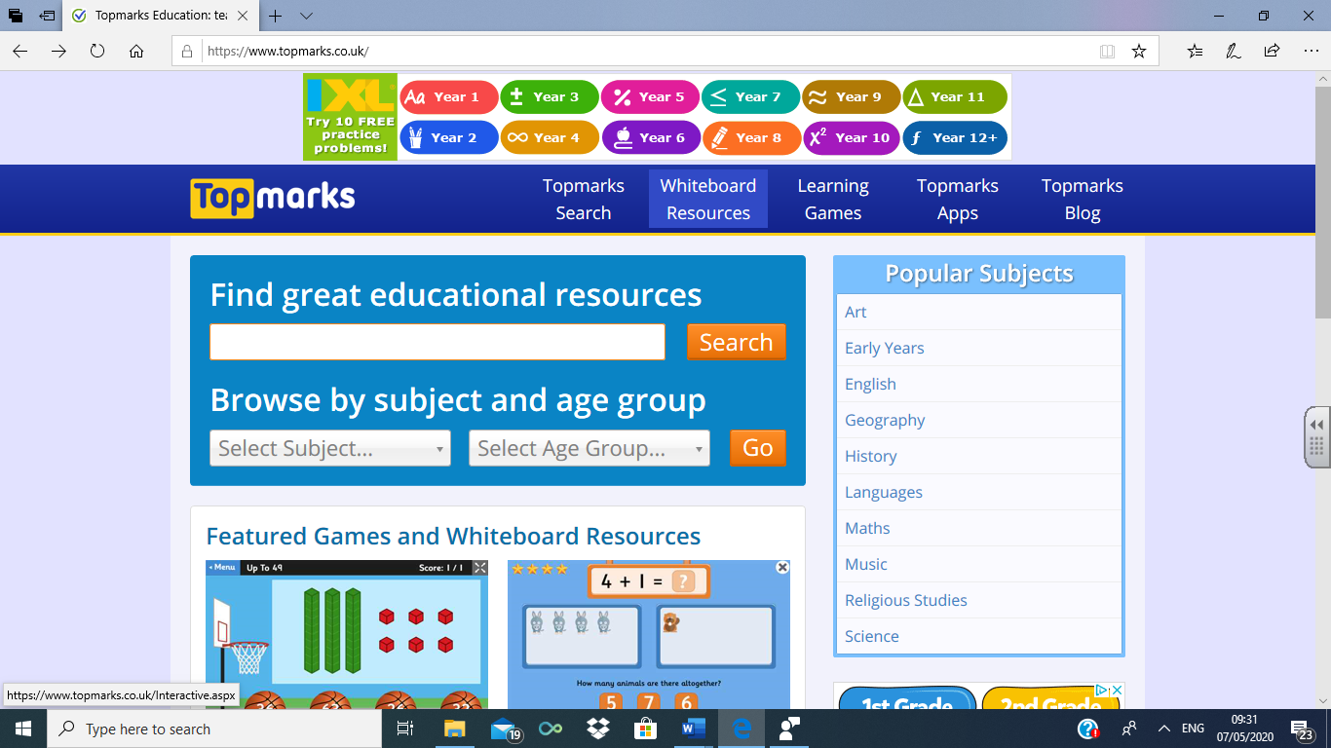

Select Science Key Stage 1
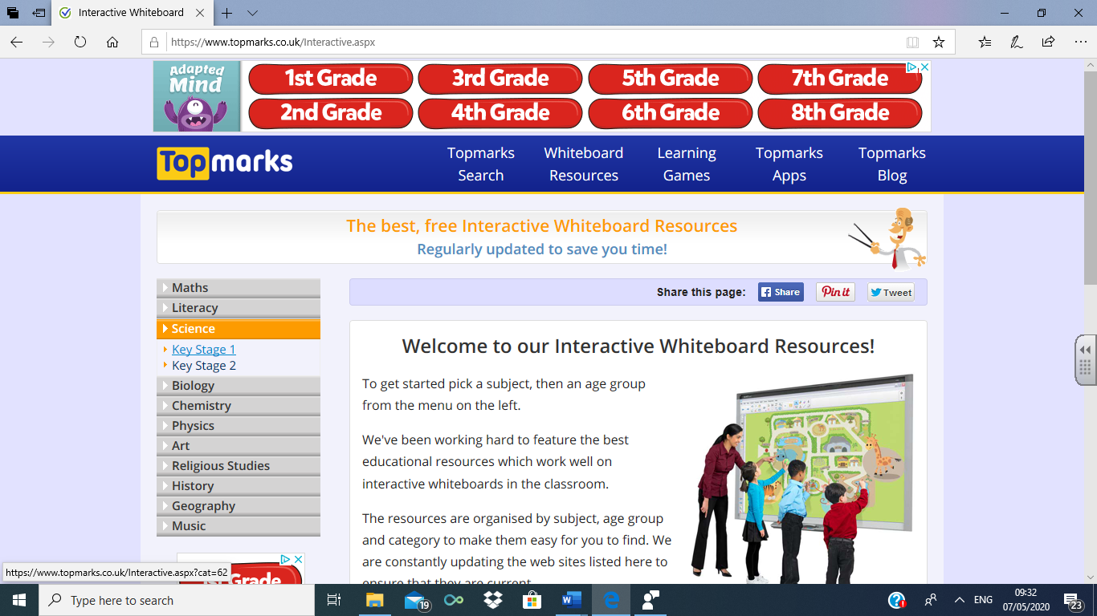

Select Light and Electricity

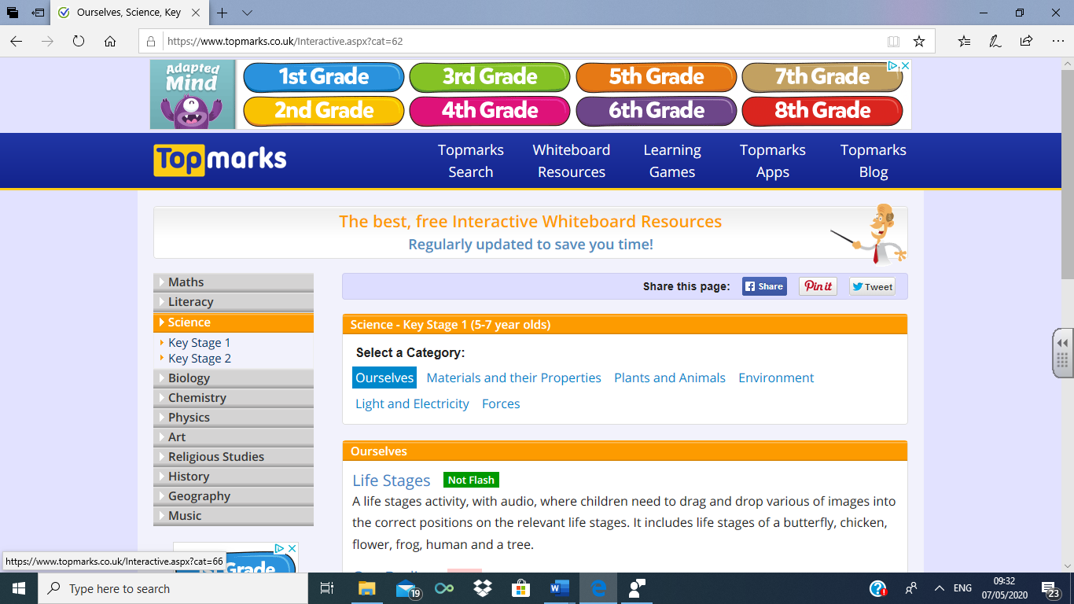

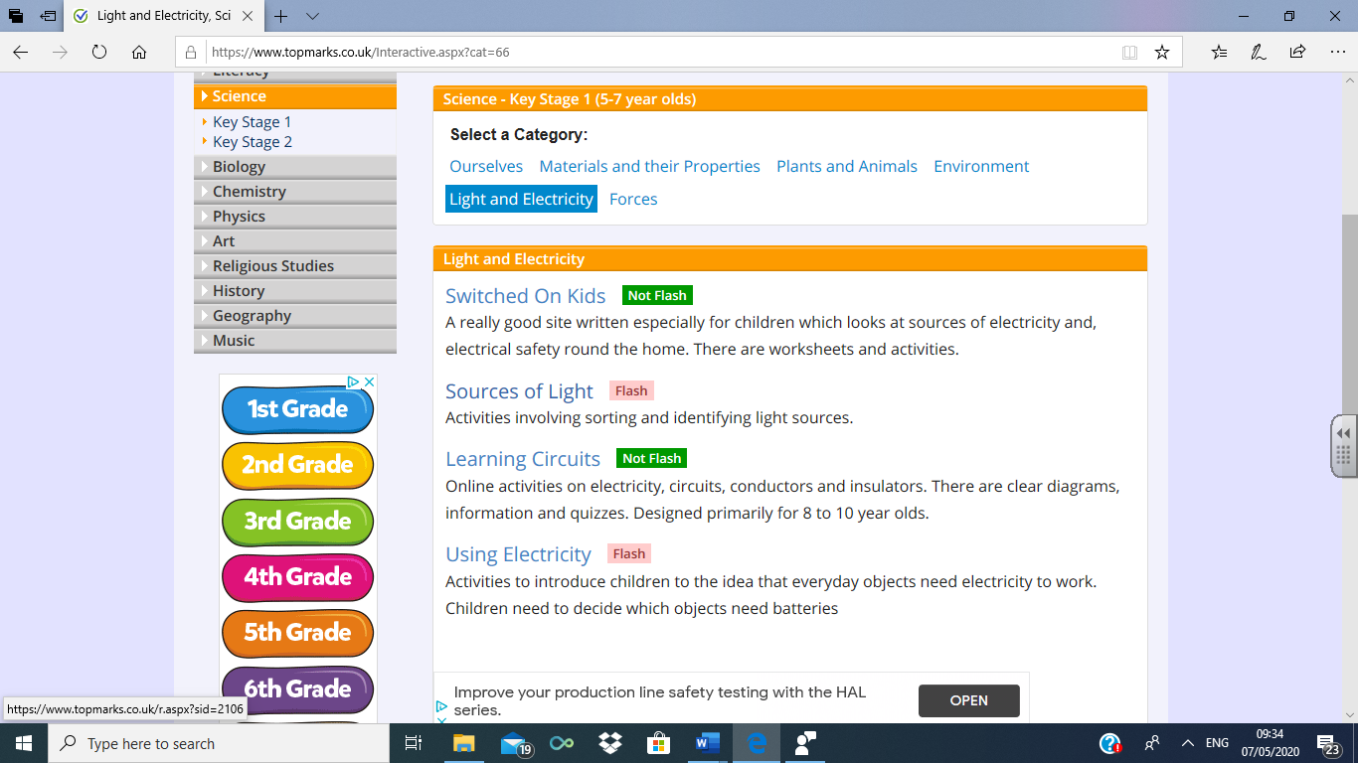

Do each part 1 to 5
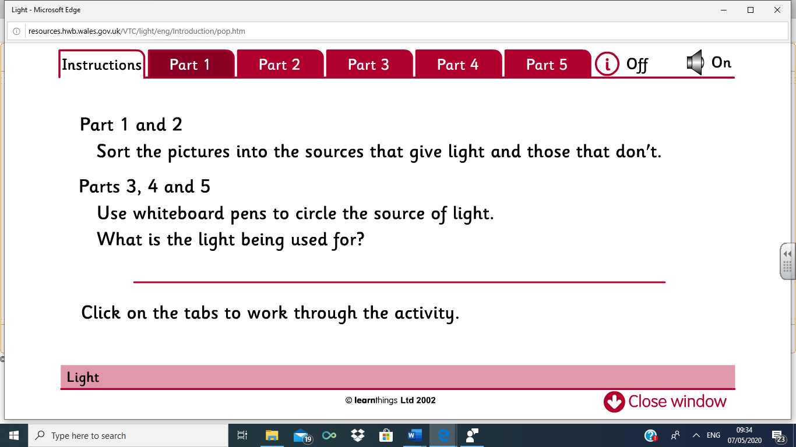

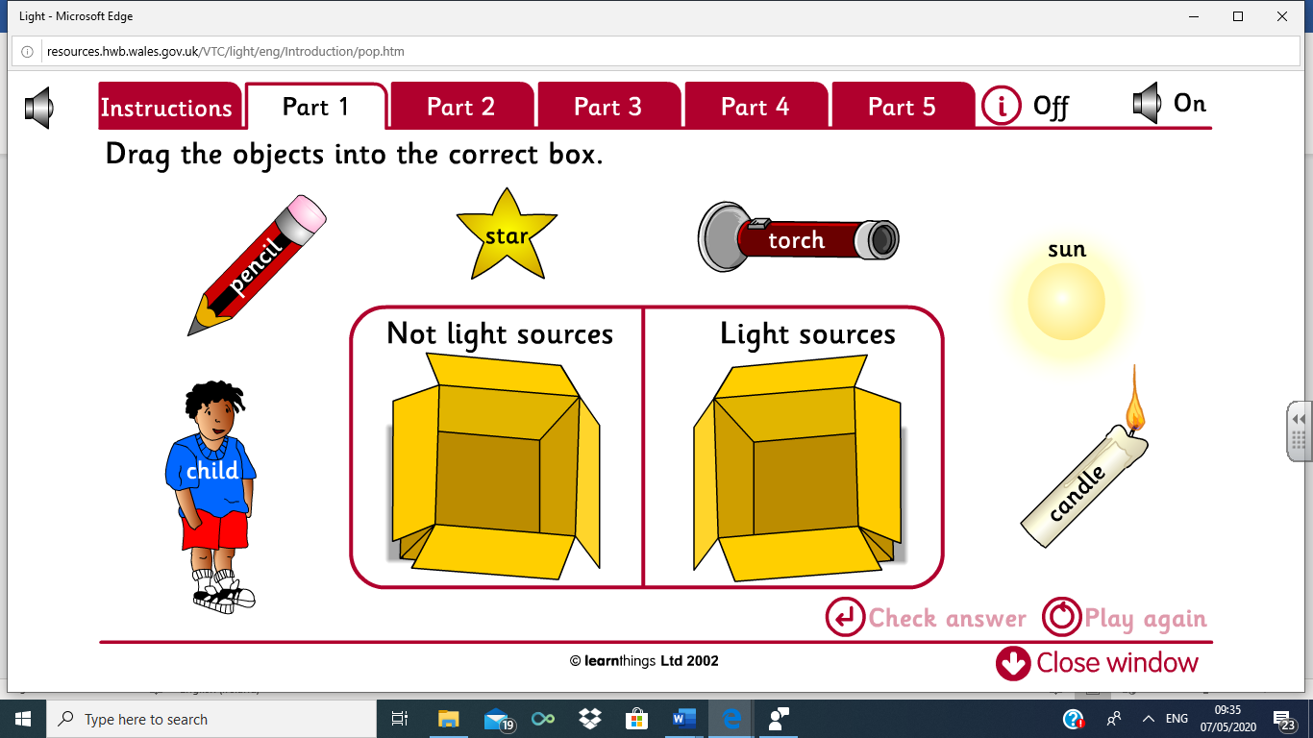
- Children identify sources of light by dragging and dropping from a selection of objects. Sources of light will include: the sun, a candle, a torch, a lamp, a light bulb and fire.

- Children to complete work sheets differentiating between items that provide light and items that do not. (attached)

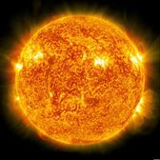
a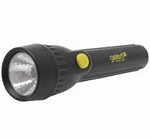

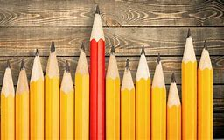

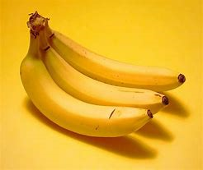

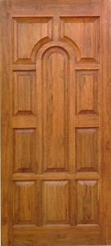
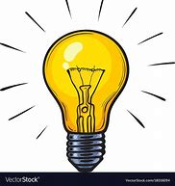

- With your child conduct a search of your house for all objects that produce light.

- Talk about objects that you find and what they are used for. Let the children experiment with turning them on and off.

- Finally explain that our main source of light comes from the sun. Let them draw a picture of the sun.

