FOUND CAT

Please help me find my home!!
…………………………………………………………………………………………………………………………..

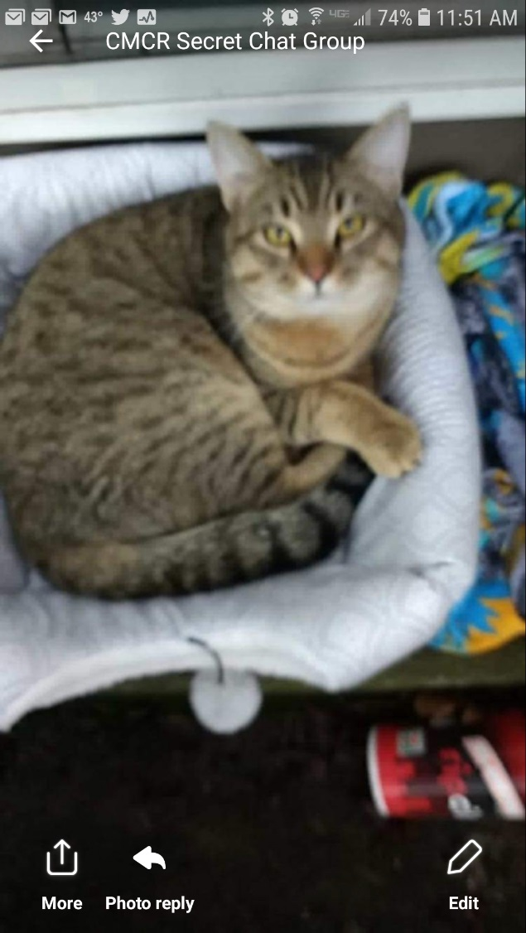
Date Found:

__________________________

Location Found:

__________________________

Please call:

____________________

Phone #:

_____________________

