HOW DO ANTACIDS WORK?
The Human Digestive System
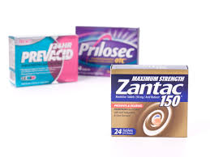
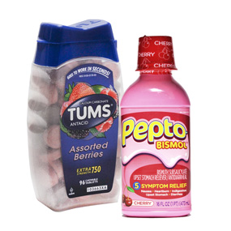
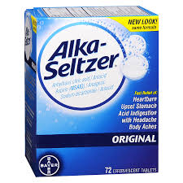
Rolaids, Tums, Mylanta, Prevacid, Alka-Seltzer – you’ve probably seen these at the drug store and on TV commercials. How do they work? Are they all the same? And what does the word ‘heartburn’ mean?

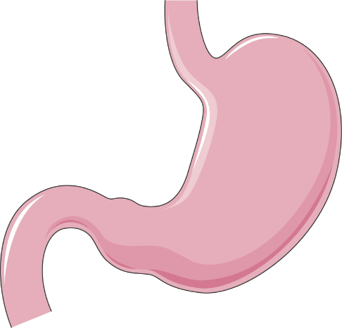
Before we answer all those questions, first we need to learn a little bit about digestion and how the stomach works.
Your stomach is kind of like a bag, or like bagpipes without the pipes sticking out. If you ask a kid where their stomach is, they will usually point to their bellybutton. But really, your stomach is higher up. Half of your stomach is tucked under your rib cage on the left. The other half lies in the middle of your body about four inches above the bellybutton. If you get a stomachache near your bellybutton, the pain is usually coming from your intestines. A true stomachache usually hurts below the sternum, also called the breastbone (this is where the term ‘heartburn’ comes from). We’re going to pretend our Ziploc bags are stomachs!
When we eat food, chewing breaks it into smaller pieces so that we can swallow it more easily. We’re going to pretend our hands are teeth – go ahead and ‘chew’ the crackers with your hands!
You have saliva (spit) in your mouth that help further break down your food. (Saliva and spit are the same thing; in science class we might use the word ‘saliva’ but with our friends, we use the word ‘spit’. Just different words for the same thing!). Saliva has enzymes in it that break down food (laundry soap has similar enzymes that break up food stains). Pour a little ‘saliva’ (water) on your crackers.
Now that we’ve chewed up the food and the saliva has broken it down a bit, we’re ready to swallow! Put the crackers in the ‘stomach’. In your body, after swallowing the food goes down your throat, through your esophagus, and into the stomach.
Your stomach is muscular, and it churns and contracts (squeezes) to break up your food even more. Your stomach also makes a very strong chemical called hydrochloric acid (chemical formula HCL) that REALLY breaks down your food. Strong acids are corrosive (another word for ‘breaks things down’). It’s so strong, as a matter of fact, it could break up metal! Your stomach also produces a chemical called pepsin that breaks down the protein in your diet, like in meat and dairy products.
We’re going to pretend the lemon juice is hydrochloric acid (lemon is acidic, too). Pour some into your bag and close it up again. Your hands are like the muscle contractions in your stomach – use them to make the food into liquidy paste.
Your food then moves into the small intestines, where more enzymes break it down further and nutrients are absorbed into the bloodstream. Eventually, anything left that your body doesn’t need comes back out! Cut off one corner of the bag and squeeze!
Now that we know more about how the stomach works, we are ready to learn about how antacids work!
What are Antacids? How Do They Work?
Antacids help relieve acid indigestion. What does that mean? Normally, stomach acid stays in your stomach. Certain foods, diseases, or other factors can cause the acid to go back up into the esophagus, and the symptoms are a burning pain that feels like it’s moving from the stomach to the chest (this is where the name heart burn comes from, but it has nothing to do with your heart!) Acid can also back up into the throat or mouth – kids call it a ‘vurp’ or ‘wet burp’.
There are three general types of antacids:
- Alginate Antacids: They create a foam barrier on top of the stomach content to prevent acid coming into your esophagus and throat. Sodium Alginate is extracted from brown algae, and forms a gummy substance when it mixes with water).
- Acid Neutralizers: these are bases that work by neutralizing acid (so that it won’t hurt you). The chemicals in antacids are bases (akalis) that neutralize stomach acid. Antacids that contain magnesium have a laxative effect, while those that contain aluminum have a constipating effect. Some antacids contain both aluminum and magnesium chemicals to balance this out.
- Stomach Acid Blockers: These reduce the amount of acid the stomach produces (H2 blockers, Proton Pump Inhibitors).
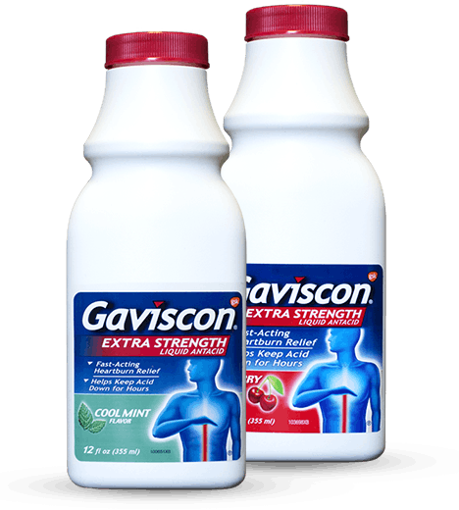
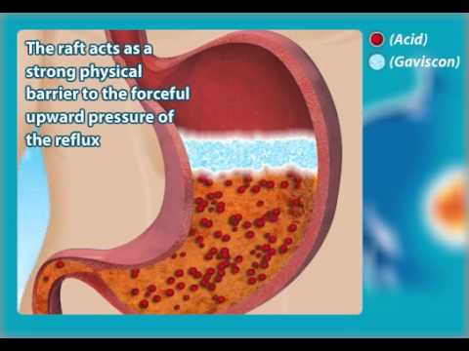
We’re going to see a demonstration about how Gaviscon works, which is an alginate antacid.

The Erlenmeyer flask is our ‘stomach’, and the neck of the bottle is the ‘esophagus’. (See the ‘Laboratory Glassware Guide’ to find out what an Erlenmeyer flask is). We’re going to fill it with ‘stomach acid’. Next, we’re going to ‘swallow’ some Gaviscon. What do you think will happen when we do that? Can you explain what’s happening?
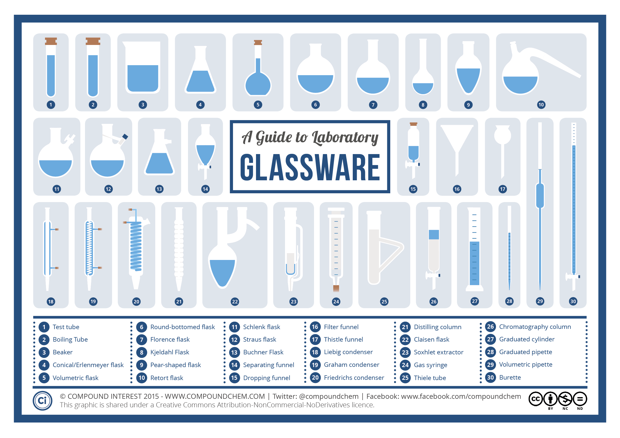
Next, we’re going to see how an acid neutralizer antacid works.
- Place about 100 mL of Milk of Magnesia in a 500 mL beaker and dilute with tap water until the beaker is about half full.
- Add about 10 mL of Universal Indicator. What do you see happening?
- Stir the mixture with your stir stick. What happens now?
- While stirring the solution, add 10-20 mL of vinegar (it doesn't have to be precise) and observe what happens next! Can you guess why this is happening?
- Add more vinegar and see what happens!
Why are there so many brands and types of antacid?
Some people get heartburn only occasionally and therefore only need the occasional antacid from the drugstore. However, some people have more chronic heartburn, and need stronger medicines available by prescription. Untreated chronic heartburn can lead to serious health problems, even esophageal cancer!
Acid Neutralizers: Fast relief but don’t last long in the body (usually not more than an hour). For infrequent, sudden episodes of heartburn. Examples are Tums, Rolaids, and Mylanta. Do not heal the lining of the esophagus. Not preventative; only treat symptoms.
H2 Blockers: These remedies reduce the amount of acid the stomach produces by blocking histamine, a compound that tells your stomach to churn out acid. Unlike acid neutralizers, helps heal the esophagus. Last up to 8 to 12 hours.
PPIs (Proton Pump Inhibitors): Heals the esophagus better than H2 blockers. PPIs block an acid-producing enzyme in the lining of the stomach.Most of these drugs require a prescription. Take time to work, not immediate like antacids. Can take up to 24 hours to work.

