Other Dance styles such as Jazz, Tap, Modern, Contemporary, Hip Hop, Salsa etc, have a little more leeway on how you are expected to wear your hair. Again it often depends on what your teacher would like but there is definitely more choice. For training purposes and class it is sensible to wear your hair back off your face but that does not mean it has to be scraped back into a bun, see below for some hair ideas which are suitable but fun!
French Plait
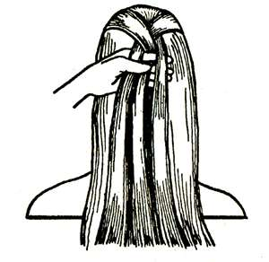
The French Plait is stylish and sensible with the intricate detail that the folding of the hair makes. This is a favorite choice for lots of dancers because it is easily adaptable for most styles of dance and stays neat and tidy.
1. Begin the French plait by gripping a small section of hair at the top of the head between your thumb and forefinger. Separate this hair into three equal strands and with it, plait hair once, crossing left strand over middle, then right strand over middle.
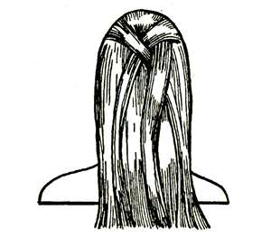
2. Grip the French plait in your right hand and keep the sections separated with your fingers. With your left hand grab a small, even section of hair from the left side of the head and add this to the left strand. Do not plait hair again until step 3.
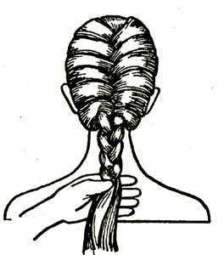
3. Switch the French plait to the left hand, keeping hair strands separated between fingers. Grab an even section of hair from the right side of the head and add it to the right strand. Plait hair again.
4. Repeat Steps 2 and 3, pulling hair tight each time you French plait hair. When you get to the nape of the neck and don’t have any more hair to add from the sides, continue with a basic braid and tie the end of the French plait with an elastic hair band.

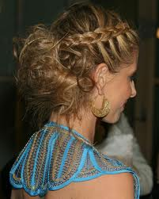
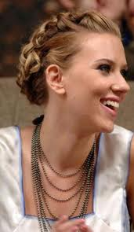
There are other ways of wearing the French Plait which can change the style and look of the hairstyle. It can be made into two plaits rather than one big one – You start the French plait in the same way but instead of making it into one large plait, you separate it into two smaller plaits. It can also be tucked up to into itself as you can see from the picture of Scarlett Johansson. This is made by simply tucking the two plaits up, twisting them round each other and pining in place. Or you can have the ends loose and pin them into a ‘messy bun’ as you can see from the picture of Sarah Michelle Gellar.

High Ponytails
High Ponytails are quick and easy but can look great, especially for dance styles such as Jazz and Disco. It can look great with both straight and curly hair and some dancers like to add hair decorations or scrunchies!
1. To make a high ponytail, with a comb/brush pull the hair back high onto the head and secure with a strong elastic band. Smooth out any lumps and bumps.
2. Spray with hairspray or Glitter Hairspray to jazz it up a bit!
National Dance
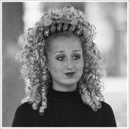
National Dance is dances from around the world from each country. Each dance has very strict costume requirements and that includes hairstyles! For example; Irish dancing is becoming more and more popular these days and the Irish are very proud of this dance style, but how does an Irish dancer have their hair? Here is a list of some hair styles you can see from dance styles from around the world:
Irish Dancing: ey love the ringlet curls, which is usually warn with a head dress. Each member of the group all wear the same costumes and hairstyle, this gives a very uniformed polish look to the performance. For those who do not have curly hair naturally, hair pieces can be brought.
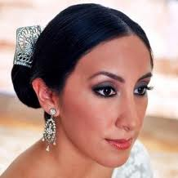
Flamenco dancing: is a strong dance style with very dramatic and sharp movements. The hair style is quite severe and dramatic in its self. The hair is either made into a centre parting or side parting and pulled into a low side bun. The hair must be smooth and slick without any bumps. The hair is often decorated with some sort of accessory, for example a large flower. Normally depending on what dress the dancer is wearing will depend on what style and color the hair decoration will be.

Greek Dancing: This dance form comes from Ancient Greece and is based upon the natural movements of the body. The movements are expressive and range from lyrical to dynamic athletic sequences. Dancers perform barefoot, wearing tunics and often use props such as scarves, ribbons or bows. Each dance has a story or meaning behind it, so usually depending on what the dance means depends on what costume and hairstyle will be needed. For example; if you were to dance a sequence which is telling the story or representing the Greek God Aphrodite, the hair may have loose curls with the front pinned up with a flower or two added. Where as, if you were dancing an athletic sequence your hair may need to be more severe and slicked back.

