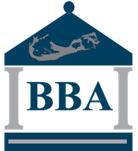

Bermuda bankers association

Press release

to: | Bermuda Media
from: | BBA
subject: | BBA Session on Cyber Threats and fraud trends
date: | 6 may 2019
CC: | BBA ExCo
On May 2nd, 2019, the BBA sponsored a learning session for staff members from all four of Bermuda’s banks. The session focused on recent cyber threats and fraud trends both globally and here in Bermuda and was delivered by a combination of Information Security and Fraud Prevention specialists from BBA members and the Bermuda Police Service. Specific instances of cyber-attacks against banks in Malta, various ransomware attacks globally and the ATM attacks in Bermuda by foreign nationals circa 2017-2018, were presented and discussed.
This effort was undertaken to enable all Bermuda banks to gain a comparable level of understanding as to the patterns and practices that indicate potential exposure to the risks present and to ask questions from the panel of well-versed representatives who deal with this threat on a daily basis.
Bermuda is uniquely exposed to both cyber-attacks and non-cyber fraud threats given its high profile in the business world and its connections to both the UK, USA and Europe. Hence, all local stakeholders have an obligation to maintain vigilance and readiness in the face of these constant threats and to stay abreast of the threat environment. This session reinforced that message and our members will now carry it forward into their customer interactions.
Further information on these threats and protective actions that can be employed, will be disseminated via the BBA website and its social media platforms.
The BBA will be undertaking future learning sessions on topics impacting the banking sector and the customers who bank with our members. We invite anyone who is interested in presenting a topic that will serve the interests of the Bermuda financial sector to contact the BBA.
For further information please contact Thomas O’Rourke at BBAExec@protonmail.com or at 441 541-5036.

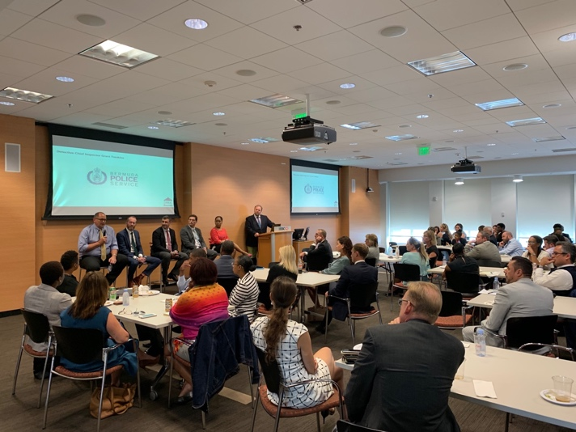

The Bermuda Bankers Association (BBA) represents the interests of all licensed banks operating in Bermuda – HSBC Bermuda, The Bank of NT Butterfield & Son, Clarien Bank and Bermuda Commercial Bank. Further information can be found at www.bermudabankers.org

