Retirement Income Management Investment Approach
The financial services industry is widespread with investment ideas. Many work for some time period, but most approaches that concentrate on a specific asset or sector do not work over the long term. This happened to Bill Miller whose concentrated "value" style of stock portfolio management collapsed on him after 15 years of good performance when he took concentrated positions in "value" financial stocks like Freddie Mac, Fannie Mae, Citigroup, AIG, Countrywide, Bear Stearns, Merrill Lynch, and Washington Mutual that led to his Value Trust fund to report a 55% loss in 2008 vs the 37% loss in the S&P 500. This concentrated approach also hurt Pimco's Bill Gross as he moved out of treasuries in 2011 as treasury bonds were increasing in price. In addition, everyone has heard the stories about investors who were mainly invested in tech stocks at the high of the Nasdaq in March 2000.
Retirement Income Management believes in a more diversified approach that invests across many asset classes and sectors based upon Modern Portfolio Theory (MPT). In addition, we also believe that a client's investments should include primarily dividend and income securities.
MPT was originally developed by Harry Markowitz in a 1952 report in the Journal of Finance. The idea of MPT is not to look at just the return/risk of one security or even a group of securities, but to look at the portfolio as a whole when looking for the highest adjusted risk/return level. MPT includes advanced financial concepts such as the efficient frontier, correlations, covariances, systematic and non-systematic risk. Since these concepts are broadly covered elsewhere, we are not going to cover them here.
MPT is not perfect. It is based upon historical data and stocks and sectors of stocks tend to become more highly correlated during downturns and panics in the market. In 2008 and 2009, almost all stock classes were very highly correlated and declined together. This included the normally "safe" Health Care, Consumer Staples, and Utilities sectors. However, high quality bonds did not move with this same type of stock sector correlation in 2008 as a weighting in corporate bonds would have help to improve the performance of a stock only portfolio and the inclusion of a large percentage of treasuries would have dramatically helped the almost -40% return of a stock only portfolio in 2008.
Despite some of the shortcomings, we believe the basis of MPT is valid and that clients portfolio should be based upon this theory. This is especially true if you were a stock only investor in Japan throughout the past several decades as the market has lost almost 80% in nominal or inflation adjusted returns as Doug Short of dshort.com outlines in the following chart. Whether the client was building wealth or in retirement, being diversified only in the Japanese market would have had a detrimental effect on the lifestyle of an individual. While we are not making the case that the U.S. stock market is going to move in lockstep with Japan, this possibility cannot be ignored and highlights the case for diversification outside of stocks and especially for those in retirement that do not have the time to recover from a Japan like scenario.
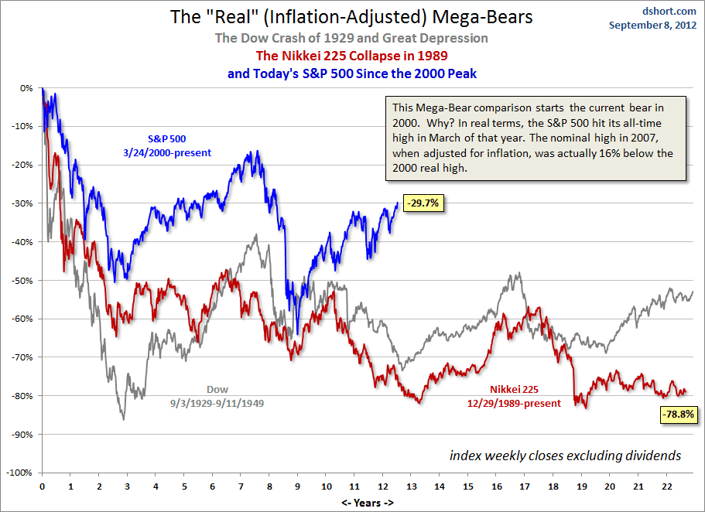
In addition to the MPT theory and the benefits of diversification, we believe that income should be a vital part of an investor's portfolio. The ability to build wealth over a lifetime through bond income and stock dividends not only will allow the investor to continue to purchase more shares of stocks and bonds as they approach retirement, but should provide for good risk adjusted returns as much of the long-term return will be highly dependable income. Using just a portfolio of conservative fixed income securities with yields of 6% will double a portfolio over about 12 years. In retirement, when income is needed, a higher percentage of fixed income, shorter maturities of fixed income, and safer dividend securities are warranted to protect against both inflation and the possibility of capital losses.
At the end of the day, regardless of the investment, our goal is to offer you returns that are commensurate with your individual risk level, but also offer a higher risk adjusted return than competing investments. We believe this approach, utilizing MPT and income, has shown good risk adjusted results and will continue to do so in the future. We thank you for your time and hope you will look further into our investment approach.

