FEATURE

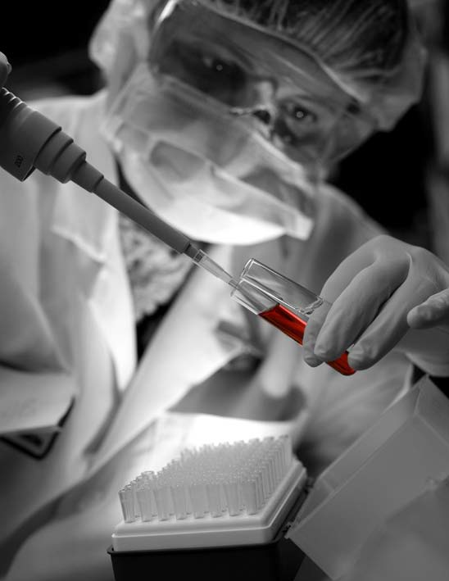
Advances in Regenerative Medicine: High-density Platelet-rich Plasma and Stem Cell Prolotherapy For Musculoskeletal Pain

Donna D. Alderman, DO Medical Director Hemwall Medical Centers
Glendale, Valencia, and Alameda, CA Trustee, American Osteopathic Association of Prolotherapy Integrative Pain Management

Robert W. Alexander, MD, DMD, FICS Bitterroot Aesthetic & Reconstructive Surgery Stevensville, MT
Associate Professor
University of Washington School of Medicine and Dentistry Seattle, WA

P

Prolotherapy is a method of regenerative injection treatment designed to stimulate healing.1 Prolotherapy is used for the treatment of chronic musculo-skeletal pain, including ligament, tendon and joint injuries, as well as osteoarthritis. The term prolo- therapy is short for proliferation therapy, as it stimulates the proliferation and repair of injured tissue.
Traditional dextrose prolotherapy originated in the 1930s and continues to be used successfully. In the 2000s, in-office platelet-rich plasma (PRP) prolotherapy was introduced. This method uses a patient’s own blood, centrifuged to concentrate growth factor–rich platelets as the proliferation formula. In the past few years, physicians have began using adult stem cells, harvested from an individual’s fat tissue or bone marrow during an in-office procedure, then combined with the individual’s PRP as the proliferation formula for injection into injured musculoskeletal tissue.
This newest form of prolotherapy, known as stem cell pro-
lotherapy, is used in difficult cases or where accelerated musculoskeletal healing is desired. Popular media reports have been emerging that cite the use of stem cell prolotherapy in professional athletes such as Bartolo Colon, starting pitcher for the New York Yankees, who had the procedure success- fully done for a rotator cuff injury earlier this year.2 Our article will review the history, science, methodology, and evidence for these types of prolotherapy, and offer a treat- ment algorithm.

Prolotherapy: The Original Regenerative Medicine Prolotherapy was “discovered” in the 1930s by Dr. Earl Gedney, an osteopathic surgeon, before the term regenerative medicine existed. However, prolotherapy is a true regenerative medicine, working by locally raising growth factor levels to promote tissue repair and regeneration.3-5
Multiple studies confirm the effectiveness of prolotherapy in the resolution of musculoskeletal pain, including low back pain,6,7 neck pain, and whiplash injuries8; chronic sprains and/or strains; tennis and golfer’s elbow9; plantar

October 2011 | Practical Pain Management 49

Periferal Blood 6% <1%

94%

RBC PLTS WBC

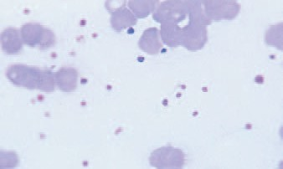
Cell ratios in a normal blood clot.

Peripheral blood smear in normal blood.

Platelet concentrates
<1% 5%

94%

RBC PLTS WBC

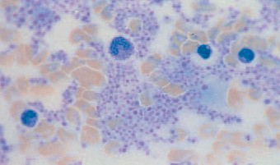
Cell ratios in platelet rich plasma.

Peripheral blood smear of platelet rich plasma.

injections to stimulate musculoskeletal connective tissue repair.18-20 PRP prolotherapy is based on the same theory as traditional dextrose prolo- therapy, however, the formula used is a high-density concentration of the patient’s circulating platelet levels isolated and concentrated by bidi- rectional centrifugation. Enhanced healing capability is possible when platelet concentrations are increased within injured or damaged tissue.21
High-density PRP (HD-PRP) is defined as autologous blood with concentrations of platelets at no less than four times the circulating baseline levels,22 and which increases the important bioactive protein load (growth factors) in a direct correlative fash
Figure 1. Difference between whole blood and platelet-rich prolotherapy. Top left, cell ratios in a normal blood clot. Top right, cell ratios in platelet-rich plasma. Bottom left, peripheral blood smear in normal blood. Bottom right, peripheral blood smear of platelet-rich plasma.
PLTS, platelets; RBC, red blood cells; WBC, white blood cells
ion.23 Cell ratios in average circulating whole blood contain only 6% plate- lets. In true HD-PRP preparations, the concentration achieved is 94%.22

fasciitis10; knee,11 ankle, shoulder pain, coccyxdynia12; chronic tendonitis/ tendonosis,13 including Achilles ten- donitis/tendonosis14; and other joint pain or musculoskeletal pain related to osteoarthritis.4

How Prolotherapy Works Prolotherapy is based on the prem- ise that chronic musculoskeletal pain is caused by an inadequate repair of fibrous connective tissue, resulting in ligament or tendon weakness and relaxation (laxity),1 also known as
connective tissue insufficiency.15 Weak connective tissue results in insufficient tensile strength or tightness,16 causing excessive “loading” of the tis- sues that stimulates pain mechanore- ceptors.15 As long as connective tissue remains functionally insufficient or ineffective, these pain mechanoreceptors continue to fire with use, causing significant pain and limitation of function.17 If the laxity or tensile strength deficit is not corrected suffi- ciently to stop pain mechanoreceptor
stimulation, chronic sprain/strain, and pain results.3
Prolotherapy works by stimulating a temporary, low-grade inflammation at the site of ligament or tendon weak- ness, “tricking” the body into initiat- ing a new healing cycle cascade.3 A common formula used in classic pro- lotherapy is dextrose, however, the choice of solution varies depending on practitioner preference and may contain sarapin, morruate, zinc, or other natural ingredients, combined with a local anesthetic.

Platelet-rich Plasma Prolotherapy
In the 1990s, the use of PRP to accelerate healing gained accep- tance in surgical circles. However, the machines were large, expensive, and only used in hospital operating rooms. By the 2000s, the machines were smaller and available for use in an office setting.
Prolotherapists, and other physi- cians in the orthopedic and sports medicine fields, began using PRP
An average patient platelet count is 250,000 platelets/dL. Four times this is 1 million platelets/dL, which is considered the desired benchmark for therapeutic PRP (Figure 1).24
Circulating platelets, when acti-vated, begin a degranulation process that secretes a variety of important growth factors and cytokines/chemokines, such as platelet-derived growth factor (PDGF; stimulates cell replication, angiogenesis), trans- forming growth factor β-1 (TGF-β1; angiogenesis), vascular endothelial growth factor (VEGF; angiogenesis), fibroblast growth factor (FGF; proliferation of myoblasts and angiogenesis), and insulin-like growth factor-1 (ILGF-1; mediates growth and repair of skeletal muscle), among others.25 Activated platelets also secrete stromal cell–derived factor 1-α (SDF-1α), which supports primary adhesion and migration of mesenchymal stem/stro- mal cells (Table, page 58).22
Platelets contain a significant number of key signal proteins, growth
Continued on Page 58 

Table. Common Growth Factors and Abbreviations Found in Platelet-rich Plasma

Platelet-derived growth factor aa,bb,ab PDGF

Transforming growth factor-β1, β2 TGF-β1, TGF-β2

Platelet-derived epidermal growth factor PDEGF

Platelet-derived angiogenesis factor PDAF

Platelet factor 4 PF-4

- selectin GMP-140

Interleukin-1 IL-1

Fibroblast growth factor FGF

Interferons: α, γ I-α, I,γ

Insulin-like growth factor ILGF

Continued from Page 50 

factors, chemokines, cytokines, and other proinflammatory bioactive fac- tors that initiate and regulate basic aspects of the inflammatory cascade resulting in natural wound healing.26 Elevated platelet concentrations are known to stimulate the proliferation, differentiation, and migration of needed mesenchymal and stromal repair cells to an injury site.27
Similar to dextrose prolotherapy, the addition of HD-PRP concen- trates results in an inflammatory and proliferative response that enhances healing and promotes tissue regeneration.28 The use of clinically proven devices to obtain this degree of con- centration is considered essential. Various portable commercial centrif- ugation units exist that can process blood samples, resulting in PRP concentrates, however only a few have been shown to concentrate plate- lets to therapeutic levels as does the FDA cleared Harvest Technologies' SmartPrep2 system.

Stem Cell Types
It is believed that there are really only two kinds of stem cells: the embryonic (prenatal) stem cell and the adult (postnatal) stem cell.29 Embyronic stem cells are, in theory, able to transform into any type of tis- sue; they are totipotent or omnipotent when an egg is fertilized. After several divisions, the stem cell is con- sidered pluripotent, and able to dif ferentiate into any of the three germ layers.30
Postnatal stem cells are those cells present that remain in an individual after birth, in an undifferentiated state, and available to maintain tis- sue homeostasis and regeneration in a tissue or organ system. Attention to the important potentials of adult stem cells has been discussed in the medical literature since 1963, when Becker et al reported on the regenerative nature of bone marrow.31 These adult stem cells can be activated to proliferate and differentiate to yield

some or all of the major specialized cell types of their tissue type when required for maintenance or repair.32 Because they typically differentiate into a variety of cellular phenotypes from one germ layer, they are recognized as multipotent, with some cells demonstrating transdifferentiation capabilities in tissue culture. Multipotent stem cells facilitate tissue maintenance, regeneration, growth, and wound healing throughout life.33 Adult stem cells can be found in all tissues in the body in various quantities.34

Adult Mesenchymal Stem Cells
In the early 1990s, existence of adult mesenchymal stem cells (MSCs), described as “non-committed progenitor cells of musculoskeletal tissues,” were discovered to have an active role in connective tissue repair.35 These cells were first labeled by Caplan as mesenchymal stem cells36 because of their ability to differentiate to lineages

Advances in Regenerative Medicine

of mesenchymal tissue, and were recognized to be an essential component of the tissue repair process.27 An interesting observation made about MSCs is their ability to “home in” and help repair areas of tissue injury.35
Although bone marrow histori- cally has been used as a source of MSCs, adipose-derived MSCs have been shown to have nearly identical fibroblast-like morphol- ogy and colonization (CFU-F), immune phenotype, successful rate of isolation, and differentiation capabilities.37 The healing potential of adipose-derived MSCs was demonstrated in early clinical use for cranial defect and chronic fistula repair, without side effects.38 MSCs, along with other cells within the adipose stroma, react to cellular and chemical signals, and have been shown in vitro to differentiate and assist

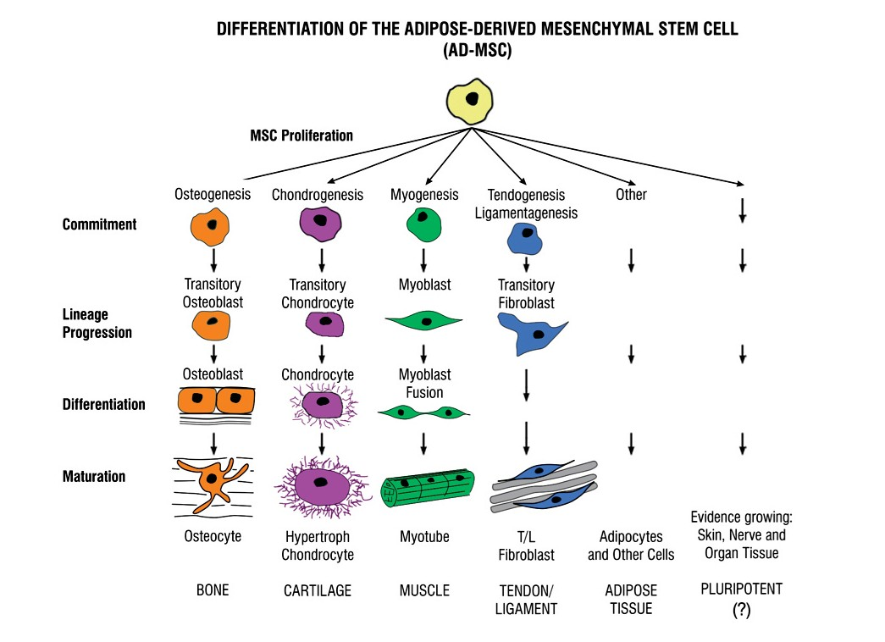
Figure 2. Flowchart elucidating possible commitment, lineage progression, and maturation of adipose- derived mesenchymal stem cells.

in healing for a wide variety of cellular types. This includes cartilage repair,39 angiogenesis in osteoarthritis,40,41 tendon defects,42-44 ligament tissue,45 intervertebral disc repair,46,47 muscle,48 nerve tissue,49 bone,50 and hematopoietic-supporting stroma.51 MSCs also actively participate in tissue homestasis, regeneration, and wound healing52; ischemic heart tis- sue53,54; graft-vs-host disease55; and osteogenesis imperfecta (Figure 2).56
In degenerative diseases, such as osteoarthritis, an individual’s adult stem cell frequency and potency may be depleted, with reduced proliferative capacity and ability to differentiate.57,58 It has been suggested that addition of these missing MSC elements might help these conditions. A number of studies have demonstrated such improvement with adult stem cell therapy by the successful regen- eration of osteoarthritic damage and articular cartilage defects.59,60 In 2003, Murphy et al reported significant improvement in medial meniscus and
cartilage regeneration with autolo- gous stem cell therapy in an animal model.61 Not only was there evidence of marked regeneration of meniscal tis- sue, but the usual progressive destruction of articular cartilage, osteophytic remodeling, and subchondral sclerosis commonly seen in osteoarthritic disease was reduced in MSC-treated joints compared with controls.61 In 2008, Centeno et al reported significant knee cartilage growth and symptom improvement in a case report using culture expanded autologous MSCs from bone marrow.62
Multiple studies support the effectiveness of adipose-derived MSCs for use in connective tissue repair, among other potential clinical uses, with more than 40 institutional review board clinical trials ongoing at this time.63 Current FDA restrictions prevent the manipulation or culture expansion of cells, however, they do allow removing cells from an individual and returning them to the same individual during the same procedure.
Historically, MSCs have been studied from bone marrow aspiration. However, bone marrow possesses very few true MSCs, and is gradually being replaced with adipose(fat)- derived stem/stromal cells (AD-SCs) as a primary tissue source.64 Like bone marrow, adipose (fat) tissue is derived from embryonic mesodermal tissue. Fat is a complex tissue that is not only easier to harvest, but offers markedly higher nucleated, undifferentiated stem cell counts65 than bone marrow. Research has shown as much as 500 to 1,000 times as many mesenchymal and stromal vascular stem-like cells exist in adipose as compared with bone marrow (Figure 3, page 60).66-68 In 2001 and 2002, Zuk et al con- firmed that adipose stroma contains relatively large numbers of undifferentiated cells capable of producing car- tilage, ligament, tendon, muscle, and bone.64,69 AD-SCs also appear to have an increased angiogenic capability versus bone marrow,70 and have been shown to promote neovascularization

October 2011 | Practical Pain Management 59

Advances in Regenerative Medicine

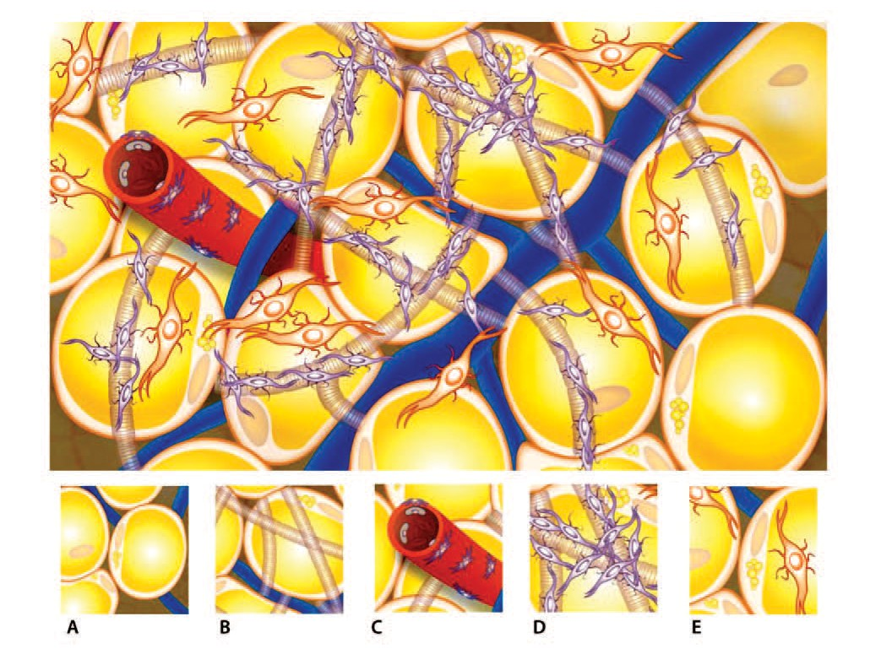
  - Adipose cells
  - Extracellular matrix (most stems there)
  - Pericytes surround vessels, important in angiogenesis)
  - Mesenchymal stem cells (the little guys)
  - Pre-adipocyte (progenitor cell)

Figure 3. Adipose tissue with progenitors and mesenchymal stem cells in stroma.

Theory of Stem Cell Prolotherapy The ability of AD-SCs to support and serve as a cell reservoir for connective tissue and joint repair is the basic theory of stem cell prolotherapy. With stem cell prolotherapy, a stem cell niche (microenvironment that favors healing) is moved from one tis- sue in which these niches are abundant (adipose) into another where they are scarce (a non-repairing connective tissue).81 Multiple studies have shown that AD-SCs improve wound healing and stimulate fibroblast proliferation, migration, and collagen secretion— thereby increasing connective tissue tensile strength and healing.82
As discussed, AD-SCs have the potential to differentiate to become cartilage, tendon, ligament, bone, and skeletal or smooth muscle. They also are capable of expressing multiple growth factors that influence, control, and manage damaged neigh- boring cells.83 Additionally, AD-SCs have been reported to be helpful in intervertebral disc regeneration,84 tendon and ligament regeneration,85 and in accelerating tendon repair and strength.86 It is reasonable to hypothesize better

in skin flaps,71 as well as safely treat depressed scars.72
AD-SCs meet the criteria suggested by Gimble et al that an ideal stem/ stromal cell for regenerative medicinal applications should:
- Be found in abundant quanitites;
- Be harvested with a minimally invasive procedure;
- Be differentiated along mul- tiple cell lineage pathways in a regular and reproducible manner;
- Be safely and effectively trans- planted.73,74

Addition of HD-PRP to AD-SC
During the 1990s, further understand- ing and enhancements to improve the success of fat grafts in cosmetic plastic surgery led to the effective addition of HD-PRP concentrates to these autologous fat grafts (AFG).75-77 It is believed that these effects are largely a result of PRP's ability to improve active angiogenesis, stimulate and promote undif- ferentiated cell adherence, prolifera- tion, and differentiation activities of precursor cells in the grafts. Studies have determined the safety and efficacy of implanted/administered AD-SCs and suggest that AD-SC in combina tion with HD-PRP also can regener ate articular cartilage78 and reverse hip osteonecrosis.79 With high levels of PDGF and cytokines, this combination provides both a living bioscaffold and a multipotent cell replenishment source useful for enhanced musculo-skeletal healing.80
Treatments when, traditional dextrose prolotherapy and/or PRP prolotherapy have not resulted in complete resolution of musculoskeletal pain and injury, stem cell prolotherapy would be the logical next step. In veterinary medicine, AD-SCs have been used effectively for more than 10 years in the treatment of osteoarthritic joints87 and connective tissue injuries in dogs. In fact, in double-blind placebo- controlled trials, AD-SC prolotherapy has be shown to be successful in more
than 80% of cases.88

HD-PRP Creates Favorable Growth Factor Environment
A concentrated growth factor environment, coupled with a living bioscaffolding, has been found to be

60 Practical Pain Management | October 2011

Advances in Regenerative Medicine

Treatment Algorithm

Evaluation
Patient history, physical exam, review of previous studies, musculoskeletal ultrasound in office to confirm diagnosis

Determine if candidate for either Dextrose prolotherapy
PRP prolotherapy or stem cell prolotherapy

Discuss Options

If excess degeneration, severe tendonosis, muscle tear, or if patient prefers PRP over dextrose prolotherapy, and if no contraindications
If average case

Dextrose prolotherapy
× 2 treatments, interval 3-4 wk

High-density PRP Standard preparation
4.4 × (Harvest Technologies)
×2 treatments, interval 4-6 wk
Re-evaluate

If no substantial improvement or if results have plateaued

If doing well, continue treatment

Re-evaluate
Dextrose prolotherapy
× 2-4 treatments, interval 3-4 wk

If doing well, continue HD-PRP at standard concentration/
re-evaluate every visit and increase concen- trations, if needed

Usual course
4-6 treatments should be completed
If no substantial improvement or if results have plateaued

Stem cell prolotherapy (note: may also start here as indicated by severity of problem or patient preference)
×1-2 treatments, every 3 mo

Should be completed (90%-100% improved) If not, re-evaluate, consider PRP prolotherapy or stem cell prolotherapy

(90%-100% improved) If doing well, continue HD-PRP
×2-4 treatments, every 4-6 wk

Should be completed (90%-100% improved)
If not, re-evaluate, consider follow-up HD-PRP treatment, if needed, in 3-6 mo

Figure 4. Treatment algorithm for dextrose, PRP, and stem cell prolotherapy. PRP, plasma-rich prolotherapy

October 2011 | Practical Pain Management 61

Advances in Regenerative Medicine

important for AD-SC use in orthope dic applications.89 HD-PRP has shown the ability to enhance musculoskeletal healing and stimulate local microenvi- ronmental regenerative capabilities,80 especially during the early phase of ten- don healing.90 Proliferation of AD-SCs and their differentiation also is believed to be directly related to platelet con- centration.27 HD-PRP releases large quantities of PDGF, TGF-B1, and many other growth factors that, when activated, significantly enhance stem/ stromal cell proliferation and angio- genesis,91-92 as well as enhancing the survival of the fat scaffolding.93

Stem Cell Fate Dependent on Microenvironment
It is clear that control of cellular fate and extracellular environment is critical in tissue regeneration and cell- based therapies.94 Stem cell fate is con- trolled by a complex set of physical and chemical signals dictated by the cellular and chemical microenvironment (niche).95 Therefore, if AD-SCs are placed within, and adherent to, dam- aged connective tissue, uncommitted progenitor and stem/stromal elements within the AD-SC graft should be stimulated toward that specific connective tissue lineage for growth and repair. For example, if placed within osteoarthritic degenerated carti- lage, chondrogenic differentiation is believed to be encouraged.96-99
In the 1990s, Young et al showed repair of an Achilles tendon tear when AD-SC was placed in a collagen matrix, then placed in a tendon defect.100 In 2010, Little et al demonstrated the successful differentiation of human AD-SCs to ligament when adipose lipoaspirate was placed in a simulated ligament matrix com- posed of native ligamentous material combined with collagen fibrin gel. Cells placed in this manner showed changes in gene expression consistent

with ligament growth and expression of a ligament phenotype.101 Albano and Alexander successfully reported an autologous fat graft as a mesenchymal stem source and living bioscaffold (termed “Autologous Regenerative Matrix”) to repair a persistent patellar tendon tear.102

Protocol for Stem Cell Prolotherapy A detailed protocol for stem cell prolotherapy was discussed in the August 2011 issue of the Journal of Prolotherapy.103 A simple means for harvesting adipose tissue is detailed using the patented Tulip MedicalTM microcannula system, which harvests cells and stroma in a safe and nontraumatic manner, preserving the mesenchymal stem/stromal cell elements.104 Lipoaspirates are decanted by gravity, or low g-centrifugation (<1,000×g for 3 minutes), and combined with highly concentrated PRP obtained via Harvest Technologies’ SmartPrep2 system. The combination of PRP and AD-SC in a fat graft matrix is then accurately injected into injured musculoskeletal and connective tissue via ultrasound-guided injection.103
In a trial series of patients, favor- able outcomes were noted (reduced pain, improved function) with regenerative repair of ligament and tendon tears and defects in those patients, documented by musculoskeletal ultra- sound. The determination of whether to start a patient with dextrose prolotherapy versus PRP versus stem cell prolotherapy is based on the severity of the physical findings in combination with patient preference. This is addressed in the treatment algorithm (Figure 4. page 61).

Conclusion
Prolotherapy has come a long way since those early days in the 1930s when Dr. Gedney injected his own injured and painful thumb, searching

for a way to get his body to do what all bodies are programmed to do: heal and regenerate. Prolotherapy is, in fact, the original musculoskeletal “regenerative medicine.” Traditional dextrose prolotherapy is still used with a high success rate in various musculoskeletal complaints. However, should dextrose prolotherapy fail or plateau, HD-PRP prolotherapy can be used to further enhance the healing process. Should HD-PRP prolotherapy fail or plateau, autologous AD-SCs combined with HD-PRP concentrates have proven very effective in the several thousand successful injections in preclinical use by physicians in the United States and elsewhere. HD-PRP prolotherapy and/ or stem cell prolotherapy also can be used as a starting point treatment in more difficult cases.
Adipose tissue effectively delivers a living bioscaffold of adult mesenchymal-directed stem and stromal cells to devitalized tissue. The addition of HD-PRP concentrates to the adipose cells enhances healing capabilities and cellular repair. Although multiple articles have shown the benefit of mesenchymal and stromal stem cells in cosmetic plastic surgery and orthopedic surgery, there has not been a stan- dardized, effective protocol addressing an outpatient, bedside procedure for the prololotherapist, sports medicine, regenerative medicine, or orthopedic physician until recently. However, now these protocols are available and being used to obtain documented successful patient outcomes. Recent protocols can be completed at the point of care within the outpatient office setting and do not violate current FDA guidelines. Outcomes and evidence so far is encouraging and positive, however, as this science continues to grow, more research needs to be done to refine these techniques and provide larger patient trials and longer term out-
comes.

62 Practical Pain Management | October 2011

Advances in Regenerative Medicine

References
- Hackett GS, Hemwall GA, Montgomery GA. Ligament and Tendon Relaxation Treated by Prolotherapy. 5th ed. Oak Brook, IL: Institute in Basic Life Principles; 1991.
- Calcaterra C. Get used to Bartolo Colon style stem cell procedures because they are going to explode in popularity. June 1, 2011. http://hard- balltalk.nbcsports.com/2011/06/01/get-used-
to-bartolo-colon-style-stem-cell-procedures- because-theyre-going-to-explode-in-popularity/
- Reeves KD. Prolotherapy: basic science, clinical studies, and technique. In: Lennard TA, ed. Pain Procedures in Clinical Practice. 2nd ed. Philadelphia, PA: Hanley and Belfus; 2000:172-190.
- Alderman D. Prolotherapy for musculoskeletal pain. Pract Pain Manag. 2007;7(1):10-16.
- Reeves KD, Hassanein K: Randomized, prospec- tive, placebo-controlled double-blind study of dextrose prolotherapy for osteoarthritic thumb and finger (DIP, PIP, and trapeziometacarpal) joints: evidence of clinical efficacy. J Altern Complement Med. 2000;6(4):311-320.
- Ongley MJ, Klein RG, Dorman TA, Eek BC, Hubert LJ. A new approach to the treatment of chronic low back pain. Lancet. 1987;2(8551):143-146.
- Cusi M, Saunders J, Hungerford B, Wisbey- Roth T, Lucas P, Wilson S. The use of prolo- therapy in the sacro-iliac joint. Br J Sports Med. 2010;44(2):100-104.
- Hauser RA, Hauser MA. Dextrose prolotherapy for unresolved neck pain. Pract Pain Manag. 2007;7(8):56-60.
- Scarpone M, Rabago DP, Zgierska A, Arbogast G, Snell E. The efficacy of prolotherapy for lateral epicondylosis: a pilot study. Clin J Sport Med. 2008;18(3):248-254
- Ryan MB, Wong AD, Gillies JH, Wong J, Traunton JE. Sonographically guided intratendinous injections of hyperosmolar dextrose/lidocaine: a pilot study for the treatment of chronic plantar fasciitis. Br J Sports Med. 2009;43(4):303-306
- Reeves KD, Hassanein K. Randomized prospec- tive double-blind placebo-controlled study of dextrose prolotherapy for knee osteoarthritis with or without ACL laxity. Altern Ther Health Med. 2000;6(2):68-74, 77-80.
- Khan SA, Kumar A, Varshney MK, Trikha V, Yadav CS. Dextrose prolotherapy for recalcitrant coc- cygodynia. J Orthop Surg. 2008;16(1):27-29.
- Topol GA, Reeves KD: Regenerative injection of elite athletes with career altering chronic groin pain who fail conservative treatment: a
consecutive case series. Am J Phys Med Rehabil. 2008;87(11):890-902.
- Ryan M, Wong A, Taunton J. Favorable outcomes after sonographically guided intratendinous injection of hyperosmolar dextrose for chronic insertional and midportion Achilles tendinosis. Am J Roentgenol. 2010;194(4):1047-1053.
- Leadbetter W. Soft tissue athletic injuries. In: Fu FH, ed. Sports Injuries: Mechanisms,
Prevention, Treatment. Baltimore, MD: Williams & Wilkins;1994:736-737.
- Frank C, Amiel D, Woo SL, Akeson W. Normal ligament properties and ligament healing. Clin Orthop Relat Res. 1985;(196):15-25.
- Biedert RM, Stauffer E, Friederich NF. Occurrence of free nerve endings in the soft tissue of the knee joint. A histologic investigation. Am J

Sports Med. 1992;20(4):430-433.
- Mishra A, Pavelko T. Treatment of chronic elbow tendinosis with buffered platelet-rich plasma. Am J Sports Med. 2006;34(11):1774-1778.
- Alderman D. Prolotherapy: Platelet rich plasma in prolotherapy. Pract Pain Manag. 2009;9(1):68-69.
- Hauser RA, Phillips HJ, Maddela H. Prolotherapy: Platelet rich plasma prolotherapy as first-line treatment for meniscal pathology. Pract Pain Manag. 2010;10(6):53-640.
- Marx R, Garg A. Dental and Craniofascial Applications of Platelet-Rich Plasma. Hanover Park, IL: Quintessence Publishing Co., Inc; 2005.
- Marx R, Kevy SV, Jacobson MS. Platelet rich plasma (PRP): A primer. Pract Pain Manag. 2008;8(2):46-47.
- Hall MP, Band PA, Meislin RJ, Jazrawi LM, Cardone DA. Platelet-rich plasma: current con- cepts and application in sports medicine. J Am Acad Orthop Surg. 2009;17(10):602-608.
- Marx R. Platelet-rich plasma: evidence to support its use. J Oral Maxillofac Surg. 2004;62(4):489-496.
- Creaney L, Hamilton B. Growth factor deliv- ery methods in the management of sports injuries: the state of play. Br J Sports Med. 2008;42(5):314-320.
- Foster TE, Puskas BL, Mandelbaum BR, Gerhardt MB, Rodeo SA. Platelet-rich plasma: from basic science to clinical applications. Am J Sports Med. 2009;37(11):2259-2272.
- Haynesworth SE, Kadiyala S, Liang LN et al. Mitogenic stimulation of human mesenchy- mal stem cells by platelet release suggest a mechanism for enhancement of bone repair by
platelet concentrates. Paper presented at: Annual Meeting of the Orthopedic Research Society; 2002; Boston, MA. www.perstat.com/ortho1.pdf.
- El-Sharkawy H, Kantarci A, Deady J, et al. Platelet-rich plasma: growth factors and pro- and anti-inflammatory properties. J Periodontol. 2007;78(4):661-669.
- Zuk PA. The Adipose-derived stem cell: look- ing back and looking ahead. Mol Biol Cell. 2010;21(11):1783-1787
- Verfaillie C. Pluripotent stem cells. Transfus Clin Biol. 2009;16(2):65-69.
- Becker AJ, McCulloch EA, Till JE. Cytological demonstration of the clonal nature of spleen colonies derived from transplanted mouse mar- row cells. Nature. 1963;197:452-454.
- http://stemcells.nih.gov/info/basics/basics4.asp
- Metallo CM, Mohr JC, Detzel CJ, de Pablo JJ, Van Wie BJ, Palecek SP. Engineering the
stem cell microenvironment. Biotechnol Prog. 2007;23(1):18-23.
- Schuster SM, Phillips MI. Commentary: The seven challenges of stem cell education in biochemis- try. Biochem Mol Biol Educ. 2007;35(1):73.
- Caplan A, Fink D, Goto T, et al. Mesenchymal stem cells and tissue repair. In: The anterior cruciate ligament: current and future concepts. Jackson, DW, ed. New York, NY: Raven Press; 1993:405-417.
- Caplan A. Mesenchymal stem cells. J Orthop Res. 1991;9(5):641-650.
- Izadpanah R, Trygg C, Patel B, et al. Biologic

properties of mesenchymal stem cells derived from bone marrow and adipose tissue. J Cell Biochem. 2006;99(5):1285-1297.
- Fraser JK, Wulur I, Alfonso Z, Hedrick MH. Fat tissue: an unappreciated source of stem cells for biotechnology. Trends Biotechnol. 2006;24(4):150-154.
- Guilak F, Awad HA, Fermor B, Leddy HA, Gimble JM. Adipose-derived adult stem cells for cartilage tissue engineering. Biorheology. 2004;41(3-4):389-399.
- Murphy JM, Fink DJ, Hunziker EB, Barry FP. Stem cell therapy in a caprine model of osteoarthritis. Arthritis Rheum. 2003;48(12):3464-3474.
- Centeno CJ, Busse D, Kisiday J, Keohan C, Freeman M, Karli D. Increased knee cartilage volume in degenerative joint disease using per- cutaneously implanted, autologous mesenchymal stem cells. Pain Physician. 2008;11(3):343-353.
- Rios CG, McCarthy MB, Arcierco C. et al. Biologics in shoulder surgery: the role of adult mesenchymal stem cells in tendon repair. Techniq Orthopaedics. 2007;22(1):2-9.
- Uysal AC, Mizuno H. Tendon regeneration and repair with adipose derived stem cells. Curr Stem Cell Res Ther. 2010;5(2):161-167.
- Obaid H, Connell D. Cell therapy in tendon disor- ders: what is the current evidence? Am J Sports Med. 2010;38(10):2123-2132.
- Little D, Guilak F, Ruch DS. Ligament derived matrix stimulates a ligamentous phenotype in human adipose-derived stem cells. Tissue Eng Part A. 2010;16(7):2307-2319.
- Hsu WK, Wang JC, Liu NQ, et al. Stem cells from human fat as cellular delivery vehicles in an athymic rat posterolateral spine fusion model.
J Bone Joint Surg Am. 2008;90(5):1043-1052.
- Hoogendoorn RJ, Lu ZF, Kroeze RJ, Bank RA, Wuisman PI, Helder MN. Adipose stem cells for intervertebral disc regeneration: current status and concepts for the future. J Cell Mol Med. 2008;12(6A):2205-2216.
- Bacou F, el Andalousi RB, Daussin PA, et al. Transplantation of adipose tissue-derived stromal cells increases mass and functional capacity
of damaged skeletal muscle. Cell Transplant. 2004;13(2):103-111.
- Santiago LY, Clavijo-Alvarez J, Brayfield C, Rubin JP, Marra KG. Delivery of adipose-derived precursor cells for peripheral nerve repair. Cell Transplant. 2009;18(2):145-158.
- Cowan CM, Shi YY, Aalami OO, et al. Adipose- derived adult stromal cells heal critical-size mouse calvarial defects. Nat Biotechnol. 2004;22(5):560-567.
- Rosenbaum AJ, Grande DA, Dines JS. The use of mesenchymal stem cells in tissue engineering:
A global assessment. Organogenesis. 2008; 4(1):23-37.
- Kim, WS, Park, BS, Sung, JH et al. Wound healing effect of adipose-derived stem cells: a critical role of secretory factors on human dermal fibroblasts. J Dermatol Sci. 2007;48(1):15-24.
- Kraitchman DL, Tatsumi M, Gilson WD, et al. Dynamic imaging of allogenic mesenchymal stem cells trafficking to myocardial infarction. Circulation. 2005;112(10):1451-1461.
- Amado LC, Saliaris AP, Schuleri KH, et al. Cardiac repair with intramyocardial injection
Continued on Page 90 

October 2011 | Practical Pain Management 63

Advances in Regenerative Medicine
Continued from Page 63 

of allogenic mesenchymal stem cells after myocardial infarction. Proc Natl Acad Sci U S A. 2005;102(32):11474-11479.
- Le Blanc K, Rasmusson I, Sundberg B, et al. Treatement of severe acute graft-verus- host disease with with third party haploi- dentical mesenchymal stem cells. Lancet. 2004;363(9419):1439-1441.
- Horwitz EM, Gordon PL, Koo WK, et al. Isolated allogenic bone marrow-derived mesenchymal cells engraft and stimulate growth in children with osteogenesis imperfect: Implications for cell therapy of bone. Proc Natl Acad Sci U S A. 2002;99(13):8932-8937.
- Murphy JM, Dixon K, Beck S, Fabian D, Feldman A, Barry F. Reduced chondrogenic and adipogenic activity of mesenchymal stem cells from patients with advanced osteoarthritis. Arthritis Rheum. 2002;46(3):704-713.
- Luyten FP. Mesenchymal stem cells in osteoarthritis. Curr Opin Rheumatol. 2004;16(5):599-603.
- Wakitani S, Goto T, Pineda SJ, et al. Mesenchymal cell-based repair of large, full-thickness defects of articular cartilage. J Bone Joint Surg Am. 1994;76(4):579-592.
- Wakitani S, Imoto K, Yamamoto T, Saito M, Murata N, Yoneda M. Human autologous culture expanded bone marrow mesenchymal cell transplantation for repair of cartilage defects in osteoarthritic knees. Osteoarthritis Cartilage. 2002;10(3):199-206.
- Murphy JM, Dixon K, Beck S, Fabian D, Feldman A, Barry F. Stem cell therapy in a caprine
model of osteoarthritis. Arthritis Rheum. 2003;48(12);3464-3474.
- Centeno CJ, Busse D, Kisiday J, Keohan C, Freeman M, Karli D. ncreased knee cartilage volume in degenerative joint disease using per- cutaneously implanted, autologous mesenchymal stem cells. Pain Physician. 2008;11(3):343-353.
- Clinical Trials. http://clinicaltrials.gov
- Zuk PA, Zhu M, Ashjian P, et al. Human adipose tissue is a source of multipotent stem cells. Mol Biol Cell. 2002;13(12):4279-4295.
- Mizuno H. Adipose-derived stem cells for tissue repair and regeneration: ten years of research and a literature review. J Nippon Med Sch. 2009:76(2):56-66.
- Fraser JK, Wulur I, Alfonso Z, Hedrick MH. Fat tissue: an underappreciated source of stem cells for biotechnology. Trends Biotechol. 2006.24(4):150-154.
- Strem BM, Hicok KC, Zhu M, et al. Multipotential differentiation of adipose tissue-derived stem cells. Keio J Med. 2005; 54(3): 132-141.
- Prockop D, Phinney D, Bunnell B. Mesenchymal Stem Cells, Methods and Protocols. Totawa, NJ: Humana Press; 2008
- Zuk PA, Zhu M, Mizuno H, et al. Multilineage cells from human adipose tissue: implications for cell- based therapies. Tissue Eng. 2001;7(2):211-228.
- Casteilla L, Planat-Benard V, Laharrague P, Cousin
B. Adipose-derived stromal cells: Their identity and uses in clinical trials, an update. World J Stem Cells. 2011;3(4):25-33.
- Sheng L, Yang M, Li H, Du Z, Yang Y, Li Q. Transplantation of adipose stromal cells promotes neovascularization of random skin flaps. Tohoku J

Exp Med. 2011;224(3):229-234.
- Kim M, Kim I, Lee SK, Bang SI, Lim SY. Clinical trial of autologous differentiated adipocytes from stem cells derived from human adipose tissue. Dermatol Surg. 2011;37(6):750-759.
- Gimble JM, Katz AJ, Bunnell BA. Adipose-derived stem cells for regenerative medicine. Circ Res. 2007;100(9):1249-1260.
- Gimble JM. Adipose tissue-derived therapeutics.
Expert Opin Biol Ther. 2003:3(5):705-713.
- Abuzeni P, Alexander RW. Enhancement of autolo- gous fat transplantation with platelet-rich plasma. Am J Cosmet Surg. 2001;18:59-71.
- Alexander RW. Use of platelet-rich plasma (PRP) in autologous fat grafting. In: Shiffman M, ed. Autologous Fat Grating. Berlin: Springer; 2010:140-167.
- Alexander RW. Fat transfer with platelet-rich plasma for breast augmentation. In: Breast Augmention: Principles and Practice. 1st ed. Berlin: Springer; 2009:Chapter 56.
- Hildner F, Albrecht C, Gabriel C, Redl H, van Griensven M. State of the art and future perspec- tives of aricular cartilage regeneration: a focus on adipose-derived stem cells and platelet-derived products. J Tissue Eng Regen Med. 2011 Jan 10. [Epub ahead of print].
- Pak J. Regeneration of human bones in hip osteonecrosis and human cartilage in knee osteoarthritis with autologous adipose-tissue- derived stem cells: a case series. J Med Case Reports. 2011;5(1):296.
- Alderman D. The new age of prolotherapy. Pract Pain Manag. 2010;10(4):54-68.
- Rigotti G, Marchi A, Sbarbati A. Adipose- derived mesenchymal stem cells: past, present and future. Aesthetic Plast Surg. 2009;33(3):271-273.
- Uysai AC, Mizuno H. Differentiation of adipose- derived stem cells for tendon repair. In: Adipose- derived stem cells: Methods and Protocols. Berlin: Springer; 2011.
- Kim WS, Park BS, Sung JH. The wound-healing and antioxidant effects of adipose-derived stem cells. Expert Opin Biol Ther. 2009;9(7):879-887.
- Hoogendoorn RJ, Lu ZF, Kroeze RJ, Bank RA, Wuisman PI, Helder MN. Adipose stem cells for intervertebral disc regeneration: current status and concepts for the future. J Cell Mol Med. 2008;12(6A):2205-2216.
- Tobita M, Uysal AC, Ogawa R, Hyakusoku H, Mizuno H. Periodontal tissue regeneration with adipose-derived stem cells. Tissue Eng Part A. 2008;14(6):945-953.
- Uysal AC, Mizuno H. Differentiation of adipose- derived stem cells for tendon repair. Methods Mol Biol. 2011;702:443-451.
- Stem cell therapy for dogs, cats, and horses. www.vet-stem.com
- Black LL, Gaynor J, Gahring D, et al. Effect of adipose-derived mesenchymal stem and regen- erative cells on lameness in dogs with chronic osteoarthritis of the coxofemoral joints: a ran- domized, double-blinded, multicenter, controlled trial. Vet Ther. 2007:8(4):272-284.
- Tapp H, Hanley EN Jr, Patt JC, Gruber HE. Adipose-derived stem cells: characterization and current application in orthopaedic tissue repair. Exp Biol Med (Maywood). 2009;234(1):1-9.

- Lyras DN, Kazakos K, Verettas D, et al. The influ- ence of platelet-rich plasma on angiogenesis during the early phase of tendon healing. Foot Ankle Int. 2009;30(11):1101-1106.
- Mishra A, Tummala P, King A, et al. Buffered platelet-rich plasma enhances mesenchy- mal stem cell proliferation and chondrogenic differentiation. Tissue Eng Part C Methods. 2009;15(3):431-435.
- Kakudo N, Minakata T, Mitsui T, Kushida S, Notodihardjo FZ, Kusumoto K. Proliferation- promoting effect of platelet-rich plasma on human adipose-derived stem cells and human dermal fibroblasts. Plast Reconstr Surg. 2008;122(5):1352-1360.
- Pires Fraga MF, Nishio RT, Ishikawa RS, Perin LF,
Helene A Jr, Malheiros CA. Increased survival of free fat grafts with platelet-rich plasma
in rabbits. J Plast Reconstr Anesthet Surg. 2010;63(12):e818-822.
- Sarkar D, Ankrum JA, Teo GS, Carman CV, Karp JM. Cellular and extracellular programming of cell fate through engineered intracrine-, paracrine-, and endocrine-like mechanisms. Biomaterials. 2011;32(11):3053-3061.
- Metallo CM, Mohr JC, Detzel CJ, de Pablo JJ, Van Wie BJ, Palecek SP. Engineering the
stem cell microenvironment. Biotechnol Prog. 2007;23(1):18-23.
- Ohlstein B, Kai T, Decotto E, Spradling A. The stem cell niche: theme and variations. Curr Opin Cell Biol. 2004;16(6): 693-699.
- Schäffler A, Büchler C. Concise review: adipose tissue-derived stromal cells—basic and clinical implications for novel cell-based therapies. Stem Cells. 2007;25(4):818-827.
- Burdick J, Vunjak-Novakovic G. Engineered micro- environments for controlled stem cell differentia- tion. Tissue Eng Part A. 2009;15(2): 205-219.
- Lund AW, Yener B, Stegemann JP, Plopper GE. The natural and engineered 3D microenviron- ment as a regulatory cue during stem cell
fate determination. Tissue Eng Part B Rev.
2009;15(3) 371-380.
- Young RG, Butler DL, Weber W, Caplan AI, Gordon SL, Fink DJ. Use of mesenchymal stem cells in
a collagen matrix for Achilles tendon repair. J Orthop Res. 1998;16(4):406-413.
- Little D, Guilak F, Ruch DS. Ligament derived matrix stimulates a ligamentous phenotype in human adipose-derived stem cells. Tissue Eng Part A. 2010;16(7):2307-2319.
- Albano JJ, Alexander RW. Autologous fat grafting as mesenchymal stem cell source and living bioscaffold in a patellar tendon tear: a case report. Clin J Sport Med. 2011;21(4):359-361.
- Alderman D, Alexander RW, Harris G, Astourian P. Stem cell prolotherapy in regenerative medicine: background, theory and protocols.
J Prolother. 2011;3(3):689-708
- Alexander RW. Autologous fat grafts as mesenchymal stromal stem cell source for use in prolotherapy: a simple technique to acquire lipoaspirants. J Prolother. 2011;3(3):680-688.

90 Practical Pain Management | October 2011

