Water Pollution in India
Gurpreet Mann
George Mason University

Introduction
India is the second most populous country in the world with 1.3 billion people who reside (CIA, 2017). The country’s population is expected to take over China’s by the year 2028 and then will inevitably become the leading populated country (Senguptha, n.d.). In 2016, India’s gross domestic product (GDP) was 8.662 trillion with a growth rate of 6.8 percent yearly (CIA, 2017). Despite the massive overall progression of the economy and resources India still has had no improvement in their environment. They are dealing with persistent issues such as a growing population who is burdening the natural resources, deforestation, overgrazing, air pollution from industrial effluents and vehicle emission (Chandra, 2015). However, poor water quality in India is reaching crisis level and needs useful and efficient policies to be put in place to save the citizens from morbidity and mortality.
This paper will focus on the background and impacts of poor water quality in India. Plus, the paper will distinguish the policy options the government has implemented about the issue. Lastly, it will offer suggestions and recommendations to the government leaders to help adequately address poor water quality in India. The country has one of the largest economies in the world; their citizens should not be without clean water. Every human deserves to have access to clean and safe water; it is a fundamental human right. Water pollution in India needs the utmost attention because it would help save millions of innocent people.
Background
One of the major causes of water pollution in India is the lack of sanitation and reckless dumping of industrial and household wastes into rivers, lakes and other fresh bodies water (Senguptha, n.d.). However, around 80 percent of the water pollution is caused by domestic sewage (MOEF, 2015). For example, the most important river system in India, the Ganges River receives 1.3 billion liters of dump per day from thousands of residents that live-in cities and villages around it (Singh et al., 2014). Additionally, of that sewage, 200 million liters daily enters the basin untreated. The risk of sewage is far-spreading, as it is estimated that about half a billion people reside within the parameters of the river basin (Singh et al., 2014). Another illustration of the poor sanitary environment in India is the lack of sewerage and toilets at residences. The result of the lack of sewerage infrastructure is children and adults defecating in the same open water sources that provide drinking and bathing water to the people (Agrawal et al., 2010).
Furthermore, the capital of India, New Delhi’s primary source of drinking water comes from River Yamuna (Agrawal et al., 2010). Over past few decades, the water quality of the river has dramatically deteriorated due to a large amount of half treated and untreated wastewater (Agrawal et al., 2010). River Yamuna now is considered the most polluted water resource in India; it currently looks like a sewer instead of a freshwater system (Agrawal et al., 2010). The large amounts of industrial effluents entering the river are not being enforced due to lack of technical and human resources (Agrawal et al., 2010). In fact, an expert in environmental health in India has suggested that “The Yamuna River is practically a toxic dump of highly polluting industries and municipal corporations which are situated in the Yamuna basin all along its course” (Goal, 2016). The leading industries causing the water pollution are distilleries, sugar, textile, electroplating, pesticides, pharmaceuticals, pulp & paper mills, tanneries, dyes and dye intermediates, petrochemicals, steel plants (MOEF, 2015). Further, industrial and disposal dumping issue in India stems from facilities not adequately treating and maintaining the water (Agrawal et al., 2010). Thus, the citizens all over India daily are receiving contaminated water.

Another factor that affects water pollution in India is the excessive amounts of metal run-offs from farming (Senguptha, n.d.). Agricultural run-off is the flow of groundwater, storm water, or meltwater from farms into a body of water. The run-off carries heavy metals found in fertilizers and pesticides. The water is removed from the normal process of precipitation because the ground is unable to absorb the water. The grounds inability to absorb is caused by over saturation (Hariprasad & Dayananda, 2013). To meet the demands of the food supply in the extremely populous country, farmers use stronger pesticides and more concentrated fertilizers. While farmers are meeting the countries food demand, the resulting pollution caused by the runoffs is detrimental to the ecosystem within the bodies of water and the animals and humans who are part of the food chain (Hariprasad & Dayananda, 2013). In fact, India ranks second in world farming runoff from the 6 million tons of fertilizers and 9000 tons of pesticides that enter the river (Singh et al., 2014).
Health Implications
A significant health implication of poor water quality is categorized into three kinds of diseases of water-borne diseases, water-washed diseases, and water-based diseases (Maria, 2003). However, the impact of waterborne diseases on Indians has the most significant impact, approximately 37.7 million citizens are affected by waterborne diseases annually. Additionally, 1.5 million children in India die of diarrheal diseases every year (Senguptha, n.d.). a study conducted among residents who utilize the Ganges River stated, there was an estimated 66 percent incidence rate of water-borne disease including acute gastrointestinal illness, cholera, dysentery, hepatitis-A, and typhoid during a one year period (Hamner et al., 2006).

Methodology
The method air pollution is studied in India is that they have implemented an eight-step water monitoring system to study the problem (CPCB, 2007). Which includes, setting water quality monitoring objectives, assessment of resources availability, reconnaissance survey, network design, sampling, laboratory work, data management, quality assurance. Through these different steps India is able to collect the adequate data needed (CPCB, 2007). All the laboratories in charge must register all their work, they make analyses such as pH, EC, BOD, etc. Furthermore, all the labs have specific rules they follow where they need to register time, they must enter data where all laboratory readings and calculation are entered (CPCB, 2007).
However, India has water pollution regulation put in place that allow them to keep track of the issues. India’s Central Pollution Control Board (CPCB) monitors the water quality of the entire nation, and sets uniform discharge standards on minimum acceptable standards (MINAS) for Industrial and Municipal discharges to be enforced by the State Pollution Control Board (SPCB) (Rajaram & Das, 2008). The CPCB and SPCB are the main governmental organization along within India who are committed to studying and monitoring the issue. Additionally, World Health Organization (WHO) South East Asia, continues to do major work on addressing the health impacts of climate change and environmental change in India (WHO, 2017). For instance, through their research they have indicated how 25- 30 percent of India’s total burden of disease is due to environmental disease (WHO, 2017).
First Supporting Case
A study conducted among residents who utilize the Ganges River stated, there was an estimated 66 percent incidence rate of water-borne disease including acute gastrointestinal illness, cholera, dysentery, hepatitis-A, and typhoid during a one year period (Hamner et al., 2006). The study found a strong correlation between water-borne diseases and the use of the Ganges River for bathing, laundry, washing eating utensils, and brushing teeth. There were 31 cases of cholera among those families who were exposed to waning or bathing in the Ganges rivers, and no cholera cases among families who were unexposed (Hamner et al., 2006).
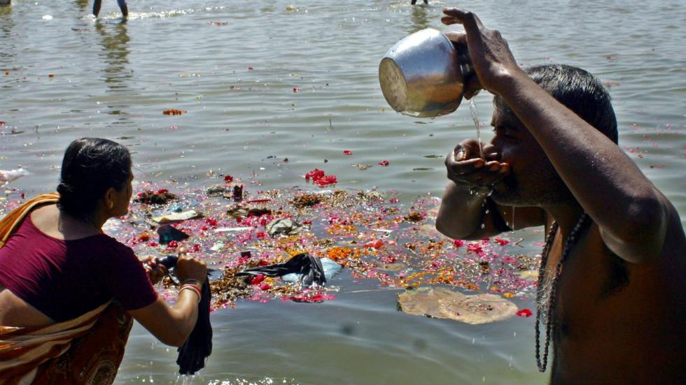

Figure 1: Man, drinking water as women washes her clothes in India
Second Supporting Case
Bangladesh has a similar water pollution crisis as India does. However, a study suggest how Bangladesh had one of the largest poisoning in history due to a contamination of groundwater by arsenic (scielosp, n.d.). This contamination caused millions of the citizens to be exposed and in danger of the health implications. When an individual has long-term exposure to arsenic from drinking water it can cause cancer and skin lesions (scielosp, n.d.). The study indicates that around 20 million inhabitants of Bangladesh may be drinking arsenic contaminated water. Tube-wells in Bangladesh have been used for decades, but the issue of arsenic contaminated water recently become an issue because of the growing number of tube-wells being used (scielosp, n.d.). Thus, increased the number of people drinking from the contaminated wells, and becoming sick (scielosp, n.d.).

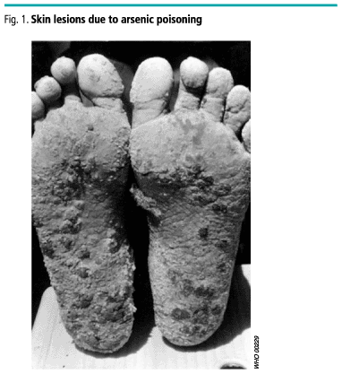Analysis
The issues of water pollution in both countries are extremely prevalent, and killing millions of innocent people. Although both cases are caused by water quality, it highlights the extreme of how many different issues can arise from contamination. It can be on a smaller scale such as the study conducted India or on a larger scale of one of largest contamination in history. However, the case is Bangladesh tremendously dangerous because it causes severe skin lesions, skin cancer and internal cancers. Nonetheless, both issue present the importance of community-based interventions that will educate and provide effective interventions that will leave long lasting impacts on the community members.
Solutions
Since 1974, India has passed three statutes to regulate water pollution: The Water Act, the Water Cess Act, and the Environmental Protection Act (Maria, 2003). The Water Act was established in 1974. The act establishes the Pollution Control Boards at the central and state level (Maria, 2003). The Water Cess Act provides funds for the Pollution Control Boards and allows them to collect taxes on water consumed by persons in particular industries and by local authorities (NBA, 1977). Next, the Environment Protection Act in 1986 was created as an umbrella legislation that focuses on the protection of the environment and seeks to fix the loopholes in the previous legislation on water. It prohibits the pollution of water bodies and enforces that any polluting activity to the consent of the local SPCB (Maria, 2003). The SPCB can inquire any information from the industry about their compliance towards the Act. Of those who decide not to comply are fined up to Rs. 10000, and for continued non-compliance, there is an additional daily fine of 5000 Rs. (Maria, 2003). Moreover, the companies who continue to be non-compliant even after the penalties, the boards now have the power to close the businesses or cut their water and power supply (Maria, 2003). Unfortunately, SPCB has shown to have a lack of efficiency, and the major cause can be blamed on the low rate of returned funds from SPCB to the central government. In recent years, the government has started paying closer attention towards the violators (Maria, 2003).
Furthermore, to combat the severe pollution in the major river systems the National River Conservation Directorate (NRCD), under the Ministry of Environment and Forest, Government of India oversees the River Action Plan. The plan is put in place to implement sewage diversion and treatment facilities and consists of mitigation of industrial pollution through either individual or common Effluent Treatment Plants (ETPs) (Maria, 2003). In 1985 the first major project Ganga Action Plan (GAP) launched. Due to the Ganga River Basin being one of the most polluted rivers in the world it was mandatory, to begin with this plan first. The primary objective of the first phase of the action plan was the diversion and treatment of sewage from surrounding cities in the river basin. Also, it provided low-cost sanitation for rural areas along with banks development and setting up of electric crematorium (Rai, 2013). Other than some aspects of the plan not fully being executed, the GAP has been an enhancement of river quality in the Ganga River. As a result of the GAP being launched, it led to action plans in other major rivers sites such as Yamuna, Gomati, and Damodar.
In addition to the River action plan, the National River Conservation Plan (NRCP) launched in 18 major rivers in 10 states of in India. The goal is for 1928 mld of sewage to be intercepted and be diverted and treated (Maria, 2003). Even with all these efforts that been made by the Indian government, India continues to deal with severe water pollution.
As part of United Nations sustainable development goals, they hope to ensure access to water and sanitation for all (UN, 2017). They want see adequate and equitable sanitation and hygiene for all and end open defection, eliminating dumping and minimizing release of hazardous chemical and materials, implement integrated water resources management, and strengthen the participation of local communities to improve water and sanitation management (UN, 2017)
Conclusion
In conclusion, the paper was able to highlight some of the severe issues of water quality in India, and why the problems are occurring. After examining the policies India has implemented thus far about the issue, it is apparent they need to establish improvements in several sectors to see substantial change. Without creating plans to address the weaknesses in all their water policies India will continue to deal with a major water crisis. The country needs to take additional recommended steps given by governmental organizations to insure change is occurring. In the meantime, further research can be conducted to continue to investigate the growing problem.

References
Agrawal, A., Pandey, R. S., & Sharma, B. (2010). Water pollution with special reference to pesticide contamination in India. Journal of Water Resource and Protection, 2(05), 432.

Central Intelligence Agency. (2017). The world factbook. Retrieved from https://www.cia.gov/library/publications/the-world-factbook/geos/in.html

Central Pollution Control Board. (2007). Guidelines for water quality monitoring. Retrieved fromhttp://www.cpcb.nic.in/upload/NewItems/NewItem_116_Guidelinesof%20waterqualitymonitoring_31.07.08.pdf

Chandra, M. (2015). Environmental Concerns in India: Problems and Solutions. J. Int'l Bus. & L., 15, 1.

Hamner, S., Tripathi, A., Mishra, R. K., Bouskill, N., Broadaway, S. C., Pyle, B. H., & Ford, T. E. (2006). The role of water use patterns and sewage pollution in incidence of water-borne/enteric diseases along the Ganges river in Varanasi, India. International Journal of Environmental Health Research, 16(2), 113-132.

Hariprasad, N.V., & Dayananda, H.S. (2013). Environmental impact due to agricultural runoff containing heavy metals- a review. International Journal of Scientific and Research Publications, 3(5)

Maria, A. (2003, October). The costs of water pollution in India. In Conference on Market Development of Water and Waste Technologies through Environmental Economics (pp. 30-31).

Ministry of Environment, Forest, and Climate Change. (2015). Vision Statement on Environment and Human Health. Retrieved from http://envfor.nic.in/sites/default/files/visenvhealth.pdf

NATIONAL BIODIVERSITY AUTHORITY. (1977). The water (prevention and control of pollution) Chess Act. Retrieved from http://nbaindia.org

Rai, B. (2013). Pollution and conservation of Ganga River in modern India. International Journal of Scientific and Research Publications, 3(4), 1-4.

Rajaram, T., & Das, A. (2008). Water pollution by industrial effluents in India: discharge scenarios and case for participatory ecosystem specific local regulation. Futures, 40(1), 56-69.

Scientific Electronic Library Online. (n.d.). Contamination of drinking-water by arsenic in Bangladesh: a public health emergency. Retrieved from https://scielosp.org/scielo.php?pid=S0042-96862000000900005&script=sci_arttext

Senguptha, S. (2012). Managing the environment: a growing problem for a growing power. India: The next Superpower?, 54-58.

Singh, K. P., Mohan, D., Sinha, S., & Dalwani, R. (2004). Impact assessment of treated/untreated wastewater toxicants discharged by sewage treatment plants on health, agricultural, and environmental quality in the wastewater disposal area. Chemosphere, 55(2), 227-255.

THE NATIONAL BUREAU of ASIAN RESEARCH. (2013). India’s water crisis: Causes and cures. Retrieved from http://www.nbr.org/research/activity.aspx?id=356

World Health Organization. (2017). Priority environment and health risk. Retrieved from http://www.who.int/heli/risks/en/

Picture retrieved from https://scielosp.org/scielo.php?pid=S0042-96862000000900005&script=sci_arttext

Picture retrieved from https://weather.com/science/environment/news/ganges-river-pollution

