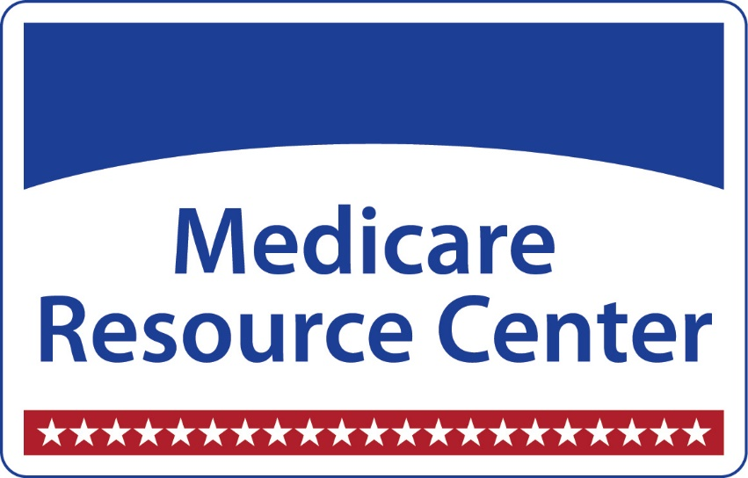
Ohio Accident & Health License
Step 1: Complete 20 Hours of pre-licensing education from an approved provider.
Step 2: Schedule the exam. Once you receive your pre-licensing certificate, you have 180 days to take and pass the licensure exam.
Step 3: Print your license
Step 4: Purchase an errors & omissions insurance policy. You can attain a “Medicare Only” policy for around $30/month.
Step 5: Submit an agent data form to your up-line
Step 6: Submit appointments from the insurance carriers (done electronically).
Step 7: Pass the AHIP exam with a 90% or better
Step 8: Compete the Medicare certifications with each individual insurance company
Step 9: Receive your writing number. Once your certifications are completed for each insurance company, you will be assigned a unique writing ID. This means that you are ready to sell and can be paid for production.
Ongoing: We train every Tuesday morning at 9:00 am for 1 hour. We highly recommend attending these trainings even before you are licensed. We will send an invite to our trainings via email.

Resources

Pre-licensing https://gateway.insurance.ohio.gov/UI/ODI.Agent.Public.UI/EduCourseProvider.mvc
Testing https://www.insurance.ohio.gov/Agent/pages/ExamAuth.aspx
Errors & Omissions Insurance https://www.napa-benefits.org/nd/errors-and-omissions
Medicare Resource Center https://www.medicaredayton.com/

