Month year, Issue #

Facebook | Instagram | Website | Podcast | YouTube
Hello, APH family!
Thank you so much for joining me for another month of encouragement and updates! I hope February treated you well. While it was a short month, it was jam-packed for Elle and me! I can’t wait to go over all the new things happening with APH, but first…
Encouragement

As always, we want to start off this month with an encouraging word. For March, our focus is Fear. We all know the feeling, but let’s dive into it a bit.
How can you overcome a feeling of fear when you aren’t sure of what the outcome will be or take a leap of faith when you’re sure you’re going to fail?
Have you ever had the feeling that you want to do something new, but the mere thought of it makes you tremble? Have you ever looked over the metaphorical cliff and thought, “There’s NO way I can take this leap of faith!”
Let me tell you, that was how Elle and I felt every step of the way with Arbuckle Publishing House. We were constantly thinking, “How is this going to work out? How are WE going to make this work?” The secret that nobody tells you is this:
Taking the first step is the hardest part.
Once you take that leap of faith and you land on solid (or wobbly) ground, the rest is way easier. That doesn’t mean the fear completely subsides, but you’ll compare the rest of your journey to that first leap.
“Oh, I can do this because NOTHING was like doing that!”
There was this string of photos I saw recently on Facebook that showed a man at the edge of a cliff. Below him was nothing but fog.
He called up to the sky, “God? Help me!”
God answered, “Jump…”
While the man hesitated, the rock he was standing on began to crumble.
“I know myself too well…” he said. “I can’t jump that far to the other rock. Help me!”
“Jump…” God replied again.
With eyes closed, he leaped off of the crumbling rock and onto a much sturdier platform. From that landing, all the way up to the next rock were stairs leading the way. It had just been covered up by the fog.
See, when you’re on the right track and going down the path you’re supposed to be on, that first leap of faith is terrifying, but doing so could lead to the best possibilities for your life. If Elle and I hadn’t made the leap of faith to start APH, we wouldn’t have two amazing authors along for the ride with us. We wouldn’t have people coming to us for help with their books and asking for ways to make their work better. If we hadn’t made the terrifying decision to apply our knowledge of writing and publishing to help others, we wouldn’t be living our dream lives. Does it take time? Yes! Does it take courage? Yes! Is it worth it? Absolutely!
This month I challenge you to do something that is scary. Take a leap of faith toward your dreams that may seem impossible! Ask that person. Make that call. Start that business. Publish that book! Whatever it is for you, take this month and apply the courage left inside you to start down the path of making your dreams come true! We believe in you!
Updates and Highlights

Here are the updates and highlights for this month! AR-buckle up because we have a lot to cover!
As we talked about last month, we have a new author with APH! Her name is T.M. Ford and we are thrilled to welcome her to the APH family. We have been working hard for her upcoming release on May 7th for The Manor’s Keeper. This is a Mystery/Romance novel that you won’t want to miss out on! It’s the perfect summer read on the beach or next to a roaring bonfire! Elle and I are SO excited to share with you the cover reveal for this amazing story! Nicole J. Salamone with Socially Awkward Studios worked hard to create this beautiful vision that T.M. Ford had for her book. We hope you love it as much as we do!
Here we go!
*
*
*
*
*
*

Isn’t it beautiful?! Thank you again, Nicole J. Salamone, for your beautiful touch and hard work. We are so grateful! Head over to her Instagram and Facebook page for a look at more of her amazing art!
As we have mentioned before, Catherine Kopf’s middle-grade novel, Breaking Order, is coming out April 14! She has so many amazing things going on this coming month. Follow her Instagram for some awesome challenges and more to the lead up of Breaking Order’s release day! In addition to challenges, character art, and more, Catherine will be having an interview with Faith Lane on March 7th at 12:30 CST. You won’t want to miss out on the awesome Q&A that afternoon. If you haven’t checked out the book trailer yet, head over to our YouTube page and see why everyone is so excited about it! In addition, head over to arbucklepublishinghouse.com/Catherine-kopf to pre-order her book. It’s available in hardcover and as a signed copy! She also has some amazing merch in her store, so give that a look while you’re over there!
Last month we announced that we are going international! Chat and Spin Radio will be hosting two interviews for us this month. Catherine Kopf will be interviewed on March 14th at 3:25 PM CST and Elle Albano will be on March 28 at 4:40 PM Eastern. Don’t forget to tune in to hear all about their upcoming releases, APH, and more! We are so proud of our partnership with Chat and Spin, so give them a like on their socials!
Books ‘N Bubbles is also a wonderful company that APH as aligned with. Owner, Jessica, does amazing book-related bath bombs, soaps, candles, crystals, and more. If you check out her Instagram, you will see all the wonderful creations she has made already! Head over to her shop for more details on pricing and products!
We talked briefly about our partnership with Angie K’s Book Store last month! APH is so excited to have Diamonds Out of Dust housed there this month! If you are in the San Antonio area, check out her adorable store housed with so many amazing titles, including the ones from APH. We are so grateful for our connection to this awesome store and look forward to adding book signings to that list as well.
Lastly, this is the month, y’all! Diamonds Out of Dust is FINALLY being released! On March 13 you will be able to order your copy from Amazon, Barns & Noble, Books A Million, and more! I am so nervous but extremely excited for you all to read and enjoy this story! While we are still a few weeks away, you can pre-order it on arbucklepublishinghouse.com/kayla-scutti. Here is where you’ll also be able to order a signed copy! If you do get a chance to read Diamonds, I ask that you leave an honest review on Amazon for others to see and consider. If you are a part of Goodreads.com, adding it there as well would be very helpful! Thank you all in advance for your support of this story! On release day, I will be hosting a live Q&A on Facebook. There’s an event lined up, so head over and hit “Going” in order to be notified when it’s starting!

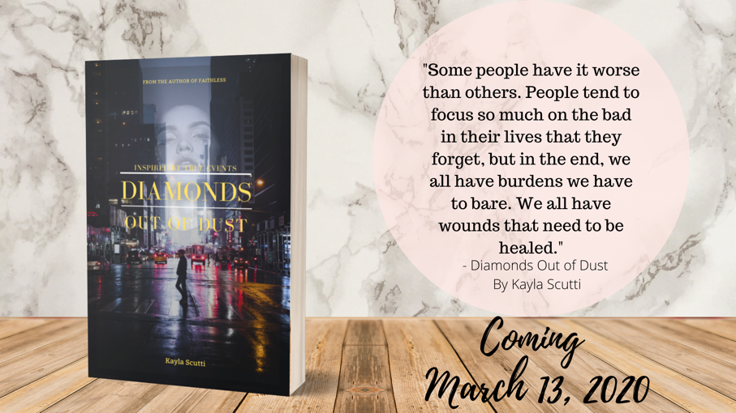

Looking Forward

That was a lot of information, but I’m glad that you’re all on board for this ride! March is going to be a whirlwind of events, so stay connected with our socials linked above!
To recap:
Diamonds Out of Dust by Kayla Scutti will be available on March 13, 2020.
Breaking Order by Catherine Kopf will be available on April 14, 2020.
The Manor’s Keeper by T.M. Ford will be available on May 7, 2020.
The 2nd edition of Trapped by L. Albano will be available on July 13, 2020.

All of these are available for pre-order at arbucklepublishinghouse.com. For signed copies, go to the author's specific store page and order from there. As always, if PayPal doesn’t work for you, send us a message on our website and we will find an alternate way for you to pay!
We are so thankful to all of you for your love and support. APH wouldn’t be anything without our authors and their readers. We look forward to seeing you at all our upcoming events, and for the next newsletter!

Happy writing and happy reading, APH fam!
Kayla Scutti & Elle Albano

