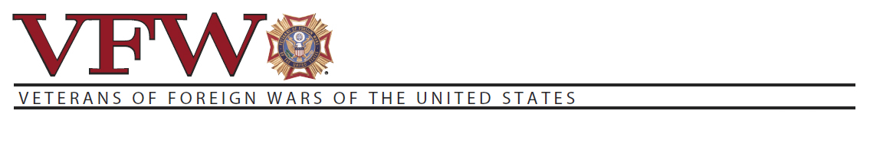
(Senators or Legislators Address)

Dear (Senators or Legislators Name):
The Budget Control Act of 2011 set arbitrary budget caps to reduce the federal budget’s discretionary spending by $1.2 trillion over nine years----equally divided between defense and non-defense programs. The federal budget would be further reduced by a 10 percent, across the board cut, if federal agencies exceed these budget caps. Since the budget caps were established in 2010, and were not based on actual or projected needs for affected agencies, they no longer reflect the realities of defense and veterans programs.

As a result, the arbitrary budget caps have significantly limited the government’s ability to carry out programs that have seen spikes in demand, such as military training and VA health care. To the VFW, sequestration is the most significant readiness and national security threat of the 21" century, and despite almost universal congressional opposition to such haphazard budgeting, no member of the House or Senate has introduced legislation to end it.

Over the past two years, countless pieces of legislation have been introduced to improve the lives of our Nation’s veterans. Unfortunately, outdated budget caps, the fear of sequestration, and congressional budget rules requiring veterans to exchange one benefit for another have prevented these important bills from becoming law. Many of these bills are urgently needed and would significantly improve the well-being of veterans, service members and their families.

Put simply, less funding for critical benefits programs and services means more stress and more financial burden for our military, our veterans, and their communities. Our Nation has a long- standing obligation to provide for the needs of those who have already sacrificed so much for our well-being. It is past time for Congress to go beyond “Thank You,” and prioritize those who have worn our Nation’s uniform.

End sequestration, so LE$$ doesn’t equal MORE.
Sincerely,

