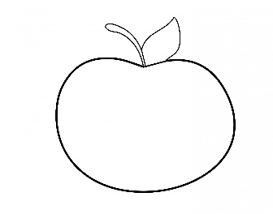
SEPTEMBER NEWS
Welcome Back to School!
Scholastic Book Club
Scholastic Book Club orders allow us, as a school, to gain points as our families purchase books. These points can be used to purchase books, laminating sheets and other educational resources. Families can either set up an account online using our school code or simply return the order form and money to school in your child’s folder.
Online Ordering Information
Web address: scholastic.com/bookclubs
Class Activation Code: H43HT
Email Addresses
If you have not received any emails from me, missliz07@verizon.net, please see me, so we can update or correct your email. It is important that we have the correct email so that you will receive all notifications from the school.
Upcoming Dates
Kid Stuff Sale: Details to follow
Friday October 4th, Pizza Friday Begins~ Order Forms to Follow
Wednesday October 9th ~Yom Kippur~School Closed
Monday October 14th, Columbus Day ~ School Closed
Craft Day ~Date & Participation Form to Follow
Trunk or Treat~ Date & Details to follow
Thursday October 31st, Halloween~ 11:30am dismissal~ 11:15am Parade (Weather Permitting)

