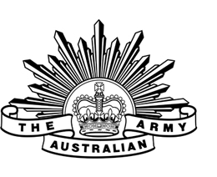 | australian army  Your Unit in Full 1st Battalion, Royal Australian Regiment | Minute
JD/01
CO Through OC

REQUEST TO ATTEND AUSTRALIAN defence force australian rules NATIONAL CHAMPIONSHIPS 08 - 22 march 2020

- The purpose of this minute is to request permission to attend the 2020 Australian Defence Force Australian Rules (ADFAR) National Championships as a player of the Australian Army Football Association (AAFA) Men’s side, to be held in Melbourne over the period 08-22 Mar 20.
- The AAFA side is conducting a training camp from 08-14 Mar 19 at Watsonia Barracks, Melbourne and the ADFAR competition games will follow the training camp from 15-22 Mar 20 at Punt Road, Seaford and Frankston, in Melbourne.
- I have been selected as a player by the Head Coach of the Men’s AAFA side. I would like to request approval and release from UNIT (1 RAR), for the above dates.
- Please find enclosed the PROVISIONAL ARMY AFL SQUADS FOR 2020 NATIONAL INTERSERVICE CARNIVAL: 08-22 MAR DATED 192025Z DEC 2019

Y Name
RANK
Sub Unit

Tel: 04xx xxx xxx
Jan 19
Enclosure:
PROVISIONAL ARMY AFL SQUADS FOR 2020 NATIONAL INTERSERVICE CARNIVAL: 08-22 MAR DATED 192025Z DEC 2019

Approved / Not Approved

CO Name
LTCOL
CO
1st Battalion, Royal Australian Regiment
Jan 19

