Northwest Atlanta Location  Groups include:  Community Involvement and Relations  Cooking Skills  Diversity Training  Housekeeping Skills  Interview Skills  Life Skills  Personal Hygiene and Grooming  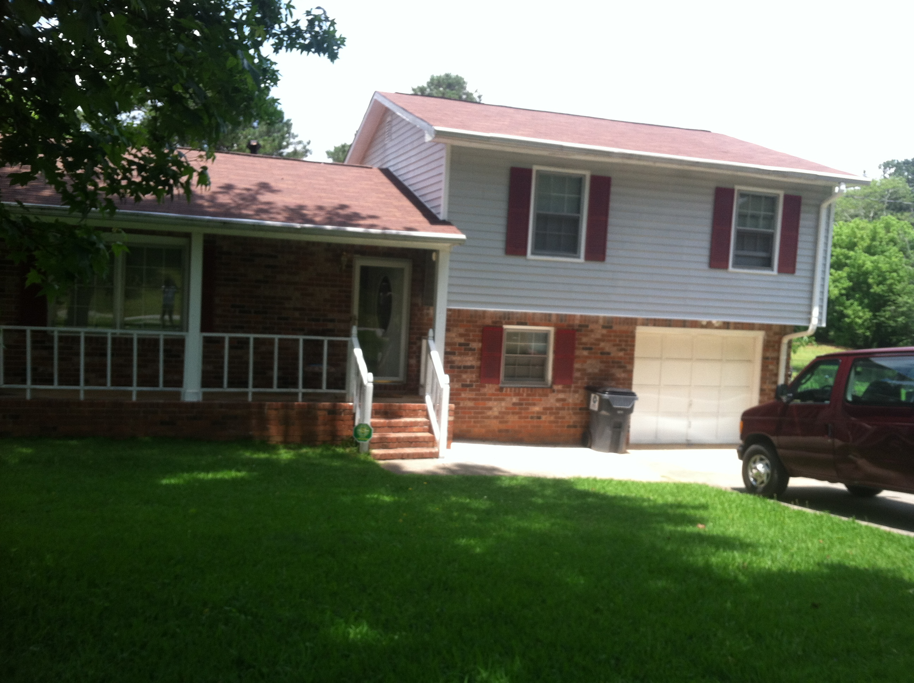  Riverdale Location |  |  | Who We Are  About Us  We are a Non-profit, Faith based, Multi-cultural organization whose goal is to offer individualized treatment for individuals that desire a positive change for their life.  ALM provides a multi-faceted approach that is designed to address each person’s mental and/or behavioral health needs while empowering our residents with the skills needed to become productive citizens, while enhancing the quality in their lives.  Contact Us  Mr. Rod A. Stovall CEO and Program Director  Main: 770-402-0112 Email: anotherlevelministriesinc@gmail.com  Another Level Ministries, Inc.  Contact us for an appointment  404-493-3549  770-402-0112 |  |  | ANOTHER LEVEL MINISTRIES, INC.  “Community Transitional Homes”  Serving Dekalb, Fulton and Clayton Counties.  Celebrating 10 years of quality services, dedication and leadership. Impacting our communities one soul at a time!  Rod A. Stovall Sr. President and Program Director  Main: 770-402-0112  Email:  Rodlop1@bellsouth.net  Website:  www.anotherlevelministries.org

Another Level Ministries Inc.  is a Non-profit organization reaching those suffering with mental illness and the effects of substance abuse and homelessness. This program is designed to teach adults to live an independent lifestyle.  Living With Dignity.  We provide a safe, clean, healthy, and caring environment in a home-like family oriented setting all year round. Our Facilities are located in the center of Atlanta, GA. |  |  | Our Mission: Is to provide a full range of in-depth educational, professional and personal development services to men and women in our community  We offer housing, individualized counseling, support, medication management, educational training, case management services and job interview skills.  Our transitional homes are faith based where you learn how to follow spiritual principles. Our facilities offers a solution to those who wish to live life with the blessings and fruits only a strong spiritual approach can provide.  Matthew 25:35-40  Follow us on… |  |  | 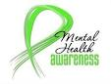  Mental Health Awareness Ribbon  Through our services and resources we are able to offer medication management for:  Adjustment disorders  Anxiety disorders  Bipolar disorders  Depression  Obsessive Compulsive disorder  Panic disorder  Post-traumatic Stress disorder  Psychiatric Evaluations (by a medical professional)  Schizoaffective disorder  Schizophrenia  *********************************************  For more information about our services visit our website at:  www.anotherlevelministries.org

