**Welcome to Shoalwater Medical Centre**

Here at Shoalwater Medical Centre we are a dedicated, experienced team of healthcare professionals and our aim is to provide the best quality health care with professional and friendly service

**We are a Bulk Billing Practice**

.  **Phone 9527 2236 for Appointments**

New Patients are welcome and we have on the day and emergency appointments available. Our highly skilled GP's can provide for all your everyday medical needs as well as MVA, workers compensation, employment medicals, drivers licence (commercial and standard), skin cancer checks, health assessments, immunisations and much more.

We have 4 General Practitioners as well as on site Physiotherapy, Australian Clinical Labs Pathology, Podiatry, Audiology, Chiropractic, and Neurology.

**General Practitioner’s:**

* **Dr Toyin Orioye**
* **Dr Ugo Egesi**
* **Dr Renuka Ranasinghe**
* **Dr Prashan Abeywardana**
* **Dr Gayani Kahatadeniya**

**Shoalwater Physiotherapy:** Angela Pontifex & Priya Kumar

**Podiatry:** Dr Crystal Loh

**Neurologist:** Dr John Cunningham

**Chiropractor:** Dr Erica Hilton

**Dietician:** Emily Rocavert

**Psychologist:** Viv Morgan

We are registered to be an AGPAL Accredited Practice. We aim to ensure the highest standard of care for our patients, your quality assurance.

**Meet Our Team**

Our friendly group of reception and admin staff will help ensure a great experience with our Medical Centre.

**Reception/Administration:**

* Sarah
* Kerry
* Leah
* Kayla

**Practice Manager:**

* Rebecca Hughes

**Practice Nurses:**

* Kylie
* Mel

**Pathology:**

Open Monday – Friday 8am-12pm

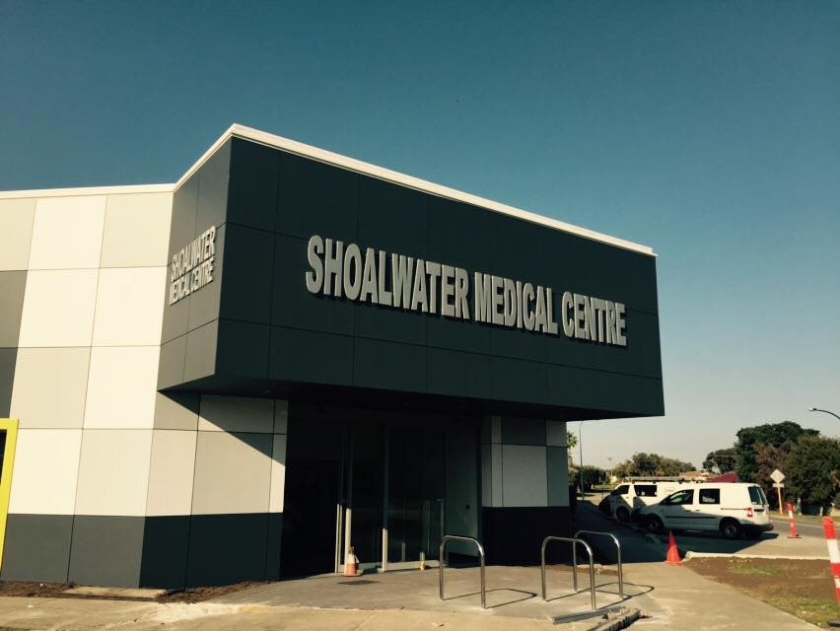**Location:** We are located at 40 Coventry Road, Shoalwater, behind the Shoalwater Shopping Centre. Our Main entry can be found on the Corner of Coventry Road and Second Avenue.

**Our Opening Hours:**

Mon - Fri: 8:00am til 7.30pm  
 Sat:         8.30am til 4:00pm

**Our Services**

We are more than just a Doctors surgery. We offer all round health care including on-site Physiotherapy, Pathology, Podiatry, Audiology, Chiropractor, Physiotherapist, Neurologist as well as Dietician and Exercise Physiologist.

**General Practitioners**

Our GP's can provide to all your general health care needs from a simple prescription to complex health care plans and everything in between. In addition to normal visits with your GP; Shoalwater Medical Centre also offers the following.

* Health Assessments (45-49 year olds and 75+)
* Diabetic Care Plans
* COPD Care Plans
* Asthma Management Plans
* Skin Cancer Checks
* Shared Care Antenatal Visits
* Childhood immunisations
* 4 year old Health Assessments
* Travel Vaccinations
* ECG and Spirometry
* Mental Health Care Plans
* Workers Compensation
* Motor Vehicle Accidents
* Pre-employment Medicals
* Drivers Licence Medical Assessments.
* Wound Management
* Pap Smears/Breast Checks and all facets of women’s health.
* Implanon insertion/removal.

**Physiotherapy**

Our experienced and friendly physiotherapists from Shoalwater Physiotherapy are Angela Pontifex and Priya Kumar. Our physiotherapists can provide you with all your physio needs including MVA, workers compensation and private patients.

Physiotherapy is private billing (except EPC patients) with HICAPS rebates available.

Phone 9527 2236 for bookings and queries or visit [www.shoalwaterphysio.com.au](http://www.shoalwaterphysio.com.au)

**Neurologist**

Our on-site Neurologist is Dr John Cunningham from South Beach Neurology. Dr Cunning is available Monday - Fridays. To book an appointment please contact his secretary on 0400 238 689.

**Podiatry**

Dr Dr Crystal Loh is our in house podiatrist and holds clinics weekly. Dr Loh is a very experienced podiatrist; taking care of all aspect of foot care including orthotics.

There is a private billing policy (except EPC patients). HICAPS rebates are available.

**Chiropractic**



Our experienced and friendly Chiropractor from Shoalwater Chiropractic is Dr Erica Hilton. Erica can help you with:

* Improved spinal function
* Back and neck pain
* Headaches
* Sciatica
* Pregnancy and Postnatal Care
* Infant and children’s health
* Sports injury management
* Geriatric spinal care
* Preventative spinal care

She sees patients from all age groups as well as MVA, Workers Compensation and EPC Care Plans. Erica also specialises in Bowen Therapy.

Chiropractic sessions are private billing, (except EPC patients) HICAPS rebates available.

**Dietitian**

Emily Rocavert from On the Go Rehab is a registered dietitian and member of the DAA (Dietitians Australia Association). Originally from New Zealand, Emily has extensive experience in chronic disease management, weight management and high performance sports nutrition. She has a background in hospital and community dietetics and has recently been working in residential care.

Emily believes that nutrition is the ideal treatment, management and prevention of many chronic diseases. She is able to provide individual nutrition advice tailored to your lifestyle for a better and healthier you.

Our dietician is privately billed (expect EPC patients) and HICAPS refunds are available. Emily is also available to see Bariatric patients, patients who are Pre and Post Operations and Weight Disorder Patients (Anorexia and Bulimia).

Phone 9527 2236 for bookings and queries.

**Psychology**

Viv Morgan from Compassion Psychology Services is our in house Psychologist. Viv comes with over 20 years of experience (with expertise in Sexual Assault and Domestic Violence) and is available for appointments 9am-5pm on Wednesdays.

Viv offers bulk billing counselling services for all pensioners and health care card holders as well as school aged children. She will also see Private Patients for a small fee, please ask reception staff if you require further information.

Compassion Psychology offers the following services:

* Coaching and counselling
* Loss and Grief
* Trauma
* Stress/Anxiety
* Depression
* Recovery from Trauma

**Our Doctors**

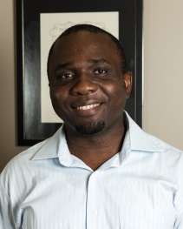 **Dr Ugo Egesi**

Ugo has been in general practice for over a decade, having practices in Victoria & overseas before moving to W.A He is a fellow at the RACGP and holds his skin cancer certificate. He is also been involved in medical student mentorship/education and training of GP registrars. Ugo is an examiner for the Royal College of General Practitioners.

Dr Egesi has wide experience with different cultural backgrounds and has a passion for management of chronic disease, mental health, occupational medicine, surgical procedures (predominately skin), geriatric medicine and women's and children's health.

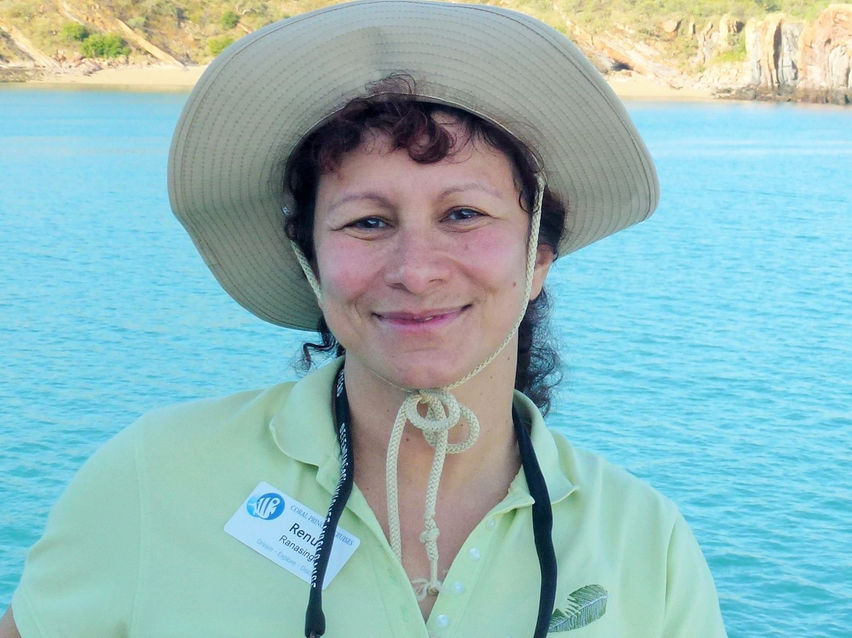**Dr Renuka Ranasinghe**

Dr Renuka qualified in the UK in 1990 and had 20 years of experience working in medicine and general practice in the UK. She has worked as a GP over the past 5 years in Western Australia. Her special interests are Skin diseases Dermatology, Skin Cancer Medicine and Skin Cancer Surgery with post graduate qualifications and experience in this in the UK and Western Australia. She has experience and interests in all aspects of general practice including Women’s Health and Chronic Medical Conditions such as Hypertension, Heart Disease, and Diabetes etc. She believes in looking after people holistically.

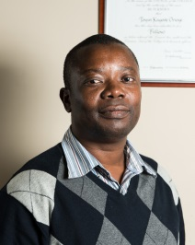 **Dr Toyin Orioye**

Toyin has been a general practitioner for over a decade. He is a fellow of the RACGP (Royal Australian College of General Practitioner's) as well as an examiner for the college. He is enthusiastic about teaching and is a medical student supervisor for university students, most currently for the University of Notre Dame.

He holds his diploma in Skin cancer medicine and dermoscopy and offers skin cancer clinics within the medical centre. He also has a long standing experience with women's health, family medicine, mental health, occupational medicine and chronic disease management.

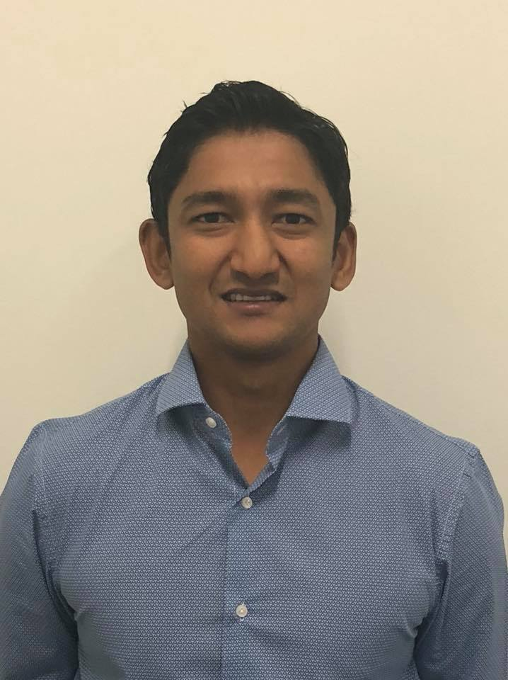**Dr Prashan Abeywardana**

Dr Prashan started with us on January 17th 2018 through the WAGPET registrar program. He has previous Hospital experience and a special interest in chronic disease and general medicine. Dr Prashan is practically excellent with young children and their health concerns. He is available for appointments Mondays, Wednesday and Friday 8am to 6pm.

Dr Gayani Kahatadeniya

Dr Gayani is our new female GP Registrar. She is working towards a fellowship through the WAGPET program. She holds a diploma in child health and has a special interest in women's health, children's health and chronic disease management.

She is available for appointments Tuesdays 8.00am - 4.30pm.

**Doctors Roster**

**Dr Ugo Egesi (weekly rotational roster)**

Week 1:Monday, Thursday, Friday and Saturday

Week 2: Tuesday, Wednesday, Thursday

**Dr Toyin Orioye (weekly rotational roster)**

Week 1: Tuesday, Wednesday, Thursday

Week 2:Monday, Thursday, Friday and Saturday

**Dr Renuka Ranasinghe**

Currently on Annual Leave

**Dr Prashan Abeywardana**

Monday, Wednesday and

Friday 8am – 6pm

**Dr Gayani Kahatedeniya**

Tuesday 8am – 4:30pm

**After Hours Services**

Our Practice opens Monday to Friday 8:00am to 7.30pm and Saturdays from 8:30am to 4.00pm.

We are closed Sundays and public holidays.

For medical Attention outside of these hours please see below.

* **In an EMERGENCY always call 000**
* Rockingham General Hospital has a 24/7 Emergency Department located on Elanora Drive, Rockingham
* Dial A Doctor 1300 030 030
* 1800 Get Better 1800 238 837 (Rockingham/Kwinana area specific)
* HealthDirect - phone service and advise 1800 022 222
* Lifeline 13 11 14 for crisis support and suicide prevention.

**Communication**

Shoalwater Medical Centre endeavours to follow up any messages, e-mail enquires or fax enquiries in a timely manner. All queries are tended to within a maximum of 24 hours wherever possible.

We can receive your queries’ via email, telephone or in person.

[**reception@shoalwatermedicalcentre.com**](mailto:reception@sevilledrivemedical.com)

**Ph.: 9527 2236 Fax: 9527 2636**

**Results**

For best patient care we encourage all patients to make a follow up appointment with their doctor to discuss any results.

Once your results arrive, they will be reviewed by your doctor and if you have not organised an appointment you will be contacted by our practice team should the doctor need to see you.

Results will NOT be given over the phone.



**Billing Policy**

Our doctors are bulk billing, this means with a valid Medicare card you will not need to pay anything for your visit.

Appointment reminders will be sent for all allied health appointments and for Dr Renuka Ranasinghe. Failure to attend your appointment with less than 24 hours’ notice or failure to reschedule/cancel apt. within 24 hours, will incur a cancellation fee of $20. Due to lengthy waiting lists and full clinic loads, Dr Ranasinghe will be unable to offer further appointments to patients that fail to attend without adequate notice upon Dr Ranasinghe’s discretion. (nb extenuating circumstances in the form of emergencies are accepted)

ALL workers compensation accounts, MVA accounts will be charged PRIVATELY, Any pre-employment medicals, drivers licence assessment, insurance forms or medicals are also PRIVATELY billed. Prices range from $120 and upwards. For further billing information please speak to reception staff.

**Privacy**

Your privacy is of the upmost importance to us. We have a strict policy on gathering, storing and releasing any personal or medical details.

You can complete a form to have your records transferred to another medical centre.

If you would like more information about privacy or how to access your health record, please ask your doctor or see reception staff.

You can request a copy of the privacy act from reception.

**Quality Improvements**

Our centre is committed to providing a state of the art health care facility with a strong focus on patient care, as part of our commitment we have listened to your feedback and improved our service.

* We are reducing wait times by making longer appointments.
* We will let you know when you arrive for your appointment how your doctor is running for time.
* If you have a clinical query or need to discuss your health over the phone we have a dedicated practice nurse that may be able to assist you.

We value your feedback, please see one of our friendly staff members to leave your comments or use our suggestion box, located on the front desk.

**Complaints and Feedback**

Thank you to all our patients for participating in our recent survey. We listened to your feedback and will implement the following changes:

* We will provide estimated wait times on arrival for all patients.
* We will add some “on the day” appointments to the appointment schedule which will give us more flexibility to fit in urgent requests more easily.
* We will display a list in the waiting room for allied health services in the area.

We value all feedback at Shoalwater Medical Centre. It helps us improve our service provide the best care for our patients.

Feedback can be given verbally to the team or written and placed in our Feedback box (located on the front counter).

Should you have any complaints please ask to speak to the Practice Manager, Rebecca.

You may also contact HADSCO – Health and Disability Services complaint Office.

The Health and Disability Services Complaints Office (HaDSCO)  
GPO Box B61  
Perth WA 6838

Complaints and enquiries line: (08) 6551 7600  
Administration: (08) 6551 7620  
Fax: (08) 6551 7630  
Country Free Call: 1800 813 583  
TTY: (08) 6551 7640

Email: [mail@hadsco.wa.gov.au](mailto:mail@hadsco.wa.gov.au)

**Did you know?**

Did you know you can book your appointment online? You can visit our website ([www.shoalwatermedicalcentre.com](http://www.shoalwatermedicalcentre.com)) or healthengine.com.au.

If you have a smart phone or tablet you can download the FREE app.



1. Download the FREE “Health Engine” app.
2. Select ADD A DOCTOR and search Shoalwater Medical Centre.
3. Select your appointment time from the list and/or your preferred doctor
4. Enter your details (you only need to do this the first time).
5. Then confirm.

**You can connect with us**

You can Like us on **FACEBOOK,** search Shoalwater Medical Centre.

Keep up to date with practice happenings as well as some great health information and articles**.**



**Visit us online**

[www.shoalwatermedicalcentre.com](http://www.shoalwatermedicalcentre.com)