December 2019 – Preschool

Monday | Tuesday | Wednesday | Thursday | Friday
2  Letter Craft | 3  Library Day | 4  Personal Hygiene Craft | 5  Show n Tell  Bring a ‘M’ Item | 6  Shaving Cream Day
9  Wear Red Day | 10  Library Day | 11  Letter Craft | 12  Show n Tell  Bring a ‘N’ Item | 13  Construct a Building
16  Letter Day | 17  Library Day | 18  Holiday Art | 19  Show n Tell  Bring a ‘O’ Item | 20  Learn How Friends Around the World Celebrate the Holidays
23  Shape Craft | 24 | 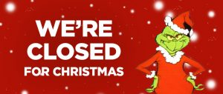  25 | 26  Show n Tell  Bring a ‘P’ Item | 27  Favorite Part of Christmas
30  Wear Green Day | 31  Library Day

Focuses: Themes:
Letters: Mm, Nn, Oo, Pp Personal Hygiene
Number: 8 & 9 Construction
Color: Red & Green Holidays Around the World Shape: Star Christmas
Skill: Sorting & Matching New Year’s Around the World

