Women Earn Higher Returns: On average, women performed better than men when it comes to investing by 40 basis points, or 0.4 percent. At first glance this may appear to be a minor difference, but can have a significant impact over time.
Looking specifically at workplace retirement accounts, women consistently saved a higher percentage of their paychecks than their male counterparts at every salary level. Women saved an annual average of 9.0 percent of their paychecks, compared to an average of 8.6 percent saved by their male counterparts.
Looking at accounts outside of workplace savings, such as IRAs and brokerage, the data showed that in proportion to their account balances, women saved more. Women added an average of 12.4 percent to their account balance, compared to 11.6 percent for men.
What can saving at a higher rate and earning a higher return mean over time? The impact can be significant, and amplified even more so for younger investors. Using current workplace savings rates, consider these hypothetical examples

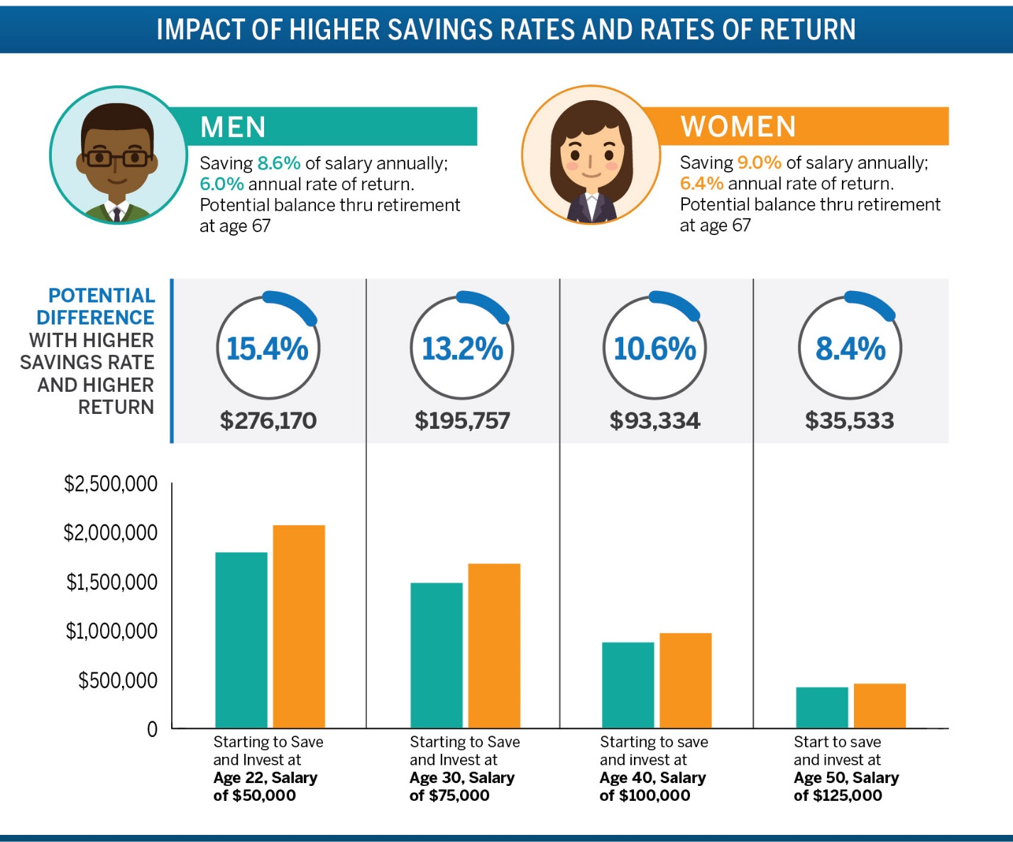

Breaking it Down: Women's Skills and Strengths
Plan with purpose, think holistically. Women often build financial plans in terms of life goals for themselves or their families, rather than focusing on performance alone. Women tend to hold a more long term, conservative view with their investments, tending to buy and hold stocks, versus taking quick action during market fluctuations.
Take on less risk. Women are more likely to have their savings allocated in a more age-based allocation of investments than their male counterparts. In fact, looking specifically at retirement savings accounts over the last three years, the percentage of women allocated appropriately for their age has increased by approximately 40 percent. Furthermore, fewer women have their savings fully invested in equities than men (which could represent too much risk and not enough diversification); and women are more likely to invest in target date funds, ensuring they are well diversified.
Practice patience. When comparing likelihood to buy/sell stocks, Fidelity's client data revealed that men are 35 percent more likely to make trades than women. Furthermore, men who trade made an average of 55 percent more trades in 2016 than their female counterparts.
Women Eager to Catch Up: More Financial Education Wanted
Research among professional women across the country shows there's no shortage of interest in learning more about financial management and investment choices, with over 90 percent saying they want to learn more about financial planning8. For many, this stems from a need to play ‘catch up,' with a majority reporting a lack of opportunity to learn financial skills earlier in life.
While parents remain the top source of financial advice for most women, only 20 percent said they felt well prepared by their parents to manage their finances as an adult. Even fewer said they learned about these topics in school. Only 24 percent learned about budgeting and setting financial goals; 14 percent said they learned about investing. Overall, only nine percent of women said their education through high school left them well prepared to manage personal finances as an adult. A slightly better 10 percent said this of their college education9.
Today, 88 percent of women say more financial education would provide them with greater confidence in managing their money. When asked what they would most like to learn with 60 minutes of professional financial advice, women across all generations listed ‘learning more about how to invest my money' as their No. 1 choice.
Three Financial Action Steps
Whether you're looking to go from saver to investor, address a specific financial task on your personal to do list or generally learn more about women and money, here are three things to do today to get the ball rolling:
Commit. Set a personal deadline to take just one step toward a financial goal. Not sure where to start? Fidelity has developed a checklist that provides fundamental steps for women at each stage of their career, and for the life events that can take place throughout our financial lives.
Check. Make sure you know what you own, what you owe, and the status of those accounts. Are your investments working to help you reach your goals?
Communicate. If you have questions, your friends and family probably do too. Not only is it time for money to stop being a taboo conversation topic, but ensuring you're on the same page with your loved ones about financial goals and responsibilities can be critical. Fidelity has numerous resources to help have these conversations with parents, partners and kids.

