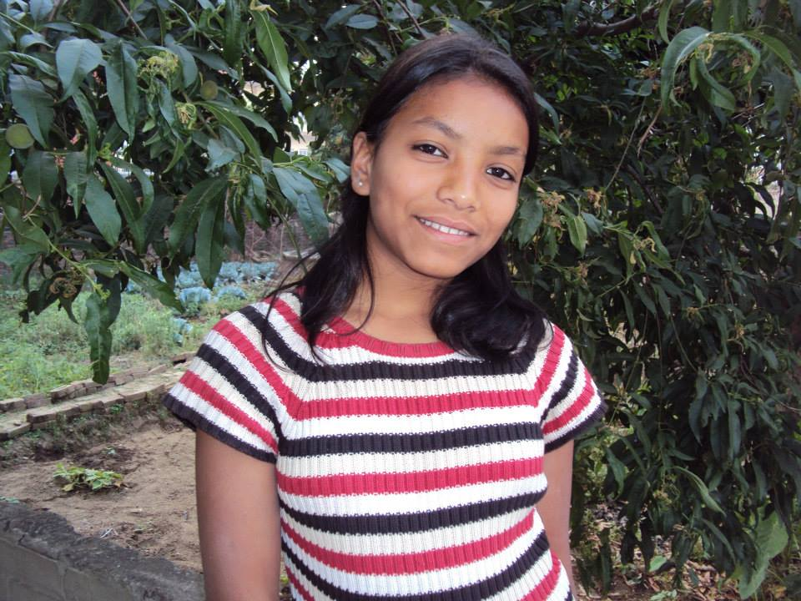
Alisha 14 Years old
CHILD’S ID NO : WPPC-0018
DOB: July 10, 1999
Alisha is the oldest child in her family. Her father was very abusive towards his wife and children. Her mother abandoned her and her sister when Alisha was 4 year old but no one knows about her mother. She disappeared. Many suspect of her being trafficked.
Alisha became responsible for entire household chores after her mother left. She had to wake up early in the morning to finish all the work and then go to the school with her sister. Additionally every day she was abused by her father. She dropped out of school and was ready to run away with a pimp. She came to the safe house with the bruises and told us that she needs safe place to live. Otherwise her life is in danger. Alisha is very quiet and shy. She struggles with her emotions and past experience of abuse. Sometimes it can be difficult for her to concentrate in her education. The safe house staff members continue to provide all the support she needs to be successful in her school and for her healing. She is in 4th grade. She loves to learn English and one day she wants be a teacher in Nepal. She has two other sisters. Your sponsorship will change her life and shape her future.

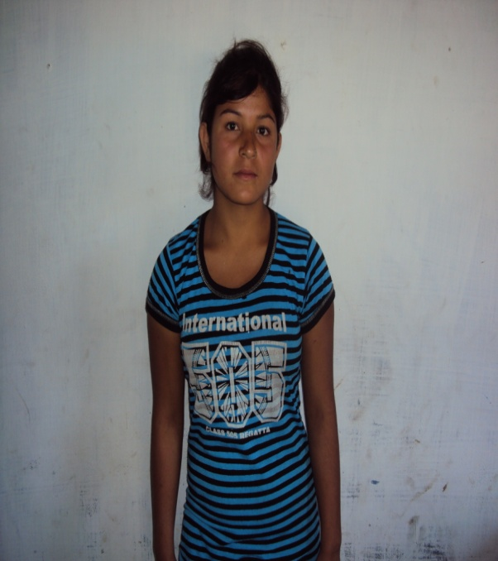
Ambika
Name : Ambika
Date of birth : 1 May 1996
Age : 16 Year
Child’s standard in school : Grade-6
Religion : Christian
Ambika is 16 years old and she is from Hetauda-8 Kamane in Makawanpur district. She has been staying with her family. Her parents are jobless. They are traditional and uneducated so her mother had been sending her own daughter named Ambika to perform in the circus at the age of 10 years old.
But luckily, she has been rescued from the circus 3 years ago and now she is staying with her family. Her family is very poor. They don't have land access and they don't have a regular income source. This causes them to not be able to provide funds to continue her education. She left the school at grade 6. She wants to continue her education but due to the low economic condition of her family she is became compelled to stop her education.
She needs an educational sponsorship so she will have a good future.

