Our Desserts
Baklava | $5.50
El Attar family recipe. Buttery layers of pastry and nuts smothered in a sweet sauce.
Basboussa | $5.50
Golden semolina cake with sweet orange blossom sauce.
Coconut Basboussa | $5.50
Coconut semolina cake with a sweet almond sauce.
Qatayef | $5.50
Crunchy nuts in a warm crispy cake and drenched with a sweet sauce.
^ Add a Scoop of Ice Cream ^  Vanilla  Baklava / Halwa / Turkish Delight |  | $2.00  $3.00
Lokum |  | $5.50
Five pieces of Turkish Delight. Perfect for sharing.
Mahallabia * |  | $5.50
Traditional Egyptian cold milk pudding.
Ruz bil Labn * |  | $5.50
Traditional Egyptian rice pudding.

*Weekends only
Our Hot Drinks
Pot of Tea  Small  Large | $4.50  $8.00
Egyptian (Sweet black with mint)
Moroccan (Sweet green with mint)
Karkadeh (Hibiscus)
Apple
Ginger and Honey
Yansoon (Aniseed)
Cardamom
Black
Green
Black with Mint
Green with Mint

Middle Eastern Coffee | $4.50
Egyptian (Strong and sweet with milk)
Turkish (Strong, sweet and black)

Hot Chocolate | $4.50
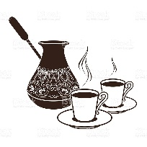

Our Cold Drinks
Ayran Yogurt Drink | $6.00
Freshly Squeezed Juice | $8.00
Orange
Apple
Carrot
Ginger

Milkshakes | $6.00
Caramel
Chocolate
Strawberry
Vanilla

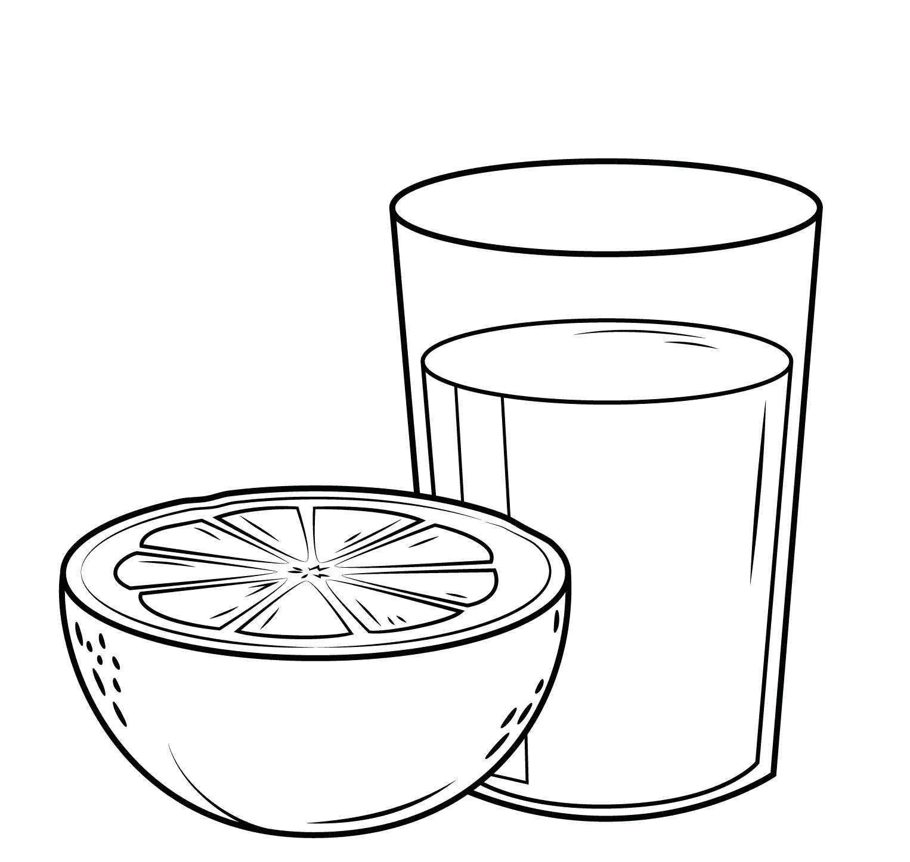
Bottled Drinks
Arabic Soft Drinks |  |  |  |  |  |  |  |  |  | $4.00
Coca Cola  Mirinda |  |  |  |  | 7 Up  Pepsi |  |  | Vimto  Tamarind
Barbican Malt Drinks |  |  |  |  |  |  |  |  |  | $5.50
Apple  Lemon | Malt  Peach |  |  |  |  | Pomegranate  Raspberry |  |  | Strawberry  Watermelon
Barista Brothers Milk |  |  |  |  |  |  |  |  |  | $5.50
Iced Chocolate |  |  |  | Iced Coffee
Bottled Juice |  |  |  |  |  |  |  |  |  | $5.00
Mango |  |  |  |  | Guava
Energy Drinks |  |  |  |  |  |  |  |  |  | $5.50
Red Bull |  |  |  |  | Mother |  |  | V
Ginger Beer |  |  |  |  |  |  |  |  |  | $5.50
Iced Tea |  |  |  |  |  |  |  |  |  | $5.50
Peach & Black |  |  |  | Lemon & Black |  |  |  | Mango & Green
Moussa Juice |  |  |  |  |  |  |  |  |  | $5.00
Apple  Cinnamon |  |  |  | Cocktail  Coconut |  |  |  | Grape  Mango
Powerade |  |  |  |  |  |  |  |  |  | $5.50
Blue  Orange |  |  |  | Purple  Red |  |  |  | Silver  Yellow
Soft Drinks – 375ml |  |  |  |  |  |  |  |  |  | $3.50
Coke  Coze Zero  Diet Coke |  | Fanta  Sprite Creaming Soda |  |  |  |  | Lift Lemonade  Lemon Squash |  | Pasito  Ginger Ale  Ginger Beer
Soft Drinks – 600ml |  |  |  |  |  |  |  |  |  | $5.50
Coke varieties |  |  | Fanta |  |  | Lift |  |  | Sprite
Water
Still  Sparkling |  |  |  |  |  |  |  |  |  | $3.50  $4.50

