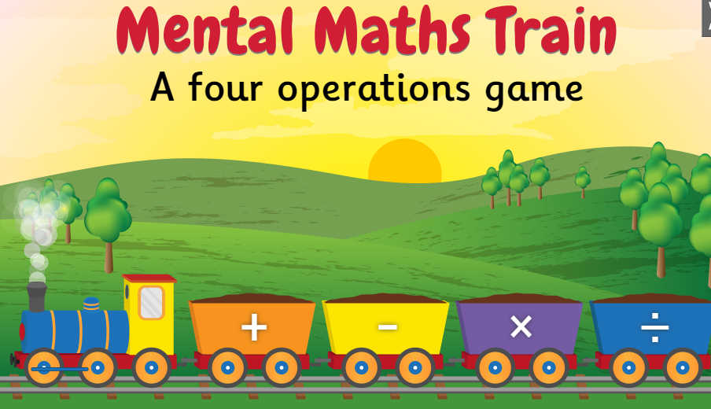

https://www.topmarks.co.uk/maths-games/mental-maths-train
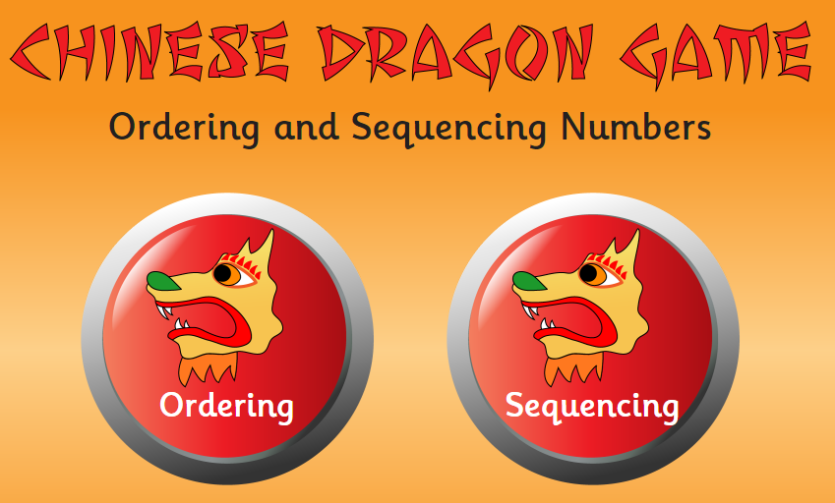

https://www.topmarks.co.uk/ordering-and-sequencing/chinese-dragon-ordering
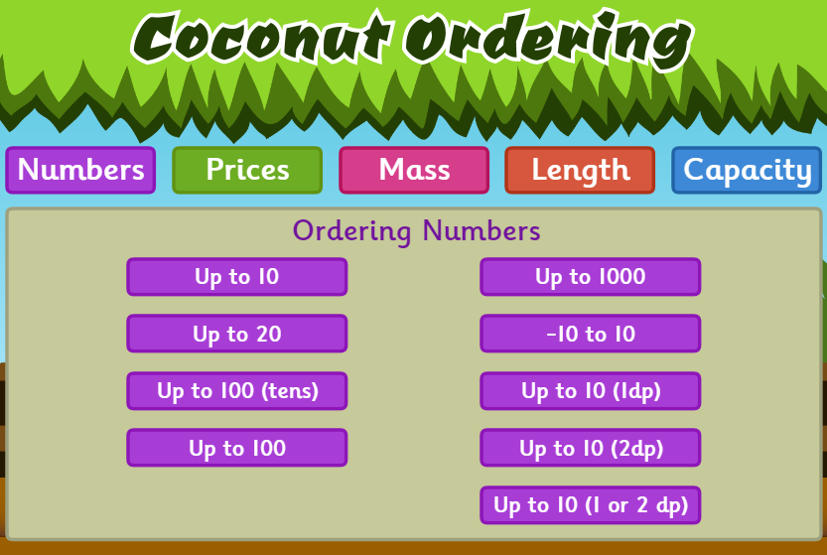

https://www.topmarks.co.uk/ordering-and-sequencing/coconut-ordering

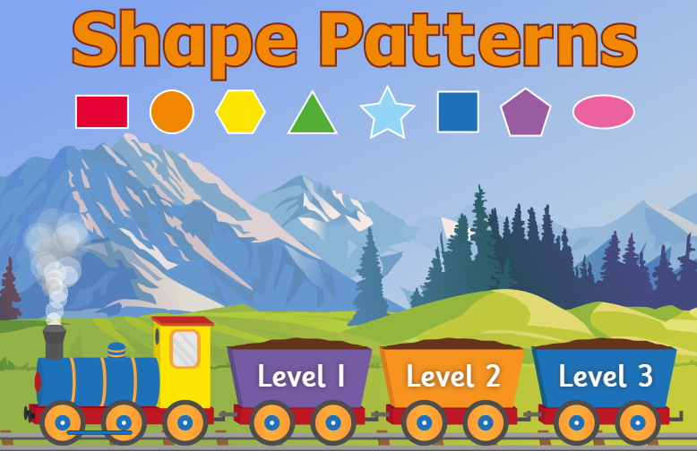

https://www.topmarks.co.uk/ordering-and-sequencing/shape-patterns
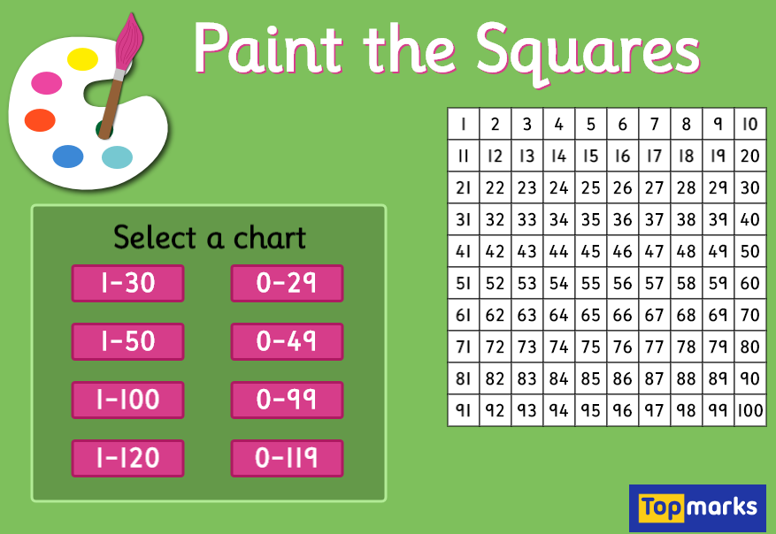
https://www.topmarks.co.uk/learning-to-count/paint-the-squares
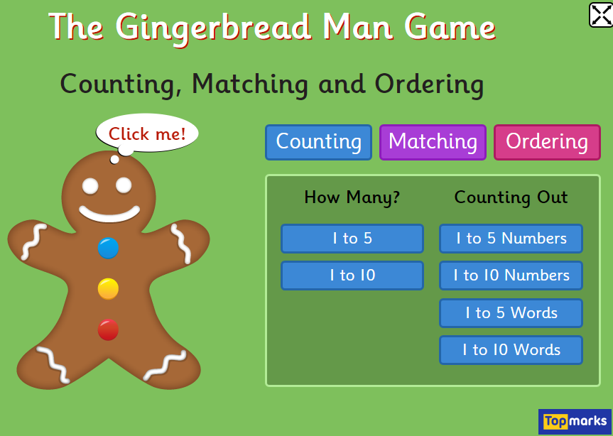

https://www.topmarks.co.uk/learning-to-count/gingerbread-man-game

