Thank you for your interest in Choice Theory: Dr William Glasser, I am delighted that this course has been given Quality Checked status by the National Counselling Society
I have included here some basic information that I hope will help you to understand what this course is all about but please do email trainingbyliberty@outlook.com if you have a question that is not covered here.
This course is aimed at counsellors, trainee counsellors or anyone in the helping professions that would like to increase their knowledge of what might be going on for their clients. It may also be of interest to those that just want to understand themselves and their motivations a bit more.
Dr William Glasser’s Choice Theory is another way to consider what is happening in the clients’ world as well as considering the motivations for their behaviours. This course will give you basic information about this fascinating theory that hopefully will spur you on to investigate more.
If you do decide you would like further training in this area then look out for working with Choice Theory, a short course coming in 2021
To register your interest or for any queries please email me on trainingbyliberty@outlook.com or complete and return the registration form that can be found at the bottom of the relevant page on www.trainingbyliberty.com
The cost of the course is £80. You can secure your place by completing the course registration form at www.trainingbyliberty.com and returning along with your £10 deposit to trainingbyliberty@outlook.com or you can contact Liberty Talking Therapy and request a registration form.
As a delegate from this course you are eligible to join the National Counselling Society with a discounted price on production of the certificate of attendance from this course
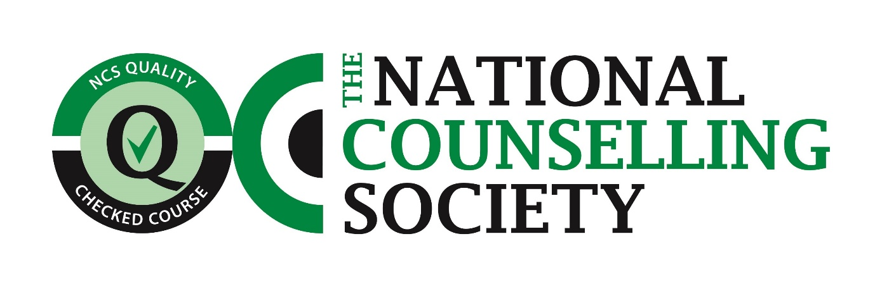
Please note that a minimum of 4 persons are required for a course to run

