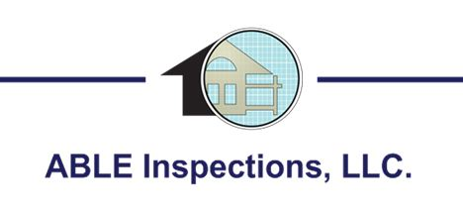
A sample home inspection report will be available soon!
(775) 397-6393

