Helpful Parent Links

SAFE KID! ([Www.safekids.org](http://Www.safekids.org)) 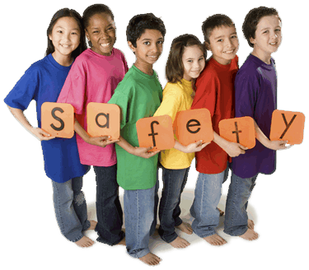

NATIONAL TRANSPORTATION CENTER FOR SCHOOL CHILDREN ([Www.mhwest.com/NTCSC](http://Www.mhwest.com/NTCSC))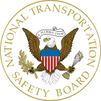

NATIONAL SCHOOL TRANSPORTATION ASSOCIATION ([Www.nhtsa.gov](http://Www.nhtsa.gov))

FEDERAL HIGHWAY ADMINISTRATION ([Www.fhwa.dot.gov](http://Www.fhwa.dot.gov))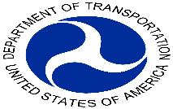

MOTHERS AGAINST DRUNK DRIVING ([Www.madd.org](http://Www.madd.org))

SOUTH CAROLINA DEPARTMENT OF EDUCATION ([Www.ed.sc.gov](http://Www.ed.sc.gov))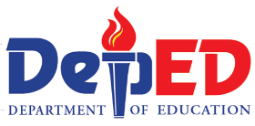

BOYS & GIRLS CLUB OF THE MIDLANDS ([Www.bgcmidlands.org](http://Www.bgcmidlands.org))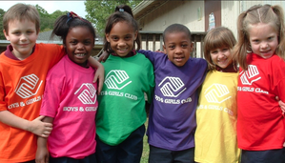

COLUMBIA URBAN LEGUE ([Www.columbiaurbanlegue.org](http://Www.columbiaurbanlegue.org))

SCHOOL TRANSPORTATION NEWS ([Www.stnonline.com)](http://Www.stnonline.com))

AMERICAN RED CROSS FIRST-AID/CPR TRAINING ([Www.centralscrecross.org](http://Www.centralscrecross.org))