解余宏医学博士（中医气功师）简介
A Brief Introduction of Dr. Yuhong Xie
--PhD in Traditional Chinese Medicine (Master of Qigong)
现任【国际太极气功中医养生论坛】主席，【国际太极气功养生协会】会长，【世界中医药联合会中医治未病专业委员会】常务理事 。
Chairman of International Taiji Qigong Chinese Medicine Health Preservation Forum.
President of International Taiji Qigong Health Preservation Association.
Executive Director of World Federation of Chinese Medicine Societies in preventive treatment of diseases.
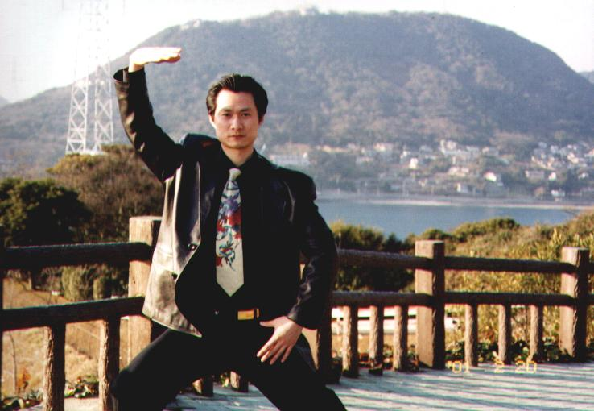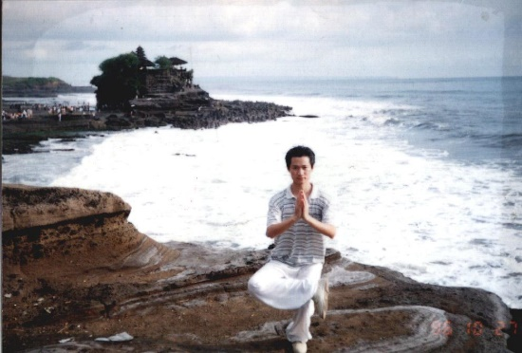
在日本福冈练《少林内劲一指禅》 在印尼巴厘岛练金鸡独立桩
Practice Shaolin Yi Zhi Chan in Fukuoka, Japan Practice Shaolin Yi Zhi Chan in Bali, Indonesia
解余宏博士，自幼爱好武术气功和中国传统文化，不仅有深厚的中医学（1990年获得南京中医药大学中医专业本科学位）和针灸推拿学（2005年获得南京中医药大学针灸推拿气功专业博士学位）教育背景，而且在医学气功领域有着更加丰富的自身修炼、临床科研和教学推广的经历。
Ever since his early childhood, Dr. Yuhong Xie has loved martial arts, Qigong and traditional Chinese culture. He has strong education background in Chinese medicine, acupuncture and tuina. Dr. Xie was awarded a Bachelor degree in Chinese medicine in 1990 and a Ph.D. degree in acupuncture and Qigong tuina in 2005 from Nanjing University of Traditional Chinese Medicine. On top of that, Dr. Xie has vast experience in self-training, clinical research and teaching and promoting medical Qigong.
一、2005-目前，在英国从事中医、针灸推拿的临床和教学工作，并在世界范围内致力于【YUHONG 🌏气针导引疗法】和太极气功的推广。
最近2-3年来主要推广的气功功法有《少林气功内劲一指禅》、《防癌抗癌郭林气功》、《传统气功养生--少林易筋经》、《华佗五禽戏》、《健身气功八段锦》、《中医五行系列功法—调心降火功》等。在中国北京，英国伦敦、曼彻斯特、兰迪德诺，瑞士苏黎世，爱尔兰都柏林、沃特福德、阿斯隆，德国科隆，波兰华沙等国家和地区举办了近20期中医气功养生培训班。
I. 2005 – present, engaged in Chinese medicine, acupuncture tuina clinical work and teaching in UK. Also promote the therapy of Qi, Zhen, Daoyin and Taiji Qigong in the world.
In recent 2-3 years, Dr. Xie concentrated in promoting "Shaolin Qigong Yi Zhi Chan", "Anti Cancer & Cancer prevention Guo Lin Qigong", "Traditional qigong health - Shaolin Yi Jin Jing", "Hua Tuo Wu Qin Xi", "Healthy Qigong Ba Duan Jin", "Chinese medicine Wu Xing series – Tiao Xin Jiang Huo" and so on. He held nearly twenty Chinese medicine Qigong health training courses in Beijing, London, Manchester, Llandudno, Switzerland Zurich, Ireland Dublin, Waterford, Athlon, Germany Cologne, Poland Warsaw and other countries and regions.

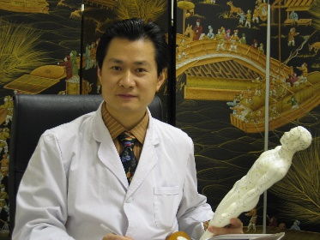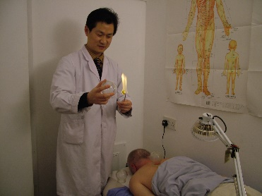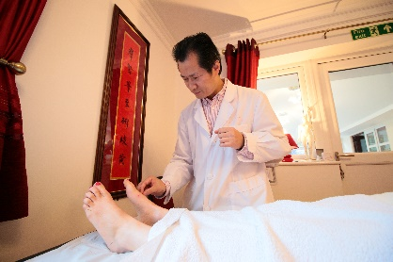
2006英国Bangor诊所 2008英国Llandudno诊所 2016英国Shulan诊所气功针灸

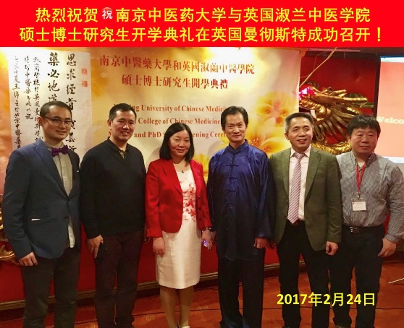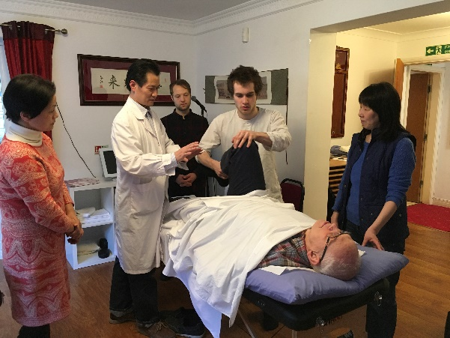
2017.2 英国淑兰学院硕博开学典礼 2017.3 指导针灸推拿专业学生
2017.2 Shulan College Master and Phd degree opening ceremony 2017.3 Supervise Acupunture & Tuina Students
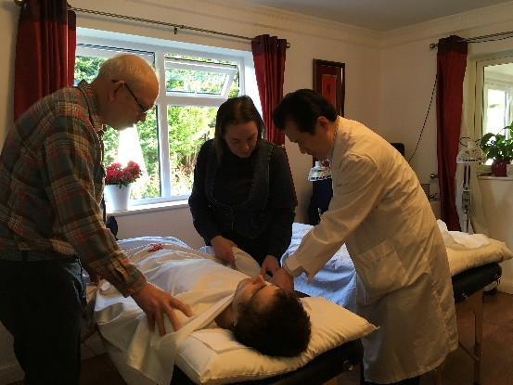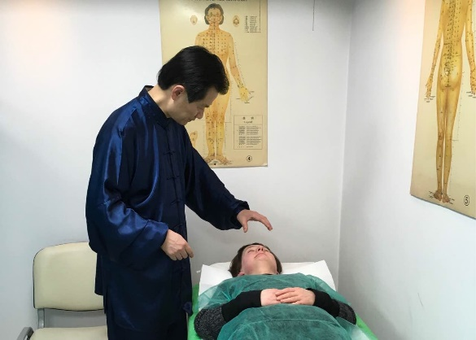
2017.3 指导学生气功点穴 2017.3 波兰华沙中医诊所气功外气治疗
2017.3 Supervise student Qigong acupressure 2017.3 Emission Qi Treatment Chinese medicine clinic Warsaw Poland
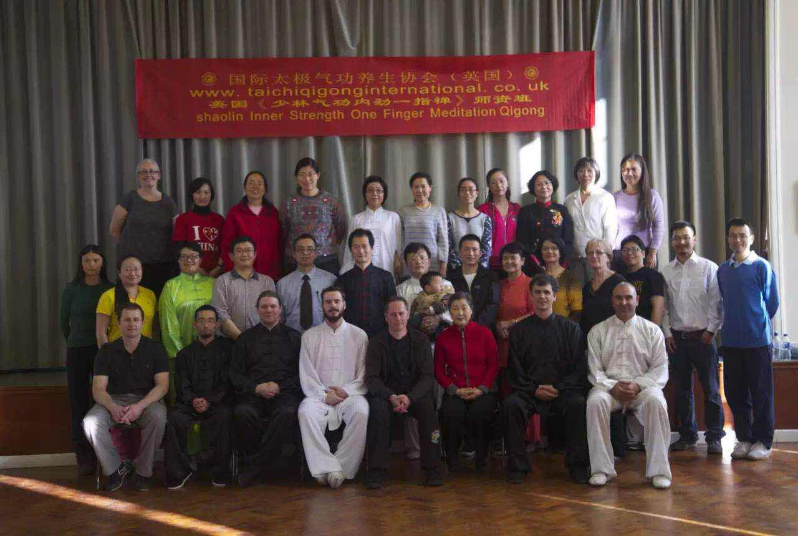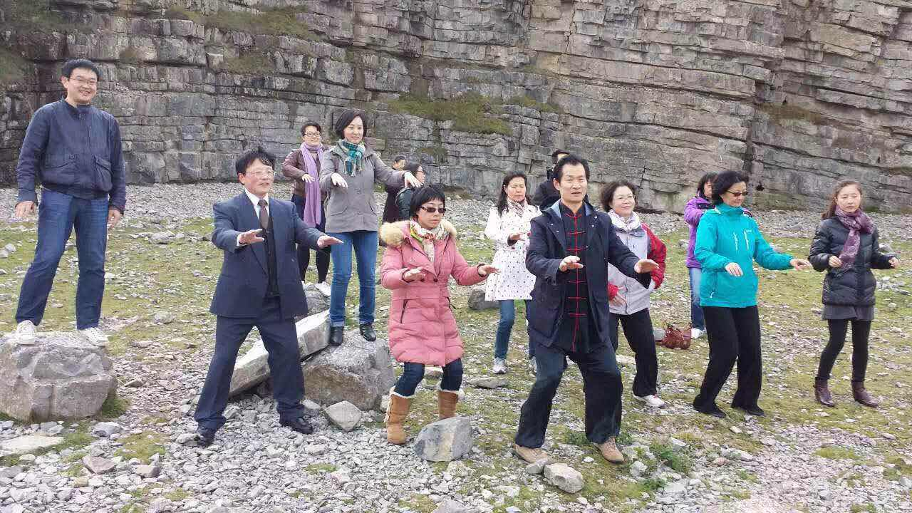
首期【少林气功内劲一指禅班】师资班（英国Llandudno）2015.10
First Shaolin Qigong Yi Zhi Chan Teacher training Llandudno UK 2015.10

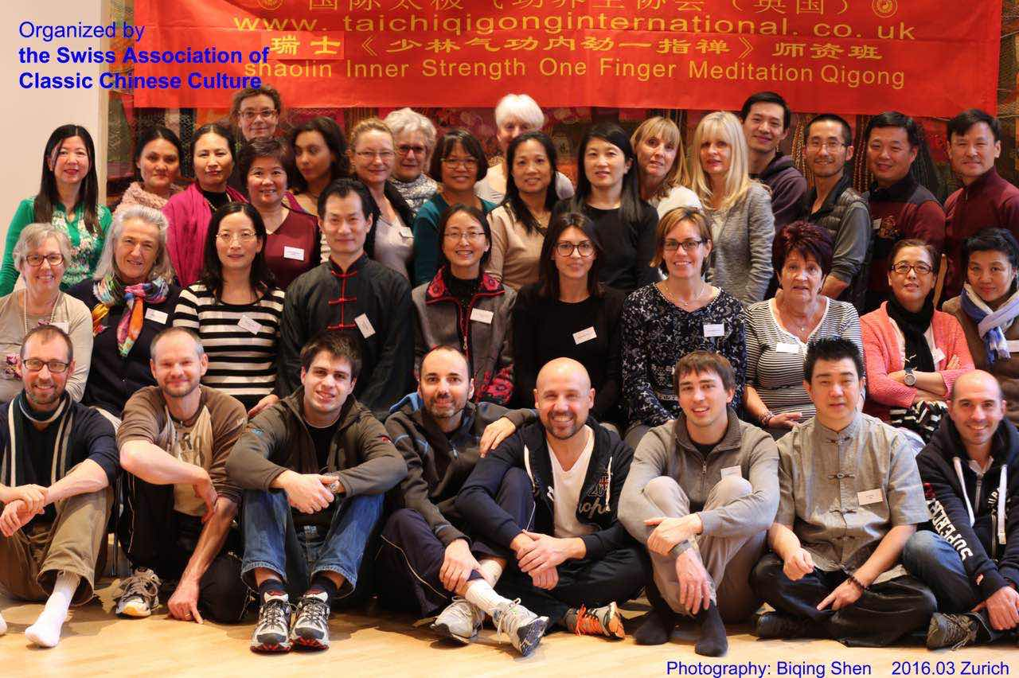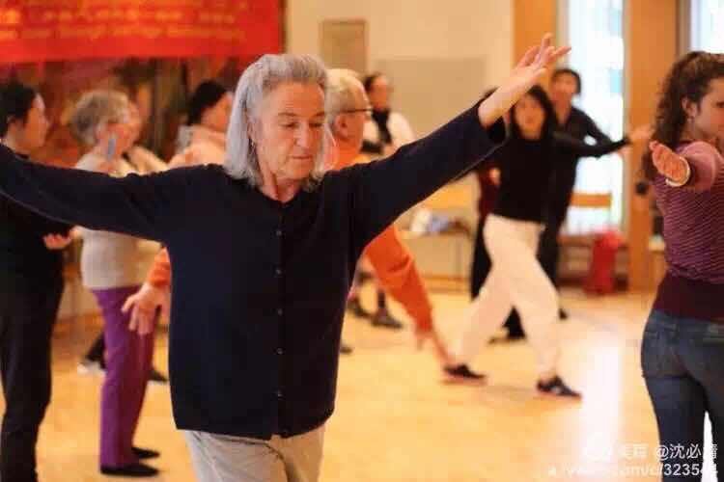
第二期【少林气功内劲一指禅班】师资班（瑞士苏黎世）2016.3
2nd Shaolin Qigong Yi Zhi Chan Teacher training Zurich Switzerland 2016.3

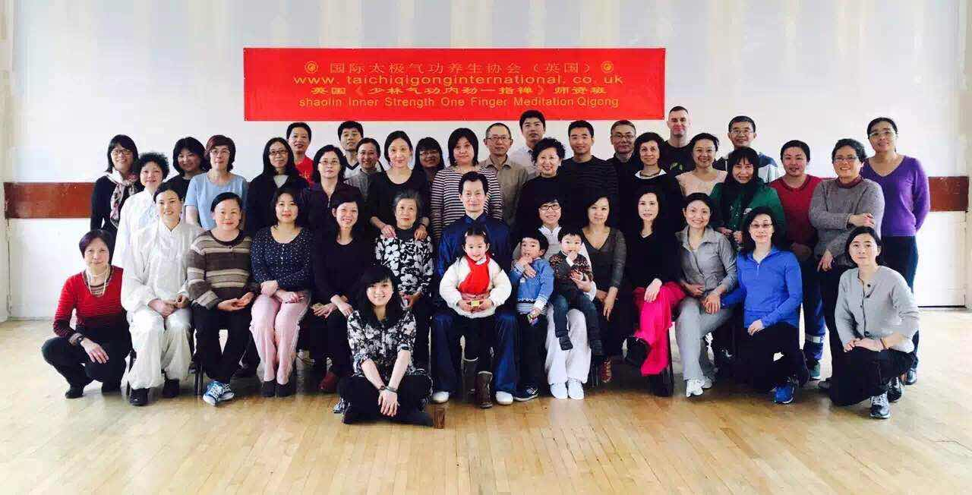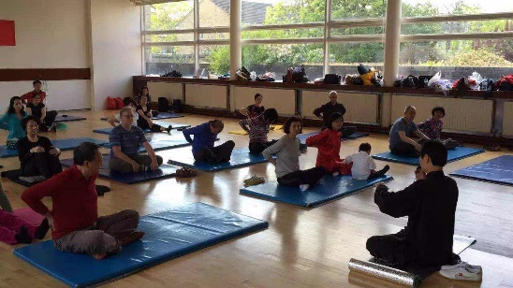
第三期【少林气功内劲一指禅班】师资班（英国伦敦）2016.3
3rd. Shaolin Qigong Yi Zhi Chan Teacher training London UK 2016.3

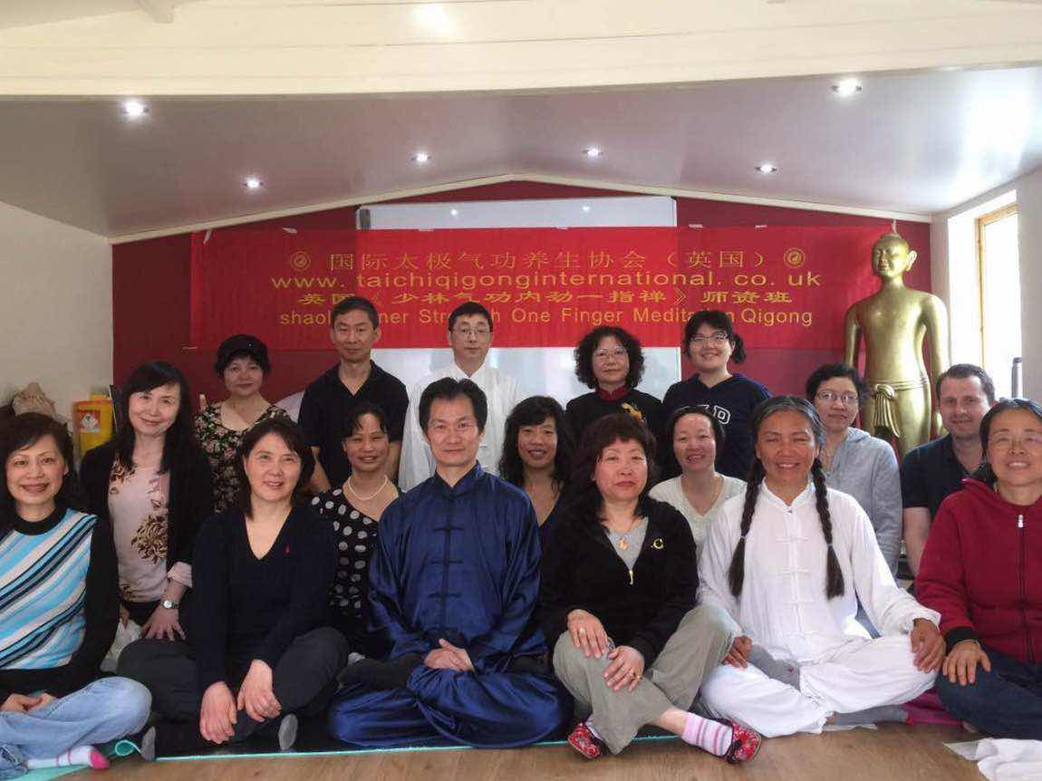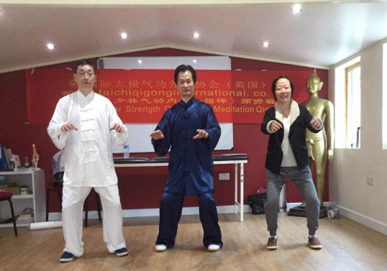
第四期【少林气功内劲一指禅班】师资班（英国曼彻斯特）2016.4
4th Shaolin Qigong Yi Zhi Chan Teacher training 2016.3

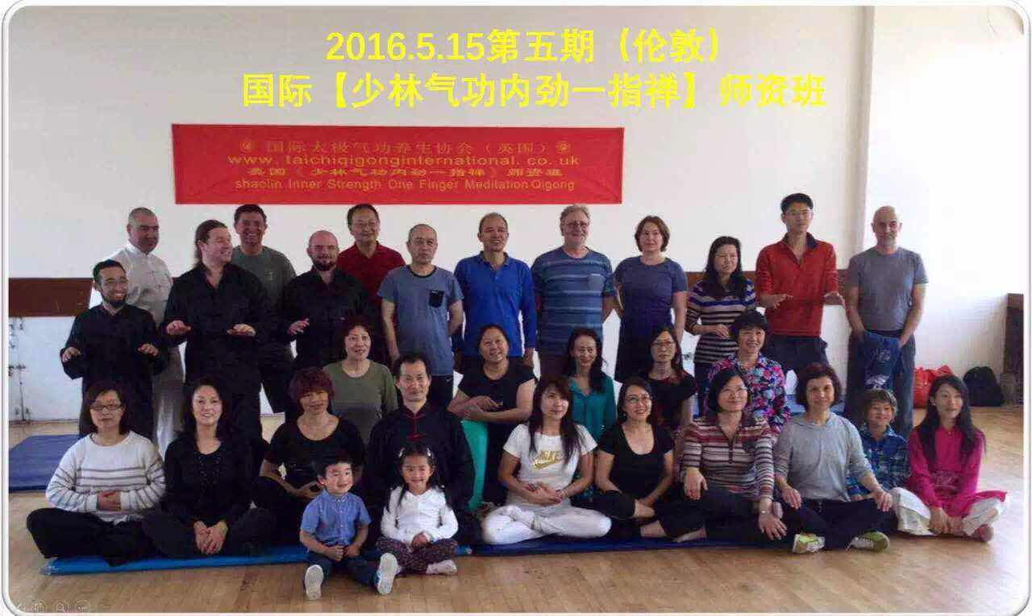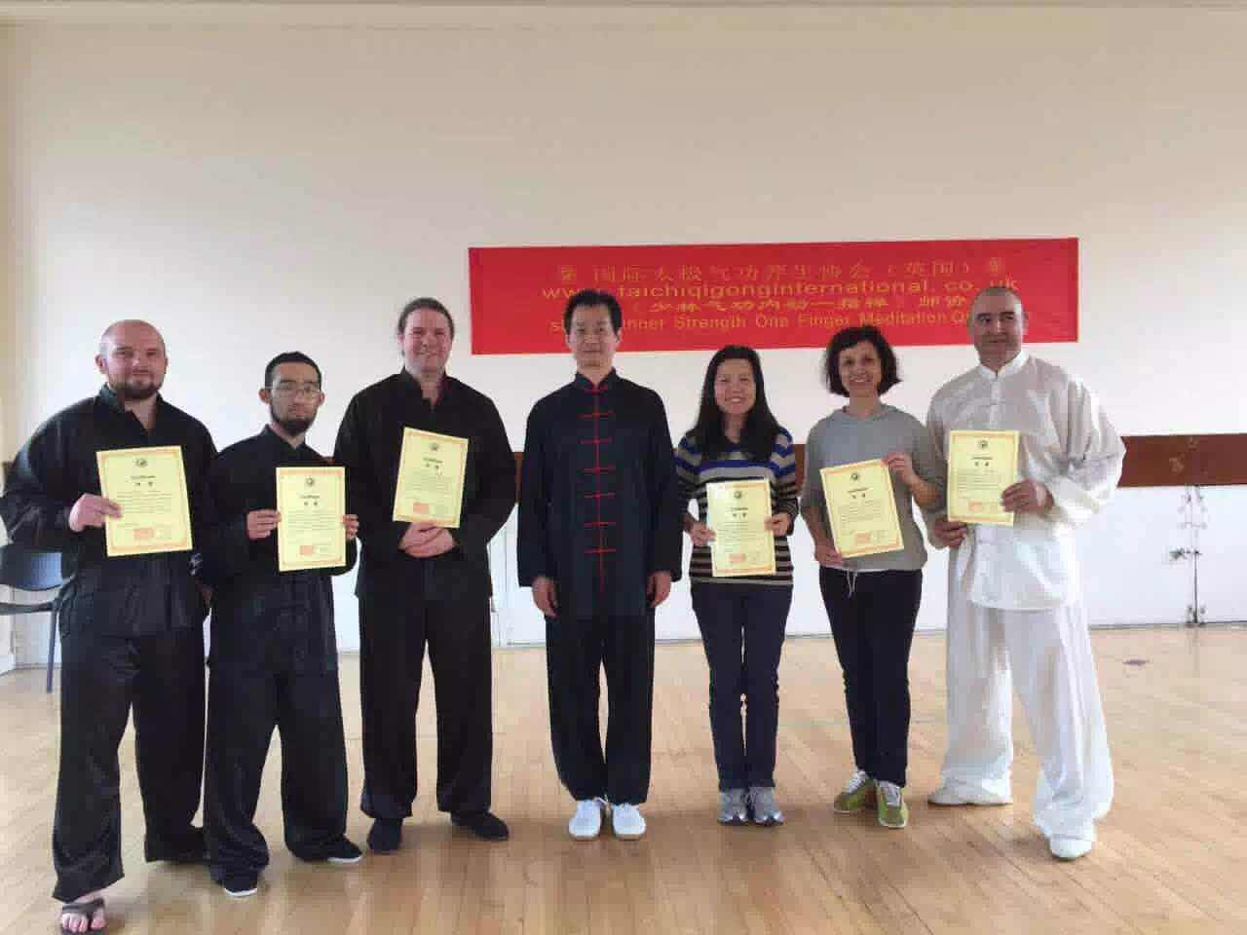
第五期【少林气功内劲一指禅班】师资班（英国伦敦）2016.5
5th Shaolin Qigong Yi Zhi Chan Teacher training 2016.5
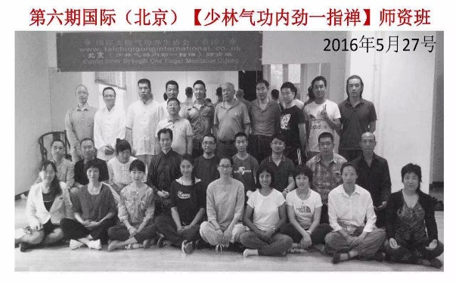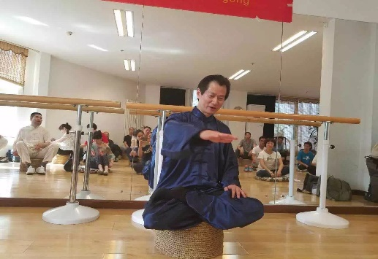
第六期【少林气功内劲一指禅班】师资班（中国北京）2016.5
6th Shaolin Qigong Yi Zhi Chan Teacher training, Beijing China 2016.5
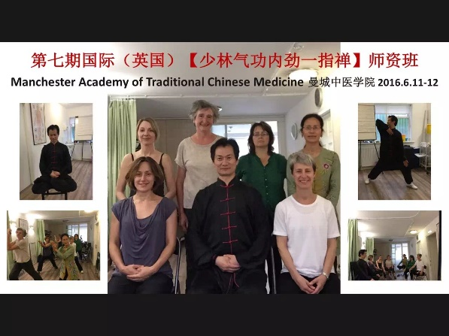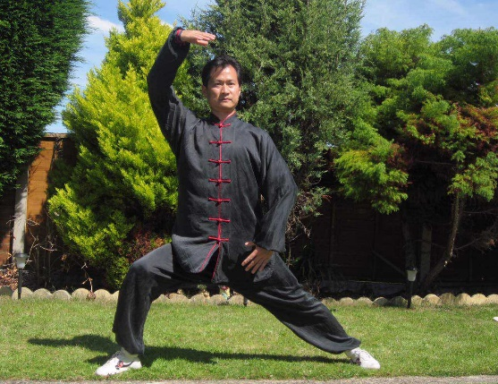
第七期【少林气功内劲一指禅班】师资班（英国曼彻斯特）2016.6
7th Shaolin Qigong Yi Zhi Chan Teacher training Manchester UK 2016.6
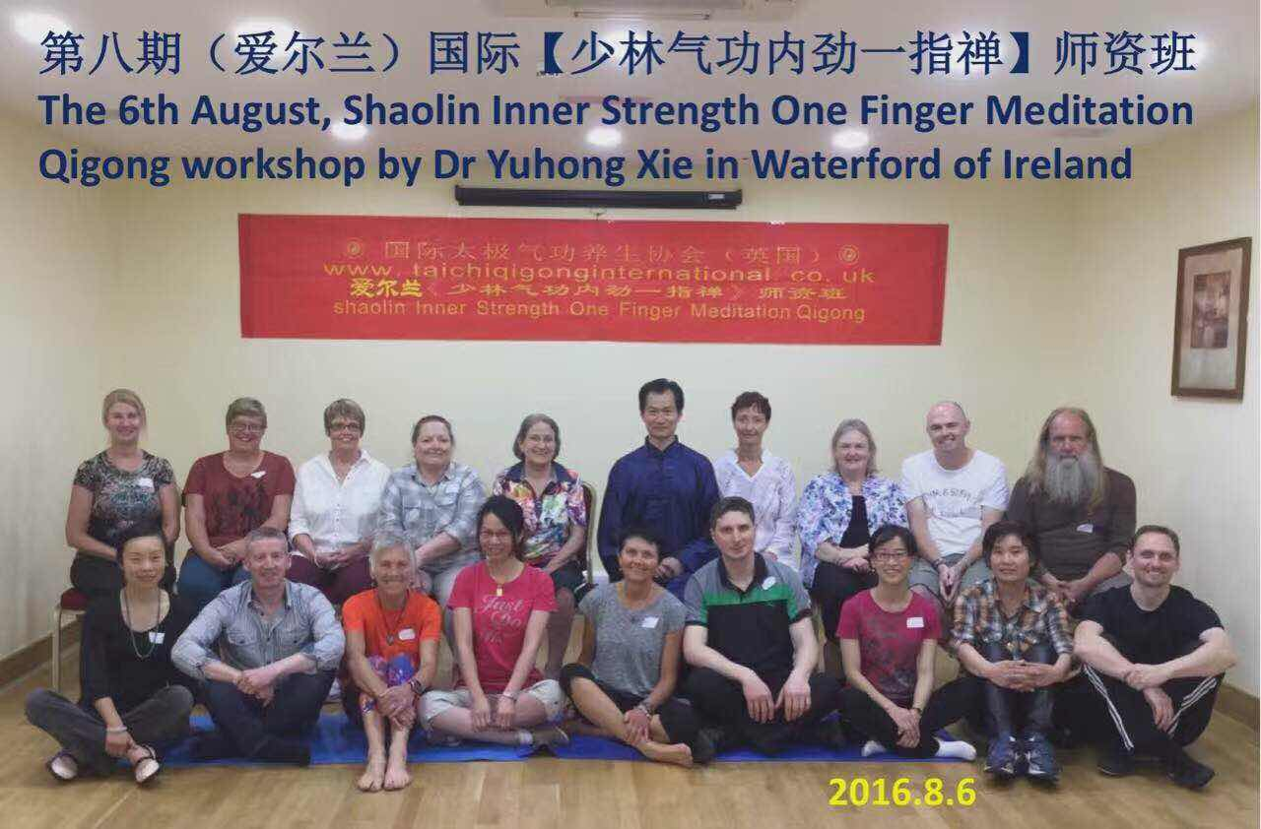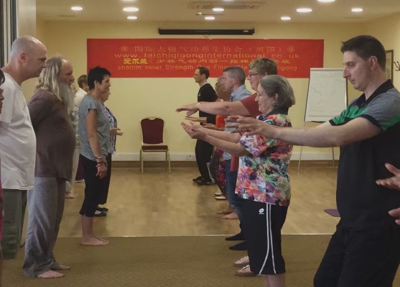
第八期【少林气功内劲一指禅班】师资班（爱尔兰沃特福德）2016.8
8th Shaolin Qigong Yi Zhi Chan Teacher training Watford Ireland 2016.8
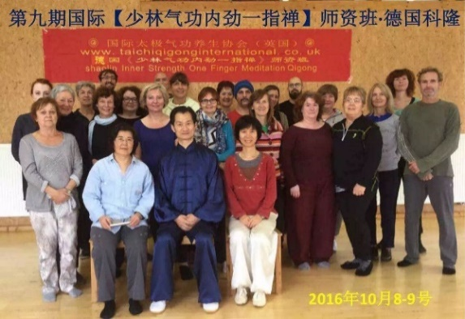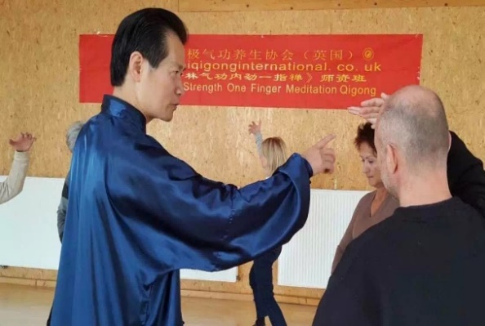
第九期【少林气功内劲一指禅班】师资班（德国科隆）2016.10
9th Shaolin Qigong Yi Zhi Chan Teacher training Cologne Germany 2016.10
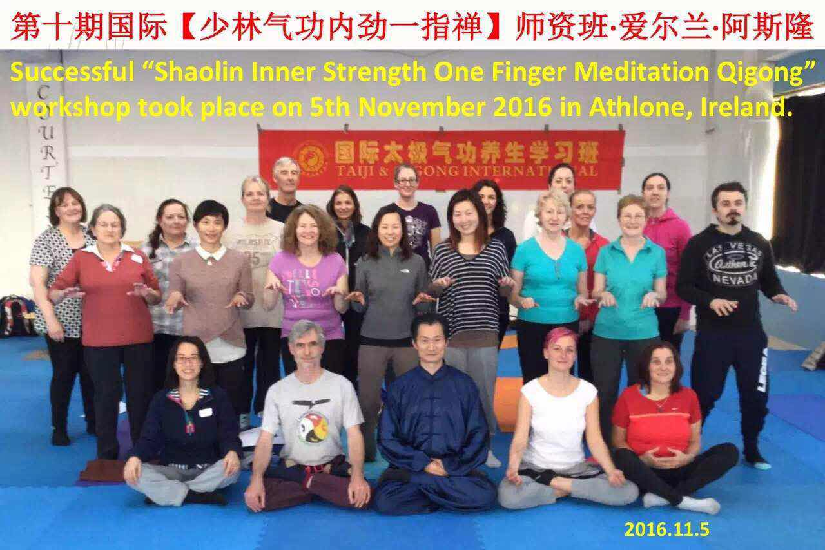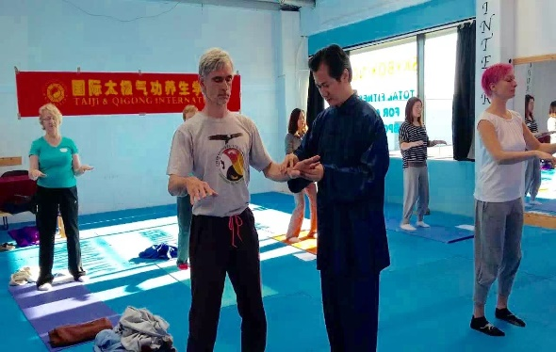
第十期【少林气功内劲一指禅班】师资班（爱尔兰阿斯隆）2016.11
10th Shaolin Qigong Yi Zhi Chan Teacher training Athlone Ireland 2016.11
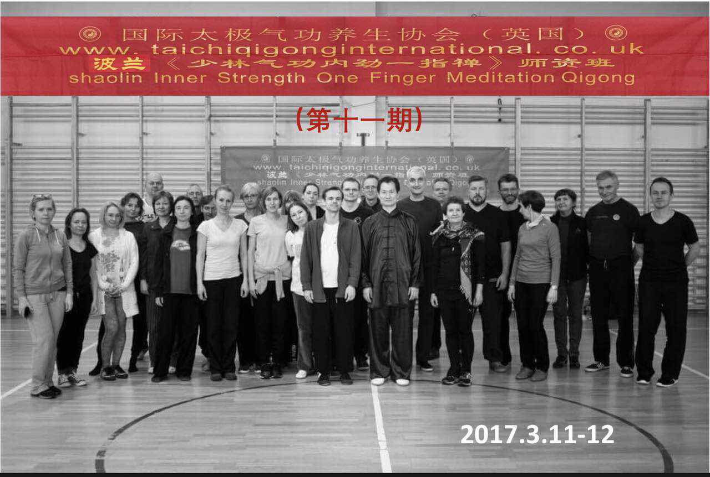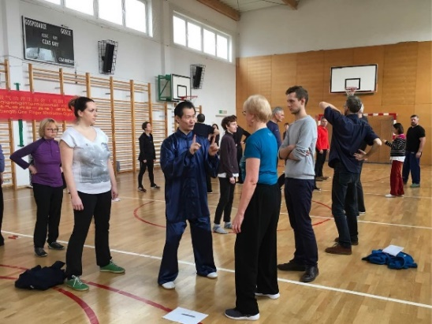
第十一期【少林气功内劲一指禅班】师资班（波兰华沙）2017.3
11th Shaolin Qigong Yi Zhi Chan Teacher training Warsaw Poland 2017.3
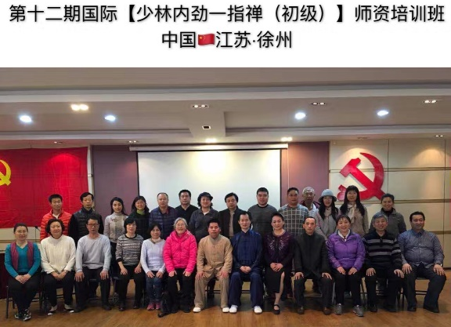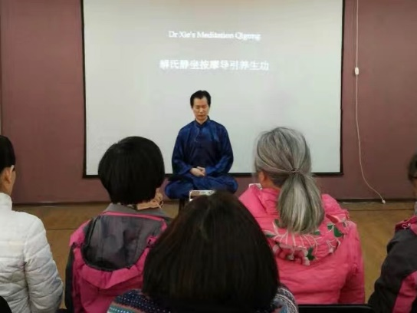
第十二期【少林气功内劲一指禅班】师资班（中国徐州）2017.3
12th Shaolin Qigong Yi Zhi Chan Teacher training Xuzhou China 2017.3
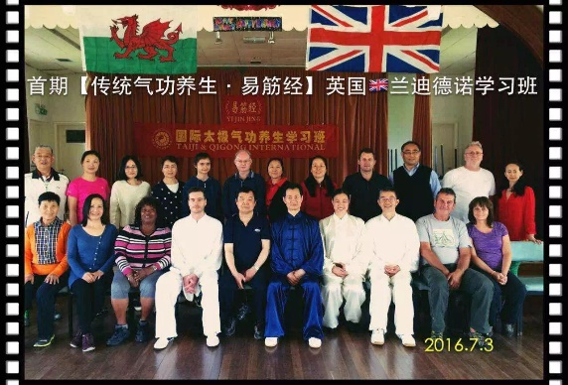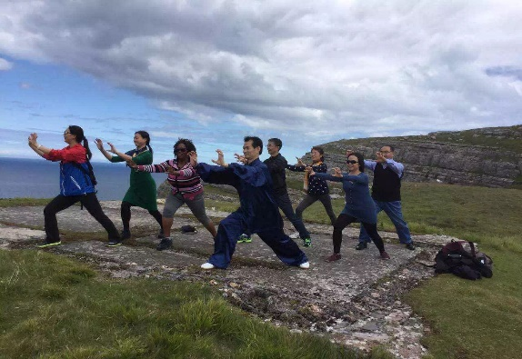
首期（总第十三期）【传统气功养生--易筋经】学习班（英国Llandudno）2016.7
13th (1st) Traditional Qigong Health Preservation Workshop Llandudno UK 2016.7
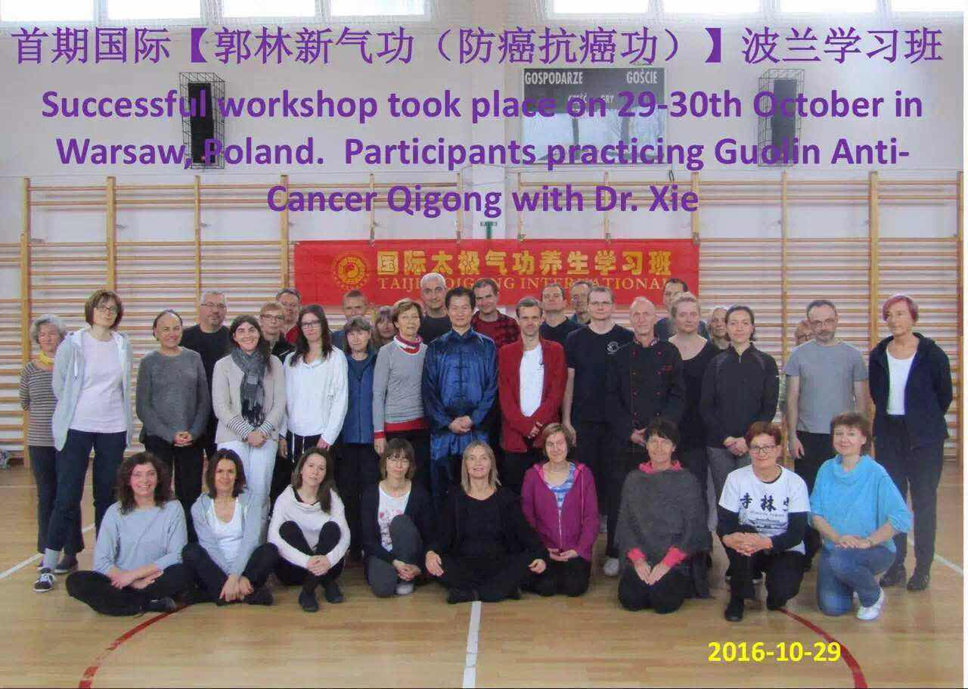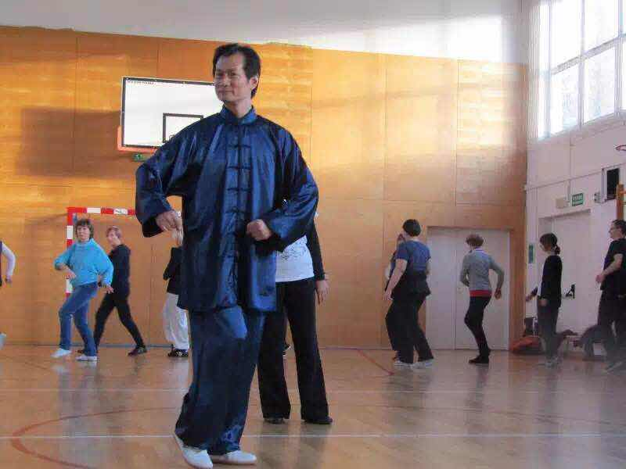
首期（总第十四期）【郭林新气功（防癌抗癌功）】学习班（波兰华沙）2016.10
14th (1st) Guolin New Qigong Anti Cancer & Prevent Cancer workshop Warsaw Poland 2016.10
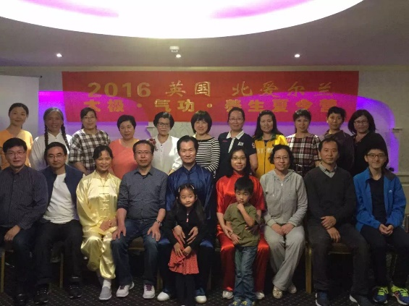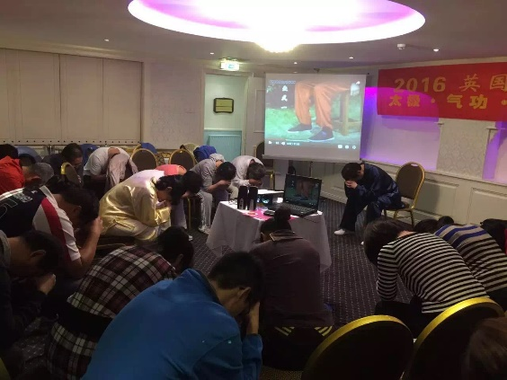
首期（总第十五期）【2016太极气功养生夏令营】（北爱尔兰）2016.8
15th (1st) 2016 Taiji Qigong health preservation Summer Camp Northern Ireland 2016.8
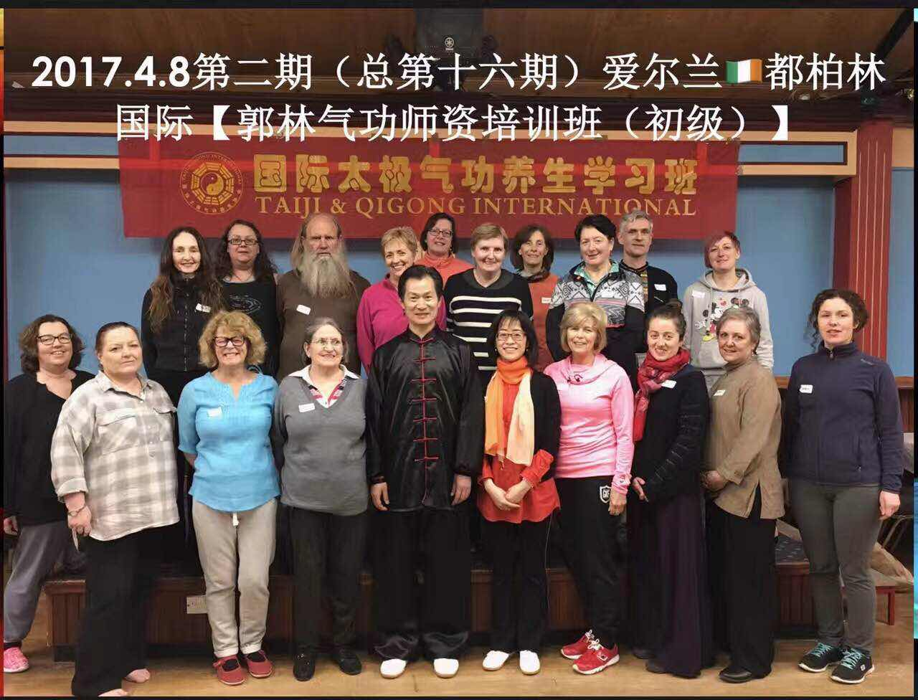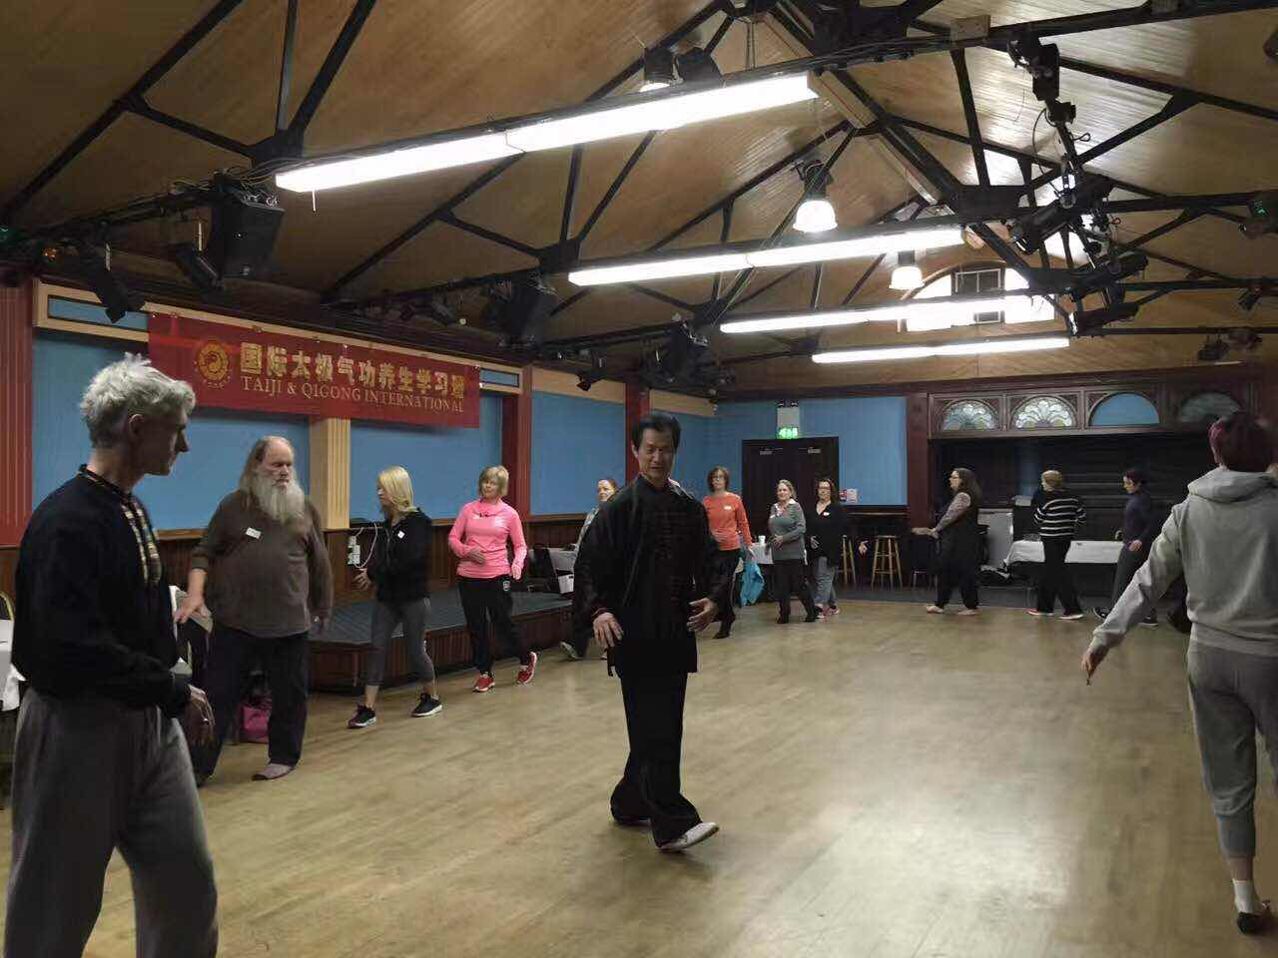
第二期（总第十六期）【郭林新气功（防癌抗癌功）】学习班（爱尔兰都柏林）2017.4
16th (2nd) Guolin New Qigong Anti Cancer & Prevent Cancer workshop Dublin Ireland 2017.4
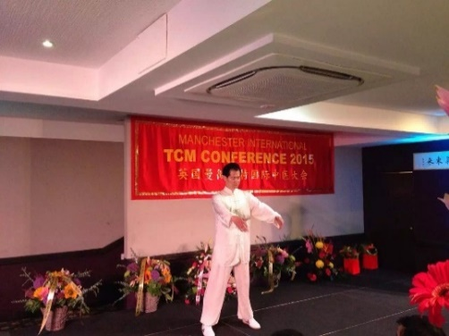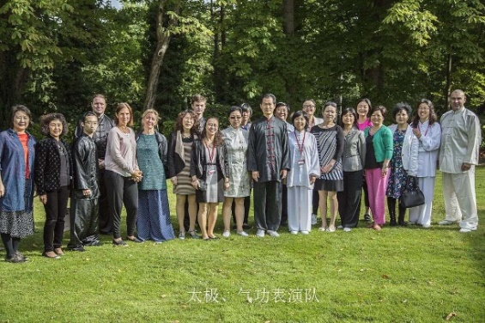
2015.7 在英国曼城国际中医药大会上带领学员表演团队演示太极气功
2015.7 Qigong demonstration with students in International Chinese Medicine Conference Manchester UK
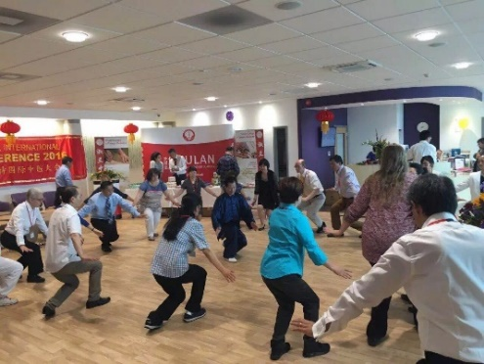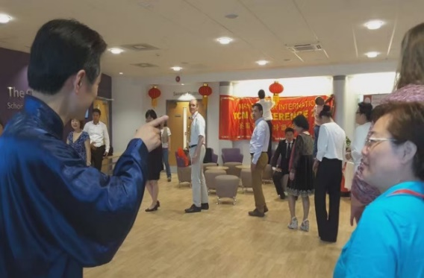
2016.7 在英国曼城国际中医药大会上带领与会的专家代表学练《防癌抗癌郭林气功》
2016.7 International Chinese Medicine Conference practise Anti Cancer & Prevent Cancer Guoling Qigong with delegates
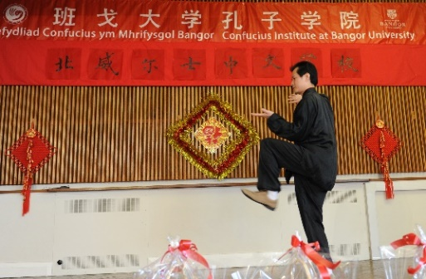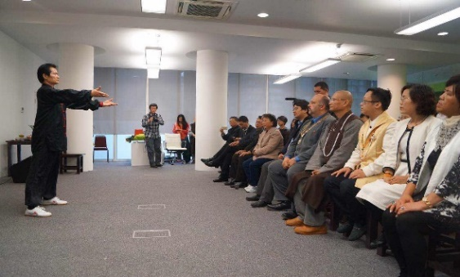
在班戈大学2012春节联欢会上表演太极拳2015.12在伦敦华夏文教基金会上演示易筋经
2012 Taiji performance at Chinese New Year Celebration Bango University
2015.12 Perform YiJinJing at Conference of Huaxia Culture & Education Foundation UK
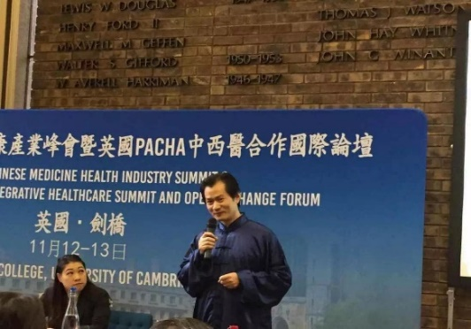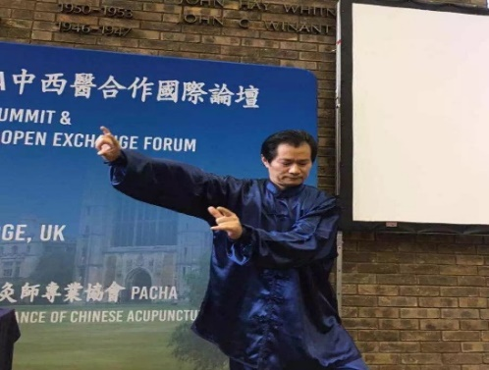
2016.11在剑桥大学丘吉尔学院英国PACHA中西医合作国际论坛上演示《华佗五禽戏》
2016.11 Perform “Hua Tuo Wu Qin Xi” at Churcill College University of Cambridge UK PACHA Chinese Medicine Health Industry Summit
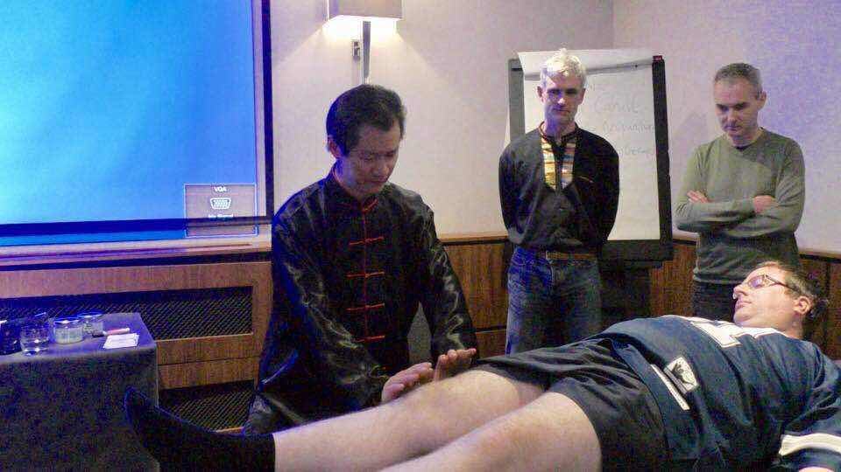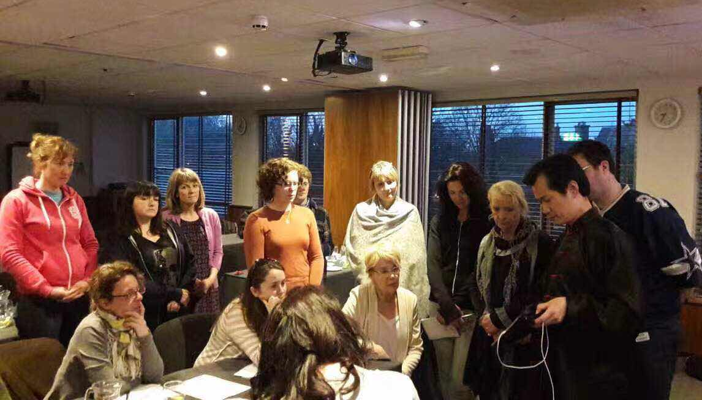
在爱尔兰都柏林给针灸推拿理疗师们讲解【YUHONG 🌏气针导引疗法】2017.4
Dr.Xie taught the theropy of Qi, Zhen and Daoyin in Dublin,Ireland on April 2017

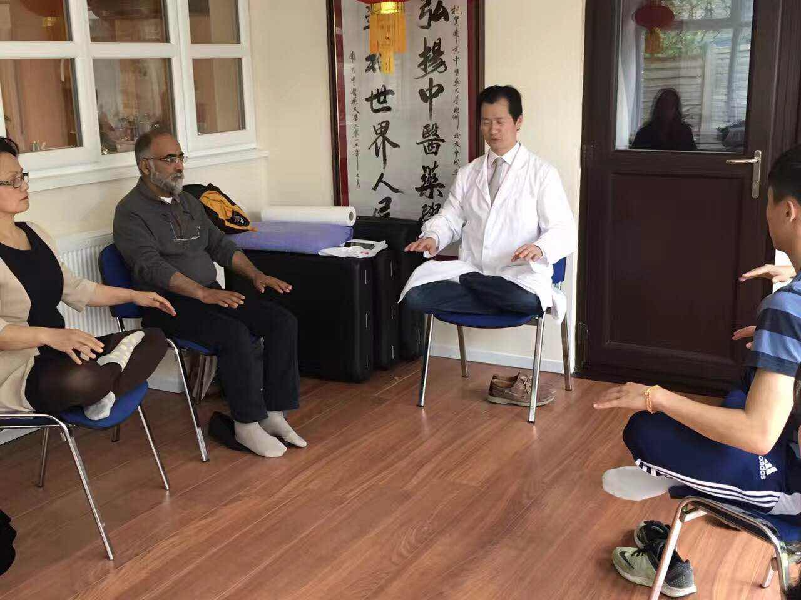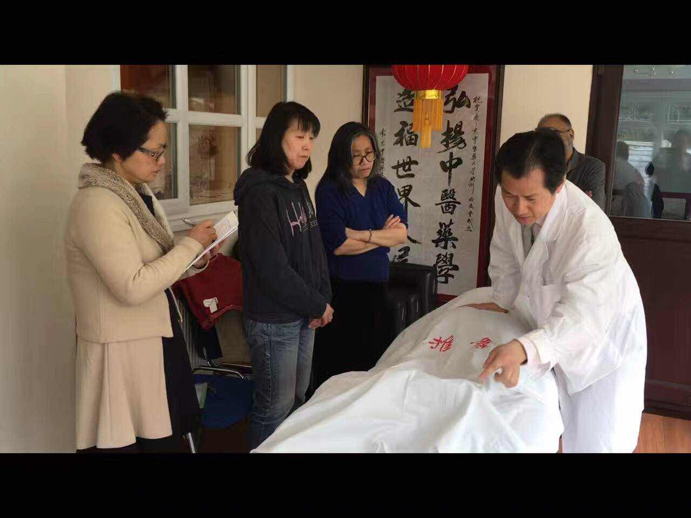

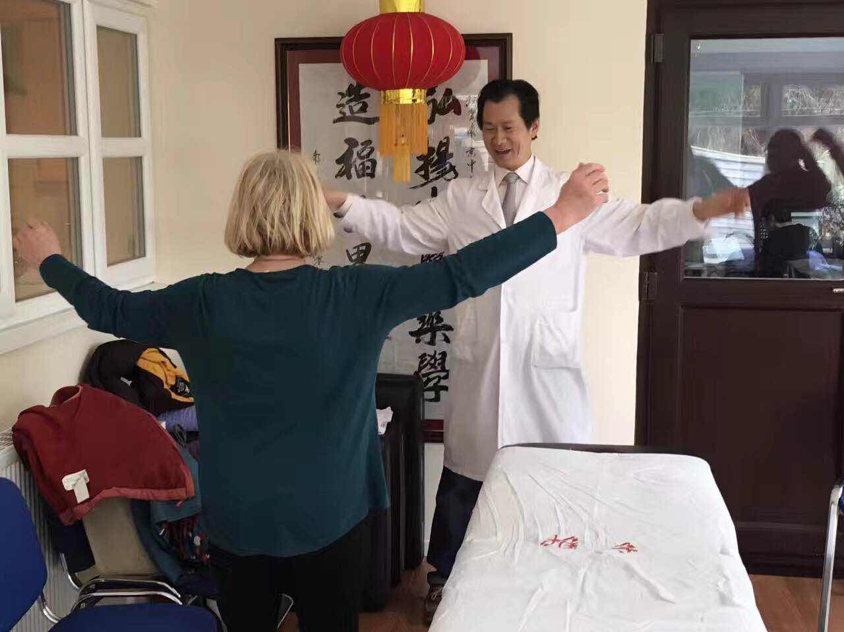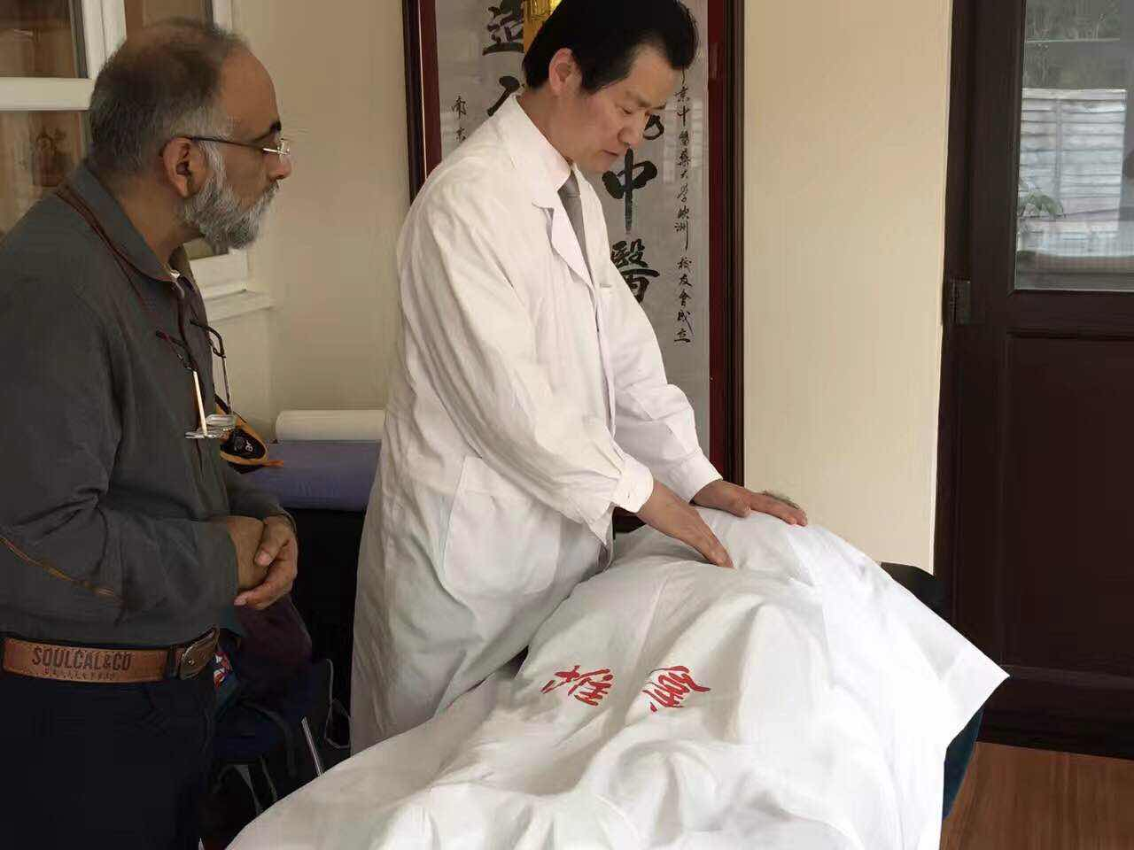

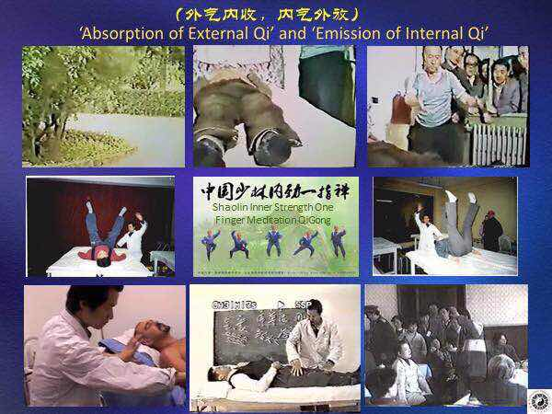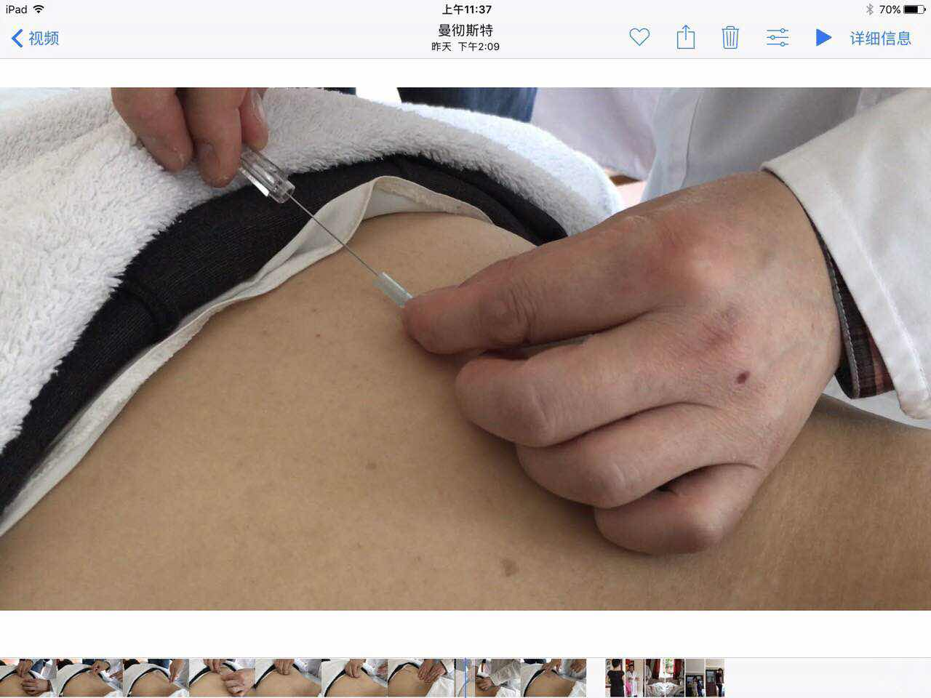
在英国曼彻斯特淑兰中医学院给学生们讲解【YUHONG 🌏气针导引疗法】2017.4
Dr.Xie taught the theropy of Qi, Zhen and Daoyin at Shulan College of TCM, UK on April 2017

气针导引疗法，是解余宏博士在总结他自己二十多年临床经验的基础上首次提出的气、针、导引三结合的中医治疗方法，这里的气针包括气指针（以指代针)、气毫针（普通针灸针）、气浮针（特殊针具），是将气功外气运用于针灸推拿临床的独特的中医治疗手段，效果神奇；这里的导引指医者或施术者运气于患者的治疗部位以助气血运行，并指导患者有针对性地练习辨病辩证医疗气功功法。
Dr. Xie (PhD & Medical Doctor) is the first to summarize the Combined Traditional Chinese Medicine (TCM) Therapy of Qi, Needle and Daoyin, based on his clinical experience for over twenty years.
Qizhen (Qi needles) consists of Qi Zhen（using finger with Qi as needle)，Qi Hao Zhen (Qi on normal acupuncture needle) and Qi Fu Zhen (Qi on special needle). This unique clinical treatment method uses external Qigong healing in acupuncture and Tuina (Chinese medical massage). The effects are commendable. Daoyin (guiding energy) means the doctor or practitioner emits Qi onto the affected area to promote the patient’s Qi and blood circulation, and also guides the patient to practice specific medical Qigong exercise which assists in identifying and healing diseases.
二、1992-2005年，在南京中医药大学教授《中医气功学》、《中医养生学》、《中医老年病学》等课程，其间参加了中国健身气功管理中心举办的首期《易筋经》、《五禽戏》、《六字诀》、《八段锦》等功法的学习。在医学气功教学临床科研和普及推广方面做了大量有成就性的工作：
II. From 1992 - 2005, Dr. Xie taught many courses in Nanjing University of Traditional Chinese Medicine, such as: "Chinese medical Qigong", "Health Preservation in traditional Chinese medicine ", "Gerontology in Chinese medicine". He also participated in the first training courses organized by the China Qigong Health Management Center: "Yi Jin Jing "," Wu Qin Xi ","Liu Zi Jue”," Ba Duan Jin ", etc.. Dr. Xie has made great contributions in the clinical research, teaching and promoting of medical Qigong.
1.能将气功和中医中药、针灸、推拿有机结合起来运用于临床治疗，对临床疑难病症（高血压、糖尿病、肿瘤等）的治疗具有非常显著的疗效。
1. Combining Qigong, traditional Chinese medicine, acupuncture, and massage in clinical treatment of difficult disease (high blood pressure, diabetes, cancer, etc.). The treatment has a very significant effect.
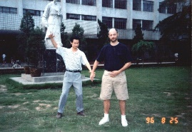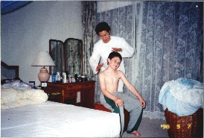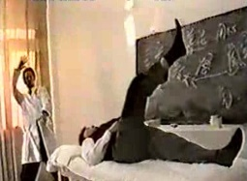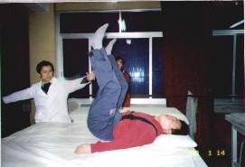
1996西班牙病人 1998德国病人 1999台湾学生 2000韩国学生
1996 Spanish patient 1998 German patient 1999 Taiwan student 2000 Korean student
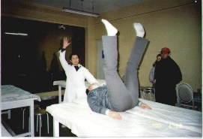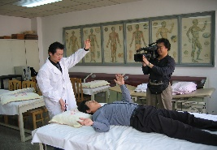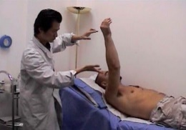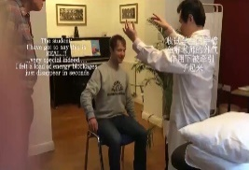
2000日本病人 2002中国病人 2004英国病人 2017英国学生
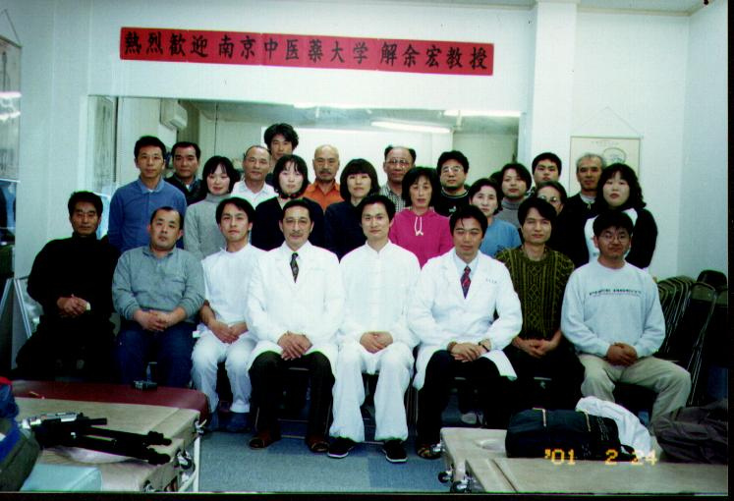
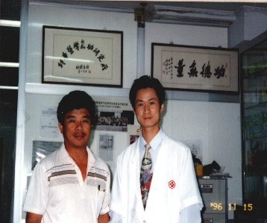
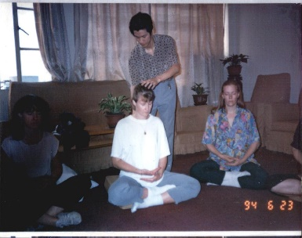
2000 Japanese patient 2002 Chinese patient 2004 UK patient 2017 UK student
1994指导德国学生练功 1996在印尼首都雅加达讲学 2001在日本综合整体学院讲学
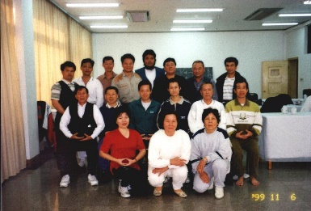
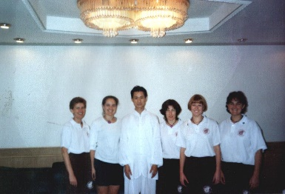
1994 supervise German students practise 1996 Lecture in Indonesia 2001 Lecture in Japan
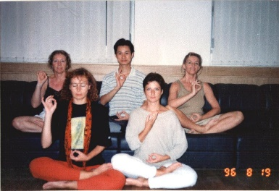
2.曾先后应邀出访了印度尼西亚、韩国和日本等国讲学及指导气功医疗临床工作，受到了国外友人的广泛赞誉。十多年来，培训和指导美国、英国、法国、意大利、澳大利亚、比利时、挪威、西班牙、韩国、泰国、台湾等数十个国家和地区的学生一千余人学习医疗气功。
2. Dr. Xie has been invited to visit Indonesia, South Korea and Japan and other countries to teach and supervise the clinical work of Qigong, he has been widely praised by foreign friends. Over the past ten years, Dr. Xie has been teaching medical Qigong to over one thousand students from more than ten countries: United States, Britain, France, Italy, Australia, Belgium, Norway, Spain, South Korea, Thailand, Taiwan and other regions.

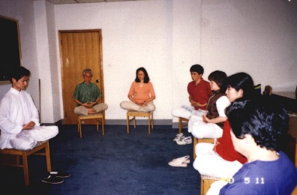
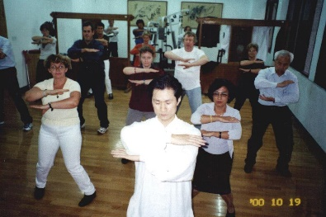
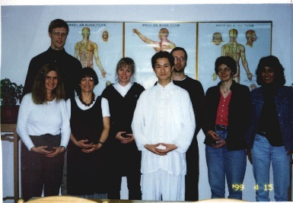
精心指导外国友人、长期及短期留学生学练医学气功
Supervising oversea friends, students to learn medical Qigong
3.在教学和临床的基础上，还积极投身于气功科研及著书立说：
1992年参加了江苏省教委课题“强身益智增视功的机理研究”工作。
1998年主持制作的《中医气功学》多媒体教学课件获得南京中医药大学优秀教学成果奖。
1999年参加了WHO的“老年心脑疾患的中医气功康复及其在社区服务中的运用”课题研究。
2000年主持的“气功疗法介入糖尿病教育”在NIDDM（Ⅱ型糖尿病）治疗中的应用研究，被江苏省中医药管理局立为重点研究课题。
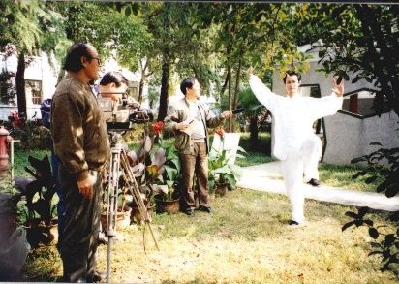
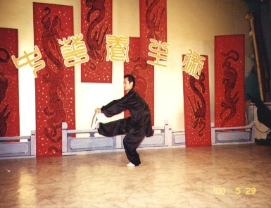
2001年，接受中央电视台、法国电视台、台湾纬来电视台的采访并摄制《气功养生术》28集，播出后引起了海内外的广泛好评。
多次接受电视台采访并摄制《中医气功养生术》、《传统医药大观》
Interviewed many times by TV. Appear in “Health Preservation in Chinese Medicine Qigong”. “Overview of Traditional Chinese Medicine”
3. Apart from teaching and clinical work, Dr. Xie has also actively engaged in Qigong research and writing books.
1992, participated Jiansu Province research project “The mechanism of strengthening health, intelligence and eyesight"
1998, produced "Chinese medicine Qigong" multimedia teaching courseware. The courseware was awarded outstanding teaching achievement award by the Nanjing University of Traditional Chinese Medicine.
1999, participated the WHO research project "Chinese medicine Qigong rehabilitation of heart and brain disease among elderly and its use in community services"
2000, his research project "Qigong therapy intervention in diabetes education" in the treatment of NIDDM (type Ⅱ diabetes) was listed key research project by Jiangsu Province Administration of Traditional Chinese Medicine.
2001, interviewed by CCTV, the French television station, Taiwan Weiyuan television. Made 28 episode TV "Qigong - preserving health". This program has been very well accepted and apprised home and abroad.
4.发表“气功疗法在高血压病康复中的运用”、“浅析少林气功对体内血液重新分布的影响”等论文二十余篇，并有5篇论文获优秀论文奖。多次参加国际医学气功大会，在2001年9月第八届上海国际医学气功学术研讨会上成功演示了少林气功布气导引。
4. Dr. Xie has published over 20 papers, 5 of them were awarded “Distinguish”. Such as: "Qigong therapy in rehabilitation of High Blood Pressure", "The impact of Shaolin Qigong on the blood redistribution in the body". He attended many International Medical Qigong Conferences. In September 2001 on the 8th Shanghai International Medical Qigong Conference, he successfully demonstrated Shaolin Qigong Daoyin.
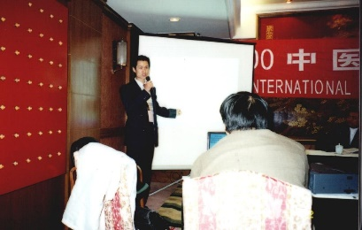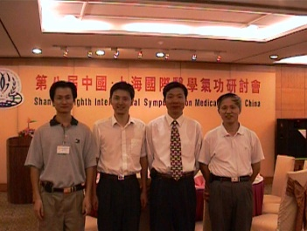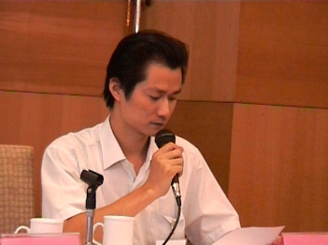
多次参加国际医学气功学术大会并在大会上演讲
Participated many International Medical Qigong Academic Conferences and delivered speech at the conference
5.出版了《中华辩证气功》、《祝您健康气功篇》、《春季进补》等专著三部，参加《中医气功学》、《中医治疗学总论》等高等中医药院校教材的编写。
5. Published "Chinese dialectical Qigong", "I wish you healthy Qigong", "Taking tonic in Spring". Participated in writing teaching text books for Universities of Traditional Chinese Medicine, including: "Chinese Medicine Qigong", "Chinese medicine therapy".
三、1990-1992，在江苏省气功科学研究会从事医学气功的调研和普及推广工作，向严新、庞鹤鸣、林厚省等二十多位气功名师学习儒、释、道、武术气功功法和医学气功治病技能。
III. From 1990-1992, worked in Jiangsu Province Qigong Science Research Institute, Dr. Xie engaged in medical Qigong research and promotion. He had the opportunities to learn from over twenty of the most well known Qigong masters in China: Yan Xin, Pang Heming, Lin Housheng, etc. He learned Confucianism, Buddhism, Taoism, martial arts and medical Qigong treatment skills.
四、1985-1990年，在南京中医药大学中医专业学习，获得医学学士学位，其间师从中国上海著名气功家，《少林气功内劲一指禅》第十九代传人王瑞亭老师学习，经过5年的刻苦锻炼，练就了很强的发放气功外气的能力。
IV. From 1985 - 1990, during his study in Nanjing University of Traditional Chinese Medicine, he learned "Shaolin Qigong Nei Jin Yi Zhi Chan" from Master Ruiting Wang (the nineteenth generation descendant of Shanghai’s famous Qigong family). After 5 years of hard training, he was able to have strong ability to emit Qi.
（THE END）

