For those completing this form for the families receiving the diapers please return to Brittney Henry or Email this form completed to bhenry@linkslikks.org If a family is self-referring they can email or call at my office number 330-620-4210 or my cell 330-760-0915 and if I am unavailable leave a detailed message with their name and diaper sizes needed.
Please keep in mind that each pack of diapers is individually hand wrapped. Diapers are distributed in packs of 25 for sizes NB-5 OR packs of 15 for size 6 and pull-ups. It is a first come first serve bases so we will do our best to accommodate based on what is available. Families can get 1 pack per child in diapers a month. If the size they need is not available they can go a size up or size down or they will be put on the waitlist for when the next supply of diapers is available. An appointment has to schedule for picking up diapers. All referrals will be processed on Fridays and pick up times will be scheduled for the upcoming week. Since the supply of Diapers are not always plentiful the diapers will be held for a week from the processing date then the family will be put on the waitlist, unless other arrangements are made

Date: _____________
Agency/Program: _______________________________________________________________
Case worker/Person making the referral: ____________________________________________
# Of children in the home ___ Ages of children in the home: _______Diaper Size(s): ________
# Of Working adult in the home: _________ Race/Ethnicity: ________________
Child’s Name: __________________________
Child’s Date of Birth: __________________________
Parent/Guardian’s Name: ________________________________
Home Address: _______________________________________________ZIP CODE: _____________
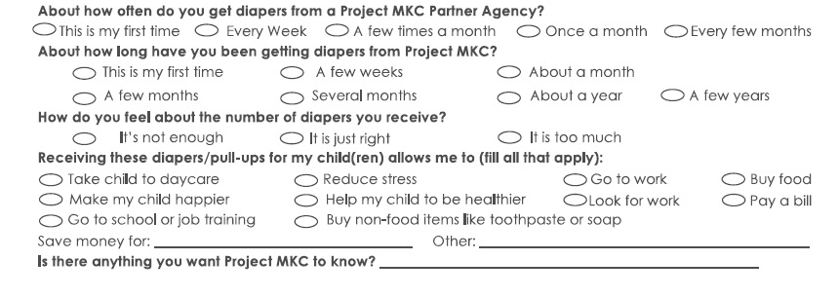
Phone: __________ Text? Yes / No Email: ___________________

