**HIGHLAND COUNTY BOARD OF DEVELOPMENTAL DISABILITIES**

**2019 ANNUAL REPORT**

*“Ensuring effective systems are available to assist people in achieving their life goals.”*



Early Childhood Services 937-393-4237

Service and Support, Residential, Intake, Family Support Services 937-393-4237

Community First Services 937-393-4237

**

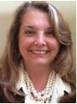From the desk of HCBDD Superintendent, Ms. Deb Buccilla

+++++++++++++++++++++++++++++++

Welcome to the 2019 Annual Report. We are excited to share information about all the things we have been up to over the last year. Our service delivery has been at an all-time high, touching approximately **500** individuals and families throughout the county. We serve newborn babies through toddlers in our Help Me Grow and Early Intervention programs; children 3-5 years in our integrated preschool; youth 14-22 in partnership with our local schools and adults throughout their life span.

Our last tax levy was passed in 2009 for the purpose of serving 285 individuals. We are so proud that we have been able to serve almost double the intended population without asking tax payors to consider additional tax levy monies. We have accomplished this by maximizing billing opportunities, securing grants and being frugal in our spending.

In 2019, we continued innovative programming, were recognized for outstanding work and maximized opportunities for creativity for those being served. We are delighted to share our story with you.

Sincerely,

Deb Buccilla, Superintendent

HCBDD Service Information

|  |  |  |  |
| --- | --- | --- | --- |
|  |  |  |  |
|  | Total Served | | |
|  | 2019 |  |  |
| **Advocacy** | 15 |  |  |
| **Preschool** | 54 |  |  |
| **Early Intervention** | 103 |  |  |
| **HMG Part C** | 173 |  |  |
| **HMG Home Visiting** | 129 |  |  |
| **Transition Youth/Employment** | 93 |  |  |
| **Special Olympics** | 103 |  |  |
| **SSA** | 218 |  |  |

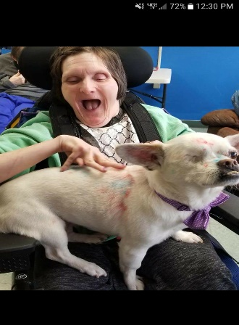**SERVICE & SUPPORT ADMINISTRATION**

The Service and Support Administration provided eligibility determination and service coordination to over **218** people in 2019. We continue our commitment of ensuring that people receive services which enhances the quality of their lives while promoting person-centered choices. This work is accomplished through services we provide that include, but are not limited to, assessment, person-centered planning, referral, linkage and monitoring.

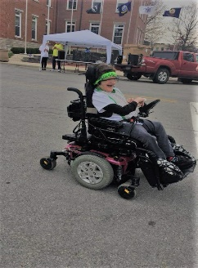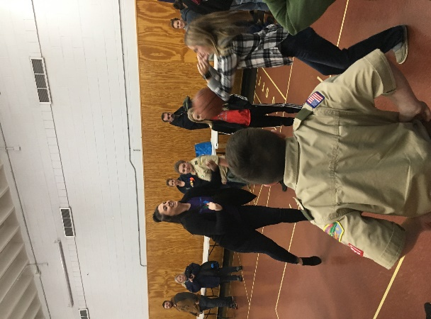Over the last year, the SSA department continued to enroll individuals on the Level 1, Individual Options and Self Empowered Life Funding (SELF) Waivers. The waivers provide funding for in-home supports for those individuals living on their own, or in shared home settings, in addition to day program supports. Twenty nineteen has been a true picture of helping people with developmental disabilities reach their personal goals. Some people are working towards job opportunities in the community while others are learning to live more independently and exploring their communities. SSAs are instrumental in being advocates for clients and often join them at various community functions, school IEP meetings and HCBDD events.

The Service & Support Administration Department is also responsible for the identification of trends and patterns involving major unusual incidents and identifying preventative measures for cases involving abuse, neglect, misappropriation and unscheduled hospitalizations.

The SSA Department is excited to report that provider options for individuals continues to increase, both agency and independent, allowing for choice of services in day to day lives. Two residential provider agencies have expanded services offering new day habilitation options for people.

Through Service and Support Administration, people are connected to services offered by the Highland County Board of Developmental Disabilities and other community partners. The Community First and Early Childhood departments work together to bring many services to the county.

**HCBDD COMMUNITY FIRST**

The Community First division is comprised of services including the Transition-Age Youth Program, Employment Services, Special Olympics, the People First Advocacy Group, Next Chapter Book Club and the Up and Beyond Art Studio**.**



The *Pre-Employment Transition* service is in the 4th year. In 2019, there were **80** youth who were served, which is an all-time high. Students ranging from age 14-22 years old from Bright Local, Hillsboro City Schools, Greenfield McClain, Fairfield, Lynchburg-Clay, FRS Connections, Hillsboro Christian Academy, Laurel Oaks, Southern Hills CTC and home-schooled students participated in pre-employment skills training. This instruction consists of Instruction in Self-Advocacy, Job Exploration Counseling, Workplace Readiness Training, Work Based Learning, and Counseling on Post-Secondary Options. Transition Coordinators work with each student to complete the modules with the goal of working in the community or attending additional educational experiences, leading to a career.

Each student is connected to Opportunities for Ohioans with Disabilities (OOD) and upon completion of the Pre-Employment Transition Services, support remains to assist in seeking a job in the community. Our *Employment Services in Job Development*, which also began in 2019, is an invaluable resource for our clients because they have access to local jobs for which they are trained.

The *Highland County People First Advocacy* group was busy in 2019, representing Highland County at monthly regional meetings in Ross County, participating in legislative days at the Ohio Statehouse, giving testimony to congressional committees, and participating in statewide meetings. A highlight of 2019 was advocating for the wage increases for Direct Support Professionals. A group of people standing in front of a crowd
Highland County members testified before the Ohio House and Senate committees in favor of the increase and rallied at the Statehouse.

Another highlight from the organization of the Community First Dept. was a Goat Show at the Highland County Fair. Several school-aged and adult participants paired up with 4-H participants and learned how to show a goat for judging and then they participated in the show together.

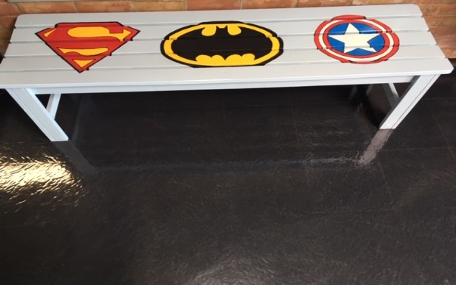The Up and Beyond Art Studio’s artists were busier than ever in 2019, participating in 14 fairs, festivals and bazaars. **41** who receive support from HCBDD benefitted from sales of their own artwork. Artwork has been requested for community-sponsored events and for the Hills and Dales preschool “Superhero” program. In total, the sales exceeded **$10,000**. This year we saw the expansion of the studio to a new location, with the addition of a wood shop. There are plans to make this a community venue for HCBDD artists to work alongside artists from the community while socializing and having fun. Stop by the studio on St. Rt. 50 in Hillsboro to purchase some interesting and beautiful artwork.

**Highland Special Olympics - 2019**



HCBDD had a very active Special Olympics program in 2019 having **103** athletes participating in many sporting events throughout the county and at state-wide events. Basketball was a very active sport having 3 different teams playing.

Flag football, Unified softball, bowling, cheerleading and golf kept athletes active throughout the year. Track and field events were held at Fairfield High School where 45 athletes participated. The Summer Games were again held at The Ohio State University where Highland County athletes brought home 15 gold medals, 4 silver and 3 bronze!

*The Special Olympics Pledge: Let me win. But if I cannot win, let me brave in the attempt.*

**OPERATIONS AND TRANSPORTATION**

Information Technology is the area that small government agencies have experienced attack by cyber criminals. We have increased our abilities to back up data, increase storage on and off site and continued training for our staff to heighten awareness of potential cybercrime. We have about **75** Highland County Board of DD staff and over **100** devices that we maintain for the staff. Through training and increased security measures, we will continue efforts to protect the sensitive information we use and store.

Highland County Board of DD transports about **50** to and from preschool each day. We travel over **254** miles throughout the entire county. Over the past three years, we have been transitioning from larger buses to smaller buses that are not as large to first time bus riders.



HILLS AND DALES PRESCHOOL

*“Where superheroes and super staff learn each day!”*

In 2019, our program had 4 all day Preschool Classrooms, 4 Intervention Specialists and 11 Paraprofessionals. We had **108** ages 3-5. We continually have large numbers of family participation from **65** for a Grandparent’s day, to **300** for Preschool Graduation.

Our program has implemented PBIS (Positive Behavior Intervention Systems) which has had a positive impact on our students’ behaviors. We have a set rule rubric that is used throughout the entire school setting, a Superhero theme, staff consistency in follow-through, and positive reinforcement-based practices that students respond well to. We continue to gain professional development around PBIS.

Our TBT (teacher-based team) meetings have successfully focused on student data, and we are incorporating Social Emotional Skills data from assessments into the data analysis and planning done in our monthly TBT meetings.

We have received further training on Communicable Diseases, Child Abuse, and meeting sensory needs of our students.

We continue to utilize the state-of-the-art Sensory Room to meet the needs of individual students through sensory breaks, as well as small group motor labs for all students. We have integrated Gym, Art, and Music in the weekly programming as well as Sign Language instruction.

We are most proud of the 5-STAR QUALITY RATING that we have maintained after an annual review from the Ohio Department of Education!



HELP ME GROW (HMG)

The HCBDD Help Me Grow home visiting program focuses on the early experiences of babies. A variety of early experiences is what shapes the brain for success in life. HMG serves families who have children that are prenatal to age three. It is a home visiting program that is voluntary and provides family support, education and advocacy for pregnant women and new parents. The service is offered in every county of the State of Ohio and HCBDD provides service in six counties: Adams, Brown, Clinton, Highland, Pickaway and Ross.

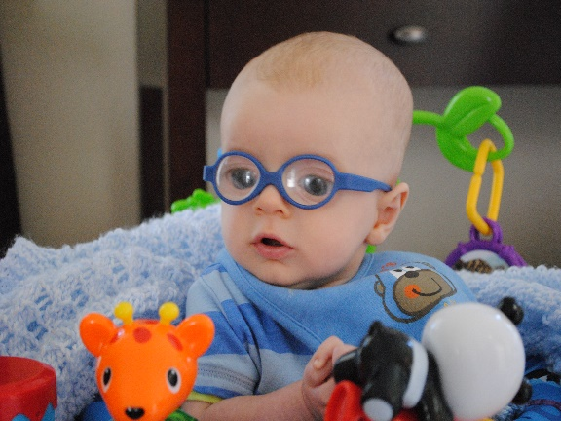

[This Photo](https://littlefoureyes.com/2010/10/22/your-stories-jacks-journey-with-infant-cataracts/) by Unknown Author is licensed under [CC BY-NC-ND](https://creativecommons.org/licenses/by-nc-nd/3.0/)

*HMG is funded thru the Ohio Department of Health and does not rely upon local tax dollars from HCBDD.*

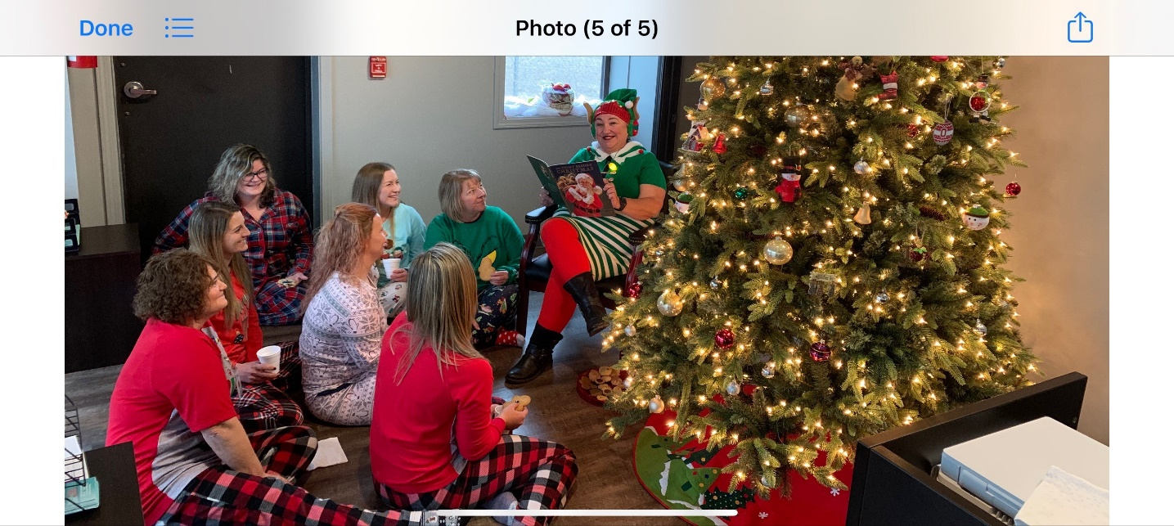In 2019, HCBDD HMG served **129** children in the program which is an increase of 33 families. During that time, we completed **1,915** home visits. HCBDD has been collaborating with the Regional Central Intake Agency (Butler County Educational Service Center) to help promote the program in all counties. During 2019, the home- visiting team continued to collaborate with the Early Intervention teams in Highland and Clinton Counties to help promote social development through play groups. Our home visiting team consists of **6** full-time home visitors, **2** part-time supervisors/home visitors and one program manager.

EARLY INTERVENTION (EI) in Highland County

**“**Why wait? Evaluate” is the mantra. Getting help at a younger age can benefit a child through an entire lifespan. Everyday learning opportunities and routines guide how the Early Intervention Team works with children and families to enhance development. These services are provided in the child’s natural environment and are centered on the interests, strengths, and priorities of the child and family. Little ones 0-3 can be referred for services in a variety of ways and reasons including a diagnosed medical condition or a suspected disability or delay. A new automatic diagnosis, added in July of this year, is infants diagnosed with NAS, Neonatal Abstinence Syndrome, also lead exposure. The infants and toddlers are assessed and evaluated for eligibility both to enter the program and as they transition into preschool. The board of DD works collaboratively with many agencies including the school districts. In 2019, 103 children were served by the EI team. The team consists of developmental specialists, nurse, occupational and speech therapist and contracted physical therapist, to serve children and coach families; building confidence and competence is an ongoing goal. The HCBDD also holds the Part C service coordination grant for Highland County and manages the Individual Family Service Plans. Additional programs include aquatic therapy, counseling and certified PLAY therapy along with a certified NBO, newborn observation clinician. Having gained popularity over the years, we continue to host monthly play groups and multi-agency activities to offer social interaction with peers, the families and the EI team. We provide an opportunity for the children to enjoy new activities in a fun, safe environment.

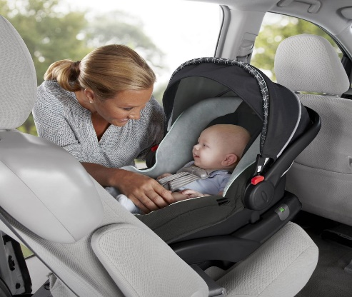

[This Photo](https://technofaq.org/posts/2017/09/where-to-put-a-car-seat/) by Unknown Author is licensed under [CC BY-SA-NC](https://creativecommons.org/licenses/by-nc-sa/3.0/)

2019 Board Members

Karen Adams, President

Elizabeth Fryman, Vice President

Cheryl Lyle, Secretary

Matthew Roberts

Michael Richards

Paul Pence

Charles Fulton

2019 Administrative Staff

Debra Buccilla, Superintendent

Sherry Burns, Executive Administrative Assistant

Lori More, Business Director

Larry Gray, Operations Director

Kraig Walker, Community First Director

Kelli Williamson, SSA Director

Suzie Janasov, Early Childhood Director

Stacy Hazelton, Education and Public Relations Director

Becky Pollard, Nurse

Jennifer Goodwin, Investigative Agent

**HCBDD**

**8919 US RT 50**

**Hillsboro, OH 45133**

**937-393-4237**

[www.highdd.org](http://www.highdd.org)

*“Ensuring effective systems are available to assist people in achieving their life goals.”*



[This Photo](http://educacionfisicaporproyectos.blogspot.com/2014/03/pagina-en-facebook.html) by Unknown Author is licensed under [CC BY-SA-NC](https://creativecommons.org/licenses/by-nc-sa/3.0/)