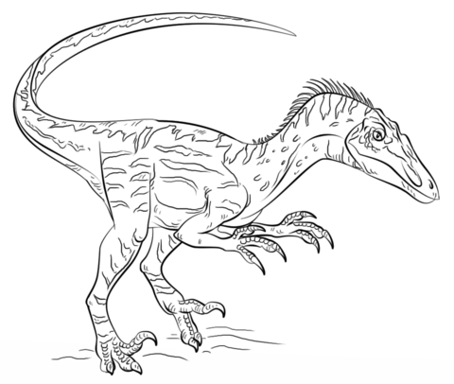
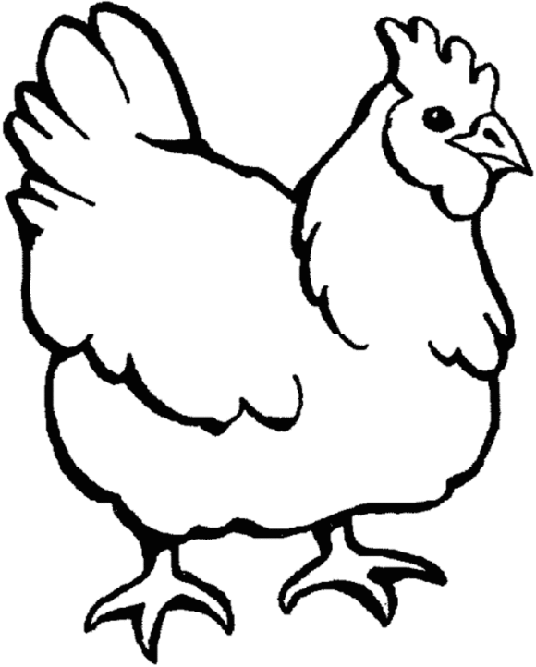
PPQG Challenge 2019

All Creatures Great and Small

We all love animals whether it’s our pets, zoo animals, or the critters frolicking outside our kitchen window! This year’s Challenge, “All Creatures Great and Small,” is a tribute to all of them. Our challenge is to make quilts containing animals in the fabric, in the quilting, in the piecing, or in the name of the blocks.

Completed quilts are due Friday, November 8, 2019 and MUST be available for BOTH PPQG meetings in order to be considered for judging. There will be a total of 4 prizes: 1st Place, 2nd Place, 3rd place, and Honorable Mention. Quilts will be judged by PPQG members taking into consideration theme, quilting, color, etc. Quilts will also be displayed at the 2020 Mid-Atlantic Quilt Show in Hampton.

Quilts must fulfill the following criteria:
- Quilts MUST contain at least one Creature (i.e. animal). Quilts can be a pieced animal picture, can use fabric containing an animal, can have an animal in the quilting, or can have blocks with an animal name. Animal content will be verified when presenting quilt for judging.
- Quilts should be completed in 2019. Quilts may not have been in a previous show.
- Quilts may be made using a purchased quilt pattern, but may NOT be made from a kit.
- Quilts must be 60” x 60” or smaller. Size will be verified when presenting quilt for judging.
- Quilts must include a label and a hanging sleeve. Instructions for a hanging sleeve can be found on the PPQG website.

There is a $2 entrance fee per quilt. Artist Statements, containing quilt name, artist name, and a descriptive paragraph about your quilt, should be emailed to Rhonda Gianturco on or before Friday, October 11, 2019.

Questions and Artist Statements can be emailed to Rhonda Gianturco at rgianturco@gmail.com.
