INSECT SPECIMEN PHOTOGRAPHY WITH PULUZ 60cm LIGHT BOX
Mike Taylor, Associate, World Museum Liverpool

INTRODUCTION

When I found the PULUZ Light Box advertised on E-bay whilst searching for ‘light box’, I was immediately attracted by its principal features. The design and construction appeared to have incorporated, within a practical portable arrangement, most of the features I had adopted in developing my own insect specimen photographic ‘work stations’ over the last twenty years.

The key features of my developed work station included controllable directional overhead lighting, ample manoeuvre room within the centre stage and space at the sides for flexible positioning of mirrors for directing ‘infill’ lighting.

The prices, ranging from £65 to £85, seemed very reasonable so I purchased one.

MY ASSESSMENT OF THE PULUS LIGHT BOX FOR INSECT SPECIMEN PHOTOGRAPHY

Some early tests on a small insect specimen of Machimus SP A (Diptera, Asilidae), wingspan 25mm and length 9mm, demonstrated that this equipment was capable of reproducing the results I have achieved with my own developed equipment.

The ability to separately ‘dim’ the two rows of LED lights was very useful, as I was able to adjust their brightness to give me the same exposure settings on the camera as is the case with my own UK and Greek equipment.

TEST RESULTS

It was soon obvious that the working space of the PULUZ equipment perfectly matched the space requirements of the angled camera and specimen stage ramps which I had developed previously.

The design proved to be very easy to use as I did not need to operate it with the front panel in its upward fixed position. This is because the angled camera/specimen ramp would have masked the specimen from the reflected light thrown forward from the inside surface of the front panel. I achieved the required ‘fill in’ lighting onto the lower parts of the specimen by deploying the same side mirrors I had already developed for this purpose for my own equipment, in a similar manner.

Fig 1 shows the seating arrangement and the PULUZ equipment in its operating position.
Fig 2 shows an angled stage being prepared for photography, the bright lighting being very helpful in this regard.
Fig 3 shows the angled stage with the two side mirrors in place ready to commence photography.
Fig 4 shows the specimen stage with microscope stage incorporated for fine adjustment of specimen position used in high magnification situations.

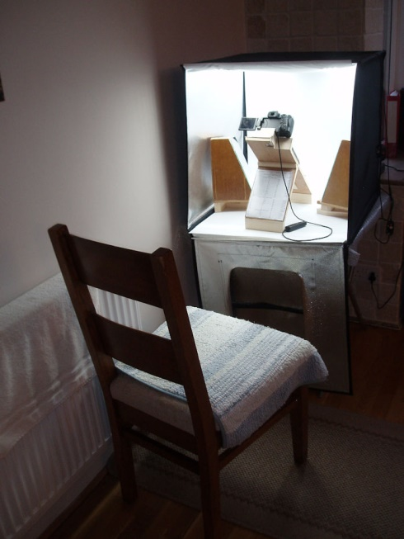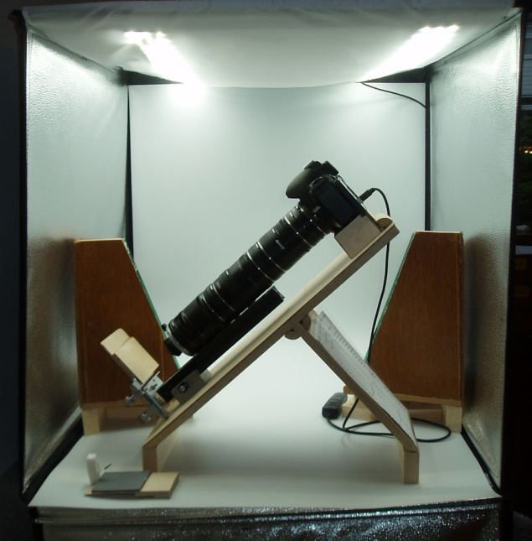
Fig 1 Fig 2

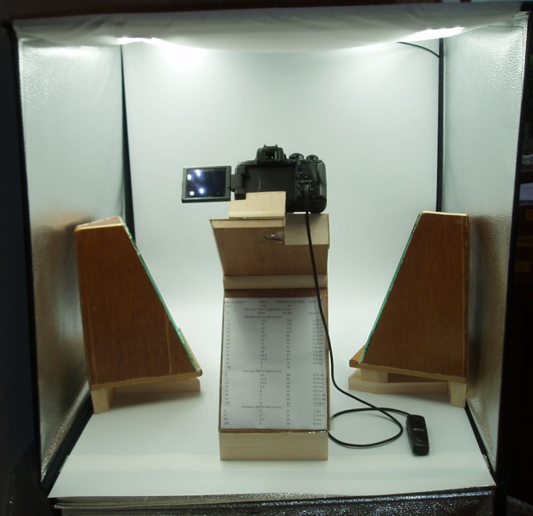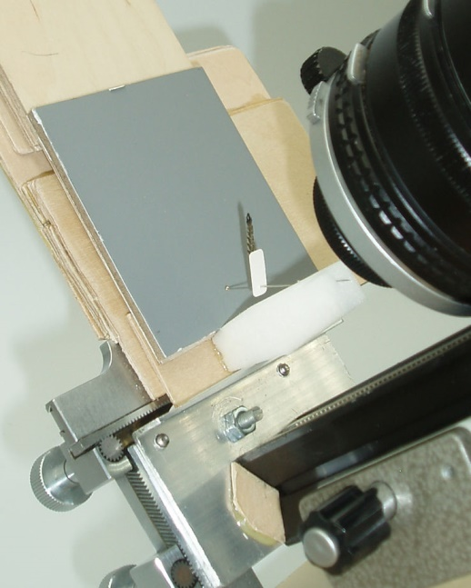

Fig 3 Fig 4

I tested a full range of Olympus Macro lenses from 50mm to 20mm focal lengths with extension tubes / bellows distances from zero to 250mm. This covered image fields of view from 1mm to 250mm. This enabled small diagnostic details and whole specimen images to be taken, all easily accommodated within the PULUZ Light Box.

Exposure tests showed that by dimming both of the LED light rows to 75% I matched the lighting of my UK and Greek equipment. Appendix 1 shows the range of Field Widths, Extensions Required, Working Distances and Exposure times required for a camera set at 100 ASA sensitivity, using (S) Speed priority, (MF) Manual Focussing and manual aperture setting on the lenses.

EXAMPLES OF PHOTOGRAPHS FROM PULUX, Machimus Sp A, Span 25mm Length 9mm.
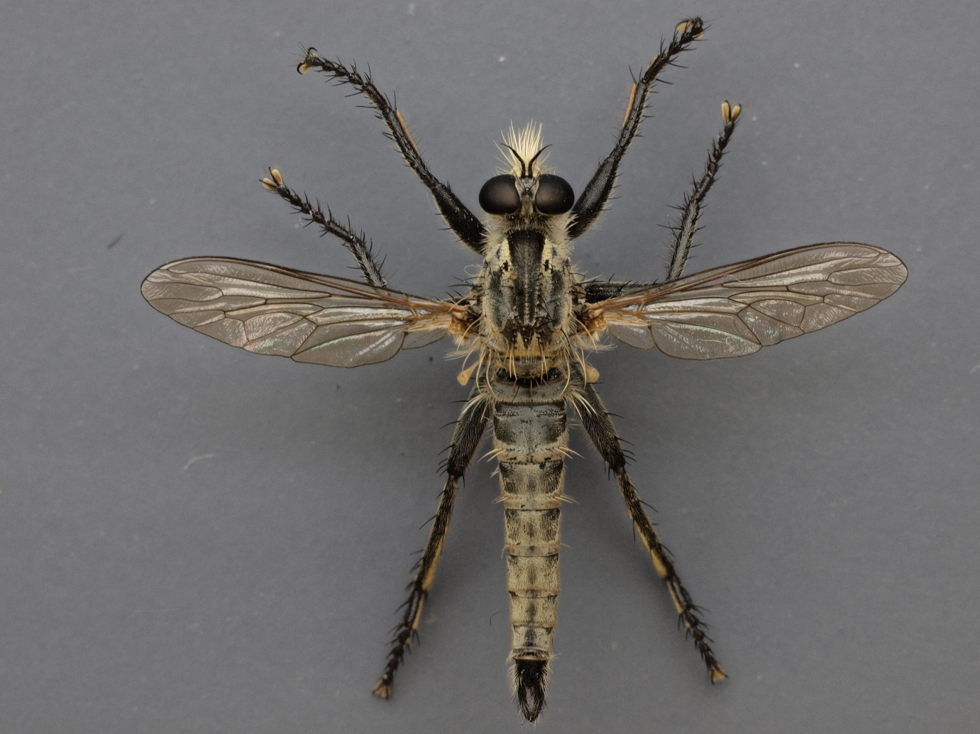

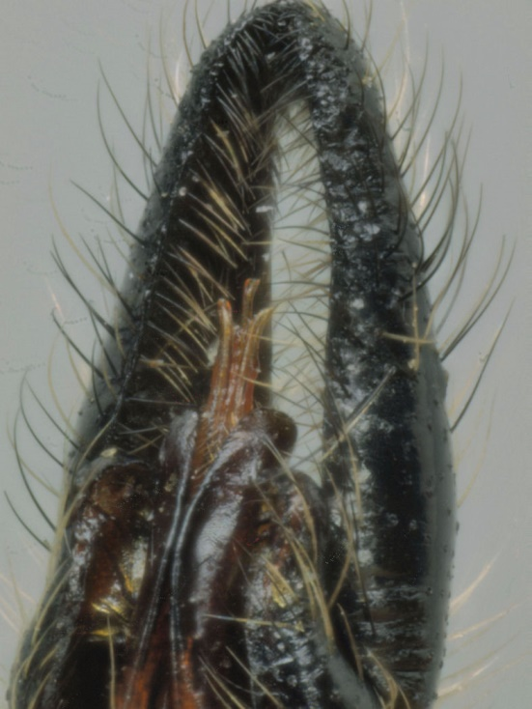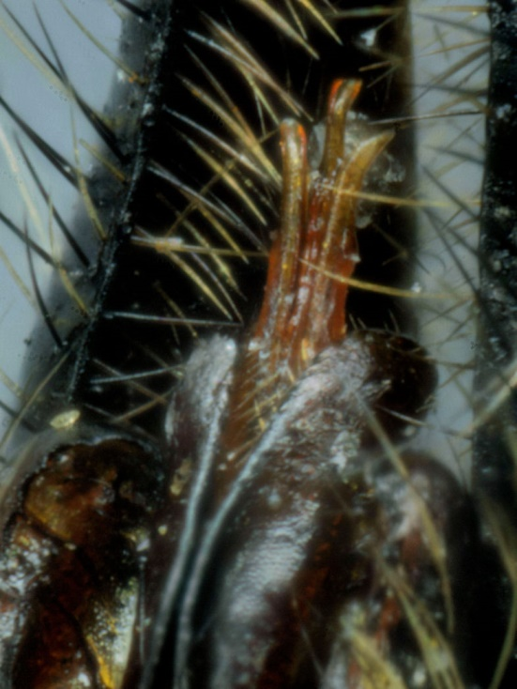
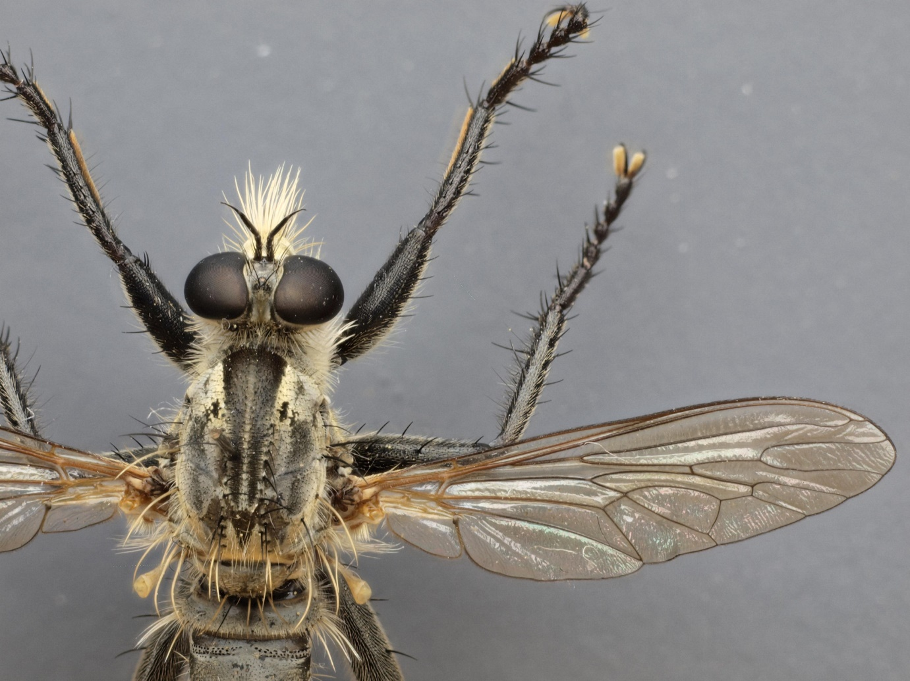

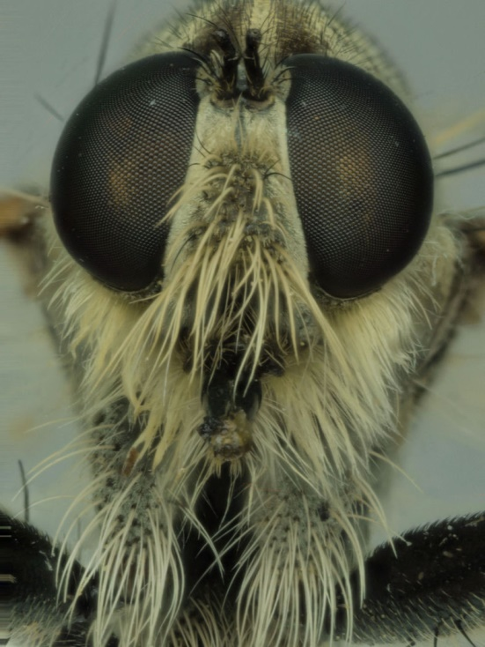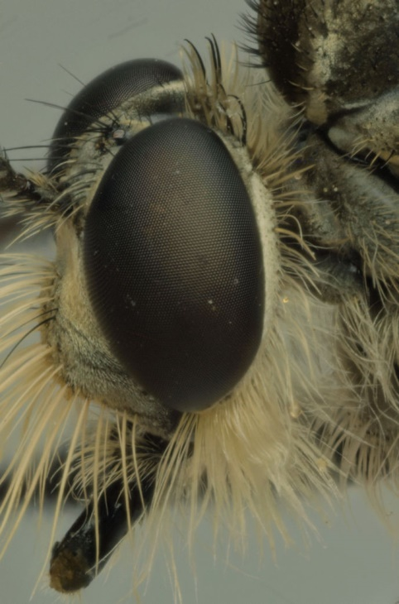

All images were produced by using computer stacking with ZERENE software.

22nd November 2017

APPENDIX 1

EXTENSION LENGTH FIELD WORKING DISTANCE SPEED at f8
mm mm mm
Olympus 35mm Digital Macro Lens
0 50/85 70/160 Auto Exp
Olympus 50mm Macro Lens
7 115 360 1/20 sec
13 70 220 1/20 sec
21 45 145 1/20 sec
31 30 100 1/15 sec 33 27.5 85 1/13 sec 38 24 83 1/10 sec
44 21 72 1/10 sec 47 19.5 71 1/8 sec
52 18 66 1/6 sec 59 14.5 57 1/6 sec 78 11.5 45 1/4 sec
92 9 35 1/4 sec
190 5 28
Olympus 38mm Macro Lens
0 13 60 1/15 sec
7 11.5 55 1/10 sec
12 10.5 50 1/5 sec
19 9.5 50 1/4 sec
33 8 45 1/3 sec
38 7 44 1/2.5 sec
78 5 40 1/1.3 sec
109 4 39 1.3 secs
218 3 34 2 secs
Olympus 20mm Macro Lens
0 5 25 1 sec
52 3 19 1.3 secs
95 2.2 19 6 secs
109 2 19 8 secs
254 1 18 20 secs

