CHIOS, GREECE, RARE DRAGONFLY REPORT, Spring 2015.
Mike Taylor, Associate, World Museum Liverpool.
Update on Rare Dragonflies on Chios
There was greatly welcomed news that the resolution to proceed with survey work and preparations for establishing the dragonfly sanctuary at the Armolia reservoir was passed at the Chios municipal council meeting last week.
Further insect survey work at Armolia this spring has made a new dragonfly discovery there, Lestes viridis ( Vander Linden, 1825), Western Willow Spreadwing. This is a quite remarkable find as this species, as its name implies, is considered to be a species of western Europe. This now brings the total number found at the Armolia reservoir to a remarkable twenty species. Previously there have only been four records from Greece, all on the mainland in 2006 and 2007, all these records being located over 300Km north-west of Armolia.
I found a fresh male and a fresh female on the 20th May, see photographs.
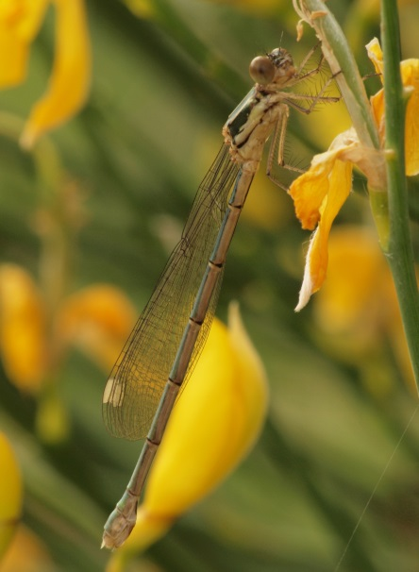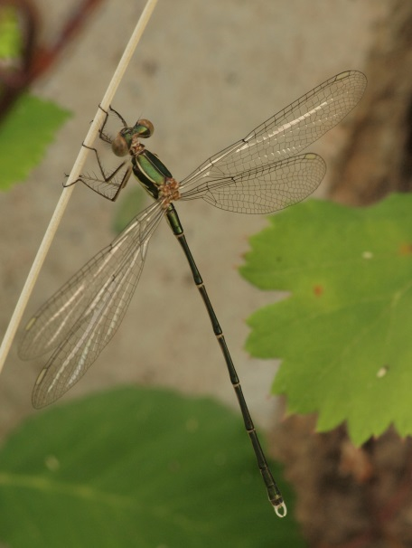
Lestes viridis female Lestes viridis male
Last year’s discovery of Lindenia tetraphylla, Bladetail Dragonfly, at the Armolia reservoir when two males were found in the first week of June, gave rise to the belief that they were breeding at the reservoir. This now seems more certain as I found and photographed a fresh male at the reservoir on the 11th June. The males usually emerge a few days before the females so I am going to regularly visit the site over the next few weeks to try and find females and if lucky, ovipositing at the site. See photographs of the male on 11th June.
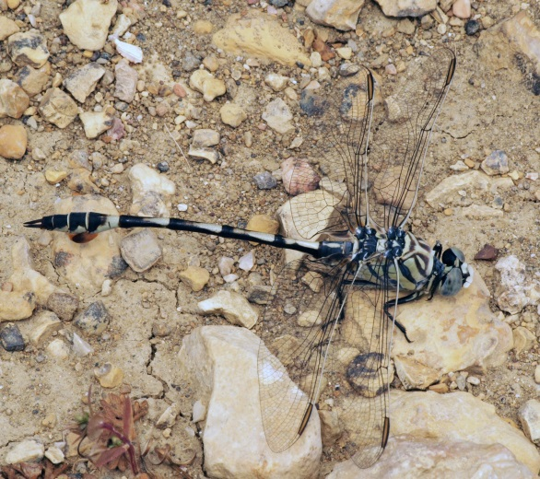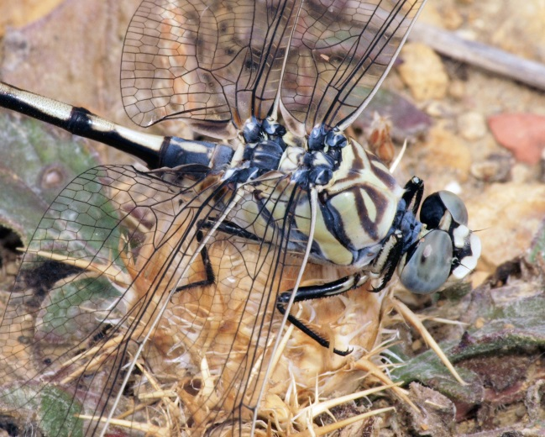
Lindenia tetraphylla male Lindenia tetraphylla male head and thorax
On the 11th June visit to the Armolia reservoir I saw, but was unable to photograph, one teneral male Selysiothemis nigra, Black Pennant Dragonfly, several pairs of which were observed ovipositing on the surface of the reservoir in 2014.
I was however able to photograph a pair of ovipositing Anax parthenope, Lesser Emperor Dragonfly, at the reservoir on the 17th May. See photograph.
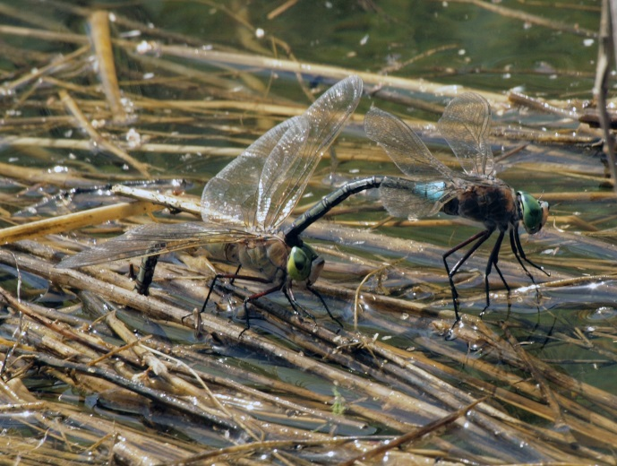
Pair of Anax parthenope ovipositing
Due to the heavy winter rains and cold weather early in the year the season was two to three weeks later than was the case in 2014. So it was not until the weekend of May 2nd and 3rd that a mass emergence of Lestes macrostigma, Dark Spreadwing, was seen at Lithi saltmarsh. On the 3rd May by mid-morning large numbers of males were seen, see photographs.
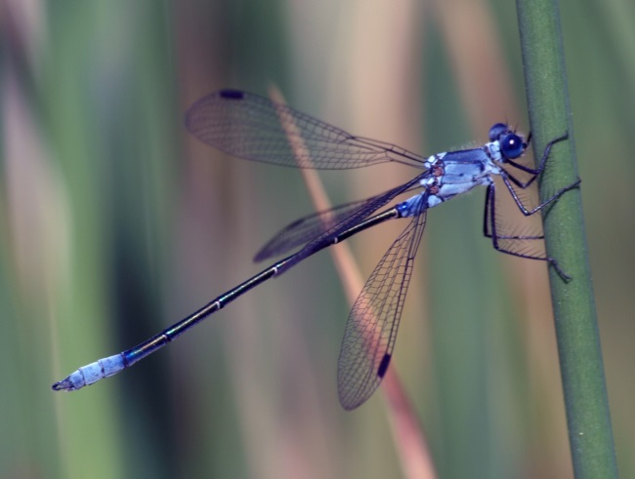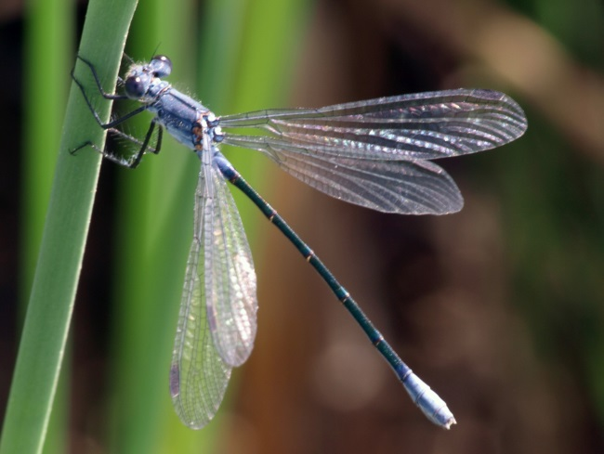
Lestes macrostigma male Lestes macrostigma teneral male
So far this year I have recorded 15 species of dragonfly at the Armolia reservoir, in addition to those covered above I have also seen:-
Sympecma fusca, Coenagrion scitulum,Enallagma cyathigerum, Anax ephippiger, Anax imperator,Crocothemis erythraea, Orthetrum cancellatum, Orthetrum coerulescens anceps, Sympetrum fonscolombei, Sympetrum striolatum and Trithemis annulata.
Implications for Future Tourism
Since I published my article ‘Dragonfly Destination, Chios, Greece’, on my website miketaylornaturalist.co.uk last autumn, I have had many visitors to the site many of whom have downloaded the document. There have been many and widespread contacts, particularly from Germany, France, UK, Belgium, Holland, Italy, Ireland, Scandinavia, Greece and Russia.
I expect that these contacts will be considering visits to Chios in future, though the current uncertainty with respect to financial stability, within Greece, may be deterring them for the time being!!!!
In this context the establishment of the dragonfly sanctuary in Armolia is of symbolic and practical importance. The willingness of the authorities to plan ahead positively in this regard will help to dispel any lingering reservations eco-tourists may have regarding visits to Chios in the future. The council must be congratulated on taking their far-sighted decision.
Reservoir Maintenance Programme 2015
The reservoir needs to undergo a maintenance programme in the late summer and early autumn this year to service the control equipment involved in water discharge for agricultural and other purposes.
The programme originally scheduled for 2013 was suspended when it was realised that the traditional programme, based on an historic ten or twelve year cycle, was no longer allowable under recent EU and European wide treaty obligations covering biodiversity protection.
These obligations include the requirement for special protective measures for species included in the species ‘Red Lists’. As far as dragonflies are concerned the requirements covering one species believed to be breeding at the Armolia reservoir are contained in ‘European Red List of Dragonflies’
Published under the authority of:-
Ladislav Miko
Director,
Directorate B:
Nature Directorate for Environment
European Commission

The Red List includes 21 species of dragonflies including 3 species found in Chios:-
Endangered
Lestes macrostigma (Eversmann, 1836), Dark Spreadwing. This species has been recorded from two sites on Chios, Lithi and Kato Fana. Both sites are protected under the recent Greek presidential decree covering wetland conservation and protection from development. The huge population at Lithi is probably one of the largest in Europe.

Vulnerable
Cordulegaster insignis Schneider, 1845,Blue-eyed Goldenring. This species is widespread and local on Chios, breeding in mountain torrents. It is not considered to be threatened in Chios. See photograph.
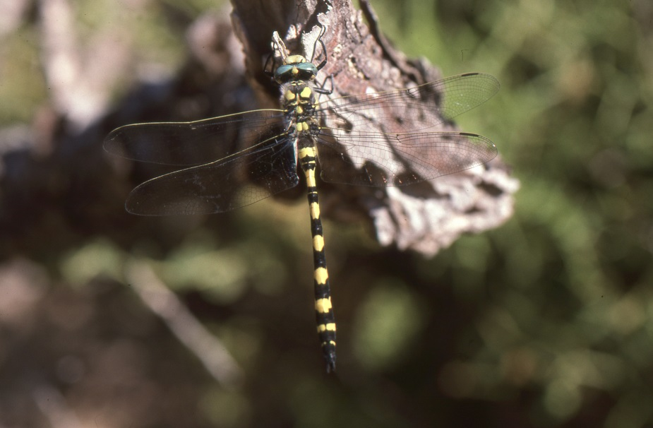
Cordulegaster insignis

Lindenia tetraphylla (Vander Linden, 1825), Bladetail. This species was first recorded at the Armolia reservoir in 2014 and is almost certainly breeding there. It is declining in Europe, now extinct in Spain and severely reduced in Italy due to over collecting and habitat loss.
Its main areas in Europe are now Sardinia and Greece, hence their governments have been given special responsibility to protect their populations by the European Commission.
This species requires highly oxygenated fresh water but nutrient poor lakes and reservoirs. The Armolia reservoir entirely meeting these habitat requirements.
The only threat to the Armolia population arises from its periodic maintenance programme currently operating on a ten or twelve year cycle. Following the suspension of the 2013 programme, advice has been sought from European specialists in order to prepare a maintenance work programme for 2015 which will include mitigation work to safeguard the dragonfly eggs and nymphs during the period of reduced reservoir water levels needed for engineering work.
Once the work has been completed and winter rains refill the reservoir it should still count as one of the most species rich dragonfly sites in Greece.
A very modest low cost work programme is all that is then needed to improve access to the site to create a dragonfly sanctuary for the benefit of interested residents and eco-tourists.
15th June 2015

