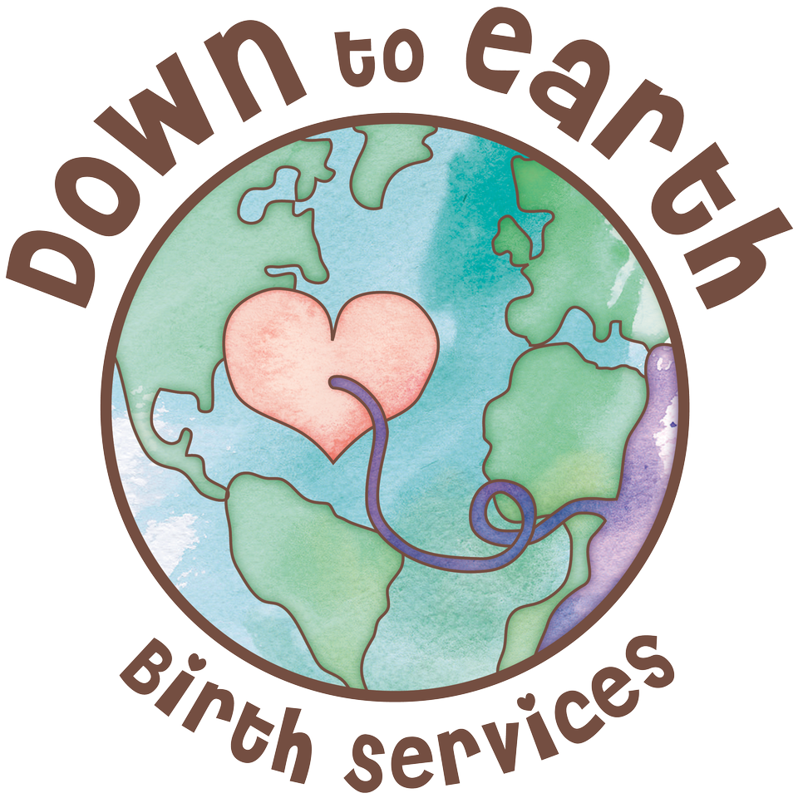
Proactive Postpartum Preparation (PPP)

This form is put together by Down To Earth Birth Services and Full Circle Postpartum Care. Use this to form, as a tool, to simplify your postpartum.
There are many things that we can NOT plan in the Postpartum period, however there are many things we CAN prepare for.
This PPP form will take approximately 30 minutes to complete with your partner and/or support people. Grab a cup of tea, get talking…and write it down.
Hang this completed form in the common area of your house so you can refer to it when needed, the fridge is a great place to hang it!
*It is not too late to use this form if you have already given birth! *

- Fill in the blanks
What makes you feel good and who can help encourage you to do these during your postpartum?
___________________________, _______________________, _____________________ and _________________ are things that make me feel good. I would like ______________ and ________________ to know this so I can be encouraged to do these in the postpartum.
- Check all that apply
These daily/weekly tasks are important for me to stay OK in postpartum.
Fill in the empty spaces for any additional tasks that are not listed, but are important to you.
(Remember we are not aiming for perfection; remember to set realistic expectations to avoid disappointment)
Showering/Bathing
Time to tidy the house
Eating 3 meals a day
That me and my partner have alone time together
Going for a walk /workout
Time to see my psychologist, chiropractor, physiotherapist, acupuncturist etc
Getting out of the house
Having company over
Filling my spiritual cup
Time to do my hair/makeup
Having time away from baby

3) Things to remember (fill in the blank where applicable)
These will help me to keep my stress, worries, anxiety, anger and depression in check and increase the level of support I feel: (Remember to add any additional tasks that are not listed, but are important to you.)

a) Having help with night duties (discuss how many days per week)
___days a week.
b) Having help with household duties (which ones need more attention) _____________________________________________________________________________________________________________________________________.
c) When I am told all the ways that I am doing a great job:_____________________________________________________________________________________________________________________________________.
d) When I have time to focus on my self care (see 2) without feeling guilty.
e) Allowing my time to share my worries and thoughts with you even though they may be scary.
f) Having support for my feeding preferences
g) Talking openly about how life has changed / shifted, without judgement
h)
i)
j)
4) Write it out!
You and your partner (or support people), list all the ways that you/they will know you are doing a great job in postpartum.

- Personal support list:
Who are 3 people who I would call to talk to if I wasn’t doing well?
(Partners or family members, these are also the people you will connect with if you know that your partner is not doing well and needs support. Sometimes partners need additional support too. It can be difficult to talk about your worries with your partner in the postpartum. But you can reach out to the support people listed here and ask them to act as per this plan.)
*Hint-think of who do you normally call when you have something important to share? Who do you call for support when you are feeling down? Who would your partner say you talk to when you need support? Please ensure they are aware that they are a part of your plan.
Name | Phone/Email

6) Professional Support List:
List 5 local perinatal support professionals that you could reach out to if you need professional support in the postpartum?
(Having a prepared list will make it easier to connect if/when you are struggling during postpartum. This is where you google!)

Name | Profession | Phone/Email
Penny Waller | Psychologist | 780-222-4616 therapy@waller.pro
Gina Wong | Psychologist | 780-434-5856 /ginapsychologist@gmail.com

7) Additional information
If you have had a baby before, please list any additional information that you want your partner, friends, family to know about you in the postpartum period. (Signs they may see if you are not okay, etc)

“Vulnerability is not knowing victory or defeat; it’s understanding the necessity of both; it’s engaging. It’s being all in.”
Brene Brown

For use of this form outside of individual use please contact Whitney Clark at down2earthbirth@gmail.com. Do not edit or copy.

