Locomotion Theatre Presents…
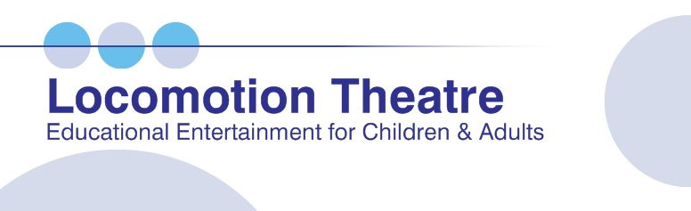

www.locomotiontheatre.com
561.361.8318
info@locomotiontheatre.com
Customized Staff Trainings, After-School, Spring Break & Summer Camp Shows Presented at Your Location.

● Staff Training Workshops
for teachers / camp / after-school counselors & supervisory staff Interactive, engaging custom trainings led by a psychotherapist. Topics include bullying, dealing with a child’s difficult behavior, leadership, communication & more.
● Teen Studio Theatre
for 5-12th grade audiences
Critical thinking and problem solving are highlighted in this interactive and thought-provoking talk-show style program! Led by a psychotherapist, this exciting format creates a forum for guided discussion and dialogue about topics of importance, including bullying, responsible behavior, and the value of learning.
● Figure It Out
for K-5th grade audiences
Lots of laughter, exciting game show fun, and audience participation in this show about problem solving! The show teaches a simple 4 step process to ‘figure things out’.
● Stargazia Blue
for preschool – age 6 audiences
This audience participation show is filled with music and make-believe! It has an imaginative outer space adventure theme that takes the children on an exciting rocket ship ride through outer space!

For a complete listing of shows, staff trainings & programs, please see our website.
Contact us for details, pricing & booking.
Office: 561-361-8318 Cell: 561-445-1305
info@locomotiontheatre.com

For more information & pricing:
Contact: Andrea Ellison
Tel: 561-361-8318
info@locomotiontheatre.com

Staff Training at Your Location for
● Summer Camp Counselor Orientation
● Afterschool Counselors ● Teachers ●Supervisors
● Support & Clerical Staff ● Lifeguards
Highlight Your Professional Development with this Exciting Talk Show-Style Workshop. It’s something different that’s thought-provoking, interactive and fun…and most importantly, effectively and clearly presents the information and the points you want your staff to take away! You Choose the Topics; we’ll build you a custom staff training!
_________________________________________________________________
FOR IMMEDIATE RELEASE: Wednesday, January 16, 2019
CONTACT: Andrea Ellison - info@locomotiontheatre.com

(Boca Raton, FL) – Locomotion Theatre, one of South Florida’s longest established and most respected educational entertainment companies, is now booking great Staff Training Workshops for Summer Camp Orientation!
We come to your location to present all shows, programs & workshops.

Two facilitators, one of whom is an experienced psychotherapist, will present a customized training for your staff that will be remembered as one of your best!
Here’s the way it works: First, we’ll talk with you and help you select 3 or 4 topics for your training. Some of the most requested topics are: Dealing with Difficult Behavior; Bullying; Effective Leadership; Communication Skills; Supervision & Safety; Professionalism; Playing Favorites/Playing Fair; Stress; Confidentiality; Working Together; and Icebreakers & Theatre Games.

The facilitators will act out a series of short skits highlighting your topics, then open a guided discussion with your staff about the situations presented…all the while staying ‘in character’ of the people portrayed in the skit! This makes it like an interactive mini-play! After the discussion, the psychotherapist will give professional opinion about the subjects at hand, and highlight and reinforce the important points you want your staff to take away. Accompanying optional handouts outlining those important points are available.

Breakout Brainstorms™ – small group activities that encourage positive problem solving and team building - are included in most staff trainings.

One hour to half & full day programs are available. Please contact us. We’ll work with you and design the program that’s right for you!

We are Professional, Experienced, and Reliable!
State of Florida Vendor/Contractor Badges ● JLA Approved ● Insured ● Approved by Palm Beach, Broward, Miami-Dade, Martin, Lee, Volusia & Osceola Schools ● Broward Children’s Services Council- Cultural Division Partnership Approved Artists ● Palm Beach County Cultural Council/Cultural Education Committee

Some of the Places We’ve Presented Staff Training & Workshops
● Bright Futures Academy ● City of Boynton Beach Recreation & Parks ● Del Prado Elementary ● Town of Surfside ● City of Hollywood ● Florida Recreation & Park Association ● Royal Palm Elementary ● Town of Sunny Isles ● The Children’s Forum ● Education Foundation of Palm Beach County Family Central/VPK ● Soref J.C.C. ● School District of Palm Beach County ● City of West Palm Beach ● City of Lauderhill ● City of Miramar ● Broward Schools Before & After Care Supervisors ● The RIPLE Project Training @Florence Fuller, The Achievement Center, YMCA Walker…and many more!

