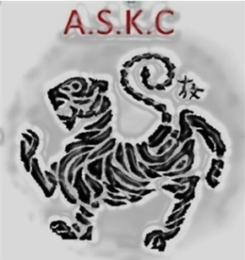

Karate Facts/ History

Who is the father of modern day Karate and the founder of Shotokan Karate?
Gichin Funakoshi

When was Gichin Funakoshi Born and when did he die?
Born: 1868 and Died: 1957 (88 years old)

Why did Gichin Funakoshi change the official records of his birth to say he was born 1870?
Only people born 1870 or after were eligible to sit the examinations to Tokyo's medical school

Who were Gichin Funakoshi's two sensei's?
Master Azato and Master Itosu

What was Gichin Funakoshi's profession for thirty years?
School Teacher

What year did the secrecy of teaching and learning karate end?
1902

What does Karate-do mean?
The open hand way

When was the first karate dojo built?
1935-1936

What was the name of the first ever karate dojo?
Shoto-kan

Name Gichin Funakoshi's six important karate rules?

1. You must be deadly serious in training
2. Train with both heart and soul without worrying about theory
3.
4. Avoid self-conceit and dogmatism
5. Try to see yourself as you truly are and try to adopt what is meritorious of others
6. Abide by the rules of ethics in your daily life, whether in public or private

What is the main purpose of a karate bow?
As a sign of respect

Has anyone ever held a 10th Dan grade in traditional shotokan karate?
Yes, funakoshi's first student to reach a black belt attained a 10th Dan.

What was the name of funakoshi's first student to reach black belt?
Master Gima

When and where was the first karate venue in Great Britain?
Grass tennis court in Essex, 1956

Can you recite the dojo kun?
1)Seek Perfection Of Character.
Hitotsu! Jinkaku Kansei ni tsutomuru koto.
2) Be Faithful.
Hitotsu! Makato no michi o mamoru koto.
3) Endeavour to excel.
Hitotsu! Doryoku no seishin o yashinau koto.
4) Respect others.
Hitotsu! Reigi o omonsuru koto.
5) Refrain from violent behaviour.
Hitiotsu! Kekki no yu imashimuru koto.

