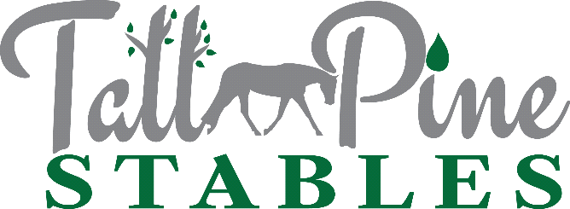
Release & Wavier of Liability
Taylor M. M. Manuel, Owner & Instructor
804.971.1688
TallPineStables@verizon.net

You Must Sign This Release & Wavier Of Liability Before Riding Or Participating In Any Equine Activities At Tall Pine Stables

In exchange for the privilege of boarding, riding, training, grooming, or otherwise participating in any type of equine (“horse”) activity at Tall Pine Stables, located in Powhatan, VA 23139, I am executing this release and wavier of liability. By signing this document, I intend to release Tall Pine Stables, Taylor Manuel, their families, boarders, employees, or other entities or persons connected with them, including any person(s) acting or working on behalf of Taylor Manuel or Tall Pine Stables from all liability for injuries to myself (or my child or to any person whom I am legally responsible) or injuries to my property. I know that I am riding or working around horses at my own risk (or I am acknowledging and accepting this risk to my child). I have other places where I (or my child) could go to participate in equine activities, but I have chosen to execute this release so I can participate in equine activities at Tall Pine Stables (“TPS”). No one has made me sign this.
I know there are many inherent risks of personal injury while participating in equine activities. I acknowledge that these risks included, but are not limited to, bodily injury or death, and that I personally assume these risks to me (or my child) anytime I (or my child) choose to ride, groom, handle, or even be in close proximity to horses. I expressly assume for myself and/or my child the dangerous risks inherent in equine activities, including, but not limited to: (i) the propensity of an equine to behave in dangerous ways which may result in an injury to the participant; (ii) the inability to predict an equine’s reaction to sound, movements, objects, persons, or animals; and (iii) hazards of surface or subsurface conditions.

I agree to hold harmless and indemnify Tall Pine Stables, Taylor Manuel, their families, boarders, employees, or other entities or persons connected with them, including any person(s) acting or working on behalf of Taylor Manuel or Tall Pine Stables (hereinafter “the parties”) and further release them from any liability or responsibility for any loss, accident, death, damage, injury or illness to me (or my child) or to any horse owned by me, or to any family member or spectator accompanying me (or my child) on the premises of Taylor Manuel or Tall Pine Stables. I also agree to indemnify the parties (provide a legal defense and reimburse for damages) in the event a claim is made against them because another individual or individual’s property is injured or damaged as a result of my actions, (my child’s actions), or my horse’s actions. I will also indemnify the parties if a claim is made against them arising out of the actions of any horse professional acting on my behalf who fails to have insurance sufficient to cover the parties as additional insured’s.
I intend for this waiver of liability and release to bind my family or representatives should I die or become incapacitated due to an injury resulting from my involvement with horses. I expressly give up my right to sue (or the right of my minor child or other person for whom I am legally responsible) to pursue a claim for damages arising out of horse activities against the parties. I acknowledge the right of any court or proper jurisdiction to dismiss such case with prejudice, without trial, based upon receipt of a copy of this document which has been signed by me. I want to be clear that I am giving up all rights (including my family’s, my representative’s, my executor’s or my minor child) to sue for money damages or to seek other compensation as a result of horse activities at TPS.
I have been advised to consult an attorney if I have any questions about this release and to read a current version of Virginia’s Equine Liability Act, which as of the writing of this document is found at Va Code Ann. Section 3.1-796-132, et seq, for more information.
My signature below indicates that I have read this entire release, I understand its wavier of liability, I am at least eighteen years old and I am under no disability which would prevent me from understanding the contents of or executing this release. If I have signed this release on behalf of a minor child or disabled person, I warrant that I have legal authority to do so. If it is later determined that I have no such authority, I agree to indemnify the parties for any claim which is allowed to proceed against the parties because of the lack of a valid waiver and release.
I intend for this release to remain in effect indefinitely. If I decide to revoke this release and waiver of liability, I must do so by providing Taylor Manuel with a written revocation, by hand delivery. Once this document is revoked, I will lose all privileges to board, ride, train, or otherwise participate in any equine activities at TPS. Virginia law governs this release.
I give my permission for photographs, audio, and video to be taken while participating in any Tall Pine Stables activities and for these images to be used by Tall Pine Stables and/or Taylor Manuel to promote in the media, on websites, and in promotional materials. Tall Pine Stables adheres to all Federal and State Laws associated with the use of these materials.

Date: ______/_______/_______ ____________________________________
Signature
Signed in Powhatan, VA. _________________________________
Print Full Name
____________________________________
Print Address
____________________________________

If I signed on behalf of a minor child: ____________________________________
Child’s Full Name
____________________________________
My Relationship to Child

Revised 1/1/18

