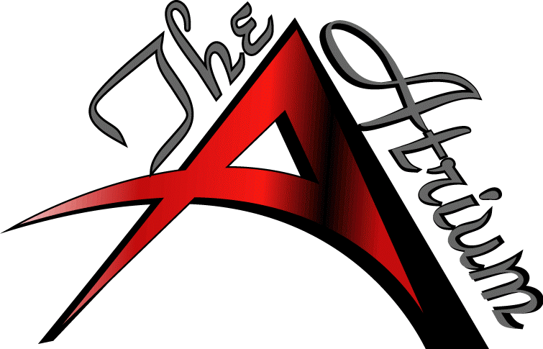
Client Name:________________________Date:___________________Type of Event:____________________
Arrival Time:______________ 60” tables_____ 48”_____ Hi Boys_____ 6ft _____ Linen: Yes or No
DIAMOND ROOM

