 | Logo | Name of Organization | Website
 |  | Texas Children’s Hospital (Lead Agency) | www.texaschildrens.org/injuryprevention
 |  | Bria’s House | www.briashouse.net
 |  | Consumer Product Safety Commission | https://www.cpsc.gov/
 |  | City of Houston – Department of Health & Human Services Consumer Health Services Commercial & Residential Pool/Spa Programs | www.houstontx.gov/health/Environmental/residentialpools.html
 |  | City of Houston – Water Resources Protection | www.houstontx.gov/health/Environmental/the%20new%20phepage.html
 |  | Greater Houston Pool Management | www.greaterhoustonpool.com
 |  | Greater Houston YMCA | www.ymcahouston.org
 | 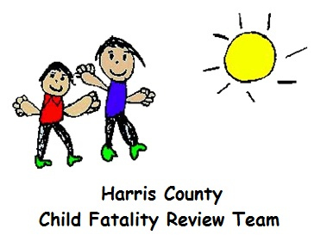 | Harris County Child Fatality Review Team | www.hc-ps.org/hccfrt/
 |  | Harris County Hospital District | www.harrishealth.org
 |  | Harris County Precinct One Commissioner - Harris County Aquatics Program | www.hcp1.net
 |  | Harris County Protective Services | www.hc-ps.org
 |  | Harris County Public Health and Environmental Services | www.hcphes.org
 |  | Houston Apartment Association | www.haaonline.org
 |  | Independent Pool Spa Service Association | www.ipssa.com
 |  | Judah Brown Project | https://judahbrownproject.org/
 |  | Katy Aquatics/Swim America | www.katyaquatics.org
 | 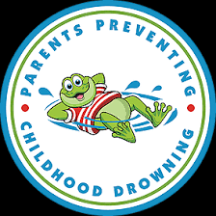 | Parents Preventing Childhood Drowning | https://www.parentspreventingchildhooddrowning.com/
 |  | Pool & Hot Tub Alliance  Greater Houston Chapter | https://www.phta.org/
25. |  | Texas Drowning Prevention Alliance | www.txdpa.com
26. |  | U.S. Army Corps of Engineers – Galveston District | www.swg.usace.army.mil

