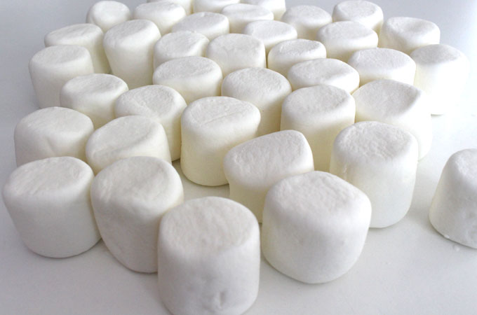
MARSHMALLOW CHALLENGE

INSTRUCTION SHEET

I. ACTIVITY

In this activity you will design a free-standing structure with a marshmallow on top.

II. MATERIALS

The Materials Manager will collect the materials for this activity.

- 1 marshmallow
- 20 sticks of spaghetti
- 1 yard of masking tape
- 1 yard of string
- Sheet of paper
- Markers
- Timer

III. INSTRUCTIONS

- Create your team structure: Project Manager, 3-4 Engineers
- Design your prototype on paper.
- Develop your prototype using the materials provided following the rules listed below.
- Start the timer as soon as you start developing your prototype

IV. RULES OF CHALLENGE

- Build the Tallest Freestanding Structure:
The winning team is the one that has the tallest structure measured from the table top surface to the top of the marshmallow. That means the structure cannot be suspended from a higher structure, like a chair, ceiling or chandelier.
- The Entire Marshmallow Must be on Top:
The entire marshmallow needs to be on the top of the structure. Cutting or eating part of the marshmallow disqualifies the team.

- Use as Much or as Little of the Kit:
The team can use as many or as few of the 20 spaghetti sticks, as much or as little of the string or tape. The team cannot use the paper bag as part of their structure. Break up the Spaghetti, String or Tape: Teams are free to break the spaghetti, cut up the tape and string to create new structures.

- The Challenge Lasts 18 Minutes:
Teams cannot hold on to the structure when the time runs out. Those touching or supporting the structure at the end of the exercise will be disqualified.

V. GROUP CLEAN UP

