June 2017

News
Upcoming Events
Opportunities
Quote of the Month
‘Reality is Observer Created’
Ray Consciousness
What are the 12 Rays?
----------------------
New Articles Coming

July 2017 Edition
JOP Magazine www.journeyofpossibilities.com

Living in the Divine Moment
Dear Cosmos:
Discovering Ancient Treasures
----------------------

ONE-TLC Practitioners
are available for YOU...

Sheryl Sitts
Rossmary Slade
Mario Rosales
Tamara Pedlow

www.thecarmineconnection.com/PRACTITIONERS.html

ONE-TLC News

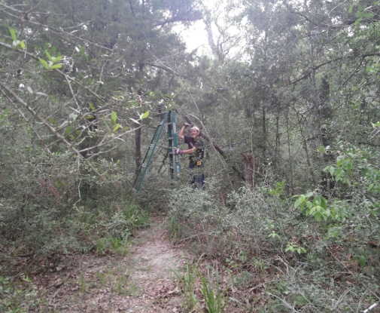
We are excited to announce the ground breaking for our first ONE-TLC Guest Cabin. We chose a site that is secluded and nestled in the loving arms of cedar and oak trees. David has been lovingly focused on designing a get-away-from-it-all retreat for Nature Lovers and Truth Seekers.

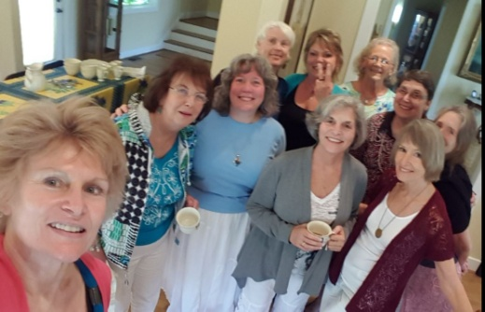
We experienced a wonderful time of Sharing, Connecting, and Healing as we gathered to understand more fully the ‘The Wound of Isis’ and the times of ‘Atlantis’ during a recent event at Living Bridge Languages in Chappell Hill.

Upcoming Events
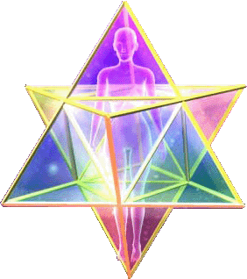
12 Ray Ceremony

You are invited to join us in this collective endeavor on July 25, 2017 to ground our intentions to live on a peaceful and harmonious Earth that allows Authentic Expression. We will bring forth the 12 Ray vibrations of Light and Consciousness into a synergistic ‘pool’ of energy to be realized more fully individually and collectively and then shared with humanity.
See Details: www.thecarmineconnection.com/EVENTS.html

(Scroll Down for Page Two)

Make a Wish Journey
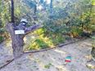
Walk this path to
Receive Clarity
Regarding an issue,
Decision or desire.
Discover Changes
you can make
Then Experience
Your Desired Outcome.
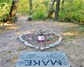

You’re Gods
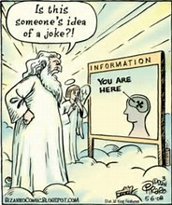
Final Revelation

Opportunities

#1. Would you like to spend more time in Nature?
Do you enjoy working together with others on projects?
What if you could do both and use your Creative Abilities to
benefit others and barter your time towards Retreat Revelations and Services at ONE-TLC?

#2. Would you like to get a nice discount on our services?
Would you enjoy being a catalyst in our
Guest Cabin development?
What if you could do both by prepaying $237 ($277 value) for
a full two day and one night Retreat Revelation where your support goes towards the $2,000 worth of Cedar
we need to complete the cabin?

#3. What if you just emailed or called us to discover
many other Now Living Potentials?

~ We’re here to assist you in many ways. ~
Please contact: info@thecarmineconnection.com or 979-278-3360

Quote of the Month

“Reality is Observer Created”
Dr. Werner Heisenberg
AND we are all the Observers…
Can You Imagine
What This really Really REALLY Means for
you ~ You ~ YOU ???

12 Ray Consciousness

The Twelve Rays relate to Colors & Vibrations which are Aspects of God/Source/Light, and since we are an Aspect of God/Source/Light they are an Aspect of us as well. In their Divine form they radiate the highest level of frequencies and consciousness possible. Through use and misuse of energy our own personal Rays can become imbalanced. Through understanding and acknowledging the Twelve Rays we gain the ability to recognize which ones may be out of balance. We can then incorporate the appropriate Rays to create a more conscious, balanced, and fulfilled life.

Coming next month: Ray One ~ Master El Morya

The Carmine Connection and ONE-TLC appreciate all donations and contributions for the continued development of the Center and Facilities.
www.thecarmineconnection.com/DONATIONS.html

