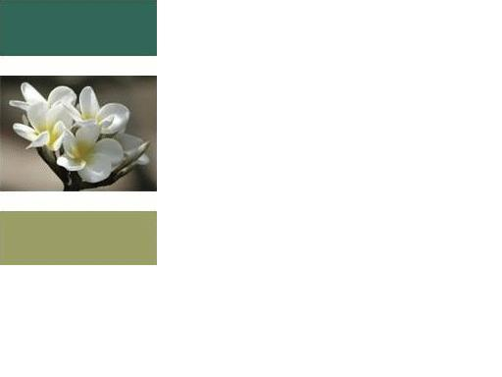

NOW

A lot of people talk about being in the “NOW” or being mindful. For some of my readers you may know what this, for others it may seem like what is the big deal with “NOW.”
“NOW” actually is just a way of saying that something or someone is in the moment. Being in the moment a person is not distracted by the past or the future. The person is actually focused on what is right in front of them and is not concerned with other thoughts that may lead a way from what he/she is currently involved in.
Why is any of this important? Its importance goes back to an earlier blog where I talked about perceiving love or fear. In the “Now” moment fear cannot exist. This is because in the “Now” everything that seems to be there or happening just is. When a person allows perceptions of fear into the moment they are not there because the perception has come from the past. Now that I got everyone confused, let me try and clear this up.
Most human perception comes from thoughts of something that has happened in the past. Well much of what is in the past is learned from fear. The whole “do this, don’t do this” way we are taught as children. What it boils down to is a bunch of rules and thoughts designed to make us feel guilty or scared. Much of what many people do not learn is how to choose love.
Before I get to far ahead I will tell you where the future fits in. The future is just are thoughts projected forward. Most of our thoughts actually based on the past.

So, we have a fearful perception that originates in our past and can be projected into the future. To perceive out of love a person just needs to be in the “Now.”
Example: A person is on their way to work and just after getting on the expressway they are stopped in traffic. A person not in the moment might think “I am going to be late. They may even get angry or frustrated (Road Rage) as they sit there, they may even explore thoughts how they could have avoided this.”
A person in the moment may just take a deep breath and enjoy a moment of peace. He/she may send light and love to the situation or he/she may realize that this traffic has an unknown benefit to it.

The main focus of this example is in the moment everything just IS, and by being in the moment a person will be at peace. By allowing our past fears take over we our letting in anger and possibly creating even a worse situation.
Before I close I would like to give you tool to help you be in the moment. All you have to do is turn your focus to your breathing. Feel the air come into your body and leave your body. Another way to focus on the moment is every now and then check your thoughts are focused on what you are doing? If the answer is “no,” then bring yourself back to the task in front of you.
I hope this helps in understanding the “NOW.” It is just a sampling of the topic, there have been whole books written on the topic. However if anyone has questions or comments I will answer them as soon as possible. Remember feel free to message or email me if you want to keep your question private.
Peace and Love,
David

