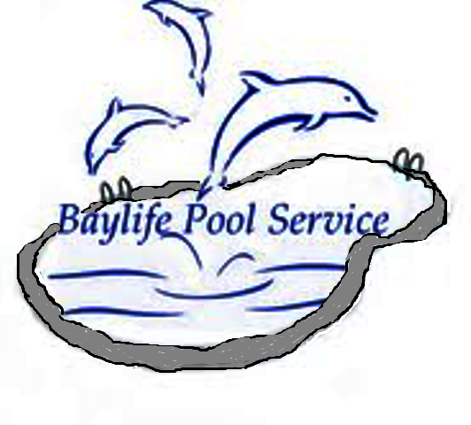

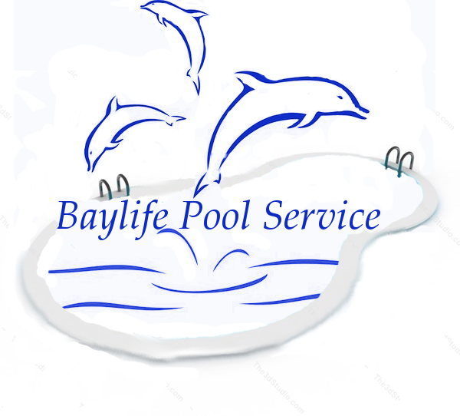

Baylife Pool Service

Email: baylifepoolservice@gmail.com

Website: www.baylifepoolservice.com

Business Number: 813-789-3136


Produce this flyer for 1 free week cleaning service with the purchase of one month of service.

Services
*Cleaning* *Chemicals* *Pressure-Washing* Professional service with the best customer service in the Tampa Bay area. Free Estimates. Over 20 years in the swimming pool industry.

