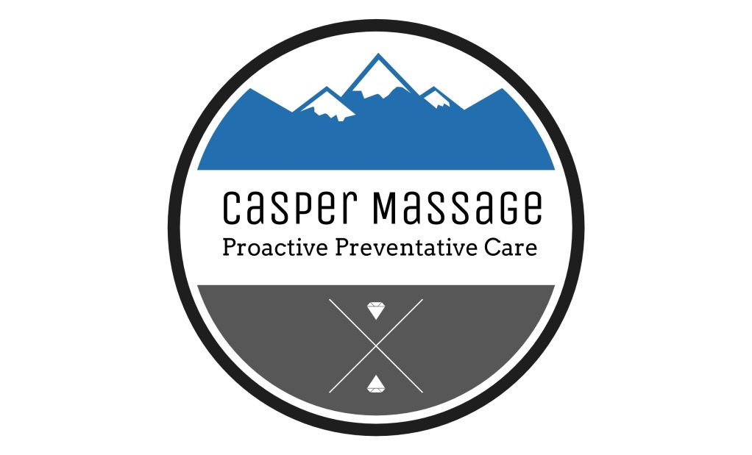
CLIENT HEALTH INTAKE
Today’s Date:
Client Name:
Date of Birth: Gender:
Phone Number:
E-Mail:
OK to contact you with news and or coupons through this email? Yes No
Emergency Contact Name and Phone:
Whom may I thank for your referral?
Have you received professional bodywork before?
If so, how long ago?
What types of bodywork or pressure levels do you prefer?

What are your dislikes or concerns from past massage experiences?

What major concerns brought you here today?

In general how is your health? (Ex. Diet, Exercise, Rest, Relaxation, Mental, Spiritual)

What are your major stressors?
Have you had any car accidents, falls, concussions, whiplash injuries, serious illnesses or surgeries?
Dates: Type:
Dates: Type:
Dates: Type:
Dates: Type:

Please continue to next page…..
CASPER MASSAGE CLIENT HEALTH INTAKE
Please indicate following conditions you have or have had in past:
Ladies, are you pregnant? Due Date:
Muscle or Joint Pain/Stiffness:
Numbness or Tingling:
Swelling: Bruise Easily:
Sensitive to touch/pressure: Varicose Veins:
Stroke, heart attack, blood clots:
High/Low Blood Pressure:
Cancer:
Neurological: (MS, Parkinson’s, Fibromyalgia, Migraine, Chronic Pain, Epilepsy)

Arthritis: (Rheumatoid, Osteoarthritis)
Osteoporosis, degenerative spine/disk:
Allergies: (Topical, Internal, Environmental)
Diabetes:
Endocrine/thyroid conditions:
Depression, anxiety:
Adrenal Fatigue:
Memory Loss, confusion, easily overwhelmed:
Please list any pharmaceutical medications you are currently taking:

I understand that massage therapy is intended to enhance relaxation, reduce pain caused by muscle tension, increase range of motion, improve circulation, and offer a positive healing experience of touch. The general benefits of massage, contraindications, and treatment procedures have been explained to me. I understand that bodywork is not a substitute for medical treatment or medications. I understand that the therapist does not diagnose illness, does not prescribe medication, and that spinal manipulation is not part of the therapy.
I understand it is my responsibility to inform the therapist of all known medical conditions and medications, as well as keeping the therapist informed of any changes. I understand that there shall be no liability on the part of the therapist due to my forgetting to relay any pertinent information.
I understand that it is my own responsibility to communicate with the therapist if I feel any pain or discomfort during the session so that the treatment can be adjusted.
I understand that therapeutic bodywork is NONSEXUAL in nature. Any sexual overtures by the client will result in the immediate termination of the session and the therapeutic relationship.

Client Signature: Date:
CASPER MASSAGE OFFICE POLICIES
IN ORDER TO ENSURE A PROFESSIONAL AND THERAPEUTIC EXPERIENCE FOR BOTH PRACTITIONER AND CLIENT PLEASE FAMILIARIZE YOURSELF WITH THE FOLLOWING POLICIES:
1. YOUR PRIVACY: I will never disclose or use any of your personal information, including contact info, health history or verbally shared thoughts or emotions, for any purpose whatsoever, other than for your health and healing and our work together as practitioner and client within this office.
2. CELL PHONE USE: Please set your phone to silent, off or just leave it in your car before you arrive for your appointment. You are here to heal, relax and retreat. Answering your phone, while already in my office, or keeping it on during our session is disrespectful to me and unconducive to an effective therapeutic environment. Please conduct any personal or business matters you must take care of before you come in this office and turn your phone to silent or off.
3. PAYMENT: Prepayment is required by credit card to book all appointments.
4. 24 HR. CANCELLATION/RESCHEDULES POLICY:
If you would like to cancel or reschedule your appointment, you must provide 24 hrs. notice before your scheduled appointment time or your full payment will be kept for that session, with no reschedules and no exceptions.
When notifying me 24 Hrs. in advance of your appointment with the intention to reschedule or cancel you can:
- Email me at info@caspermassage.org
- Following link to your account in online scheduler that was sent in your confirmation emails
- Logging into your account through online scheduling menu on website..
- Leave a voicemail at 307-251-4431
- CANCEL: If you are completely cancelling appointment you will be refunded amount you paid, minus $25 booking fee. Refunds can take 7-10 business days.
- RESCHEDULE: If you are rescheduling, you will be issued office credit to use whenever you would like to reschedule. You can then reschedule by leaving voicemail or going online and using "redeem gift certificate menu" to override required prepayment. You get one reschedule a month and after that each reschedule is a $25 fee due at beginning of your next appointment time.
5. NO SHOWS/NO CALLS: If you make an appointment, don’t show up and don’t notify me in any way, you may find a different massage therapist to work with. I do not have time for people who do not respect my time/income. Your payment for that session will be kept in full. NO REFUNDS.
6. TARDINESS: If you arrive more than ten minutes late then you have missed your appointment. I do not have time in my schedule to wait around for tardiness. If once you arrive you excessively delay our actual appointment time for any reason your session will be cut short to fit within your appointment time. You will not be refunded for any portion of your session. I have this time booked for you and then I have people coming in after you.
7. SICKNESS: Massage/bodywork is not appropriate care for infectious or contagious illness. It will not make you feel better and I do not want to touch you if you are sick! Please cancel your appointment as soon as you are aware of an infectious or contagious condition. In most cases I will waive my reschedule and cancellation policy if you are sick. Please be compassionate to the fact that I have an extremely compromised immune system as a two time cancer survivor and I do not want you to come get me sick so that I lose 3 weeks of income over a matter of money.
8. GIFT CERTIFICATES: Gift Certificates cannot be combined with other offers, discounts, promotions or coupons. When purchasing gift certificates please be advised that your recipient will have six months from the date of purchase (not from date when you give it to them but date when you purchased it from me) to come in and use the certificate. I do not honor expired gift certificates except for in certain extenuating circumstances. I do not refund money for unused gift certificates for any reason and they are not transferable to another person.
9. PACKAGES AND GIFT CERTIFICATES NO SHOWS AND CANCELLATIONS:
If you have a package deal with me or gift certificate and you do not give 24 hr. notice to cancel or reschedule or just don’t show up without any notification, your gift certificate will be considered used or with package deals one session will be considered used. If you are or are going to be more than 10 minutes late then you have missed your appointment.
10. INAPPROPRIATE BEHAVIOR: Please note that Casper Massage is strictly non-sexual. If you are looking for a sexual experience you have come to the wrong place and any such behavior will not be tolerated and will result in your personal information being sent to Casper Police Department. This includes lewd comments/jokes about profession, interest in therapist beyond professional relationship or any other offensive gestures. I am a health professional and have worked very hard in my life and education to help others in illness or pain and will absolutely not tolerate this.
Thank you for your mindfulness regarding these important policies.

Client Signature: Date:

