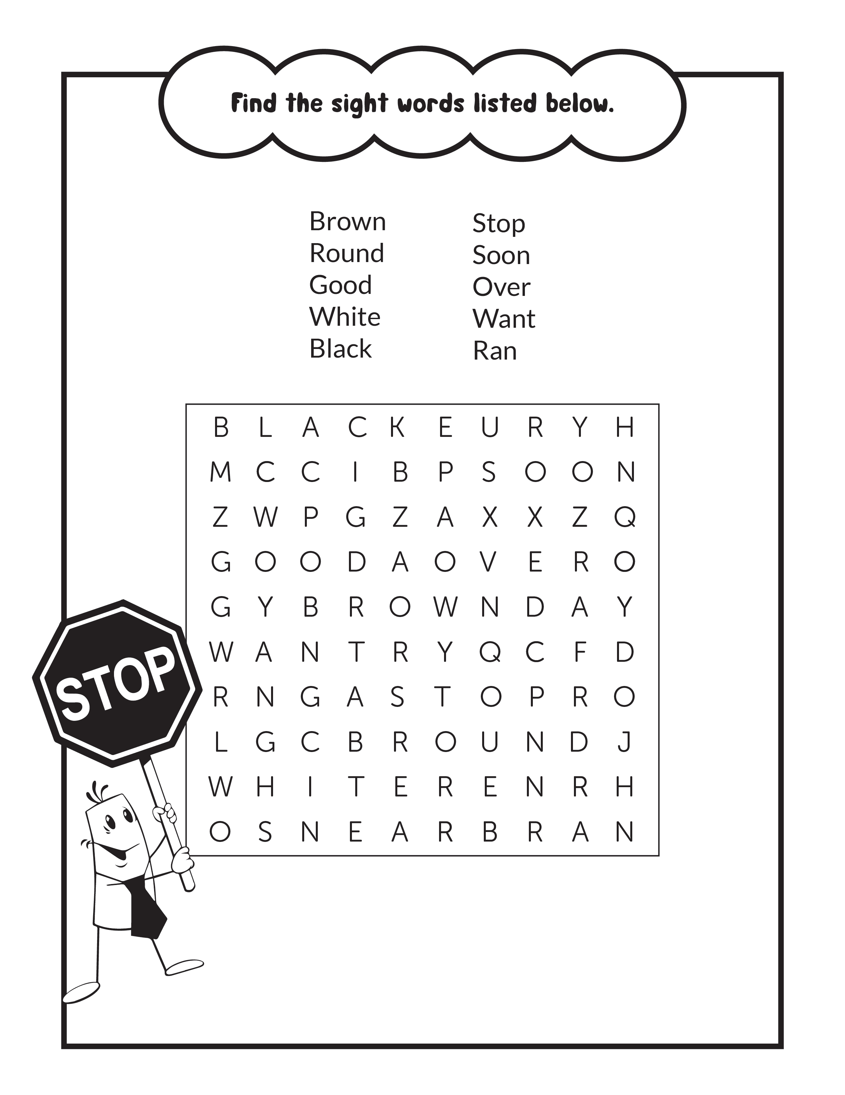
www.Jazzyscreativecenter.com

