Dietitian 4 Health

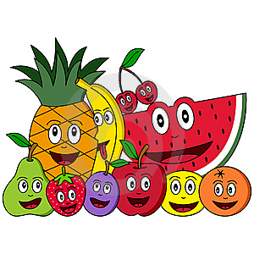
THREE DAY FOOD RECORD
Instructions:

Fill in everything your child eats or drinks for 3 days

Use 1 page for each day

- Write down the time of the meal or snack

- Measuring the food will give the best accuracy, otherwise you can estimate using the following method:

An adult fistful is about 1 Cup

An adult palm the size of a deck of playing cards is about 3-4 ounces of meat

An adult thumb is about 1 tablespoon, or 1 ounce

- Write down how much your child drank, including water

- Write down how it was prepared (baked/ steamed/ fried)

- Write down whether anything was added to the food (butter/salt)

- Write down the brand name if it was a packaged food

- Write down the amount that was eaten, not offered

Example of a detailed food record:

Time | Food/Beverage | Amount
7:20 am | Corn flakes | 3/4 cup
 | 1% milk | 1/2 cup
 | Strawberries, sliced | 5
10 am | PC dipped chocolate chip granola bar | 1 whole
 | Water | 1 cup
12 noon | Ham and cheese sandwich | (only ate half sandwich)
 | black forest ham | 3 slices
 | Cheddar cheese | 1 slice
 | Low fat mayo | 1 tbsp
 | Whole wheat bread | 2 slices
 | Baby carrots | 5
 | Water
3pm | Cheese string | 1 whole
 | Juice box(100% orange) | half
6:30pm | Chicken drumstick with skin | 1
 | Pasta with butter and parmesan | 1/2 cup
 | Steamed broccoli with olive oil | 1/2 cup
 | 1% milk | 1 cup
7:30 pm | Chips ahoy chocolate chip cookies | 2
 | 1% milk | 1/2 cup

Food Record Day 1 Name: Date:

----For Dietitian use------
Time | Food/Beverage | Amount | F/V | Gr | Pro | Ca | Fe

Food Record Day 2 Name: Date:

----For Dietitian use------
Time | Food/Beverage | Amount | F/V | Gr | Pro | Ca | Fe

Food Record Day 3 Name: Date:

----For Dietitian use------
Time | Food/Beverage | Amount | F/V | Gr | Pro | Ca | Fe

